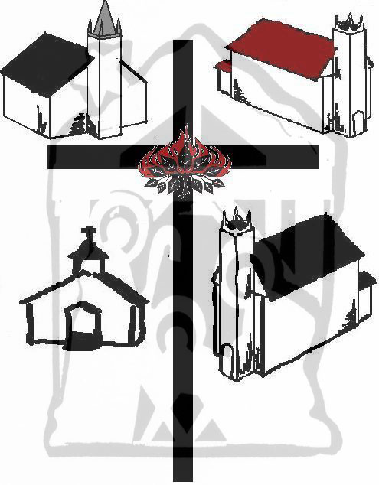
December 22nd 2013
A Christian Church at Christmas

St. James’ Presbyterian Church

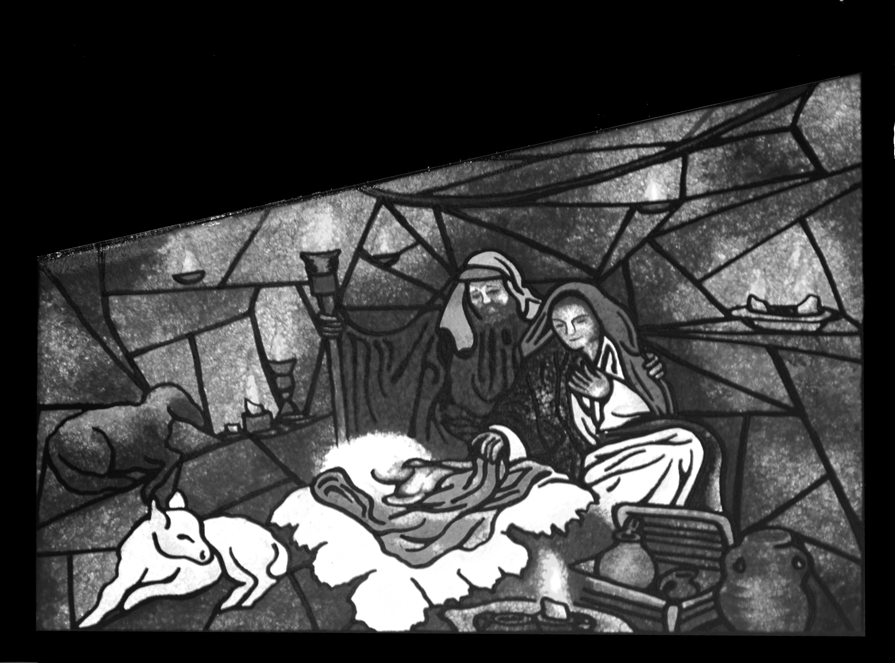
The Bass River Pastoral Charge

The Presbyterian Church in Canada

A First Christmas
Christmas Songs -
Introduction – Cupboards and Boxes
Around this time of year we all tend to get out a box or to, somewhere in getting out the decorations, or clearing space for company.
These boxes of memories and these cupboards of this-and-that’s that build up through the days are those little memories we set aside; a button we cannot find a shirt for, tape from wrapping a package, a pack of seeds left from the spring gardening, notes, receipts, a couple of nails, a pack of tacks, an extra battery or two, these are the things that are not quite discarded in our life where so much is disposable.
Maybe - tucked to one side - is a thank you card after you gave a gift, or did a favour. Pictures too, of friends and their new babies, from newspaper clippings, these things you might want to scrap book, but who has the time.
Yeah, this shoebox, or the drawer, or the cupboard is filled with all the little incompletes that fill our lives that can be so short on time. We are not finished with it, we just don’t know what to do with it, so it ends up here. And then comes a day when we cannot find something we need, and we stumble into that drawer or shoebox so filled with everything, and there is the answer we were looking for. And then your mystery, of why you held onto that one
And then there are the days when we just fumble around in those old boxes and cupboard for no better reason then we just decided to see what was waiting in there, just because we have a moment.
It’s okay if your life feels like a drawer of jumbled junk and oddities. The key to getting through that kind of life is to make sure that every once and a while you open yourself to your past, all its lessons and all the things you know you’ve left undone, half-done, unsolved or set aside.
An odds-and-ends cupboard is not really a ‘junk drawer’ is one of those places in life where we discover our need for forgiveness. Every time we open that drawer, every time we stash another ‘this’ or ;that’ in there, we are leaving things undone, a promise if not broken, suspended, pending, left in anticipation. Oh, everything has a purpose a use, it just might not yet be the season or you might not be the person to know what that purpose is.
God does not have a junk drawer, because he does not have junk. God has a purpose for every one of us, whether we believe it or not, whether we chose to realize it or not. God looks into our lives and sees potential and possibilities, and all God is asking that we do the same.
So let’s look to this new year, with all the junk that may come, and with a little bit of faith, let’s see the possibilities and celebrate the purpose that is in every one of us, God’s beloved children.

Opening prayer

Scripture: Luke 1:26-38
²⁶In the sixth month, God sent the angel Gabriel to Nazareth, a town in Galilee, ²⁷to a virgin pledged to be married to a man named Joseph, a descendant of David. The virgin’s name was Mary. ²⁸The angel went to her and said, “Greetings, you who are highly favored! The Lord is with you.”
²⁹Mary was greatly troubled at his words and wondered what kind of greeting this might be. ³⁰But the angel said to her, “Do not be afraid, Mary, you have found favor with God. ³¹You will be with child and give birth to a son, and you are to give him the name Jesus. ³²He will be great and will be called the Son of the Most High. The Lord God will give him the throne of his father David, ³³and he will reign over the house of Jacob forever; his kingdom will never end.”
³⁴“How will this be,” Mary asked the angel, “since I am a virgin?”
³⁵The angel answered, “The Holy Spirit will come upon you, and the power of the Most High will overshadow you. So the holy one to be born will be called£ the Son of God. ³⁶Even Elizabeth your relative is going to have a child in her old age, and she who was said to be barren is in her sixth month. ³⁷For nothing is impossible with God.”
³⁸“I am the Lord’s servant,” Mary answered. “May it be to me as you have said.” Then the angel left her.

Carol: Away in a Manger
Away in a manger, no crib for a bed, The little Lord Jesus laid down his sweet head.
The stars in the bright sky looked down where he lay, The little Lord Jesus asleep on the hay.

The cattle are lowing, the Baby awakes, But little Lord Jesus no crying he makes,
I love thee, Lord Jesus; look down from the sky, And stay by my side until morning is nigh.

Be near me, Lord Jesus, I ask thee to stay / Close by me forever, and love me, I pray.
Bless all the dear children in thy tender care, And fit us for heaven to live with thee there.

Special Music
Narrative – A New Stocking
A New Stocking

It became a tradition when they were first married. Their first Christmas the young husband and wife decided to fill stockings for each other along with their usually presents. A gifted knitter, the young lady decided to knit their stockings herself. It was quite an intricate pattern, with ribbing and cabling, and while not overly large they could fit a lovely assortment of treats, trinkets and a few toiletries. Their first Christmas together it was a great deal of fun to hang the stockings, fill them and then empty them together on Christmas morning.
But, the next Christmas brought with it a new addition to the family, born just a little more than a month before Christmas was the couple’s first child, a son. This meant another new stocking. And changing the pattern a little and thing the stocking could be a little bigger perhaps and more stretchy, the new stocking was big enough to fit the goodies for the little baby and the baby too; and the little lad was not fond of being stuffed in a sock like an orange or a candy cane, it did make for a cute picture of that first Christmas together.
The next year their son did not quite fit into the stocking, but he was far more interested in what was in there. And it was a bit of a game to watch him empty the stocking, then fill it back up, and them empty it again. Yes, that was the year that he played more with the boxes than the presents.
And the following Christmas, though their little son was rather sick that year, the excitement of pulling out one fantastic new gift after another could not be hidden – though the stocking along with a few other things need some extra careful cleaning, after the over excitement got to the little guy’s stomach.
The next year was blessed with another joy; another boy, and another stocking to pattern and make. Their first son, now three welcomed a baby brother to the Christmas tree, explaining all of the exciting things about Christmas from the stories, to the songs, to showing how to efficiently decorate a tree by putting most of the decorations in a two foot space near the bottom.
And as their family grows, so this tradition will continue.
When we come together in to new friendships, fellowships and relationships, a pattern is already been thought up for all of us. We are knitted together in these relationships in a special way. No two exactly the same. And gifts are poured into the different families and friendships we form, we receive and hold onto these gifts, using them in different way. It is incredibly intricate, yet it works, wondrously.
We are gathered here because we are celebrating the birth of Christ, God giving himself by giving His only begotten Son. But let’s not forget all the gifts that God gives us from, birth till eternal life, and all in Jesus name. We need to open those gifts, and celebrate those gifts and rejoice in God who gives us everything. And it is always better to be able to open and use those gifts together.

I don’t know all your family traditions, but I do know that our family traditions, shared this time of year, are here to remind us how much we ought to love each other, how much we need to love and honour God; to rejoice in sons and daughters, mothers and father, friends and neighbours, all of us brothers and sister, in Christ. In every song we sing, prayer we share, gift we give and receive, let us embrace our traditions of loving in the love of God, tonight and each night we remember the gift of Christ.

Carol: The First Nowell
The first Nowell the angel did say; Was to certain poor shepherds in fields as they lay;
In fields where they lay tending their sheep, On a cold winter’s night that was so deep.
Refrain: Nowell, Nowell, Nowell, Nowell, Born is the King of Israel.
They lookèd up and saw a star; shining in the east, beyond them far;
And to the earth it gave great light, And so it continued both day and night. Refrain

And by the light of that same star; three wise men came from country far;
To seek for a King was their intent, And to follow the star wherever it went. Refrain

This star drew nigh to the northwest, o’er Bethlehem it took its rest;
And there it did both stop and stay, Right over the place where Jesus lay. Refrain

Then entered in those wise men three, full reverently upon the knee,
And offered there, in His presence, Their gold and myrrh and frankincense. Refrain

Then let us all with one accord, sing praises to our heavenly Lord;
That hath made heaven and earth of naught, & with His blood mankind hath bought. Refrain

Scripture: Matthew 1:18-25
¹⁸This is how the birth of Jesus Christ came about: His mother Mary was pledged to be married to Joseph, but before they came together, she was found to be with child through the Holy Spirit. ¹⁹Because Joseph her husband was a righteous man and did not want to expose her to public disgrace, he had in mind to divorce her quietly.
²⁰But after he had considered this, an angel of the Lord appeared to him in a dream and said, “Joseph son of David, do not be afraid to take Mary home as your wife, because what is conceived in her is from the Holy Spirit. ²¹She will give birth to a son, and you are to give him the name Jesus, because he will save his people from their sins.”
²²All this took place to fulfill what the Lord had said through the prophet: ²³“The virgin will be with child and will give birth to a son, and they will call him Immanuel”—which means, “God with us.”
²⁴When Joseph woke up, he did what the angel of the Lord had commanded him and took Mary home as his wife. ²⁵But he had no union with her until she gave birth to a son. And he gave him the name Jesus.

Special Music
Carol: In the bleak mid-winter
In the bleak midwinter, frosty wind made moan, Earth stood hard as iron, water like a stone;
Snow had fallen, snow on snow, snow on snow, In the bleak midwinter, long ago.

H’ven cannot contain Him, nor the earth sustain; Heaven and earth shall welcome Him when He comes to reign.
Yet, in the bleak midwinter a stable place sufficed The Lord God incarnate, Jesus the Christ.

Angels and archangels may have gathered there, Cherubim and seraphim thronged the air;
But His mother only, in her maiden bliss, Worshipped the beloved with a loving kiss.

What can I give Him, poor as I am? If I were a shepherd, I would bring a lamb;
If I were a Wise Man, I would do my part; Yet what I can give Him: give my heart.

Poem– The Empty Space
So full of fun, those years & days
Filled with dreams, and songs to sing.
Achievements came with labours paid
Till it seemed that I could do anything

And from my friends stood one,
Who filled my heart to burst with joy
And we at last shared name, and heart and home
Fulfilled in self in the others; answer to ‘why?’

Yet more than this came life,
In precious smallness, yet still so abundant
Growing, filling, over whelming, never /always strife
Till years are moments as children rise to leave but not abandon

Around the seasons’ festivities we raced
And year to year, in wholeness sought life and destiny
Never enough hours, time so full of dreams to chase
Till each year would end beneath a tree decorated with memories.

Then time was filled, and with proud steps we marched to graduate,
To find the time to meet, reunion and come home again,
And see each no longer child find life, a call, a life-long mate
While quietly I turned towards retirement, resigned

Then, the empty space is there, where once they stayed or played,
And moments are in voluminous vacuum, vacant
Where I stood abreast the tide of noisier days
Now empty rooms rest silent stand

Faith, that once called on God to see me through days too full to end,
Now prayers are for purpose against the tide of time and silent days
Across these empty spaces we reach, and precious time we spend
In memory’s garden, life a now completed maze

And my dearest dear, you too have taken leave
To step beyond touch, yet love remains, will not depart
My hand reaches, roams the memory scented breeze
And I long for the voice that fills the silence in my heart

Yet empty moments are lit with bright strung lights of joy,
Sparkling with hope like the stars against life’s empty canvass,
Words by angels spoken for all men, “Born for the peace of all, a boy!”
“You will find Him, in empty night, in stark manger, in your own heart he rests.”

There are no empty days, no silent hours, no vacant ways
For tied to all life’s memories is the promise of eternity
Faith finds fulfillment like the sun warms the seed with its rays
And we are called not to die, but to rise beyond indemnity

Do not fear the quiet times, those silent days, the empty space
Or long for years, a long time past; they never were meant to last
But to open your eyes, your heart, to see His face
To be filled, fulfilled and whole ,in God’s love so vast.

Carol: It came upon a midnight clear
It came upon the midnight clear, That glorious song of old,
From angels bending near the earth, To touch their harps of gold:
"Peace on the earth, goodwill to men / From heavens all gracious King!"
The world in solemn stillness lay / To hear the angels sing.
Still through the cloven skies they come, With peaceful wings unfurled;
And still their heavenly music floats / O'er all the weary world:
Above its sad and lowly plains/ They bend on hovering wing,
And ever o'er its Babel sounds / The blessed angels sing.
O ye beneath life's crushing load, Whose forms are bending low,
Who toil along the climbing way / With painful steps and slow;
Look now, for glad and golden hours / Come swiftly on the wing;
Oh rest beside the weary road / And hear the angels sing.
For lo! the days are hastening on, By prophets seen of old,
When with the ever-circling years / Shall come the time foretold,
When the new heaven and earth shall own / The Prince of Peace, their King,
And the whole world send back the song / Which now the angels sing.

Candles – Someone will come around to light your candle
Scripture: Isaiah 9:2-7
² The people walking in darkness
have seen a great light;
on those living in the land of the shadow of death£
a light has dawned.
³ You have enlarged the nation
and increased their joy;
they rejoice before you
as people rejoice at the harvest,
as men rejoice
when dividing the plunder.
⁴ For as in the day of Midian’s defeat,
you have shattered
the yoke that burdens them,
the bar across their shoulders,
the rod of their oppressor.
⁵ Every warrior’s boot used in battle
and every garment rolled in blood
will be destined for burning,
will be fuel for the fire.
⁶ For to us a child is born,
to us a son is given,
and the government will be on his shoulders.
And he will be called
Wonderful Counsellor,£ Mighty God,
Everlasting Father, Prince of Peace.
⁷ Of the increase of his government and peace
there will be no end.
He will reign on David’s throne
and over his kingdom,
establishing and upholding it
with justice and righteousness
from that time on and forever.
The zeal of the LORD Almighty
will accomplish this.

Conclusion – First & Final
First Christmas picture frames and decorations, we treasure our first times because they only come the once, and when they are past the are a poignant memory of what should or should not be. The first impression, the first moment, first taste, the first look, the first kiss, the first year; all those first times are so precious, even innocent.
Last Christmases are precious.

Carol: Silent night
Silent night, holy night All is calm all is bright
'Round yon virgin Mother and Child; Holy infant so tender and mild
Sleep in heavenly peace, Sleep in heavenly peace
Silent night, holy night, Shepherds quake at the sight.
Glories stream from heaven afar, Heav'nly hosts sing Alleluia;
Christ the Savior is born, Christ the Savior is born
Silent night, holy night, Son of God, love's pure light.
Radiant beams from Thy holy face, With the dawn of redeeming grace,
Jesus, Lord, at Thy birth; Jesus, Lord, at Thy birth

Please enjoy a time of fellowship; cookies and hot chocolate available.
Thanks to Bev, Freda & Tracy, Marly, and everyone who came together to give the gift of this worship.
And may God bless all of you for being a part of this night.

May the joy of Christ’s birth be a warming light to you and yours.

We rejoice in the light,
And we echo the song
That comes down through the night
From the heavenly throng.
Ay! we shout to the lovely evangel they bring,
And we greet in his cradle our Savior and King.
Josiah Gilbert Holland (1819–1881)

Merry Christmas

Where everything begins
An angel speaks into the mind,
Of Mary, maid, so pure and gracious;
Sounds the words of prophets’ songs
All time fulfilled in the most unlikely places

Thus everything begins, and again

A little child, the word fulfilled,
Made flesh, no shortage of divinity
And all the ages wonder, wait,
Hope in Love’s lasting prosperity

Thus everything begins, and again

And ages to ages may pass,
Faith falters from far flung fellowship
That we once cherished, our own true treasure
Purpose and calling to take ownership

Thus everything begins, and again

In our past, our shared inheritance,
There is a humble stable, a mother, man & child
And a place the among the shepherds or the kings,
And feign to reach and hold God but for a while

In that place of peace and hope, joy and love,
Inside us all
Where we begin again

