“Going to Visit” Session Four: Living and Dying - Loss and Transformation

Grief and Bereavement
What do we mean: “Grief” / “Bereavement”? – any response to loss
Sources for “Grief” / “Bereavement” – Loss & Separation
The Grieving Person: Physical responses - tightness, sighing, emptiness, dryness, exhaustion/weak, loss of appetite.

Psychological/Social responses – life centered on the post, the loss, or the deceased; Identification with the deceased, adoption of characteristics and mannerisms

Emotional responses - Hostility about what was done, left undone; Restlessness, aimlessness, confusion, disorganization
Spiritual responses - Blame and accusations from a sense of guilt; living in a state of loss

The Mourning and Grief Process
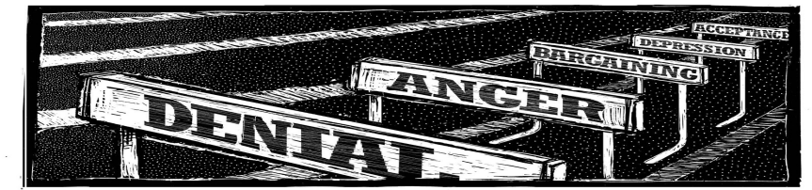
Bereavement -

Mourning -

Grief –

Important Clinical Implications of the definition of Grief
- Grief is experienced in each of three major ways/behaviour, relationships and emotions.
- Grief is a continuing development (process).
- Grief is a natural expectable reaction.
- Grief is a reaction to all types of loss, not just death.
- Grief is dependent on the individual’s unique perception of loss.

Guidelines for Supporting a Grieving Person
1. Be present! Be with the person who is grieving. Listen. You don't have to say the "right thing."
2. Validate their experience
3. Spiritual release & coping. Prayer & meditation. Offer our burdens to God; prayer
4. Keep lines of communication open. Provide opportunities for speaking and listening. Prayer is also helpful.
5. Don’t try to defend, or explain away what has happened, solve it, or transfer blame.
6. Allow emotions of anger and disappointment to play themselves out in time; and there is no right time.
7. As long as there is progression towards acceptance and normality, do not set time limits or goals on grief
8. Losses can connect and transfer, remembrances of past losses are normal; it is a search for means of coping (mechanisms).
9. Recognize how you are affected. Listen for your cues of anxiety, anger. Are you in grief too? Empathy?
10. Visits do not have to be long. If more time is needed find other ways/times.

Finding Happiness
Each one of us with out bodies, our hearts, our minds is beautiful.
Each one of us has our own cycle of growth which brings with it ups and downs, summer and winters, good times and bad times; set backs and times of drought are part of life. They are phases we have to go through, and a new start is always possible. Jean Vanier, Seeing Beyond Depression, p. 43

