Vacation Bible School

Celebrating
“In the Garden”
Life in God’s Kingdom
Plant a seed and watch it grow. It’s all a part of what God made long ago. The beautiful world, our awesome friends, the ends of the universe, and a future that never ends.
Welcome to the garden
August 7th to 11th
9AM to Noon
Hosted at the
Beersville Community Hall
New friends are always welcome to join in any day!!
Children of all ages invited to participate in this exciting journey.
Discover your place in God’s beautiful garden.
Call 785-4383 for more info
Registration form on reverse
There will be a snack time each day. Lunch provided on the final day at the Manse for a picnic with our families.
Looking ahead!! VBS @ Brown’s Yard August 14th-18th
Really Something
Some people will try and tell you that a good life is measured by the stuff you have or how popular you are. These things don’t ever last and believing in them is like trusting in the dust floating in the sunlight.
Other times we become convinced that life is abut what we know or about always have a sense of well-being, and being happy. But even that also does not last forever; at least not in this lifetime.
But our Creator does not leave us to figure all this out on our own. We are given guidance and support, understanding and leadership, to do more than have a good life today. Christian faith is about enjoy what is really best about this life forever.
Because the journey does not end here. We are welcomed, through God’s Son, to a wonderful and perfect fellowship, not because we are right, have everything figured out, or even if we are good, but just as we are; the people that we are and the way we see life now. That is who God calls together. God see us, loves us, and whether we know it or not in God’s eyes we are really something.
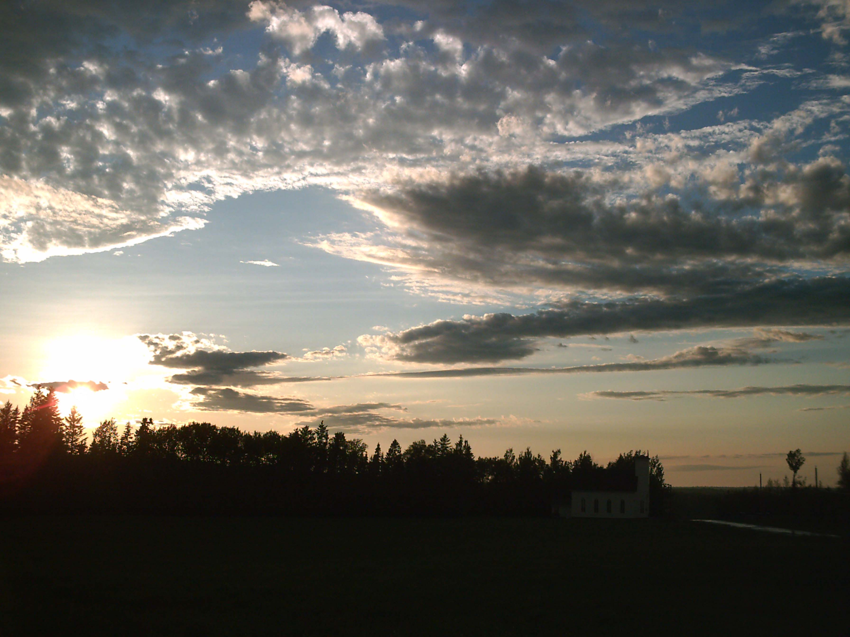

Rev. [Sandy] A.D. Sutherland BA, BTh, MDiv
The Presbyterian Manse 3279 Route 465
Home#: 506-785-4383 Cell #: 506-521-0705 Email: thebrpc@gmail.com

The Bass River Pastoral Charge
St. Mark’s, Bass River; St. James, Beersville;
St. Andrew’s, Clairville & Zion, West Branch
http://pccweb.ca/brpc

Be a part of this year’s
Summer Events
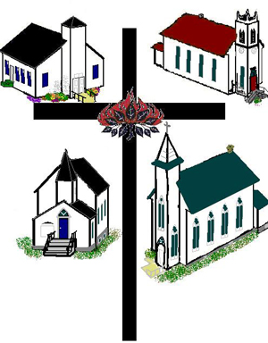
Summer 2017

We shall seek joy together every day.
The Bass River Pastoral Charge is made up of four congregations in different four corners of Kent County. We each serve as a compass point, pointing the way to Christ.
We look forward to meeting you.

The Bass River Pastoral Charge
a part of
The Presbyterian Church in Canada

Homecoming/Memorial Services:
Homecoming {Memorial} events are a chance to rediscover our heritage of faith, and to welcome old friends into the fellowship of these communities and worship in the congregations.
We look forward to seeing you at our Memorial & Homecoming Services through the summer:
July 23rd at 2pm
St. Matthew’s United [Memorial], Clairville
On the 465, just down from St. Andrew’s in Clairville. Near Fillmore Trucking
August 13th at 2pm
St. Mark’s Presbyterian Church, Bass River
Just south of the 490 junction in Bass River
August 20th at 3pm
St. James’ Presbyterian Church, Beersville On the 465, mid way between Coal Branch and Smith’s Corner
August 27th at 2:30pm
St. Andrew’s Presbyterian Church, Clairville
On the 465, just north of Coal Branch and south of Beersville.
September 10th at 2pm

Harcourt Memorial Service
On the 126 at the Pond Chapel site by the Harcourt School
Also:
TBA
Music Evening @ Zion
Zion Presbyterian Church, West Branch
West off the 495 on the Zion Church Road.
These special gatherings host all sorts of special worship events including; guest musicians, special service themes, and interesting heritage moments.
Still, they are all opportunities to welcome new and old friends alike, share in enriching worship, and rejoice in the fellowship we have been given. We look forward to seeing you

Our Weekly Services
Each Sunday we hold two services in the pastoral charge. We take turns, and it can be hard to figure out when and where our services are being held. Here is the list of our services for the summer. We look forward to seeing you.
June 28th [Canada Day special service]
- Clairville 9:30am, Bass River 11:15am
July 2nd
- West Branch 9:30am, Beersville 11am
July 9th
- Clairville 9am, Bass River 11:15am
July 16^{h}
- West Branch 9:30am, Beersville 11am
July 23rd
- Clairville 9:30am, Bass River 11:15am
July 30th
- West Branch 9:30am, Beersville 11am
August 6th
- Clairville 9:30am, Bass River 11:15am
August 13th
- West Branch 9:30am, Beersville 11am
August 20th
- Clairville 9:30am, Bass River 11:15am
August 27th
- West Branch 9:30am, Beersville 11am

How to find us http://pccweb.ca/brpc
St. James' Presbyterian Church, Beersville
On the 465, mid way between Coal Branch and Smith’s Corner
St. Andrew’s Presbyterian Church, Clairville
On the 465, just north of Coal Branch and south of Beersville.
St Mark’s Presbyterian Church, Bass River
Just south of the 490 junction in Bass River

Zion Presbyterian Church, West Branch
West off the 495 on the Zion Church Road.
Vacation Bible School
“In the Garden”
Life in God’s Kingdom
http://pccweb.ca/brpc/vbs
August 7th to 11th
9AM to Noon
Please cut the form from the pamphlet and bring it to register on your first day
Name:_______________________
Age:___
Home Church:________________
_____________________________

Favourite Sport:_______________
Favourite Juice:_______________
Allergy?______________________
_____________________________
Ever attend a VBS before?
__yes __no
Special Concerns: _____________
_____________________________
_____________________________Parent/Guardian’s Name[s]:
_____________________________
_____________________________
Contact Information:
Phone #:_____________________
Alternate #:___________________
Email:_______________________
If your child is not able to join at the beginning of the program, they are invited to join any day.

