
A Christian Family of Faith in Fellowship

The Bass River Pastoral Charge

The Presbyterian Church in Canada
St. Mark’s, Bass River; St. James, Beersville; St. Andrew’s, Clairville & Zion, West Branch
Organists: Heather Morton, Marly Sutherland, Rodney Girvan, Dolly MacDonald, Shanece Wilson
Minister: Rev. Alexander [Sandy] D. Sutherland; B.A., B.Th. M.Div
Manse #: 506-785-4383 Cell #: 506-521-0705 Email: thebrpc@gmail.com Twitter: thebrpc
www.pccweb.ca/brpc
April 13th 2014 – Palm/Passion

ORDER OF SERVICE
Welcome
Call to Worship Palm Sunday Liturgy insert
Opening Praise: NBoP 677 My faith looks up to Thee
BoP 398
Prayer of Approach, Confession & The Lord’s Prayer (debts/debtors NBoP831; BoP605)

Responsive Reading - Psalm 118:14-29[Pew Bible]
¹⁴ The LORD is my strength and song, and is become my salvation.
¹⁵ The voice of rejoicing and salvation is in the tabernacles of the righteous: the right hand of the LORD doeth valiantly.
¹⁶ The right hand of the LORD is exalted: the right hand of the LORD doeth valiantly.
¹⁷ I shall not die, but live, and declare the works of the LORD.
¹⁸ The LORD hath chastened me sore: but he hath not given me over unto death.
¹⁹ Open to me the gates of righteousness: I will go into them, and I will praise the LORD:
²⁰ This gate of the LORD, into which the righteous shall enter.
²¹ I will praise thee: for thou hast heard me, and art become my salvation.
²² The stone which the builders refused is become the head stone of the corner.
²³ This is the LORD’S doing; it is marvellous in our eyes.
²⁴ This is the day which the LORD hath made; we will rejoice and be glad in it.
²⁵ Save now, I beseech thee, O LORD: O LORD, I beseech thee, send now prosperity.
²⁶ Blessed be he that cometh in the name of the LORD: we have blessed you out of the house of the LORD.
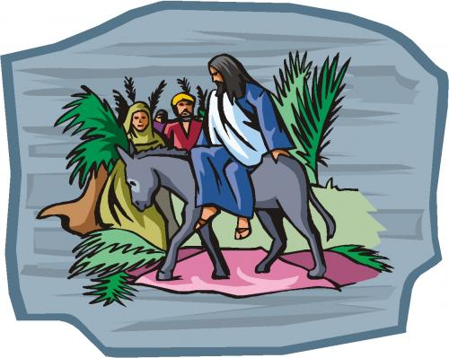
²⁷ God is the LORD, which hath showed us light: bind the sacrifice with cords, even unto the horns of the altar.
²⁸ Thou art my God, and I will praise thee: thou art my God, I will exalt thee.
²⁹ O give thanks unto the LORD; for he is good: for his mercy endureth for ever.
KJV

¹⁴ The LORD is my strength and my song; he has become my salvation.
¹⁵ Shouts of joy and victory resound in the tents of the righteous:
“The LORD’S right hand has done mighty things!
¹⁶ The LORD’S right hand is lifted high; the LORD’S right hand has done mighty things!”
¹⁷ I will not die but live, and will proclaim what the LORD has done.
¹⁸ The LORD has chastened me severely, but he has not given me over to death.
¹⁹ Open for me the gates of righteousness; I will enter and give thanks to the LORD.
²⁰ This is the gate of the LORD through which the righteous may enter.
²¹ I will give you thanks, for you answered me; you have become my salvation.
²² The stone the builders rejected has become the capstone;
²³ the LORD has done this, and it is marvellous in our eyes.
²⁴ This is the day the LORD has made; let us rejoice and be glad in it.
²⁵ O LORD, save us; O LORD, grant us success.
²⁶ Blessed is he who comes in the name of the LORD. From the house of the LORD we bless you.£
²⁷ The LORD is God, and he has made his light shine upon us.
With boughs in hand, join in the festal procession up£ to the horns of the altar.
²⁸ You are my God, and I will give you thanks; you are my God, and I will exalt you.
²⁹ Give thanks to the LORD, for he is good; his love endures forever.
NIV

Children’s story –
Children’s Hymn: NBoP 218 Hosanna, loud hosanna
BoP 157

Scripture Readings: OT – Isaiah 50:4-9a
⁴The Lord GOD hath given me the tongue of the learned, that I should know how to speak a word in season to him that is weary: he wakeneth morning by morning, he wakeneth mine ear to hear as the learned. ⁵The Lord GOD hath opened mine ear, and I was not rebellious, neither turned away back. ⁶I gave my back to the smiters, and my cheeks to them that plucked off the hair: I hid not my face from shame and spitting. ⁷For the Lord GOD will help me; therefore shall I not be confounded: therefore have I set my face like a flint, and I know that I shall not be ashamed. ⁸He is near that justifieth me; who will contend with me? let us stand together: who is mine adversary? let him come near to me. ⁹Behold, the Lord GOD will help me; who is he that shall condemn me? lo, they all shall wax old as a garment; the moth shall eat them up.
KJV
⁴ The Sovereign LORD has given me an instructed tongue, to know the word that sustains the weary.
He wakens me morning by morning, wakens my ear to listen like one being taught.
⁵ The Sovereign LORD has opened my ears, and I have not been rebellious;
I have not drawn back.
⁶ I offered my back to those who beat me, my cheeks to those who pulled out my beard;
I did not hide my face from mocking and spitting.
⁷ Because the Sovereign LORD helps me, I will not be disgraced.
Therefore have I set my face like flint, and I know I will not be put to shame.
⁸ He who vindicates me is near. Who then will bring charges against me?
Let us face each other! Who is my accuser? Let him confront me!
⁹ It is the Sovereign LORD who helps me. Who is he that will condemn me?
They will all wear out like a garment; the moths will eat them up.
NIV
Epistle – Philippians 2:5-11
⁵Let this mind be in you, which was also in Christ Jesus: ⁶Who, being in the form of God, thought it not robbery to be equal with God: ⁷But made himself of no reputation, and took upon him the form of a servant, and was made in the likeness of men: ⁸And being found in fashion as a man, he humbled himself, and became obedient unto death, even the death of the cross. ⁹Wherefore God also hath highly exalted him, and given him a name which is above every name: ¹⁰That at the name of Jesus every knee should bow, of things in heaven, and things in earth, and things under the earth; ¹¹And that every tongue should confess that Jesus Christ is Lord, to the glory of God the Father.KJV

⁵Your attitude should be the same as that of Christ Jesus:
⁶ Who, being in very nature£ God, did not consider equality with God something to be grasped,
⁷ but made himself nothing, taking the very nature£ of a servant, being made in human likeness.
⁸ And being found in appearance as a man, he humbled himself and became obedient to death—
even death on a cross!
⁹ Therefore God exalted him to the highest place and gave him the name that is above every name,
¹⁰ that at the name of Jesus every knee should bow, in heaven and on earth and under the earth,
¹¹ and every tongue confess that Jesus Christ is Lord, to the glory of God the Father.
NIV
Hymn of Illumination: NBoP 507 Break now the bread of life
BoP 285

Scripture Readings:
Gospel – Matthew 21:1-11
¹And when they drew nigh unto Jerusalem, and were come to Bethphage, unto the mount of Olives, then sent Jesus two disciples, ²Saying unto them, Go into the village over against you, and straightway ye shall find an ass tied, and a colt with her: loose them, and bring them unto me. ³And if any man say ought unto you, ye shall say, The Lord hath need of them; and straightway he will send them. ⁴All this was done, that it might be fulfilled which was spoken by the prophet, saying, ⁵Tell ye the daughter of Sion, Behold, thy King cometh unto thee, meek, and sitting upon an ass, and a colt the foal of an ass. ⁶And the disciples went, and did as Jesus commanded them, ⁷And brought the ass, and the colt, and put on them their clothes, and they set him thereon. ⁸And a very great multitude spread their garments in the way; others cut down branches from the trees, and strawed them in the way. ⁹And the multitudes that went before, and that followed, cried, saying, Hosanna to the Son of David: Blessed is he that cometh in the name of the Lord; Hosanna in the highest. ¹⁰And when he was come into Jerusalem, all the city was moved, saying, Who is this? ¹¹And the multitude said, This is Jesus the prophet of Nazareth of Galilee.
KJV

¹As they approached Jerusalem and came to Bethphage on the Mount of Olives, Jesus sent two disciples, ²saying to them, “Go to the village ahead of you, and at once you will find a donkey tied there, with her colt by her. Untie them and bring them to me. ³If anyone says anything to you, tell him that the Lord needs them, and he will send them right away.”
⁴This took place to fulfill what was spoken through the prophet:
⁵ “Say to the Daughter of Zion,
‘See, your king comes to you, gentle and riding on a donkey, on a colt, the foal of a donkey.’ “£
⁶The disciples went and did as Jesus had instructed them. ⁷They brought the donkey and the colt, placed their cloaks on them, and Jesus sat on them. ⁸A very large crowd spread their cloaks on the road, while others cut branches from the trees and spread them on the road. ⁹The crowds that went ahead of him and those that followed shouted,
“Hosanna£ to the Son of David!”
“Blessed is he who comes in the name of the Lord!”£
“Hosanna£ in the highest!”
¹⁰When Jesus entered Jerusalem, the whole city was stirred and asked, “Who is this?”
¹¹The crowds answered, “This is Jesus, the prophet from Nazareth in Galilee.”

NIV

Sermon: WHO is this?!
Somewhere between our days in Sunday school, our own devotions, bible studies and a good movie or documentary, we’ve all been given some education about the Bible, and about what it says and means that goes beyond what is preached Sunday by Sunday. Yet, there is something that no matter how much I preach, our how much you or anyone reads, no one can understand about who Jesus is until they proclaim Him for themselves and what Jesus has done in their own words. There is something we do not learn or understand about the Christ until we proclaim Him ourselves, not just in words, but especially in deeds, in the way we live our lives and conduct ourselves, and care for others, and what we stand for in our community and society.
The people in your life expect you to know the answer to this question, in verse ten when someone asks “Who is this?” (and the real answer is not in the verse at the end of our reading).
The answer to the question in the middle of our gospel reading should be made clear in the way we live our lives, care for each other, and offer guidance and hope to the people who surround us in our families and our community.
And the answer to this question “Who is This?” is, ‘Jesus, the prophet of Nazareth in Galilee’, that is a street level answer, a bare minimum of facts answer. That is an answer that can be trapped in the past, but the truth shines bright right here in the present and onto a future we cannot yet see, but we will see.
In order to get the answer about who this really is you have do more than simply read the Bible or hear the preaching on the Bible. In order to get this message you have to step right into the fullness of the gospel in Jesus Christ and respond to that good news. The people in Jerusalem had their response, but what is the way that you and I can raise a palm branch? And when we welcome Christ what are we welcoming Him to do in our lives?
The people in Jerusalem were welcoming Jesus to bring about change, not just in our lives but in the whole world as they knew it. They were welcoming him as the ‘Son of David’, they were welcoming Jesus as ‘he who comes in the name of the Lord’ but they also shouted ‘Hosanna!’, and that word meant more than any of the other titles they were attributing to Jesus.
‘Who is this?’ the apostle Paul gives us an answer. He says :
“Who, being in very nature God, did not consider equality with God something to be grasped,
⁷ but made himself nothing, taking the very nature of a servant, being made in human likeness.
⁸ And being found in appearance as a man, he humbled himself and became obedient to death—
even death on a cross!
⁹ Therefore God exalted him to the highest place and gave him the name that is above every name,
¹⁰ that at the name of Jesus every knee should bow, in heaven and on earth and under the earth,
¹¹ and every tongue confess that Jesus Christ is Lord, to the glory of God the Father. ”
That means that Jesus is God. In the very nature, God. Not a blessing from on high, not some title designated by lineage or history, or teaching, or high regard. Jesus, being in the very nature God, did the impossible to become humbled to our stature, into human likeness, the form of a servant, and obedient servant who was obedient unto death, the most horrible and painful of deaths. God, who is eternal, who cannot died, made it possible to die, so that death would have no power over you. Heaven is yours, there is no earning, no ritual, Jesus the Christ has died and heaven is yours. All you have to do is accept this amazing gift, given by God, for you.
The thing about amazing gifts, is it is usually good to do something in response to them. Jesus came to be our friend; to be the Messiah and the fulfillment of prophecy; to be the anointed, the Christ, the Lord, the King of Kings; but none of these are good enough for what God intends until it comes down to the very personal name that Jesus is for everyone that gathered outside those gates and lined the streets and responded to Jesus coming into their lives with the word ‘Hosanna!’
And ‘hosanna’ is not just a good praise word, it is what you say to respond in thanks and praise for one very specific action. ‘Hosanna’ is a word of praise for salvation; the saving of nations, of peoples, of society, of faith and religion, yes. Still, the very best meaning for ‘Hosanna!’ is personal. Jesus came as more than a saviour for a place or a particular nation of people, Jesus came as the personal Saviour for all people. He is not just the Saviour of a long ago people, or the Jewish people, or the Israelite people, but Jesus is your Saviour.
And you cannot stop Jesus from being your Saviour. He came for you before you got it all figured out. He came for your salvation before you realized you needed saving. He came while you were fighting with your neighbour, he came while you were hurting yourself and others, he came when you doubted and disbelieved, he came in the midst of your selfishness, he came while you were still a sinner, and as if he was riding down our streets on the back of donkey, he came for everyone of us here today, and everyone who could not be bothered, everyone who is bowed in prayer and everyone who has never prayed.
The salvation in Jesus the Christ, the Son of the living God, the Son of David, the King of kings and Lord of lords, our teacher, our redeemer our friend, one who makes us brothers and sisters in his love for us, that salvation is more than salvation of a society or a people, but it is both universal - for the whole world – and personal – Christ Jesus is your personal Saviour.
“Who is this?” They did not know it yet, but they were getting very close and were about to see the full meaning of the salvation they were proclaiming was coming in Jesus the prophet of Nazareth in Galilee.
We can respond to the salvation that is in Christ Jesus in how we welcome Him into our lives and proclaim Him in midst of the lives of the people who are surround, and who are asking in so many ways “who is this?.
Today you go forward with palm branches as a proclamation of your faith in Christ. But I pray that your faith is so apparent that people encounter the good news in Jesus Christ in everything you say and do, and that you are asked, that we a a re church are once again asked by the world “Who is this?!”
And we will respond, and bear our testimony, and offer our witness, and proclaim our Saviour, and Lord, the Son of God who is also the Son of Man, and we will begin that proclamation with “Hosanna!” “Hosanna in the highest!”

Prayer of Thanksgiving and Intercession
Announcements:

Hymn Sing - This afternoon at 2:30pm at Grangeville Baptist Church, come and sing in fellowship with our larger church community. Fellowship to follow.
Maundy Thursday Dinner We gather to commemorate the meal that Jesus shared with his disciples, looking back over the history and faith of God’s people and how we share in their everlasting faith through Christ Jesus our Saviour.
Good Friday – A candlelight service will be hosted at Zion, West Branch 7pm. All are welcome to share in this time of devotion, reflection & prayer
Easter Sunday We share the Lord’s Supper as a part of our worship, with special readers and contributions to the service.
- Rev. Sutherland will also be participating in worship at the Rexton Lion’s Nursing Home at 3pm. All are invited to share this worship with the residents.
Pastoral Charge Meeting – handouts available show the results of the discussion held this past Wednesday. Please share this information with others.

Programs & Activities: Please pray for our ongoing work & learning
Bible Study Psalms Continuing this Wed. at Jessie Kelly’s, 6:30pm
Bible School – Weekly Mondays at 6 pm @ Fillmore Trucking. All ages.
Community Food Bank - There is a need for canned meat & milk, and diaper
God’s Tithes and our gifts
Doxology (NBoP 830; BoP 603) & Offertory Prayer

The Sacrament of the Lord’s Supper
Our celebration of the Lord’s Supper
Jesus came into Jerusalem that he might celebrate the feast of God remembrance of his people, the Passover. But in God’s new covenant he did not pass over us to save us, but dwelt among us.
We rejoice at the coming of the king, the arrival of the loving Shepherd, the entrance of the paschal [sacrificial] lamb, who came to take away the sin of the world.
They will come from the east and west, and from the north and south, and sit at table in the kingdom of God. [Luke 13:29]
Invitation to the Lord’s Table:
The Lord Jesus Christ chose to humbly walk with us. He has come to dwell with us, to be with us in our lives. Through Christ we pray; In faith in Him our lives are healed; and through Him our sins are forgiven.
Blessed is he who comes in the name of the Lord!
Hosanna in the highest!
Jesus gave us the witness of his own words and actions, that we might speak and act, seeking understanding and purpose in God.
Blessed is he who comes in the name of the Lord!
Hosanna in the highest!
The only begotten Son of God has come, and facing the curse of our He sin conquered death, that we might know the Full measure of God’s love.
Holy, holy, holy Lord, God of power and might; heaven and earth are full of your glory. Hosanna in the highest!
The Institution of the Lord’s Supper:
This is the joyful feast of the people of God!
We come to this table at Christ’s invitation, given in the grace of the Loving Shepherd who lays down his life for his sheep. The institution of this sacrament belongs to Jesus the Christ, for it is the memorial of Christ’s life, death, and the new life we share in Him.
In the words of the Apostle Paul, we declare this sacrament of our faith to draw from this truth:
“the Lord Jesus on the night when he was betrayed took bread, ²⁴and when he had given thanks, he broke it, and said, “This is my body which is for you. Do this in remembrance of me.” ²⁵In the same way also the cup, after supper, saying, “This cup is the new covenant in my blood. Do this, as often as you drink it, in remembrance of me.” ²⁶For as often as you eat this bread and drink the cup, you proclaim the Lord’s death until he comes.”
Yet the Apostle Paul also gives us this warning:
²⁷Therefore, whoever eats the bread or drinks the cup of the Lord in an unworthy manner will be guilty of sinning against the body and blood of the Lord. ²⁸A man ought to examine himself before he eats of the bread and drinks of the cup. ²⁹For anyone who eats and drinks without recognizing the body of the Lord eats and drinks judgment on himself.
[1 Corinthians 11:23-29]
This holy meal is a gift to all who confess with heart, and mind, and soul, the living and eternal Christ Jesus is Lord; who by God’s grace and the Holy Spirit’s power, gives us the understanding to know God in faith. Let us then, offer God our confession of faith as we together declare . . .
Confession of faith:
I believe in God the Father almighty, Maker of heaven and earth:
And in Jesus Christ, His only Son, our Lord, Who was conceived by the Holy Ghost, born of the Virgin Mary, and suffered under Pontius Pilate, was crucified, dead, and buried; He descended into hell. The third day He rose again from the dead; He ascended into heaven, and sits on the right hand of God the Father Almighty; from thence He shall come to judge the quick and the dead.
I believe in the Holy Ghost; the Holy Catholic Church; the communion of saints; the forgiveness of sins; the resurrection of the body; and the life everlasting. AMEN
Communion prayer:
Lord God of all mercy, we bring to this table our souls, humbled by your grace in all its signs. Our spirits are in need of the cleansing that can only come through Christ.
Lord, hear our prayer and set us free.
Hear our cry for mercy, for we lift our eyes to the cross and see the cost of our salvation. Know our cry for peace as we lower our eyes in shame
Lord, hear our prayer and draw us together in peace.
O Lord, this is your table, and we come seeking your presence; let nothing separate the Lord God and His people.
Lift the gifts of your Holy Spirit - humility, goodness, kindness, self control, knowledge, perseverance, and most of all love - as signs to the world of our faith; as we seek to be more like Christ.
Lord, this bread is made from the grain that you caused to grow and this cup is filled with the fruitfulness of the vine you have sustained. You brought them to this table and now, O Lord, we pray that by your blessing this bread and cup will be renewed as a blessing in their use in the special purpose you have for us in this sacrament.
Help us understand, that in Jesus we must recognize that we are made for more than ordinary purposes. Let feel the support of the communion of faith in the Church, as we are gathered with all who confess faith in Christ and seek His presence in their life.
O Father in Heaven, by your Holy Spirit, let us be drawn together with you because of Jesus, our Saviour and Lord; who was begotten, who was born, who lived and died, and who is risen, and who is coming again.
In Jesus name we pray, Amen
The Holy Communion of the Lord’s Supper
We are gathered by God to this table with the whole Church. We are gathered with all who proclaim Christ, name Him Lord, and in communion with all who rejoice before God in glory.
In accordance with the teaching and direction of the good news in Jesus Christ, we do this:
The Lord Jesus - on the night he was betrayed - took bread, and after giving thanks to God, he broke it and said: “Take, eat, this is my body that is broken for you. This, you do, in remembrance of me.”
Bread distributed to all
When we break the bread it is the sharing in the body of Christ 1 Corinthians 10:16
We eat the bread together
In the same way also Jesus took the cup, After they had sup, and said: “This cup is the new covenant in my blood. Whenever you drink it, do so in remembrance of me”
The cup is shared
In remembrance, let us share the cup of the new covenant.
We drink the cup together
This bread and this cup are a proclamation; by them we declare the power and purpose of the Lord’s death until he comes.
Prayer of Thanksgiving
Loving God, thank you for the assurance of this sacrament of faith, and all the blessings we have received in Jesus Christ, our Lord. We rejoice that we are renewed in our spiritual bond to the whole of your Church through Christ’s sacrifice, here recalled. O God, give us the grace to carry his words into the world in the way we live our faith, as we are lifted up in all manner of being, because of Christ, through the Holy Spirit in your love:
Jesus, Lamb of God, have mercy on us
Jesus, bearer of our sins, have mercy on us
Jesus, redeemer of the world, grant us your peace.
Amen
Now, go out into the world in peace. Whatever you do, in word or in deed, do everything in the name of the Lord Jesus, giving thanks to God through him

Commissioning Hymn: NBoP 350 To God be the glory
BoP 157
Benediction
Dismissal: A&D 24 I am tempted like Lord Jesus
Next Week’s Services:
9:30am – St. Andrew’s Presbyterian Church (Clairville)
11:15am – St. Mark’s Presbyterian Church (Bass River)

Next week’s readings: Jeremiah 17:1-7, Psalm 95, Romans 5:1-11, John 4:5-42
If you are visiting, or are new to the community we would like to getting to know you, and celebrating your gifts and growing together in our faith in Christ. God bless you.

Announcements:
Hymn Sing - This afternoon at 2:30pm at Grangeville Baptist Church, come and sing in fellowship with our larger church community. Fellowship to follow.
Maundy Thursday Dinner We gather to commemorate the meal that Jesus shared with his disciples, looking back over the history and faith of God’s people and how we share in their everlasting faith through Christ Jesus our Saviour.
Good Friday – A candlelight service will be hosted at Zion, West Branch 7pm. All are welcome to share in this time of devotion, reflection & prayer
Easter Sunday We share the Lord’s Supper as a part of our worship, with special readers and contributions to the service.
- Rev. Sutherland will also be participating in worship at the Rexton Lion’s Nursing Home at 3pm. All are invited to share this worship with the residents.
Pastoral Charge Meeting – handouts available show the results of the discussion held this past Wednesday. Please share this information with others.

Programs & Activities: Please pray for our ongoing work & learning
Bible Study Psalms Continuing this Wed. at Jessie Kelly’s, 6:30pm
Bible School – Weekly Mondays at 6 pm @ Fillmore Trucking. All ages.
Community Food Bank - There is a need for canned meat & milk, and diaper
Givings Your offerings & gifts support the work of this congregation, the teaching of our children, the expenses of ministry, local and foreign mission, the work of Presbyterian Sharing and upkeep of this building. Tax receipts are available. The expenses of our pastoral charge and our buildings continue even if weekly worship was cancelled due to weather.
Prayers of the Pastoral Charge - Do you have a prayer, or know someone we should be praying for? Pray, as we support each other in faith, hope & love. Our Prayers are for: Savannah, Carmen, Joe, Janet, Percy, Dorothy, Denis, Phyllis, John Allison & family
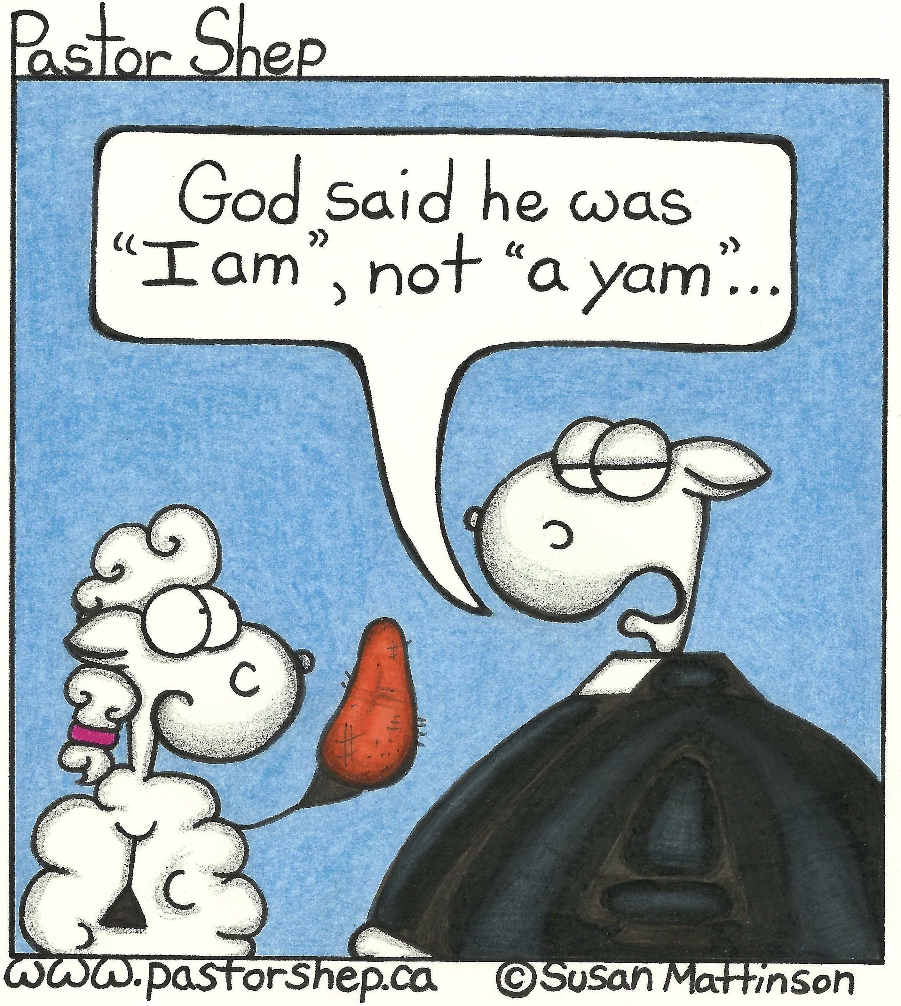
Mission Moments HIV and AIDS education in Kenya The Presbyterian Church in Canada and the Presbyterian Church of East Africa are working together to address the issue of HIV and AIDS in Kenya. Presbyterians Sharing supports Dr. Rick Allen, who has been working with the PCEA for the past 19 years on public health issues. Each year, Rick teaches an introductory class on HIV to about 300 students at the Presbyterian University of East Africa, fulfilling the government requirement that all university students take a course on HIV. He also teaches classes on nutrition and health, and helps the PCEA run week-long workshops for pastors on HIV and AIDS. So far, almost 450 pastors have completed the course, which is designed to give ministers the skills they need when dealing with HIV in their parishes and communities. Rick’s work has helped change people’s approach to HIV and AIDS, transforming stigma and discrimination into love and support.

