
A Christian Family of Faith in Fellowship

The Bass River Pastoral Charge

The Presbyterian Church in Canada
St. Mark’s, Bass River; St. James, Beersville; St. Andrew’s, Clairville & Zion, West Branch
Organists: Heather Morton, Marly Sutherland, Rodney Girvan, Dolly MacDonald, Shanece Wilson
Minister: Rev. Alexander [Sandy] D. Sutherland; B.A., B.Th. M.Div
Manse #: 506-785-4383 Cell #: 506-521-0705 Email: thebrpc@gmail.com Twitter: thebrpc
www.pccweb.ca/brpc

ORDER OF SERVICE
August 10th 2014 – Pentecost
Welcome & Announcements
Call to Worship A&D 1 A new commandment
Prayer of Approach, Confession & the Lord’s Prayer (debts & debtors NBoP831; BoP605)
Opening Praise: BoP 230 When morning guilds the skies
Responsive Reading - Psalm 85 [pew Bible]
¹ You showed favour to your land, O LORD;
you restored the fortunes of Jacob.
² You forgave the iniquity of your people
and covered all their sins.
Selah
³ You set aside all your wrath
and turned from your fierce anger.
⁴ Restore us again, O God our Saviour,
and put away your displeasure toward us.
⁵ Will you be angry with us forever?
Will you prolong your anger through all generations?
⁶ Will you not revive us again,
that your people may rejoice in you?
⁷ Show us your unfailing love, O LORD,
and grant us your salvation.
⁸ I will listen to what God the LORD will say;
he promises peace to his people, his saints—
but let them not return to folly.
⁹ Surely his salvation is near those who fear him,
that his glory may dwell in our land.
¹⁰ Love and faithfulness meet together;
righteousness and peace kiss each other.
¹¹ Faithfulness springs forth from the earth,
and righteousness looks down from heaven.
¹² The LORD will indeed give what is good,
and our land will yield its harvest.
¹³ Righteousness goes before him
and prepares the way for his steps.

Children’s story – floating
Children’s Hymn BoP 459 Standing by a purpose true
Scripture Readings: OT – Genesis 37:12-28
¹²Now his brothers had gone to graze their father’s flocks near Shechem, ¹³and Israel said to Joseph, “As you know, your brothers are grazing the flocks near Shechem. Come, I am going to send you to them.”
“Very well,” he replied.
¹⁴So he said to him, “Go and see if all is well with your brothers and with the flocks, and bring word back to me.” Then he sent him off from the Valley of Hebron.
When Joseph arrived at Shechem, ¹⁵a man found him wandering around in the fields and asked him, “What are you looking for?”
¹⁶He replied, “I’m looking for my brothers. Can you tell me where they are grazing their flocks?”
¹⁷“They have moved on from here,” the man answered. “I heard them say, ‘Let’s go to Dothan.’”
So Joseph went after his brothers and found them near Dothan. ¹⁸But they saw him in the distance, and before he reached them, they plotted to kill him.
¹⁹“Here comes that dreamer!” they said to each other. ²⁰“Come now, let’s kill him and throw him into one of these cisterns and say that a ferocious animal devoured him. Then we’ll see what comes of his dreams.”
²¹When Reuben heard this, he tried to rescue him from their hands. “Let’s not take his life,” he said. ²²“Don’t shed any blood. Throw him into this cistern here in the desert, but don’t lay a hand on him.” Reuben said this to rescue him from them and take him back to his father.
²³So when Joseph came to his brothers, they stripped him of his robe—the richly ornamented robe he was wearing—²⁴and they took him and threw him into the cistern. Now the cistern was empty; there was no water in it.
²⁵As they sat down to eat their meal, they looked up and saw a caravan of Ishmaelites coming from Gilead. Their camels were loaded with spices, balm and myrrh, and they were on their way to take them down to Egypt.
²⁶Judah said to his brothers, “What will we gain if we kill our brother and cover up his blood? ²⁷Come, let’s sell him to the Ishmaelites and not lay our hands on him; after all, he is our brother, our own flesh and blood.” His brothers agreed.
²⁸So when the Midianite merchants came by, his brothers pulled Joseph up out of the cistern and sold him for twenty shekels of silver to the Ishmaelites, who took him to Egypt.

Epistle – Romans 10:5-15
⁵Moses describes in this way the righteousness that is by the law: “The man who does these things will live by them.” ⁶But the righteousness that is by faith says: “Do not say in your heart, ‘Who will ascend into heaven?’” (that is, to bring Christ down) ⁷“or ‘Who will descend into the deep?’” (that is, to bring Christ up from the dead). ⁸But what does it say? “The word is near you; it is in your mouth and in your heart,” that is, the word of faith we are proclaiming: ⁹That if you confess with your mouth, “Jesus is Lord,” and believe in your heart that God raised him from the dead, you will be saved. ¹⁰For it is with your heart that you believe and are justified, and it is with your mouth that you confess and are saved. ¹¹As the Scripture says, “Anyone who trusts in him will never be put to shame.” ¹²For there is no difference between Jew and Gentile—the same Lord is Lord of all and richly blesses all who call on him, ¹³for, “Everyone who calls on the name of the Lord will be saved.”
¹⁴How, then, can they call on the one they have not believed in? And how can they believe in the one of whom they have not heard? And how can they hear without someone preaching to them? ¹⁵And how can they preach unless they are sent? As it is written, “How beautiful are the feet of those who bring good news!”

Hymn of Illumination: BoP 425 How firma foundation
Scripture Readings: Gospel – Matthew 14:22-33
²²Immediately Jesus made the disciples get into the boat and go on ahead of him to the other side, while he dismissed the crowd. ²³After he had dismissed them, he went up on a mountainside by himself to pray. When evening came, he was there alone, ²⁴but the boat was already a considerable distance from land, buffeted by the waves because the wind was against it.
²⁵During the fourth watch of the night Jesus went out to them, walking on the lake. ²⁶When the disciples saw him walking on the lake, they were terrified. “It’s a ghost,” they said, and cried out in fear.
²⁷But Jesus immediately said to them: “Take courage! It is I. Don’t be afraid.”
²⁸“Lord, if it’s you,” Peter replied, “tell me to come to you on the water.”
²⁹“Come,” he said.
Then Peter got down out of the boat, walked on the water and came toward Jesus. ³⁰But when he saw the wind, he was afraid and, beginning to sink, cried out, “Lord, save me!”
³¹Immediately Jesus reached out his hand and caught him. “You of little faith,” he said, “why did you doubt?”
³²And when they climbed into the boat, the wind died down. ³³Then those who were in the boat worshiped him, saying, “Truly you are the Son of God.”

Sermon: Firm Faith to stand on
With the wind whipping around the boat, and the waves lapping at the sides, the disciples felt the fear that comes to everyone who feels like the world is against them.
Theologian A.W. Tozer suggest s that we have a different attitude when it come to reading the Holy Scriptures, he says: “A new world will arise out of the religious mists when we approach our Bible with the idea that it is . . . a book which is now speaking.” When read our Bible today, we might be surprised about how much an event that happened over two thousand years ago as real meaning today; as if it is telling us about something, helping us really see something that is going on in our lives today.
Today’s reading from the gospel of Matthew takes us to such a scene, and such a moment.
The crowds gathered to hear Jesus speak. The people had come from everywhere in the countryside to witness the miracles that Jesus was doing. The multitude of thousands had sat down on the hillsides and received the miraculous meal of fish and bread that should only have fed a little boy. But then Jesus dispersed the crowd.
That is where our reading today begins. Jesus disperses the crowd. People are dismissed to go back to whatever lives they had before, perhaps changed, perhaps curious, perhaps skeptical, but the point is they are not in the picture anymore. The disciples on the other hand are told to get into a boat and to wait for Jesus while Jesus sends people on their way.
What we see is a difference that Jesus makes between the Church and the world. The Church is directed by Christ to be gathered together and to wait for him. You see it when the disciples are called by Jesus; when they are gathered at Jesus feet to hear his teaching, when they are gathered for prayer, when they are called to the table to share a meal; and when they await the Holy Spirit after Christ rose, and rose into heaven. Those who would be the truest followers of Jesus wait for Jesus and listen for Jesus’ instruction.
So the disciples get into the boat, and Jesus disperses the crowd. You see, some will only come for the show. They will only come for the big event. They will come when the rest of the crowd shows up, but once the excitement is done, and the miracles are hard to see or some story of the past, well they move with the crowd as they have always done. The fun, the show, the excitement is over, now back to ‘real life’. So Jesus dismisses them. It is not that He doesn’t want them, but by dismissing them only then might they realize how empty everything else is without Christ.
And the church is going through a time period much like this. It seems as though a lot of people have been dismissed. We know that they are missing Christ in their lives, we know that they are unfulfilled and looking for meaning because they know that something isn’t present in their lives.
So, the disciples find themselves out in the boat. Left as just a few of the once thousands, and meant to wait for the Lord.
The disciples seem to have an ongoing problem with this waiting, and that too might be something we in the church share. Waiting for Jesus needs to be done actively, not passively. If you are picking someone up on the side of the road, do you do it with the brake off? It seems the disciples were not paying attention because they did not just drift a little bit our from Jesus, but several stadia. The KJV of the bible retranslates this to mean they were in the middle of the sea, the NIV states it simply as the disciples were several hundred feet away from shore; either way, the disciples we not where they should be if they were waiting for Jesus.
And if we are drawing parallels in today’s reading and I invite you to make these observations. If the boat-load of disciples are truly represent the church today then perhaps we might look and see how and if we have drifted away from Christ. Can you see where we should draw up the work of the church so that we are arriving right at the feet of Jesus? Can you make out the expression of Jesus face for what we are saying and doing amongst ourselves? Can you hear Christ’s voice as he is calling out to us? Can you even see him as a dot on the shore?
If you have a friend that has a boat that goes out to sea in the Northumberland [or anywhere else for that matter] get them to drive the boat out the length of three or more football fields (or hockey rinks; stadia) and see how well you can make out people and things upon the shore.
Jesus told his disciples to get into the boat, but once they were in the safety and security of their own little group and comfort zone they drifted away, they drifted out, they drifted from the sight, sound, and sense of Jesus. So I suggest to you again if we should not consider ourselves, to consider that the Church has drifted out of sight and out of contact with Christ Jesus, because aren’t we supposed to be waiting for Him too?
And now it is the fourth watch: It is dark, and it is windy. We have been pushed now, out into the midst of the world with wind and waves that force the church to turn this way, and that. Wind and waves that turn us around until we are not sure which shore is which or where we are going. And as we begin to realize that our inattention, or self-attention, or if you want to call it laziness or selfishness, feel free; but before were are completely overcome by the winds of change and the waves of worldly troubles, we see it, we are called to see it, we cannot help but see it, because in our heart of hearts, in our very soul He is everything we have ever wanted to see. And that is Christ and he is standing there on top of all our troubles and in the midst of all our despair, and he is doing what we would call impossible because Jesus is walking on the waves that would wash us, and this boat, and everything that is good and familiar and truest to us, Jesus is more real, more true, more sturdy than this ship or any other.
I know some people will jump from on ship to another, to another, to another looking for Christ in one of the boats, but when we feel as though the church is in trouble we might need to just look out into the world of our worries and our fears and our doubts and see that ghostly shape, that impossible vision of Jesus walking over the troubles and doubts of the world and how he is heading straight for us.
And He speaks
And they are startling words. When people are in trouble and full of fear they are ready to hear a message of fear. They go looking for more doubt, and when they hear the words of comfort they are often deaf to it, or they are terrified by. And Jesus calls out to the disciples in distress just as he calls out to the church today and he says: “Be brave [take courage]! It is I. Do not be afraid.”
Jesus does not calm the storm when he comes to the boat and sees the trouble and distress of his disciples. It is a hard lesson, but fear is nothing you should afraid of unless it is the fear of the Lord.
Can we take those words to heart for a moment? Sitting here in the church building, being here in the fellowship of the Church, saying: ‘Do not be afraid. Be brave’, What comes to mind?
What are we afraid of? What is the wind? what are the waves? What is it that is buffeting and beating on the side of your church that is threatening to wash us over and sink us?
Lack of people?
A fear of being disregarded and named as insignificant?
Lack of resources? Not just money, but the physical, mental, spiritual abilities to keep on going as we have been going.
A fear of change? We have been doing it this way, and going in this direction for so long, that even though it may not be the right direction , the right way, it is the only boat we know.
The apostle Paul gives some good advice in our reading from Romans today. He asks whether we can make Jesus come to us, or whether we can go up to Him in Heaven or down to some deep place in the earth or ourselves to find him. And the answer is no, and not just no, but as if it was blasphemy to even think it, emphatically, dramatically, NO!
But in proclaiming Christ, and in naming Christ Jesus as Lord and Saviour, Jesus is there, right there with you and beside you in darkest moment or brightest day. The Lord is with you. Can we set aside our fear? Can we answer Jesus words, Jesus calling to the church again telling us not be afraid?
How many disciples were there. Twelve? Maybe twelve, likely more, in the boat and how many respond to Jesus calling out to them on the water.

And I do not think that it is any mistake that it is Peter, who of all the disciples speaks the words “ You are the Christ! The Son of the living God.”, that it is he who calls out to Christ Jesus and says: “Lord, if it’s you, tell me to come to you on the water.”.
That is the way to respond to Jesus in your life.
Make it a part of your prayer. “Jesus, you are there, show me how to stand up on all of these impossible troubles and overwhelming fears. Help me to step out into the world in your name.
Peter recognizes that he is not mean to be in the boat forever. The life of the people of the church is not limited to our work within this ship. We are called by Christ who stands on the trouble of the world to come and join him and be the church outside fo the safety and security of the boat, because we - like the disciples – are making our survival about whether or not we can hold onto the ship rather than if we are holding onto Christ.
Peter gets out of the boat, and at Christ’s initiation Peter comes to Christ. A few steps anyway.
The fears and doubts can seem so real. The wind whips and the seas laps and wash over Peter, and Peter loses sight of Christ – at least in His heart and Peter falls. Getting out of our comfort zone when it comes to our life of faith, and doing it because we feel called by God, does not mean we will not crash and even sink to the edge of drowning. We, like Peter, can be of such little faith. Why do we doubt? Why do we forget Christ, even though we are not the crowd that Jesus dismisses, we too forget Christ.
But even though our hearts might turn from him and focus on the trouble of our lives, and we might in our fear abandon Christ; Christ Jesus does not abandon you. Instead, into the waves and against the wind he reaches out to lift us from the very waves of our fear and draws us up to stand with him upon the washing worries of life, and then Christ joins us in this place and in this fellowship.
If Christ is not in the boat then get out of the boat, but once Christ is in the boat, rejoice as the seas calm and the troubles ease. When Jesus climbs into our boat we can see just how powerful the whipping wind of world troubles really is, and we can with the disciples, proclaim him; For truly He is the Son of God.

Prayer of Thanksgiving and Intercession
God’s Tithes and our gifts
Doxology (NBoP 830; BoP 603) & Offertory Prayer
Commissioning Hymn: NBoP 651 Guide me, O Thou great Jehovah/Redeemer
BoP 504
Benediction
Dismissal: A&D A&D 23 Holy Spirit, On us fall

Next week’s Services
9:30am – Zion Presbyterian Church (West Branch)
11:00am – St. James’ Presbyterian Church (Beersville)

Next week’s Readings: Genesis 28:10-19a, Psalm 86, Rom. 8:12-25, Matt. 13:24-43

Together we rejoice in the fulfillment of faith, Christ Jesus. As God’s people we seek to welcome others knowing that there are many who seek to belong. God’s Holy Spirit draws us together, to search and encourage each other’s calling and purpose. If you are visiting, or are new to the community we would like to getting to know you, and celebrating your gifts and growing together in our faith in Christ. God bless you.

Announcements:
Memorial Services Looking at dates for Memorial services; starting next week, Aug. 17 for St. Mark’s & Aug 24th for St. James’, Aug 31st for St. Andrew’s; Also, St. Matthew’s Memorial in Clairville July 20th & St. Andrew’s Memorial in Harcourt in September.
Pamphlet – our Summer Activities pamphlet is available by the entrance to the church. Please take a copy for visitors and friend and help grow the church in its work, mission and programs.
Corn Boil & Social – September 4pm-6pm hosted at the Beersville Hall. A time for fellowship with neighbours and friends and to share a good meal of cob corn and potluck treats. Rolls, corn and butter provided. Hope to see you there
Programs & Activities: Please pray for our ongoing work & learning
Bible Study The Bible study has finished up for the summer, but the materials are available from the church website. www.pccweb.ca/brpc.
Bible School –Bible School has paused till September. Thanks Tanya & Tracy
Birthday Party – Congratulations to Merrillyn Murphy who celebrated her 65th birthday at a party yesterday with family and friends. Happy Birthday!!
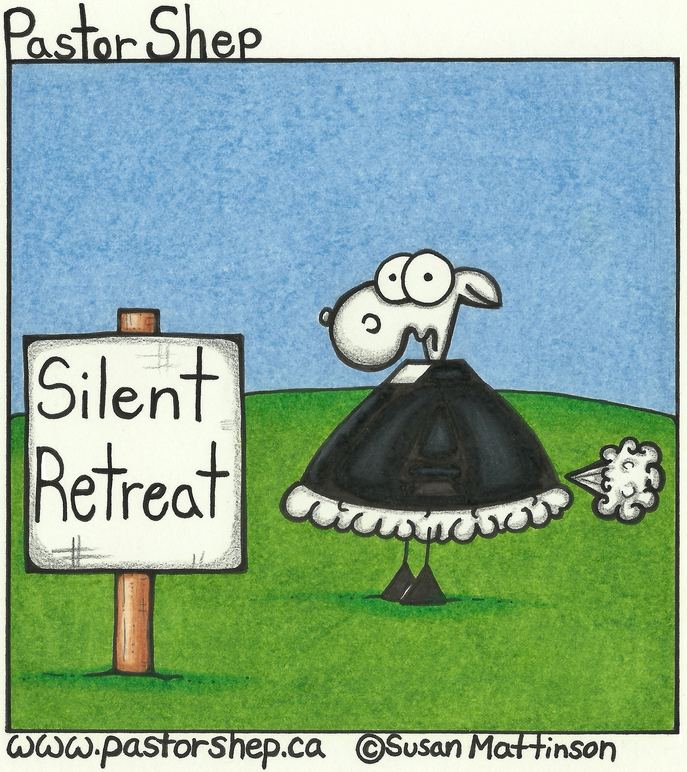
Community Food Bank – Think about what you will be planting in your garden. Can you plant extra carrots? Potatoes? Let’s all help with what we have.
Givings Your offerings & gifts support the work of this congregation, the teaching of our children, the expenses of ministry, local and foreign mission, the work of Presbyterian Sharing and upkeep of this building. Tax receipts are available.
Prayers of the Pastoral Charge - Do you have a prayer, or know someone we should be praying for? Pray, as we support each other in faith, hope & love. Our Prayers are for: Savannah, Carmen, Joe, Janet, Percy, Marilyn, Ruby, Kent & Dawn, Susie, John Allison & family
Mission Moments A shining light in Hamilton Almanarah is an Arabic word that means “lighthouse.” With support from Presbyterians Sharing Almanarah Church is sharing Christ’s light with Arabic-speaking people in and around Hamilton, Ontario. This church draws people from many places, including Egypt, Iraq, Sudan and Ethiopia. Members feel a real sense of belonging. A refugee woman started to attend Sunday worship after bringing her four-year-old son to the church’s vacation Bible school. She is happy to be able to read the Bible in her own language. At a recent service, as the children were leaving the chapel for Sunday school with their teacher, a seven-year-old Sudanese boy who attends church with his brother and grandmother excitedly called out, “I love this church!” As the Rev. Amin Mansour says, “What a blessing!”

