A Family of Faith in Fellowship

The Bass River Pastoral Charge

The Presbyterian Church in Canada
St. Mark’s, Bass River; St. James, Beersville; St. Andrew’s, Clairville & Zion, West Branch
Organists: Heather Morton, Marly Sutherland, Bev Dunn, Dolly MacDonald, Pam Wilson, Shanece Wilson
Minister: Rev. Alexander [Sandy] D. Sutherland; B.A., B.Th. M.Div
Manse #: 506-785-4383 Cell #: 506-521-0705 Email: thebrpc@gmail.com
pccweb.ca/brpc
Epiphany III
February 7th, 2016

ORDER OF SERVICE
Welcome
Call to Worship A&D 11 I love you Lord

Prayer of Approach, Confession & The Lord’s Prayer (debts/debtors NBoP831; BoP605)

Opening Praise: BoP 225 Mine eyes have seen the glory

Responsive Reading - Psalm 99 [Pew Bible]
¹ The LORD reigns,
let the nations tremble;
he sits enthroned between the cherubim,
let the earth shake.
² Great is the LORD in Zion;
he is exalted over all the nations.
³ Let them praise your great and awesome name—
he is holy.
⁴ The King is mighty, he loves justice—
you have established equity;
in Jacob you have done
what is just and right.
⁵ Exalt the LORD our God
and worship at his footstool;
he is holy.
⁶ Moses and Aaron were among his priests,
Samuel was among those who called on his name;
they called on the LORD
and he answered them.
⁷ He spoke to them from the pillar of cloud;
they kept his statutes and the decrees he gave them.
⁸ O LORD our God,
you answered them;
you were to Israel£ a forgiving God,
though you punished their misdeeds.£
⁹ Exalt the LORD our God
and worship at his holy mountain,
for the LORD our God is holy.

Children’s story –
Children’s Hymn: BoP 507 Jesus, Friend of little children

Scripture Readings:
OT – Exodus 34:29-35
²⁹When Moses came down from Mount Sinai with the two tablets of the Testimony in his hands, he was not aware that his face was radiant because he had spoken with the LORD. ³⁰When Aaron and all the Israelites saw Moses, his face was radiant, and they were afraid to come near him. ³¹But Moses called to them; so Aaron and all the leaders of the community came back to him, and he spoke to them. ³²Afterward all the Israelites came near him, and he gave them all the commands the LORD had given him on Mount Sinai.
³³When Moses finished speaking to them, he put a veil over his face. ³⁴But whenever he entered the LORD’S presence to speak with him, he removed the veil until he came out. And when he came out and told the Israelites what he had been commanded, ³⁵they saw that his face was radiant. Then Moses would put the veil back over his face until he went in to speak with the LORD.

Epistle – 2 Corinthians 3:12-4:2
¹² Therefore, since we have such a hope, we are very bold. ¹³ We are not like Moses, who would put a veil over his face to keep the Israelites from gazing at it while the radiance was fading away. ¹⁴ But their minds were made dull, for to this day the same veil remains when the old covenant is read. It has not been removed, because only in Christ is it taken away. ¹⁵ Even to this day when Moses is read, a veil covers their hearts. ¹⁶ But whenever anyone turns to the Lord, the veil is taken away. ¹⁷ Now the Lord is the Spirit, and where the Spirit of the Lord is, there is freedom. ¹⁸ And we, who with unveiled faces all reflect£ the Lord’s glory, are being transformed into his likeness with ever-increasing glory, which comes from the Lord, who is the Spirit.
^{4:1} Therefore, since through God’s mercy we have this ministry, we do not lose heart. ² Rather, we have renounced secret and shameful ways; we do not use deception, nor do we distort the word of God. On the contrary, by setting forth the truth plainly we commend ourselves to every man’s conscience in the sight of God.
Hymn of Illumination: BoP 219 Thy kingdom come on bended knee

Gospel – Luke 9:28-36
²⁸About eight days after Jesus said this, he took Peter, John and James with him and went up onto a mountain to pray. ²⁹As he was praying, the appearance of his face changed, and his clothes became as bright as a flash of lightning. ³⁰Two men, Moses and Elijah, ³¹appeared in glorious splendor, talking with Jesus. They spoke about his departure, which he was about to bring to fulfillment at Jerusalem. ³²Peter and his companions were very sleepy, but when they became fully awake, they saw his glory and the two men standing with him. ³³As the men were leaving Jesus, Peter said to him, “Master, it is good for us to be here. Let us put up three shelters—one for you, one for Moses and one for Elijah.” (He did not know what he was saying.)
³⁴While he was speaking, a cloud appeared and enveloped them, and they were afraid as they entered the cloud. ³⁵A voice came from the cloud, saying, “This is my Son, whom I have chosen; listen to him.” ³⁶When the voice had spoken, they found that Jesus was alone. The disciples kept this to themselves, and told no one at that time what they had seen.

Sermon: A Changing God?
Before David was born I did all kinds of carpentry from assembling his crib and dresser, to designing and building a closet organizer and a change table. For Jack all I did was tighten a few nuts, bolts and screws. For this child I thought maybe just a sign, over the change table that reads, “We shall not all sleep, but we shall be changed [1 Cor. 15:51]”.
It comes down to facing the reality of our lives; change is what we are about. Change is a fact of human life. Change is what being temporal, or living in time, is all about. And change is more real than being immutable or unchanging life. We may want life to never change; to go on with long-established routine – especially when we reached some fabled – stable point in out lives when we finally get the house in order, the finances in order, the family sorted out and friendship firmly established, but we know that as soon as we ever seem to get to that moment, the line from scripture ‘This too shall pass’ comes in like a wind and it is yet another day.
There was a moment like that with Jesus. One where those, who were Jesus’ closest friends, wanted to keep that moment as unchanging. A.W. Tozer wrote “In God no change is possible; in men change is impossible to escape. Neither the man is fixed nor his world, and he and it are in constant flux.”
When Jesus took his disciples James, John & Peter up the mountain he took them to a time of prayer unlike any other they had experienced, but a moment of prayer which is like every moment of prayer that they, or we, have ever experienced. Prayer is that time when our true nature is shown, and we bear our soul before our God. It is a moment of great vulnerability, when emotions are raw, because we are open and exposed before God who knows us to beyond the subatomic and very soul of our being. It is that truest being that the disciples with Jesus saw glimpses of in those moments. They also say the kind of relationship that Jesus kept when he was in prayer, Moses & Elijah. Who is with you when you speak with God? Because those moments where you speak with God are real moments of change.
There are some who would argue that God changes in the midst of our prayers, but it is more true that God – who is timeless and eternal does not change, even though we might want God to change his mind. IN the book of Exodus, just a couple of chapters before what we shared today, God relents after the Moses’ prays for the sake of God’s people who sinned the great sins at the base of God’s mountain at Sinai. God wants to destroy them and God has every right to destroy them, but Moses pleads and then God seems to cool down and does not kill them outright, but does God change his mind. Does God change?
It was a beautiful spring day, the first of April, when a friend of mine asked me over to help him repair his deck after a particularly rough winter. I was glad to help, and I was glad for the opportunity. This particular friend was a bit of a joker, and I had been the victim of but a few of his pranks. I awaited my opportunity. The repair was simple, the rails needed to be replaced after ice had fallen and cracked them, so first we had to measure the existing rails. My friend is one of those measure twice cut once people, and I planned to use that to serve my humorous end. My friend first measure the board, then we would change places and he would measure again, except each time he did I would move the end of the tape the difference of and inch or two; a small enough amount that he could not see that the tape was not tight on its end. I think I nearly had him convinced that the board measure one way was longer than when measure in the other direction, and for some strange reason, though he laughed at the joke, I was never asked back to help him on any projects, though I told him not to ask me on April fools day.
The point is, that sometimes our measure of life makes it seem like it is God who changes His mind about us, about the world - and even the words of the Bible seem to have God flip-flopping a bit of the time - but isn’t it really humanity that changes and instead it is how we see God, how e perceive God that transforms; that transfigures. The Bible also tells us that God is the same now and forever, and like God kingdom, God was, is and forever-shall-be.
It was not that Jesus changed somehow, but those three disciples were made able to see Jesus more truly for who he is. So it is also true with God in our lives; whether in our high places or in our low places, God does not change toward us – loving us one moment and then denying us the next, but our measuring point from God changes all the time and we apply the distance between us and God.
God allows us to change because to be transformed all at once from an unbeliever into one who can fully stand before God is overwhelming to the point being far beyond us. See how the disciples react to a moment of the reality of Jesus; with fear and trembling, and yet they also wanted to make that moment with Jesus last forever.
That we can change is the miracle that Jesus encourages his disciples to not only try but embrace. Jesus is that wonder where the immortal put on mortality, where the unchangeable God put on changablitity and became as one of us. In Jesus vulnerability we are meant to discover our journey towards God, to that life that is eternal, and the truths that are universal, and to see that journey is and can only be in Christ and through the fellowship of believers who are willing to grow and change and be challenged in their faith. There was a challenge before God’s people as they marched out into the desert of their change.
What is ahead in your season of change?

Prayer of Thanksgiving and Intercession
Prayers of the Pastoral Charge - Do you have a prayer, or know someone we should be praying for? Pray, as we support each other in faith, hope & love. Our Prayers are for: Joe, Angus & Ruby, the Donahur, Fillmore, and Beers families, Kirk W., Neil Ryan, our AGMs

Announcements
Sermon series – Revelation
Treasurer –Our new Treasurer for the Bass River Pastoral Charge has not been appointed yet. Please speak to an elder or Rev. Sutherland if you have interest.
Bible Study – Tuesday at 7pm at the home of Jen Beers in Emerson looking at ‘Hymns, praise and the Bible’ (on pause for this week). Another Bible study is being planned for Lent titled ‘Wilderness Survival’ starting Feb 11 2pm @ Manse
Session – The Joint Session is called to meet at the back room of Zion, West Branch, February 15th at 7pm. Individual session meetings will also happen through the coming month in preparation for annual meetings.
Condolences – The heartfelt prayers of the congregations are extended to the family and friends of M. Leona Donahur who passed away this passed week. her funeral was yesterday at Immaculate Conception Roman Catholic Church .
We also extend prayers and sympathies to the family & friends of Carmen Fillmore. Carmen was a beloved member of St. James Beersville, and the gentle joy with which he touched everyone’s life will be a presence missed by all.
Our Prayers – are with the Beers family of Emerson, and with their friends and neighbours.
Annual Meetings- Zion, West Branch Complete
St. James’ Beersville Complete
St. Mark’s Bass River Today 12:30pm Sunday, February 7th 2016
St. Andrew’s, Clairville Tomorrow 7pm @ Fillmore Trucking
Rexton Lions Club – Senior’s Dinner March 20th 4-6pm with live entertainment and the BLMS presenting speeches at 6:30. Donation’s Received Givings – Your offerings & gifts support the work of this congregation, the teaching of our children, the expenses of ministry, local and foreign mission, the work of Presbyterian Sharing and upkeep of this building. Tax receipts available.

Tithes and the celebration of Gifts
Doxology (NBoP 830; BoP 603) & Offertory Prayer

Commissioning Hymn: BoP 519 Nearer my God, to Thee

Benediction

Dismissal: A&D 24 I am tempted like Lord Jesus
[tune Westridge BoP 411]
I am tempted, like Lord Jesus,
To take an easy road,
But I’ll live by God’s own Word,
Not bread alone.

I will share my life’s hard lessons,
With the world each day,
Testing not God’s love or graces,
But follow the way.

Not to hold the world by power,
Not by fear, or might,
But in worship, love the Lord,
All day and night.

Next Week’s Services:
9:30am – Zion Presbyterian Church (West Branch)
11:00am – St. James’ Presbyterian Church (Beersville)

If you are visiting, or are new to the community we would like to getting to know you, and celebrating your gifts and growing together in our faith in Christ. God bless you.

Announcement:
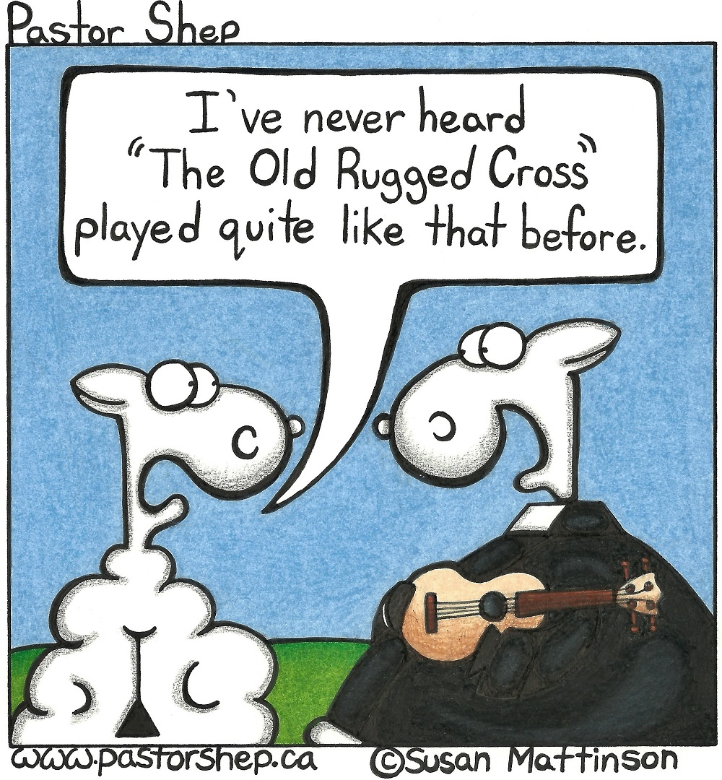
Mission Moments Syrian Refugees Call Canada Home In response to Christ’s call to serve and defend the vulnerable and the persecuted, Presbyterian World Service & Development provides humanitarian aid to refugees worldwide, while promoting and protecting their rights. This past year, the Pickering Presbytery Mission and Outreach Committee headed a refugee sponsorship project with support from PWS&D. An outpouring of generosity from member churches allowed the presbytery to raise enough money to sponsor not one, but five Syrian families escaping violent conflict. “Although many of the churches in our presbytery are small—as partners together—we have been able to do something really meaningful, ” said Liz Stark, a member of the Pickering committee. In generosity, faith and partnership, Presbyterians are helping refugees on their journey toward peace.

