
A Christian Family of Faith in Fellowship

The Bass River Pastoral Charge

The Presbyterian Church in Canada
St. Mark’s, Bass River; St. James, Beersville; St. Andrew’s, Clairville & Zion, West Branch
Organists: Heather Morton, Marly Sutherland, Rodney Girvan, Dolly MacDonald, Shanece Wilson
Minister: Rev. Alexander [Sandy] D. Sutherland; B.A., B.Th. M.Div
Manse #: 506-785-4383 Cell #: 506-521-0705 Email: thebrpc@gmail.com Twitter: thebrpc
www.pccweb.ca/brpc

ORDER OF SERVICE
July 13th 2014 – Pentecost
Welcome & Announcements
Call to Worship A&D 11 I love you Lord

Prayer of Approach, Confession & the Lord’s Prayer (debts & debtors NBoP831; BoP605)

Opening Praise: BoP 328 All creature of our God and King

Responsive Reading - Psalm 65 [pew Bible]
¹ Praise awaits [is fitting to] you, O God, in Zion; to you our vows will be fulfilled.
² O you who hear prayer, to you all men will come.
³ When we were overwhelmed by sins, you forgave [atoned for] our transgressions.
⁴ Blessed are those you choose and bring near to live in your courts!
We are filled with the good things of your house, of your holy temple.
⁵ You answer us with awesome deeds of righteousness, O God our Saviour,
the hope of all the ends of the earth and of the farthest seas,
⁶ who formed the mountains by your power, having armed yourself with strength,
⁷ who stilled the roaring of the seas, the roaring of their waves, and the turmoil of the nations.
⁸ Those living far away fear your wonders; where morning dawns and evening fades you call forth songs of joy.
⁹ You care for the land and water it; you enrich it abundantly.
The streams of God are filled with water to provide the people with grain, for so you have ordained it.
¹⁰ You drench its furrows and level its ridges; you soften it with showers and bless its crops.
¹¹ You crown the year with your bounty, and your carts overflow with abundance.
¹² The grasslands of the desert overflow; the hills are clothed with gladness.
¹³ The meadows are covered with flocks and the valleys are mantled with grain; they shout for joy and sing.

Children’s story –
Children’s Hymn BoP 393 Jesus bids us shine

Scripture Readings: OT – Genesis 25:19-34
¹⁹This is the account of Abraham’s son Isaac.
Abraham became the father of Isaac, ²⁰and Isaac was forty years old when he married Rebekah daughter of Bethuel the Aramean from Paddan Aram and sister of Laban the Aramean.
²¹Isaac prayed to the LORD on behalf of his wife, because she was barren. The LORD answered his prayer, and his wife Rebekah became pregnant. ²²The babies jostled each other within her, and she said, “Why is this happening to me?” So she went to inquire of the LORD.
²³The LORD said to her,
“Two nations are in your womb,
and two peoples from within you will be separated;
one people will be stronger than the other,
and the older will serve the younger.”
²⁴When the time came for her to give birth, there were twin boys in her womb. ²⁵The first to come out was red, and his whole body was like a hairy garment; so they named him Esau. ²⁶After this, his brother came out, with his hand grasping Esau’s heel; so he was named Jacob. Isaac was sixty years old when Rebekah gave birth to them.
²⁷The boys grew up, and Esau became a skillful hunter, a man of the open country, while Jacob was a quiet man, staying among the tents. ²⁸Isaac, who had a taste for wild game, loved Esau, but Rebekah loved Jacob.
²⁹Once when Jacob was cooking some stew, Esau came in from the open country, famished. ³⁰He said to Jacob, “Quick, let me have some of that red stew! I’m famished!” (That is why he was also called Edom. )
³¹Jacob replied, “First sell me your birthright.”
³²“Look, I am about to die,” Esau said. “What good is the birthright to me?”
³³But Jacob said, “Swear to me first.” So he swore an oath to him, selling his birthright to Jacob.
³⁴Then Jacob gave Esau some bread and some lentil stew. He ate and drank, and then got up and left.
So Esau despised his birthright.

Epistle – Romans 8:1-11
¹Therefore, there is now no condemnation for those who are in Christ Jesus, ²because through Christ Jesus the law of the Spirit of life set me free from the law of sin and death. ³For what the law was powerless to do in that it was weakened by the sinful nature, God did by sending his own Son in the likeness of sinful man to be a sin offering. And so he condemned sin in sinful man, ⁴in order that the righteous requirements of the law might be fully met in us, who do not live according to the sinful nature but according to the Spirit.
⁵Those who live according to the sinful nature have their minds set on what that nature desires; but those who live in accordance with the Spirit have their minds set on what the Spirit desires. ⁶The mind of sinful man is death, but the mind controlled by the Spirit is life and peace; ⁷the sinful mind is hostile to God. It does not submit to God’s law, nor can it do so. ⁸Those controlled by the sinful nature cannot please God.
⁹You, however, are controlled not by the sinful nature but by the Spirit, if the Spirit of God lives in you. And if anyone does not have the Spirit of Christ, he does not belong to Christ. ¹⁰But if Christ is in you, your body is dead because of sin, yet your spirit is alive because of righteousness. ¹¹And if the Spirit of him who raised Jesus from the dead is living in you, he who raised Christ from the dead will also give life to your mortal bodies through his Spirit, who lives in you.

Hymn of Illumination: BoP 366 Come let us sing of a wonderful love

Scripture Readings: Gospel – Matthew 13:1-9, 18-23
¹That same day Jesus went out of the house and sat by the lake. ²Such large crowds gathered around him that he got into a boat and sat in it, while all the people stood on the shore. ³Then he told them many things in parables, saying: “A farmer went out to sow his seed. ⁴As he was scattering the seed, some fell along the path, and the birds came and ate it up. ⁵Some fell on rocky places, where it did not have much soil. It sprang up quickly, because the soil was shallow. ⁶But when the sun came up, the plants were scorched, and they withered because they had no root. ⁷Other seed fell among thorns, which grew up and choked the plants. ⁸Still other seed fell on good soil, where it produced a crop—a hundred, sixty or thirty times what was sown. ⁹He who has ears, let him hear.”
¹⁰The disciples came to him and asked, “Why do you speak to the people in parables?”
¹¹He replied, “The knowledge of the secrets of the kingdom of heaven has been given to you, but not to them. ¹²Whoever has will be given more, and he will have an abundance. Whoever does not have, even what he has will be taken from him. ¹³This is why I speak to them in parables:
“Though seeing, they do not see;
though hearing, they do not hear or understand.
¹⁴ In them is fulfilled the prophecy of Isaiah:
“‘You will be ever hearing but never understanding;
you will be ever seeing but never perceiving.
¹⁵ For this people’s heart has become calloused;
they hardly hear with their ears,
and they have closed their eyes.
Otherwise they might see with their eyes,
hear with their ears,
understand with their hearts
and turn, and I would heal them.’ Isaiah 6:9,10
¹⁶But blessed are your eyes because they see, and your ears because they hear. ¹⁷For I tell you the truth, many prophets and righteous men longed to see what you see but did not see it, and to hear what you hear but did not hear it.
¹⁸“Listen then to what the parable of the sower means: ¹⁹When anyone hears the message about the kingdom and does not understand it, the evil one comes and snatches away what was sown in his heart. This is the seed sown along the path. ²⁰The one who received the seed that fell on rocky places is the man who hears the word and at once receives it with joy. ²¹But since he has no root, he lasts only a short time. When trouble or persecution comes because of the word, he quickly falls away. ²²The one who received the seed that fell among the thorns is the man who hears the word, but the worries of this life and the deceitfulness of wealth choke it, making it unfruitful. ²³But the one who received the seed that fell on good soil is the man who hears the word and understands it. He produces a crop, yielding a hundred, sixty or thirty times what was sown.”

Sermon: More than scattered seeds
How does your garden grow?
The manse property has several soil types. The front has fairly rugged soil, dry soil with good drainage, but lots of stone. Not good for growing vegetables, but nice for the rugged perennials that David is growing around a spruce tree in what we call Davy’s garden. Along the side by the garage is another area that is dry, but there is more clay, and while most years it yields some nice potatoes this year we hope to have a lovely crop of sunflowers. To the back is a richer more water soil, where the biggest fight is not to keep things watered, but to hold back the weeds that race to take over each row.
We misread the parable of the seeds and the soils when we place a label on any one person or group of people, naming them the path ground, the rocky ground, the weedy or thorny ground, and leave it at that. Every good gardener knows that in order to keep having good soil it needs to be worked, the stones taken out, mulch, compost and fertilizer need to be added, and of course once planted there is the weeding.
And we have all been put to task in this. We have been given the garden of this community and this world, and we have been sent out as workers in God’s field. Jesus says in Matthew chapter 9 “The harvest is plenty, but the workers are few.”
We are tasked with cultivating the word of God. You each have been given gifts in the Holy Spirit to do this very thing. We are here in worship today to celebrate all that God is accomplishing in our midst as these gifts, these seeds that were planted in each of us bear fruit. Our worship should be a celebration of what God has planted in us, and how it is bearing fruit for each of us.
We are all of us called out into the garden. We have to stir up peoples lives, and we have to keep them from becoming hard packed and beaten down by the business of life. We need to help each other get those stones and rocks out of our lives, those struggles that hold us back from really working and living for Christ. We need to help and being willing to be helped ourselves, in setting good priorities in life; so that the distractions of wealth or poverty, employment or leisure does not choke out and cut down what God has called us to do with our lives.
The future rests on you, it rests on this community’s young families, it rests on the children in our schools and not yet in school. What will the yield be? Thirty-fold?, sixty? A hundred? A great deal has been entrusted to you. If that seems like a lot of pressure consider the case of Isaac.
Everything rested on Isaac. I know, we put a lot of pressure on our children, but as Abraham passed on the promise he was given from God it must have felt over whelming. Can you imagine Abraham sitting Isaac down saying, “Now don’t worry. God has promised to make a nation out of our family.”
Abraham may have been the father of a nation, but Isaac was that seed that fulfilled the promise of Abraham. From Isaac came Israel; Jacob who fooled a brother Esau out of his birthright and wrestled with God on the shoreline. From Isaac comes the embodiment of the old testament. Where the new testament in Christ, the Old testament is through Abraham, through Isaac, and Jacob.
The book of Genesis is about looking to see how things began. It is a chance to glance again the seeds of our faith, more than even the roots of faith, these people are the seeds of faith.
There are times where it is most appropriate to look back over a course of time; a time of study, a marriage, a life. Perhaps it is a reunion, or an anniversary, or a birthday. These are special days, for the celebration and the fellowship, but also for the chance it gives us to look and recognize the significant moments of our lives and the people that helped bring us to where we are.
We can see, in looking back, those moments when we might have chosen different, chosen better, and while we might say that we regret nothing - and some people do feel this way –few people, given the chance would make every decision the same way given a second chance. Genesis is about see the choices that were made before us, and for our sakes. Some of those choices were wrong, yet some of those choices have set the course of history. Certainly, our choices – right and wrong – shape our own history; our own lives. All growth that is not in God is decay.
Our choices, and the choices made by the people around us, shape the soil into which God’s word is sown. We need to re-cultivate the lives that have been hardened by busy-ness; too busy to even hear the word before it is snatched away on the wind or worse. We need to take away the troubles that cause people to fall away from the message of faith they are being given, so that they may have joy for more than simply today but truly forever more. We need to pluck out the weeds of the worries of wealth, whether for richer or poorer, we need to remember the heavenly store house and let what we have and who we are be used for God’s glory; better to be rich in God than rich in gold.
When in devotion, or like today in our worship, when we come to Jesus’ description of how God people receive and live out God’s Word in the parable of the seeds: we should take the pause to look and see our own history and the reality of our faith as a church. Which soil have we become, what is the soil of our community? Can we become again the good soil, ready to receive and grow in God’s word? What is it that will be said of us, and what will we offer as we each bear fruit? Thirty, fifty, a hundred fold of what God has sown into us?
Be the good soil in which God’s word is sown. Receive that word and grow in that word. Grow in God’s word and bear fruit in that word. Share that word, and care for those that God has placed in your life to nurture and grow the fruits of the Spirit in this community. And may God water us with the grace of his ever lasting love as we look forward together to the great day of harvest when God’s promises are all fulfilled at last.

Prayer of Thanksgiving and Intercession

Announcements:
Sutherland’s on Vacation Sandy & Marly will be traveling to Calgary, August 3rd as Sandy is conducting a wedding there, and they will also celebrate their fifth wedding anniversary. Jack & David will watch over things here.
Steeple at St. Mark’s in Bass River It was agreed at a meeting following service last week that a simple roof will replace the current steeple until the problem of roof leaks is solved. Some fund raising may be required for this
Memorial Services Looking at dates for Memorial services; all are confirmed, Aug. 17 for St. Mark’s & Aug 24th for St. James’, Aug 31st for St. Andrew’s; Also, St. Matthew’s Memorial in Clairville July 20th & St. Andrew’s Memorial in Harcourt in September.
Hymn Sing – Zion west Branch will be hosting a evening hymn sing on Sunday July 27th at 7pm, an ice cream social will follow.
Programs & Activities: Please pray for our ongoing work & learning
Bible Study The Bible study has finished up for the summer, but the materials are available from the church website. www.pccweb.ca/brpc.
Bible School –Bible School has paused till September. Thanks Tanya & Tracy
VBS – July 14th to 18th, 9am to Noon with a curriculum designed by teachers and Rev. Sutherland called God’s Brave people. We will look at the heroes of scripture to discover our heroic purpose in God’s world. Grad school ages, teen helpers needed. Please contact Tanya or Tracy for more information.
Community Food Bank – Think about what you will be planting in your garden. Can you plant extra carrots? Potatoes? Let’s all help with what we have.
Givings Your offerings & gifts support the work of this congregation, the teaching of our children, the expenses of ministry, local and foreign mission, the work of Presbyterian Sharing and upkeep of this building. Tax receipts are available.

God’s Tithes and our gifts
Doxology (NBoP 830; BoP 603) & Offertory Prayer

Commissioning Hymn: BoP 307 The Church’s one foundation

Benediction

Dismissal: A&D A&D 23 Holy Spirit, On us fall

Next week’s Services
9:30am – Zion Presbyterian Church (West Branch)
11:00am – St. James’ Presbyterian Church (Beersville)

Next week’s Readings: Genesis 28:10-19a, Psalm 86, Rom. 8:12-25, Matt. 13:24-43

Together we rejoice in the fulfillment of faith, Christ Jesus. As God’s people we seek to welcome others knowing that there are many who seek to belong. God’s Holy Spirit draws us together, to search and encourage each other’s calling and purpose. If you are visiting, or are new to the community we would like to getting to know you, and celebrating your gifts and growing together in our faith in Christ. God bless you.
Prayers of the Pastoral Charge - Do you have a prayer, or know someone we should be praying for? Pray, as we support each other in faith, hope & love. Our Prayers are for: Savannah, Carmen, Joe, Janet, Percy, Marilyn, Ruby, Kent & Dawn, John Allison & family
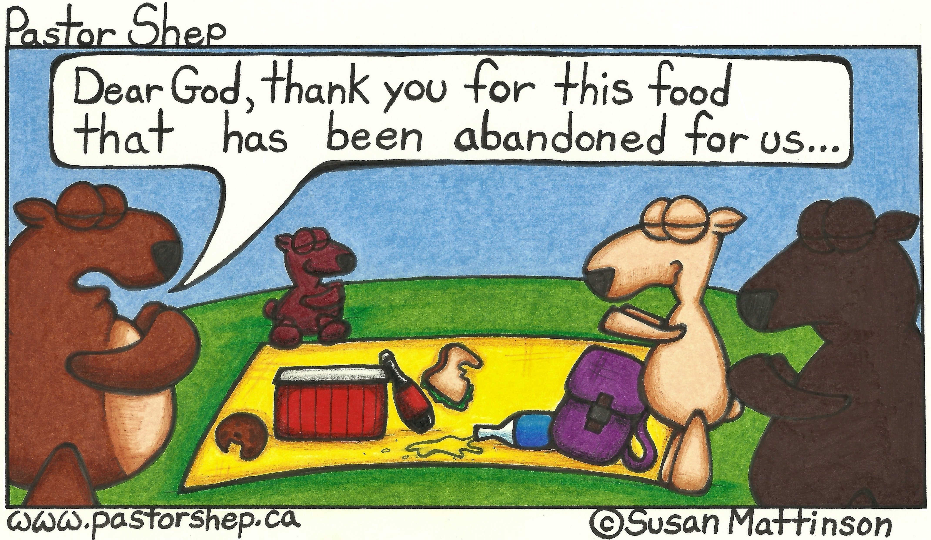
Mission Moments Sharing gifts in China The Amity Summer English Program invites volunteers from around the world to provide English training and demonstrate teaching methodology to Chinese English teachers. Volunteers provide a three-week English training course to teachers from primary and middle schools in rural and remote areas. Past participant Anne Saunders shares, “The program is about people coming together for conversations. The experiences of relationship-building and intercultural exchange provide opportunities for “love made manifest” and glimpses of God in our midst today.” This year, Presbyterians Sharing will support a team of four from Knox church in Waterloo as they share their gifts and strengthen the PCC’s partnership with the Amity Foundation.

