A Family of Faith in Fellowship

The Bass River Pastoral Charge

The Presbyterian Church in Canada
St. Mark’s, Bass River; St. James, Beersville; St. Andrew’s, Clairville & Zion, West Branch
Organists: Heather Morton, Marly Sutherland, Bev Dunn, Dolly MacDonald, Pam Wilson, Shanece Wilson
Minister: Rev. Alexander [Sandy] D. Sutherland; B.A., B.Th. M.Div
Manse #: 506-785-4383 Cell #: 506-521-0705 Email: thebrpc@gmail.com
pccweb.ca/brpc
March 27th 2016 - Easter

ORDER OF SERVICE
Welcome
Call to Worship A&D He is Lord
Responsive Easter Reading - insert
Prayer of Approach, Confession & The Lord’s Prayer (debts/debtors NBoP831; BoP605)
Opening Praise: NBoP 65 Now let the vault of heaven resound
BoP 197
Responsive Reading - Psalm 114[Pew Bible]
Children’s story –
Children’s Hymn: NBoP 662 Jesus Christ is risen today
BoP 190
Scripture Readings:
OT – Isaiah 65:17-26
Epistle – Revelation 1:8-18
Gospel – Luke 24:13-49
Hymn of Illumination: NBoP 543 Here, o my Lord I see Thee face to face
BoP 342
The Celebration of the Lord’s Supper
Sermon: Reasons to celebrate
Prayer of Thanksgiving and Intercession
God’s Tithes and our gifts
Doxology (NBoP 830; BoP 603) & Offertory Prayer
Commissioning Hymn: NBoP 352 And can it be that I should gain
BoP 173
Benediction
Dismissal: A&D 10 Hosanna
Next Week’s Services:
9:30am – St. Andrew’s Presbyterian Church (Clairville) @ Fillmore Trucking
11:15am – St. Mark’s Presbyterian Church (Bass River)

If you are visiting, or are new to the community we would like to getting to know you, and celebrating your gifts and growing together in our faith in Christ. God bless you.
Announcements:
Treasurer – Our new Treasurer for the Bass River Pastoral Charge was nearly in place, and anyone interested in the position is asked to make contact with Sheila Ryan or Rev. Sutherland ASAP.
Session – The joint Session is called to meet this Wednesday March 30th at 7pm for what should be a short meeting to discuss the spring and plans for the summer, including sacraments and VBS.
Girls Guides – Today we are very happy to welcome the First Beersville Girl Guides to share in our worship service in Beersville today. These young ladies have been using our St. James facility through this winter, and we are very glad to have them with us leading worship today.
Bible Study – Our Easter/Lent Bible study titled ‘Wilderness Survival’ meets Mondays at the home of Jessie Kelly 1982 Rte 495 East Branch, and Thursday afternoons at the manse [3279 Rte 465], both at 1pm.
Our Tuesday Bible study is on hold for the coming weeks.
Sunday School – In-Church lessons continue bi-weekly at St. Mark’s during worship with Sheila Ryan. The Clairville Bible School is back up and running on Monday nights 6-7pm (off for March Break). Call Tanya 785-6696
Canada Youth 2016 – Registration is now open and available online at http://presbyterian.ca/2016/02/18/cy2016-registration-now-open/
Session – The Joint Session is called to meet at April 13th 2016
Sermon Series – Through Lent & Easter Rev. Sutherland will be offering Sermons reflecting on the book of Revelation.
Participation in Worship – Reading for each week are available prior to the Sunday worship. Volunteers are welcome to lead reading or perhaps share a children story or a gift of music as a part of worship. We all have gifts to share.
Givings – Your offerings & gifts support the work of this congregation, the teaching of our children, the expenses of ministry, local and foreign mission, the work of Presbyterian Sharing and upkeep of this building. Tax receipts available.
Prayers of the Pastoral Charge - Do you have a prayer, or know someone we should be praying for? Pray, as we support each other in faith, hope & love. Our Prayers are for: Carmen, Joe, Freda, Angus & Ruby Reid, the Reidpath family, Kirk W., & Neil Ryan,
Mission Moments Thank you for your gifts!
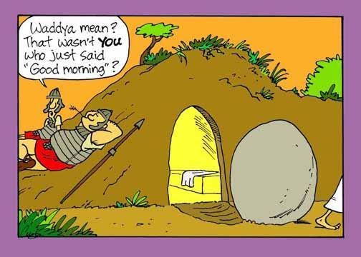
Thank you for your generous gifts to Presbyterians Sharing! Together with Presbyterians across Canada, you are encouraging and equipping congregational renewal and development; supporting inner city, native and refugee ministries; sending mission personnel to work with our international partners; developing innovative ministries for children and youth; equipping ministers and lay leaders to do effective ministry; bringing people together to share experiences and learn new skills through events like Stewards by Design and Canada Youth; supporting healing and reconciliation ministries… and so much more! As we participate together in the life-giving mission of God, we are making a difference, in Canada and around the world.

