The Haggadah – the telling
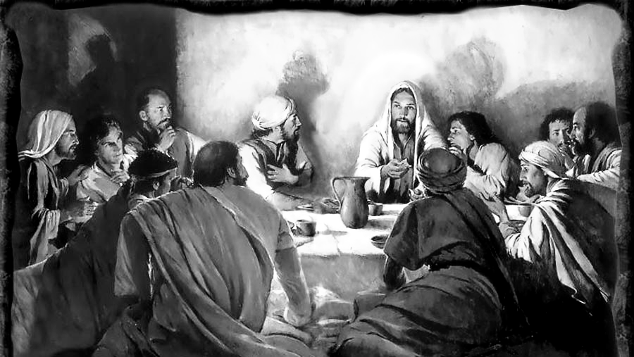
Exodus 13:8 ref. "v'higgade-ta" ‘and you shall tell’

Personal Preparation for the Service:
Before the meal begins please take a moment to wash your hands in the basins provided.
Tonight we celebrate the many ways that God cleans us, especially by forgiving our sins and teaching us right from wrong.
As you wash your hands tonight, remember how Jesus washed his disciples’ feet, how he encouraged them to serve each other and help each other; And how we must forgive as we are forgiven.
The Washing of Hands¹: {John 13:13-20}

You are invited to remember that you are a part of a great history. Think of family you have known, ancestors you have heard about, and the history of salvation you have learned. Tonight you rediscover that this history extends back through the ages to beginnings you perhaps have not imagined. Tonight we gather with those who shared meals like this thousands of years ago, to honour and remember all that we are, and who Christ Jesus is.

A Reading from Scripture: Matthew 26:17-19²
Now on the first day of Unleavened Bread the disciples came to Jesus, saying, “Where will you have us prepare for you to eat the Passover?”
Jesus said, “Go into the city to a certain one, and say to him, ‘The Teacher says, My time is at hand; I will keep the Passover at your house with my disciples.’” And the disciples did as Jesus had directed them, and they prepared the Passover at that place.

Greeting:
Leader: The Lord be with you.
People: And also with you.
L: Lift up your hearts.
P: We lift them up to the Lord.
L: Let us give thanks to the Lord our God.
P: It is right to give God thanks and praise.

Prayer of Approach

L: O Lord God, you brought us into being to be a steward in the midst of all your creation.
P: O Lord God, you give and in your gifts we discover our purpose in service. You have made us in Your image; male and female, and we pray that we might reflect your goodness, your truth, and your love in who we are
L: We have been given the resources of the world, a day for rest, plants and creatures to care for, a law to guide us, people to love, and the great gift and sacrifice of Jesus our Lord, by whom we are saved.
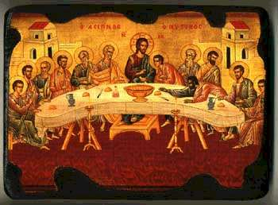
P: Let us always praise You, O God, for the grace of this creation; May Your love ever flow as an everlasting refreshing spring, through our live unto eternity.
L: Praise be to You, O Lord our God, who creates and gives his people the fruit of the vine & grain of the field.
P: Let us be refreshed in body, mind and spirit by these gifts, and to all gifts we enjoy this evening.

AMEN

Hymn: An upper room did out Lord prepare (Folksong; The water’s wide)
An upper room did our Lord prepare,
for those he loved until the end:
and his disciples still gather there,
to celebrate their Risen Friend.
A lasting gift Jesus gave his own,
to share his bread, his loving cup.
Whatever burdens may bow us down,
he by his Cross shall lift us up.
And after Supper he washed their feet,
for service, too, like sacrament.
In him our joy shall be made complete
sent out to serve, as he was sent.
No end there is! We depart in peace.
He loves beyond our uttermost:
in every room in our Father's house
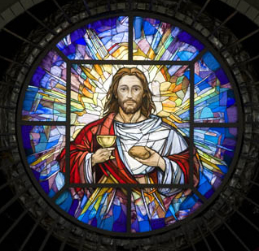
he will be there, as Lord and host.

The Cup of Promises: (Blessing of the Feast)
God made promises to human kind long ago
We remember & rejoice in God’s everlasting promises, his Covenant:
- God placed the earth beneath us and made it so the land could produce food.
- God saved people from the flood of righteous rage, and preserved the creatures of the earth in the ark with God’s servant, Noah.
- God promised to preserve the generations in the same faith that was Abraham’s.
- God promised freedom from slavery, even the slavery from our own sin.
- God promised to teach us truth and life, and God gave us law that we might know and live with justice against sin.
- God promised salvation, and sent God’s own Son, our Saviour Jesus.
- God promises to be our God, and that we will be God’s people.
Lord, we seek to understand how your promises are being fulfilled in us.

The cups are now filled. We will take a few drinks now, so please don’t drain your cup with the first toast.

The Blessing of the Cup
L: Praise to You, O Lord our God, who has given us the means to prepare food, that it may be safe and nourishing to our bodies.
All: Praise to You, O Lord our God, Ruler of the Universe for giving us life, for sustaining us and enabling us to gather this night in celebration of all you have done.

Scripture Reading: Psalm 24: 3-6⁴
Who shall ascend the hill of the LORD? And who shall stand in his holy place? Those who have clean hands and pure hearts, who do not lift up their souls to what is false, and do not swear deceitfully.
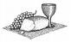
They will receive blessing from the LORD, and vindication from the God of their salvation. Such is the company of those who seek him, who seek the face of the God of Jacob

The Serving of the Meal: [explanation⁹]

The Bread⁵

A Child’s Questions: On other nights we eat bread that rises made with leaven or yeast. On this night, why do we eat only flat unleavened bread?
How is this night different from other nights⁶?

Answer: Tonight is different because with tonight’s meal we are trying to understand and think about things that happened a long time ago, before any of us were born.
The unleavened bread reminds us of when the Israelites left Egypt, they were in such a hurry that they didn’t have time to let their dough rise. Instead, they baked it flat. This flat bread reminds us of that day of hurry. We eat the matzoh, the flat bread, to remember this.

L: Praise to You, O Lord our God, who raises the grain from the seed planted in the earth, that we may have bread
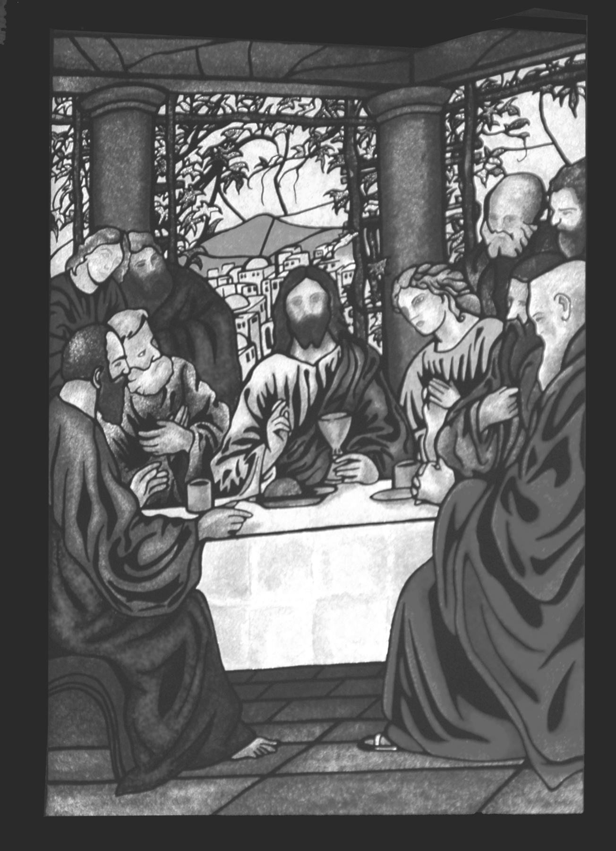
Hymn Break Thou the bread of life
Break Thou the bread of life, dear Lord, to me,
As Thou didst break the loaves beside the sea;
Beyond the sacred page I seek Thee, Lord;
My spirit pants for Thee, O living Word!
Bless Thou the truth, dear Lord, to me, to me,
As Thou didst bless the bread by Galilee;
Then shall all bondage cease, all fetters fall;
And I shall find my peace, my all in all.
Thou art the bread of life, O Lord, to me,
Thy holy Word the truth that saveth me;
Give me to eat and live with Thee above;
Teach me to love Thy truth, for Thou art love.
Oh, send Thy Spirit, Lord, now unto me,
That He may touch my eyes, and make me see:
Show me the truth concealed within Thy Word,
And in Thy Book revealed I see the Lord.

The Bread is served.
Scripture Reading: Exodus 12:14-20 & 39⁷
“This is a day you are to commemorate; for the generations to come you shall celebrate it as a festival to the LORD—a lasting ordinance. ¹⁵For seven days you are to eat bread made without yeast. On the first day remove the yeast from your houses, for whoever eats anything with yeast in it from the first day through the seventh must be cut off from Israel. ¹⁶On the first day hold a sacred assembly, and another one on the seventh day. Do no work at all on these days, except to prepare food for everyone to eat—that is all you may do.
¹⁷“Celebrate the Feast of Unleavened Bread, because it was on this very day that I brought your divisions out of Egypt. Celebrate this day as a lasting ordinance for the generations to come

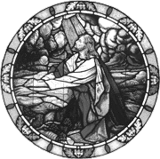
L: (raising the bread)This is the bread of affliction and of grace, the bread of haste and of remembrance. P: All who are hungry, let them enter and eat. All who are in need, let them come and celebrate. Today we are here, and tomorrow is in God’s hands. We are bound now to this world; tomorrow we will be with God.

The Bitter Herbs
Herbs are served and the dipping sauces and salt water are presented.
A Child’s Question: On other nights we eat all kinds of vegetables. On this night, why do we eat only bitter herbs?
How is this night different from other nights?

Answer: Tonight is different because tonight we remember the bitterness of slavery. We eat the bitter herbs to remind us that life was bitter for the Israelites in Egypt. They were slaves and their lives were bitter with hard, back- breaking work as they slaved to make bricks and mortar. They worked hard in the fields and were often beaten. Today, there are people who still have to endure bitter lives. We eat the bitter herbs to remember.
The Parsley⁸ is uncovered.
The Salt water and sweet sauce is served.

A Child’s Question: When we dip vegetable at other time the sauce does not look like this. Why do we dip the vegetables this way?
How is this night different from other nights?

Answer: Tonight is different because we are remembering the tears and toil that people who have loved God have suffered through the ages.
First, we dip our herbs into the salt water to remind us of the tears of the slaves, Then, we dip our herbs in the sweet sauce to remember that even the bitterest things in life can be sweetened by our hope in God. (Try one dip, both, or the parsley by itself. Repeat this throughout the meal)
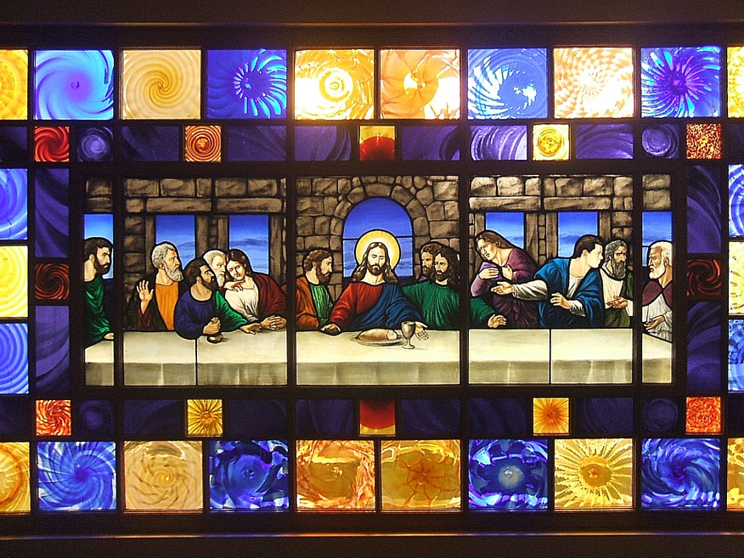
L: Praise to You, O Lord our God, for you have given to us the fruits of the earth. [Explanation⁹]

The Vegetables^{10&11} and Lamb¹²
Dishes of vegetables are served and the meat is uncovered.
L: Praise to You, O Lord our God, who has provided the goods of the field for our nourishment.
P: Praise to you O Lord our God
L: Praise to you, O Lord our God, for the provision of meat.
P: We rejoice in the gifts from God.

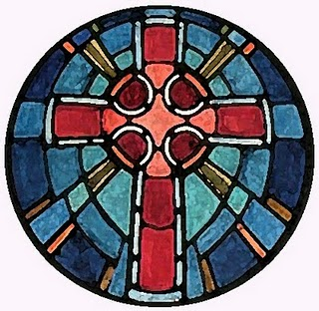
The dishes of the meal are served. We eat the meal. Please take some time to get to know the people you are eating with, and share your thoughts on what we are commemorating. Pay special attention to the children, as this is a wonderful way for them to learn.

Later on in the meal we pause
The Cup of Remembering:
L: Once we were slaves, but God made us promises. God brought us out of Egypt. God freed us from slavery. We were saved by God’s hand. We are God’s people and God is our God. We remember this and we rejoice as God’s people.
P: Blessed are you, O Lord our God

Scripture Reading: John 6:35- 40¹⁴
Jesus said to them, “I am the bread of life; he who comes to me shall not hunger, and he who believes in me shall never thirst. But I said to you that you have seen me and yet do not believe. All that the Father gives me will come to me; and him who comes to me I will not cast out. For I have come down from heaven, not to do my own will, but the will of him who sent me; and this is the will of him who sent me, that I should lose nothing of all that he has given me, but raise it up at the last day. For this is the will of my Father, that every one who sees the Son and believes in him should have eternal life; and I will raise him up at the last day.”
John 15:5-9
“I am the vine; you are the branches. If a man remains in me and I in him, he will bear much fruit; apart from me you can do nothing. If anyone does not remain in me, he is like a branch that is thrown away and withers; such branches are picked up, thrown into the fire and burned. ⁷If you remain in me and my words remain in you, ask whatever you wish, and it will be given you. ⁸This is to my Father’s glory, that you bear much fruit, showing yourselves to be my disciples. As the Father has loved me, so have I loved you. Now remain in my love.”

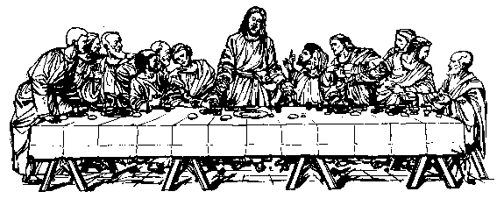
The Cup of the Prophet Elijah:
Scripture Reading: John 1:35-41
The next day again John was standing with two of his disciples; and he looked at Jesus as he walked, and said, “Behold, the Lamb of God!” The two disciples heard him say this, and they followed Jesus. Jesus turned, and saw them following, and said to them, “What do you seek?” And they said to him, “Rabbi” (which means Teacher), “where are you staying?” He said to them, “Come and see.” They came and saw where he was staying; and they stayed with him that day, for it was about the tenth hour. One of the two who heard John speak, and followed him, was Andrew, Simon Peter’s brother. He first found his brother Simon, and said to him, “We have found the Messiah” (which means ‘the Christ’).

Elijah was a mighty prophet who taught us about God. Many Israelites believed that Elijah would come at Passover to announce the coming of the Messiah. Jesus compared his cousin, John the Baptist, to Elijah. He said “John the Baptist is the Elijah who was to come”
We make room for all who come to speak God’s words to us, our door is unlocked and there is room at this table so we can welcome any who comes.
Let us raise the third cup, remembering those who speak for God.
This is the cup of the prophet, of Elijah, and all who speak for God.

L: Blessed are you , O Lord our God.
Blessed are you, O Lord our God.

The meal continues until the food is gone, or the people are full. All remaining food is taken away from the table¹⁶.

Prayer of Thanksgiving:
Blessed are you, O Lord our God, King of the Universe, who feeds the world with goodness. We thank you for your loving kindness and your pity. Your loving kindness lasts forever.
We thank you for this group of faithful people who have gathered to sit at table with Jesus. In this holy week we thank you for the things that free us. Help us to share this good news with others.
With your people of all places and times, and with the whole company of heaven, we proclaim your greatness and pray the words of your servants:
Holy, Holy, Holy, Lord God of Hosts, heaven and earth are full of Thy glory; Glory be to Thee, O Lord Most High. Blessed is He that cometh in the name of the Lord: Hosanna in the Highest.

The Cup of Remembrance and Praise:
We raise our glasses recognizing the fourth cup of this meal, the cup of remembering. May we always share and pass on the lessons we have learned. May our children walk in the steps of the Lord.
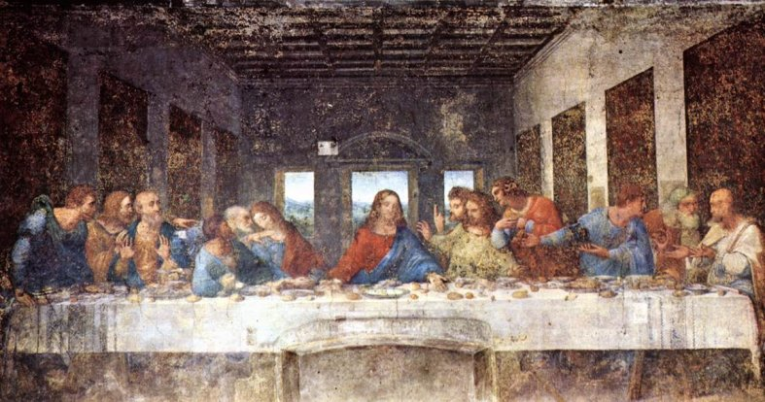
Blessed are you, O Lord our God, King of the Universe, who preserves your people, giving us drink even in the deserts.

{Bread baskets are refilled, but are covered}
{Cups are refilled and not drunk from}

The Lord’s Supper
Scripture Reading: 1 Corinthians 11:23-26[27-29]¹⁷
²³For I have received of the Lord that which also I delivered unto you, That the Lord Jesus the same night in which he was betrayed took bread: ²⁴And when he had given thanks, he brake it, and said, Take, eat: this is my body, which is broken for you: this do in remembrance of me. ²⁵After the same manner also he took the cup, when he had supped, saying, This cup is the new testament in my blood: this do ye, as oft as ye drink it, in remembrance of me. ²⁶For as often as ye eat this bread, and drink this cup, ye do show the Lord’s death till he come.
L: The Apostle Paul – also guided the church in its understanding of this sacrament – said: “²⁷Therefore, whoever eats the bread or drinks the cup of the Lord in an unworthy manner will be guilty of sinning against the body and blood of the Lord. ²⁸A man ought to examine himself before he eats of the bread and drinks of the cup. ²⁹For anyone who eats and drinks without recognizing the body of the Lord eats and drinks judgment on himself.”

THE BREAD, THE BODY: While they were eating, Jesus took bread and he broke it, and said, “Take & eat; this is my body which is broken for you: do this in remembrance of me.”
Once the Bread is distributed
“Take & eat, the body of Christ was broken for you. This you do in remembrance of Him.”

THE CUP OF THE NEW COVENANT: In the same manner also He took the cup saying: “This cup is the new testament in my blood: do this as often as you drink it, in remembrance of me. “
As people raise their cups:
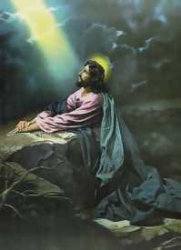
This cup is the new covenant in the blood of Christ which is shed for many unto the remission of sins; Drink all of it.

[Pause for silent prayer]

L: Lamb of God, who takes away the sins of the world
All: Have mercy on us.
L: Lamb of God, who bears the weight of our sins.
All: Have mercy on us.
L: Lamb of God, who redeems the world in grace.
All: Grant us your peace. Amen

Scripture Reading: Matthew 26:26-30¹⁸
²⁶During the meal Jesus took some bread in his hands. He blessed the bread and broke it. Then he gave it to his disciples and said, “Take this and eat it. This is my body.”
²⁷Jesus picked up a cup of wine and gave thanks to God. He then gave it to his disciples and said, “Take this and drink it. ²⁸This is my blood, and with it God makes his agreement with you. It will be poured out, so that many people will have their sins forgiven. ²⁹From now on I am not going to drink any wine, until I drink new wine with you in my Father’s kingdom.” ³⁰Then they sang a hymn and went out to the Mount of Olives.

Hymn: A new commandment
A new commandment I give unto you,
That you love one another as I have loved you,
That you love one another as I have loved you.
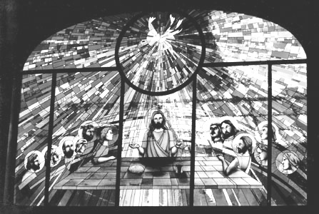
By this shall all know you are my disciples;
if you have love one-for-another;
By this shall all know you are my disciples;
if you have love one-for-another.

Benediction:

Shalom Chaverim, shalom chaverim, Shalom, shalom.
Le-hit-ra-ot, le-hit-ra-ot, shalom, shalom.
Farewell, dear friends, stay safe, dear friends, have peace, have peace.
We’ll see you again, we’ll see you again, have peace, have peace.
References, Notes, Explanations & Recipes:

1.The washing of the disciples’ feet presents an example of the kind of ministry of hospitality -mutual stewardship - we as Christians should share. This part of the narrative of the Last Supper also shows that prior to being able to serve our Lord we must humbly receive the Lord’s service of the gracious forgiveness of sins. In Jewish customs concerning purity, hands must be washed before the eating of any meal [also after in some traditions]. This act of purification is especially important at religiously significant meals and is included as part of many liturgies around meals.
2. [Matthew 26:17-19; NRSV]
4. [Psalm 24: 3-6; RSV]
5.Tonight we are using tortia, which we use as replacement for more traditional matzah. However, here is a recipe for the traditional bread: Matzah [Matzot; plural]: Prepare: 1. Depending on how many matzot you want, measure 1 part water and 3 parts flour. 2. Quickly mix and knead into a firm ball of 1-2 inches. 3. Roll out dough as thin as possible. 4. Poke holes in the dough. 5. Check to make sure no more than 15 minutes passed since the flour and water were mixed. Put matzah onto baking sheet [preferably stone ware cooking sheet, or metal sheet with wax paper]. 6. Bakes quickly [for 3 minutes in a good hot oven] until done [browned]. Tips: 1. Too many bakers can spoil the dough. It is best to have a few people working together when making matzah. Have one person do the mixing and the kneading, another person rolling out the dough, and the last person putting the matzah into the oven. 2. This can be a fun activity to do the afternoon before the Seder [meal]. 3. Traditionally, it was important to make sure the matzah was made quickly [some have suggested that eighteen minutes from mixing to baked] because it is the ‘bread of haste’.
6.This question is deeply rooted in the Jewish tradition and is said to be the question of Ishmael at the first Passover to his uncle, Moses. The understood purpose in this question echoes the purpose of the rest of the dinner. The dinner is to physically and especially orally share the memory of the community, and so the answer to this question is traditionally [Jewish tradition]: “It was on this night that the Lord passed over his people with the final plague upon Egypt that set them free from bondage.” For us, as Christians, it is important to include: “ That Jesus celebrated this important dinner with His disciples the night before he was crucified. Because Jesus died, we are all saved from the bondage of sin. We remember this by sharing the same meal as he shared with his disciples, and also by sharing in the institution of the Last Supper, which offers communion with all that do and have believed that Jesus is their Lord and their Saviour.” It is so very important to share our faith with our children, with our families, and with everyone that God brings to our lives. Yet, the children need these lessons most, while they are young and may grow in the faith.
7 [Exodus 12:14-20 & 39; RSV]
8. Parsley is the most common of the bitter herbs used for a Passover dinner, however, cilantro and dill may also be used. These herbs and other savouries are found in many of the dishes that are served in this meal.
9.The bitter herbs remind us of the bitterness of bondage, and the bitterness of sin. Even the salt water or oil we dip them in reminds us of the tears and strain that the Israelites suffered in the past, and the struggle we still face today as a people of faith. This bread is called a bread of haste. It is made quickly because the Israelites did not have time to make big loaves of bread. This bread also reminds us of the bread given by God to the people as they travelled in the desert. We, as Christians, remember also that Jesus took the bread and broke it and said, “This is my body that is broken for you.” He did this so that even when we cannot see his crucifixion we can be reminded of it by the breaking of the bread at this meal. The lamb of this meal reminds us of how, when God said that he would come and kill the first born of Egypt, he would not hurt the first born of Israel, who were to mark their door with the blood of the lamb. The people were to use that lamb for their meal that night and eat all of it, because they would not be able to take any part of the meal with them when they left Egypt. All of the other food of this meal, from the root vegetables to the beans and rice, are foods that remind us of the journey that lies ahead. They also remind us of the many ways that God provides for His people; from the roots of the earth to the tops of trees. Finally the wine, or the juice, reminds us of how the Israelites bled and died in slavery. The first cup of the supper reminds us of the pain of our own journey in faith. The last cup of the supper is the cup of the communion that Christ shared with His disciples, when he said, “This cup is the New Covenant in my blood, do this as often as you drink it in remembrance of me.” This is a meal where we remember all that God has done for His people”.
010.Carrot [Root Vegetable] Kugel: 1. Cut 5 lbs of carrots into chunks [1/2 inch] (you may add in a couple of white potatoes, sweet potatoes, or parsnips] These should cover in two loose layers your cassarole dish [9x9] 2. Mix in about ½ cup of raisins [more if you like raisins] 3. Steam root vegetables until colour begins to change, or in the case of potatoes, they begin to soften. Add either pear or grape juice [½ cup] to water. Simmer till vegetables just begin to soften. Let them stand for a while. 4. Pre-heat oven to 350º. 5. In a large bowl cream 6 ounces of margarine/butter, and blend in 1 cup sugar [brown preferably, white is fine], 2 tsp starch [potato, or corn starch], ¼ cup cracker crumbs [not bread crumbs], and ½ tsp cinnamon. Then beat in one egg to mixture. 6. Blend all ingredients and place in a casserole dish. Sprinkle lightly with more cracker crumbs [not bread crumbs], and if desired a little bit of kosher salt. 7. Bake in oven, covered, for no more than fifteen minutes, then uncover and brown the top [5min or so]. Let sit for fifteen minutes. Re-heating at lower temperature for no more than ten minutes, or in microwave is fine. May serve cold as well. Feeds fifteen as main side.
11.BLACK BEANS (Parve) {This dish can also be served with rice. It is a great summer salad} The recipe calls for dried beans, but canned black beans may be substituted. One cup of dried beans cooks up to approximately 2 ½ cups of cooked beans. This recipe is vegetarian, low fat, and adds fibre to the diet. 2 cup dried black beans (2 cans) 4 tablespoons olive oil 1 onion, sliced 2 cloves garlic, minced 1 cup chopped green pepper 4 rib celery, sliced 1 teaspoon cumin 1 teaspoon oregano 2 can (16 ounces) tomatoes, undrained, diced 1 tablespoon lemon juice (try lime for slightly different flavour) ½ teaspoon hot sauce, or to taste ½ cup water ½ teaspoon brown sugar salt to taste, optional Place washed beans in saucepan and cover with water. Heat to boiling and simmer for 3 to 5 minutes. Turn off heat and let stand for 1 hour. Then simmer the beans for 1 to 1 ½ hours, or until tender. Heat oil in large skillet and add onion and garlic, cook over medium heat until onion becomes soft. Add green pepper and celery and cook for about 5 more minutes. Drain beans and add, mashing them somewhat with a spatula. Add other ingredients except salt. Cover pan. Simmer for 30 minutes. Add salt if desired. Serves six.
212.Leg of Lamb: This is a classic, rotisserie cooked leg of lamb with a great marinade that gives you the perfect leg of lamb. INGREDIENTS: - leg of lamb (Boneless does cook more quickly) - ½ cup olive oil - ½ cup white vinegar - ½ cup balsamic vinegar - ½ cup lemon juice - 4-6 cloves of garlic - ¼ cup fresh chopped parsley - 1 teaspoon paprika - 1 tablespoon black pepper - Season with grape juice or red wine when beginning roasting PREPARATION: Cut excess fat from leg of lamb. Make four to six deep holes into lamb and insert on pealed clove of garlic into each hole. Set aside to allow it to reach room temperature. Mix other ingredients in a bowl or baking dish large enough to accommodate the lamb. Add lamb and cover. Place in refrigerator for 6-8 hours, turning over every hour. Preheat grill. Place lamb on rotisserie skewer and put on grill. Reduce temperature to low. Cook for 2 hours brushing with remaining marinade every ½ hour. Cut into thin slices.
414. [John 6:35- 40; RSV]
15. [John 15:5-9; NIV]
. [John 1:35-45; NIV]
617.In the Jewish tradition of the Passover the elements of the meal, which are cooked, cannot be served again, since the Passover is limited to one place and time, as a meal of haste. So also this is a reminder that the manna given in the desert was not given so that there would be excess, but so that there would be enough. If there is any part of the meal which is not eaten it must be either eaten before the sun rises, or burnt. It must be completely used, either by eating or by fire.
718. [1 Corinthians 11:23-26; KJV]
819. [Matthew 26:26-30; ESV] 

