A Family of Faith in Fellowship

The Bass River Pastoral Charge

The Presbyterian Church in Canada
St. Mark’s, Bass River; St. James, Beersville; St. Andrew’s, Clairville & Zion, West Branch
Organists: Heather Morton, Marly Sutherland, Bev Dunn, Dolly MacDonald, Pam Wilson, Shanece Wilson
Minister: Rev. Alexander [Sandy] D. Sutherland; B.A., B.Th. M.Div
Manse #: 506-785-4383 Cell #: 506-521-0705 Email: thebrpc@gmail.com
pccweb.ca/brpc

May 22nd 2016 – Pentecost -

ORDER OF SPECIAL SERVICE
Announcements & Welcome
Announcements: Today! We celebrate a joined worship at Saint James Presbyterian Church in Beersville for the whole Pastoral Charge as we welcome Celtic Flavour into the leadership of our worship service [no 9am service].
Summer ?Picnic? Fellowship – Looking for a date for another get together
Summer Gospel Gathering – This is in the planning stages for June Treasurer – A job description for a new Central Treasurer for the Bass River Pastoral Charge is now available, and anyone interested in the position is asked to make contact with Sheila Ryan or Rev. Sutherland ASAP.
Breakfast – The Beersville community Hall will be hosting a breakfast next Saturday starting at 7:30 till 10am. please support your local hall.
Bible Study –Our Bible studies have rounded up for the summer but are making plans for the fall. Past Bible studies are available on our website.
Sunday School – In-Church lessons continue bi-weekly at St. Mark’s during worship with Sheila Ryan. The Clairville Bible School has finished up for the season, but we will be planning VBS for July 4th –8th .
Condolences – Prayers for strength and peace are extended to Rose Fillmore and her family at the passing of her father and also her aunt.
Thanks! – The BVFD would like to thank everyone for coming our in support of yesterday’s supper, and for making pies, rolls and items for the bake sale.
Canada Youth 2016 – Registration is now open and available online at http://presbyterian.ca/2016/02/18/cy2016-registration-now-open/
Session – Will next meet on Wednesday June 29th 2016
Food Bank – The Rexton Food bank [located next to Presto Stitch] is currently in need of donations of cereal, canned milk and instant coffee.
Fellowship after worship - Everyone is welcome to a light luncheon that will follow today’s service. There is a gluten free option, but only those who suffer from gluten related issues should try them out as there are limited quantities.
Participation in Worship – Reading for each week are available prior to the Sunday worship. Volunteers are welcome to lead reading or perhaps share a children story or a gift of music as a part of worship. We all have gifts to share.
Givings – Your offerings & gifts support the work of this congregation, the teaching of our children, the expenses of ministry, local and foreign mission, the work of Presbyterian Sharing and upkeep of this building. Tax receipts available.

Call to Worship I'll Sing the Almighty Powers of God - Celtic Flavour

Prayer of Approach, Confession & The Lord’s Prayer (debts/debtors NBoP831; BoP605)

Opening Praise: BoP 47 O praise the Lord for He is good

Responsive Reading - Psalm 8 [Pew Bible]
¹ O LORD, our Lord,
how majestic is your name in all the earth!
You have set your glory
above the heavens.
² From the lips of children and infants
you have ordained praise£
because of your enemies,
to silence the foe and the avenger.
³ When I consider your heavens,
the work of your fingers,
the moon and the stars,
which you have set in place,
⁴ what is man that you are mindful of him,
the son of man that you care for him?
⁵ You made him a little lower than the heavenly beings£
and crowned him with glory and honor.
⁶ You made him ruler over the works of your hands;
you put everything under his feet:
⁷ all flocks and herds,
and the beasts of the field,
⁸ the birds of the air,
and the fish of the sea,
all that swim the paths of the seas.
⁹ O LORD, our Lord,
how majestic is your name in all the earth!

Psalm 137 - Celtic Flavour

Scripture Readings: OT – Isaiah 12
¹In that day you will say:
“I will praise you, O LORD.
Although you were angry with me,
your anger has turned away
and you have comforted me.
² Surely God is my salvation;
I will trust and not be afraid.
The LORD, the LORD, is my strength and my song;
he has become my salvation.”
³ With joy you will draw water
from the wells of salvation.
⁴In that day you will say:
“Give thanks to the LORD, call on his name;
make known among the nations what he has done,
and proclaim that his name is exalted.
⁵ Sing to the LORD, for he has done glorious things;
let this be known to all the world.
⁶ Shout aloud and sing for joy, people of Zion,
for great is the Holy One of Israel among you.”

Gospel – John 16:12-15
¹²“I have much more to say to you, more than you can now bear. ¹³But when he, the Spirit of truth, comes, he will guide you into all truth. He will not speak on his own; he will speak only what he hears, and he will tell you what is yet to come. ¹⁴He will bring glory to me by taking from what is mine and making it known to you. ¹⁵All that belongs to the Father is mine. That is why I said the Spirit will take from what is mine and make it known to you.

Psalm 121 - Celtic Flavour

Hymn of Illumination: BoP 458 Be Thou my Vision

Our Reflection on the Word – A children’s Story – Ellen’s many gifts
Ellen had made many friends at school, but her closest friends were the friends she knew from Sunday school. So besides playing they would sing together, learn about Jesus together and they would pray together.
But of course, they loved playing together.
Ellen & Tara – Bicycle
& Scott – Marbles
& Timothy – Jump Rope
& Jenny - Costumes
& Allison – Princess Precious Perfect easy bake oven
& her sister Sarah – Dolls
But then one day Ellen got Sick, very sick
Doctors always frowned to her parents even though they smiled at her
She was sick, but her friends visited her and told her stories
Sometimes they prayed with her
Made her feel better
Made her feel like she was on those adventures too, and playing games and even baking in the Princess Precious Perfect easy bake oven
But one day she started to get better
And then one day she was all better
And so Tara was going to give her back her bike, but she was too big for the bike, and scott wanted to give back the marbles but they were all scratched and worn, and the skip rope had a about fifty knots in it from being tied back together, and the costumes were either too small or worn so thin they were nothing mor than rags, and the Princess Precious Perfect easy bake oven was completely burnt out so that it would not even warm soft bread anymore, and well her sister Sarah was just never going to give back the dolls, because they were her dolls now and she was just not giving them back.
But that was okay. Ellen gave her friends these things so they would use them. She shared them and it was like she played with them even when it was her friends who had them
That is how it is with God’s gifts to us. Except God’s gifts never wear out. God gives us gifts and then rejoices in the wonderful was we discover to use them. Sometimes it is to travel to far away and strange places to sing for people, other times God’s gifts just make our every day just that much more fun. God gives us gifts so that we will have joy and so we can help each other have joy to. And joy is perfect happiness.
God’s Tithes and our gifts

All Things Are Thine - Celtic Flavour

Doxology (NBoP 830; BoP 603) & Offertory Prayer

Prayer of Thanksgiving and Intercession

I Know Where I'm Going, I Would Be True (Londonerry Aire) - Celtic Flavour

Commissioning Hymn: BoP 403 Amazing Grace

Grace for the meal -

Benediction Irish Blessing - Celtic Flavour

Dismissal: A&D 23 Holy Spirit on us fall

Next Week’s Services:
9:30am – St. Andrew’s Presbyterian Church (Clairville) @ Fillmore Trucking
11:15am – St. Mark’s Presbyterian Church (Bass River)

Prayers of the Pastoral Charge - Do you have a prayer, or know someone we should be praying for? Pray, as we support each other in faith, hope & love. Our Prayers are for: Joe, Angus & Ruby Reid, Tom M., Kirk W. & Neil Ryan, Fillmores & Martins, Fort McMurray

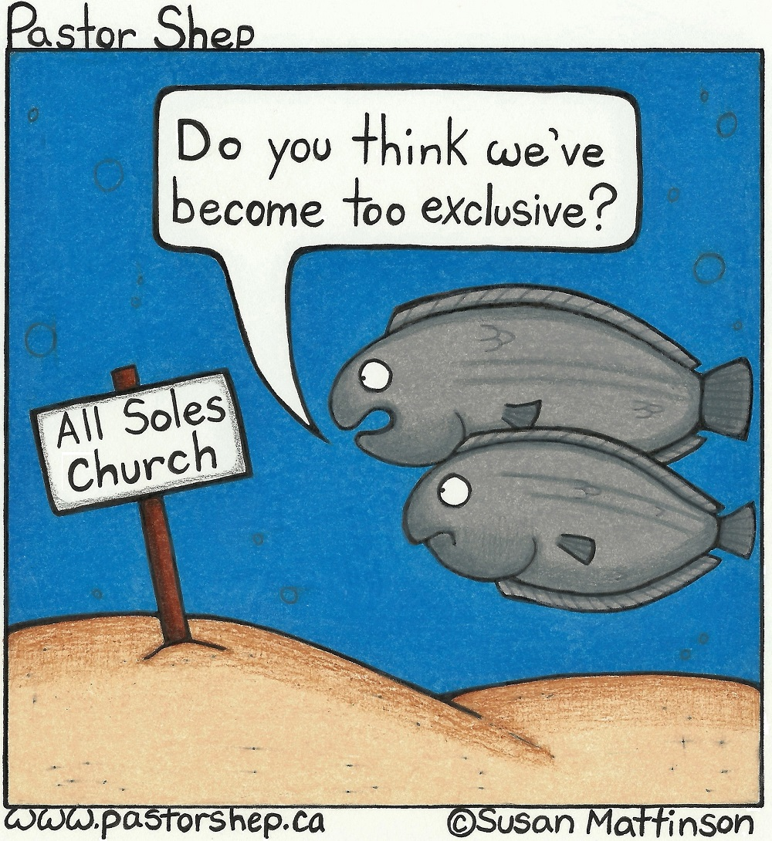
Mission Moments Translating the Bible in Taiwan Your gifts to Presbyterians Sharing support the Rev. Dr. Paul McLean as he serves as a Bible Translation Adviser in partnership with the Presbyterian Church in Taiwan and the Bible Society in Taiwan. Mission and church growth among Taiwan’s indigenous peoples expanded rapidly between the late 1920s and the 1950s. Today there are over 500 indigenous congregations in the PCT! Indigenous Bible translation work began in the 1950s and continues to this day. Paul is helping five indigenous translation teams who are preparing Bibles in the Amis, Bunun, Drekay, Paiwan and Pinuyumayan languages. He also promotes the Hakka Bible which was published in 2012. The PCT, the BST, and the PCC are deeply committed to preserving and promoting all of Taiwan’s non-Mandarin languages so that people can read, hear and share God’s life-giving Word in their own mother-tongues.

