A Christian Church, A Family of Faith in Fellowship

The Bass River Pastoral Charge

The Presbyterian Church in Canada
St. Mark’s, Bass River; St. James, Beersville; St. Andrew’s, Clairville & Zion, West Branch
Organists: Heather Morton, Marly Sutherland, Rodney Girvan, Dolly MacDonald, Pam Wilson, Shanece Wilson
Minister: Rev. Alexander [Sandy] D. Sutherland; B.A., B.Th. M.Div
Manse #: 506-785-4383 Cell #: 506-521-0705 Email: thebrpc@gmail.com Twitter: thebrpc
http://pccweb.ca/brpc
Sunday May 24th 2015 – Pentecost

ORDER OF SERVICE
Welcome & Announcements
Call to Worship A&D 11 I love you Lord
Prayer of Approach, Confession & The Lord’s Prayer (debts/debtors NBoP831; BoP605)
Opening Praise: NBoP 471 We are one in the Spirit
Responsive Reading - Psalm 104 1-4 & 24-35[Pew Bible]
¹ Bless the LORD, O my soul. O LORD my God, thou art very great; thou art clothed with honour and majesty.
² Who coverest thyself with light as with a garment: who stretchest out the heavens like a curtain:
³ Who layeth the beams of his chambers in the waters: who maketh the clouds his chariot: who walketh upon the wings of the wind:
⁴ Who maketh his angels spirits; his ministers a flaming fire:
²⁴ O LORD, how manifold are thy works! in wisdom hast thou made them all: the earth is full of thy riches.
²⁵ So is this great and wide sea, wherein are things creeping innumerable, both small and great beasts.
²⁶ There go the ships: there is that leviathan, whom thou hast made to play therein.
²⁷ These wait all upon thee; that thou mayest give them their meat in due season.
²⁸ That thou givest them they gather: thou openest thine hand, they are filled with good.
²⁹ Thou hidest thy face, they are troubled: thou takest away their breath, they die, and return to their dust.
³⁰ Thou sendest forth thy spirit, they are created: and thou renewest the face of the earth.
³¹ The glory of the LORD shall endure for ever: the LORD shall rejoice in his works.
³² He looketh on the earth, and it trembleth: he toucheth the hills, and they smoke.
³³ I will sing unto the LORD as long as I live: I will sing praise to my God while I have my being.
³⁴ My meditation of him shall be sweet: I will be glad in the LORD.
³⁵ Let the sinners be consumed out of the earth, and let the wicked be no more. Bless thou the LORD, O my soul. Praise ye the LORD.

KJV
¹ Praise the LORD, O my soul.
O LORD my God, you are very great; you are clothed with splendour and majesty.
² He wraps himself in light as with a garment; He stretches out the heavens like a tent
³ and lays the beams of his upper chambers on their waters.
He makes the clouds his chariot and rides on the wings of the wind.
⁴ He makes winds his messengers, flames of fire his servants.
^{104: 24} How many are your works, O LORD!
In wisdom you made them all; the earth is full of your creatures.
²⁵ There is the sea, vast and spacious, teeming with creatures beyond number — living things both large and small.
²⁶ There the ships go to and fro, and the leviathan, which you formed to frolic there.
²⁷ These all look to you to give them their food at the proper time.
²⁸ When you give it to them, they gather it up; when you open your hand, they are satisfied with good things.
²⁹ When you hide your face, they are terrified; when you take away their breath, they die and return to the dust.
³⁰ When you send your Spirit, they are created, and you renew the face of the earth.
³¹ May the glory of the LORD endure forever; may the LORD rejoice in his works —
³² he who looks at the earth, and it trembles, who touches the mountains, and they smoke.
³³ I will sing to the LORD all my life; I will sing praise to my God as long as I live.
³⁴ May my meditation be pleasing to him, as I rejoice in the LORD.
³⁵ But may sinners vanish from the earth and the wicked be no more.
Praise the LORD, O my soul. Praise the LORD.

NIV
Children’s story – Really want to say something
Children’s Hymn: NBoP 499 Tell me the old, old story
BoP 401
Scripture Readings:
OT – Ezekiel 37:1-14
¹The hand of the LORD was upon me, and carried me out in the spirit of the LORD, and set me down in the midst of the valley which was full of bones, ²And caused me to pass by them round about: and, behold, there were very many in the open valley; and, lo, they were very dry. ³And he said unto me, Son of man, can these bones live? And I answered, O Lord GOD, thou knowest. ⁴Again he said unto me, Prophesy upon these bones, and say unto them, O ye dry bones, hear the word of the LORD. ⁵Thus saith the Lord GOD unto these bones; Behold, I will cause breath to enter into you, and ye shall live: ⁶And I will lay sinews upon you, and will bring up flesh upon you, and cover you with skin, and put breath in you, and ye shall live; and ye shall know that I am the LORD. ⁷So I prophesied as I was commanded: and as I prophesied, there was a noise, and behold a shaking, and the bones came together, bone to his bone. ⁸And when I beheld, lo, the sinews and the flesh came up upon them, and the skin covered them above: but there was no breath in them. ⁹Then said he unto me, Prophesy unto the wind, prophesy, son of man, and say to the wind, Thus saith the Lord GOD; Come from the four winds, O breath, and breathe upon these slain, that they may live. ¹⁰So I prophesied as he commanded me, and the breath came into them, and they lived, and stood up upon their feet, an exceeding great army. ¹¹Then he said unto me, Son of man, these bones are the whole house of Israel: behold, they say, Our bones are dried, and our hope is lost: we are cut off for our parts. ¹²Therefore prophesy and say unto them, Thus saith the Lord GOD; Behold, O my people, I will open your graves, and cause you to come up out of your graves, and bring you into the land of Israel. ¹³And ye shall know that I am the LORD, when I have opened your graves, O my people, and brought you up out of your graves, ¹⁴And shall put my spirit in you, and ye shall live, and I shall place you in your own land: then shall ye know that I the LORD have spoken it, and performed it, saith the LORD.
KJV
¹The hand of the LORD was upon me, and he brought me out by the Spirit of the LORD and set me in the middle of a valley; it was full of bones. ²He led me back and forth among them, and I saw a great many bones on the floor of the valley, bones that were very dry. ³He asked me, “Son of man, can these bones live?”
I said, “O Sovereign LORD, you alone know.”
⁴Then he said to me, “Prophesy to these bones and say to them, ‘Dry bones, hear the word of the LORD! ⁵This is what the Sovereign LORD says to these bones: I will make breath£ enter you, and you will come to life. ⁶I will attach tendons to you and make flesh come upon you and cover you with skin; I will put breath in you, and you will come to life. Then you will know that I am the LORD.’”
⁷So I prophesied as I was commanded. And as I was prophesying, there was a noise, a rattling sound, and the bones came together, bone to bone. ⁸I looked, and tendons and flesh appeared on them and skin covered them, but there was no breath in them.
⁹Then he said to me, “Prophesy to the breath; prophesy, son of man, and say to it, ‘This is what the Sovereign LORD says: Come from the four winds, O breath, and breathe into these slain, that they may live.’” ¹⁰So I prophesied as he commanded me, and breath entered them; they came to life and stood up on their feet—a vast army.
¹¹Then he said to me: “Son of man, these bones are the whole house of Israel. They say, ‘Our bones are dried up and our hope is gone; we are cut off.’ ¹²Therefore prophesy and say to them: ‘This is what the Sovereign LORD says: O my people, I am going to open your graves and bring you up from them; I will bring you back to the land of Israel. ¹³Then you, my people, will know that I am the LORD, when I open your graves and bring you up from them. ¹⁴I will put my Spirit in you and you will live, and I will settle you in your own land. Then you will know that I the LORD have spoken, and I have done it, declares the LORD.’”
NIV
NT – Acts 2:1-12
¹And when the day of Pentecost was fully come, they were all with one accord in one place. ²And suddenly there came a sound from heaven as of a rushing mighty wind, and it filled all the house where they were sitting. ³And there appeared unto them cloven tongues like as of fire, and it sat upon each of them. ⁴And they were all filled with the Holy Ghost, and began to speak with other tongues, as the Spirit gave them utterance.
⁵And there were dwelling at Jerusalem Jews, devout men, out of every nation under heaven. ⁶Now when this was noised abroad, the multitude came together, and were confounded, because that every man heard them speak in his own language. ⁷And they were all amazed and marvelled, saying one to another, Behold, are not all these which speak Galilaeans? ⁸And how hear we every man in our own tongue, wherein we were born? ⁹Parthians, and Medes, and Elamites, and the dwellers in Mesopotamia, and in Judaea, and Cappadocia, in Pontus, and Asia, ¹⁰Phrygia, and Pamphylia, in Egypt, and in the parts of Libya about Cyrene, and strangers of Rome, Jews and proselytes, ¹¹Cretes and Arabians, we do hear them speak in our tongues the wonderful works of God. ¹²And they were all amazed, and were in doubt, saying one to another, What meaneth this?
KJV

¹When the day of Pentecost came, they were all together in one place. ²Suddenly a sound like the blowing of a violent wind came from heaven and filled the whole house where they were sitting. ³They saw what seemed to be tongues of fire that separated and came to rest on each of them. ⁴All of them were filled with the Holy Spirit and began to speak in other tongues£ as the Spirit enabled them.
⁵Now there were staying in Jerusalem God-fearing Jews from every nation under heaven. ⁶When they heard this sound, a crowd came together in bewilderment, because each one heard them speaking in his own language. ⁷Utterly amazed, they asked: “Are not all these men who are speaking Galileans? ⁸Then how is it that each of us hears them in his own native language? ⁹Parthians, Medes and Elamites; residents of Mesopotamia, Judea and Cappadocia, Pontus and Asia, ¹⁰Phrygia and Pamphylia, Egypt and the parts of Libya near Cyrene; visitors from Rome ¹¹(both Jews and converts to Judaism); Cretans and Arabs—we hear them declaring the wonders of God in our own tongues!” ¹²Amazed and perplexed, they asked one another, “What does this mean?”
NIV

Hymn of Illumination: songs 134 Sweet Hour of Prayer

Scripture Readings:
Gospel – John 15:26 – 16:11
^{15:26}But when the Comforter is come, whom I will send unto you from the Father, even the Spirit of truth, which proceedeth from the Father, he shall testify of me: ²⁷And ye also shall bear witness, because ye have been with me from the beginning.
^{16:1}These things have I spoken unto you, that ye should not be offended. ²They shall put you out of the synagogues: yea, the time cometh, that whosoever killeth you will think that he doeth God service. ³And these things will they do unto you, because they have not known the Father, nor me. ⁴But these things have I told you, that when the time shall come, ye may remember that I told you of them. And these things I said not unto you at the beginning, because I was with you. ⁵But now I go my way to him that sent me; and none of you asketh me, Whither goest thou? ⁶But because I have said these things unto you, sorrow hath filled your heart.
⁷Nevertheless I tell you the truth; It is expedient for you that I go away: for if I go not away, the Comforter will not come unto you; but if I depart, I will send him unto you. ⁸And when he is come, he will reprove the world of sin, and of righteousness, and of judgment: ⁹Of sin, because they believe not on me; ¹⁰Of righteousness, because I go to my Father, and ye see me no more; ¹¹Of judgment, because the prince of this world is judged. ¹²I have yet many things to say unto you, but ye cannot bear them now.
KJV
^{15:26}“When the Counselor comes, whom I will send to you from the Father, the Spirit of truth who goes out from the Father, he will testify about me. ²⁷And you also must testify, for you have been with me from the beginning.
¹“All this I have told you so that you will not go astray. ²They will put you out of the synagogue; in fact, a time is coming when anyone who kills you will think he is offering a service to God. ³They will do such things because they have not known the Father or me. ⁴I have told you this, so that when the time comes you will remember that I warned you. I did not tell you this at first because I was with you.
⁵“Now I am going to him who sent me, yet none of you asks me, ‘Where are you going?’ ⁶Because I have said these things, you are filled with grief. ⁷But I tell you the truth: It is for your good that I am going away. Unless I go away, the Counselor will not come to you; but if I go, I will send him to you. ⁸When he comes, he will convict the world of guilt£ in regard to sin and righteousness and judgment: ⁹in regard to sin, because men do not believe in me; ¹⁰in regard to righteousness, because I am going to the Father, where you can see me no longer; ¹¹and in regard to judgment, because the prince of this world now stands condemned.
NIV

Sermon: Spiritual Conditions
A young man decided to become a monk.
He joined the local monastery to be initiated into the spiritual life.
As part of his training he was told he must live in one room, with one meal a day in complete silence. Every six months he was allowed out of the room and could say three words.
After the first six months the man was let out of the room and taken to the Abbot. The Abbot asked, do you have anything to say? The man replied "bed too hard." Ok said the Abbot, we will see what we can do.
Six months later the man was let out of the room again and taken to see the Abbot. "Do you have anything to say?" asked the Abbot. The man replied "room too cold." Ok said the Abbot, we will see what we can do.
After another six months the man was let out of the room again and the Abbot asked him if he had anything to say. "Not enough food" replied the man. Ok said the Abbot, we will see what we can do.
After another six months the man came out of his room and the Abbot said to him "I am sorry but you have failed to become a monk".
"But why?" asked the man.
The Abbot replied, "you complain too much".
In another story about monastic living, four young monks who take a vow of silence. They're sitting in the meditation hall, when one of them complains out loud about something.
Then the second one says "be quiet!" then the third one says, "you are both talking!"
then the last one says, proudly, "I am the only one who has not spoken!"
We are not accustomed to vows, and while we make promises, the kinds of promises that people taking ‘holy orders’ as it is sometimes called are outside our normal comfort zone.
Vows, such as a vows of silence, chastity, obedience & poverty are meant to do more than just separate a religious person from temptation. They are meant as building blocks upon the true foundation of Christian love, to rebuild in the faithful the covenant relationship with God. They set up conditions for spiritual growth – in fact these kinds of vows are meant to make room for spiritual growth and development. In the vows that I took for ordination into the ministry of word and sacrament, I promised to make room – time, space & effort - for spiritual development as a significant and important aspect of my professional life; for the sake of these congregations, but also for the whole of the denomination and indeed for the continued participation with all Christians everywhere.
Your elders made similar vows; promising devotion to God’s word, accepting responsibilities for the good order and care of the congregation, especially in the area of praying on your behalf for your growth in faith, wellness of spirit as well as of body, and so that these congregations might have people open and ready to listen for spiritual direction.
The disciples of Christ were told to back to the city to wait for Christ Jesus’ promise of the Holy Spirit to come upon them. They were in prayer, they were talking about their experiences with Jesus, and they shared their living and looked after each other. I think it is very important for the our church to take a very close look at the ways that we prepare – as a group of believers – to be ready and to welcome the Holy Spirit.
What is your spiritual condition? Are you open to receiving spiritual direction, and that may be to encourage and celebrate the path of life that you have chosen, or to challenge you to the very core of what you believe? Are you willing to look into your life and try and see what God and other s are seeing about the way you live out your faith? Is your experience of faith all about yourself, or is there room for concern and compassion towards the faith experience of the people around you.
It is a particular mark about Christianity that the living out of faith is most truly done in concert, in cooperation or at the very least in context with other people and their life’s experience. Our faith is only ever a surface faith if it is not challenged by the faith and even the disbelief of the people around us.
A preacher, when questioning a member of the church who had not been in attendance for some time was told by the absent member, “There are just too many hypocrites there! It bothers me to be in the company of people who will one day be a sweet Christian and the next a bitter and mean sinner.”
“Well,” replied the preacher, “when it comes to the church, the only seat that does not have a hypocrite in it s the empty pew.” [See also author and preacher Arthur R. Adams]
To this scholar Oswald Chambers wrote about a hundred years ago saying “The world is glad of an excuse not to listen to the gospel message, and the inconsistencies of Christians is the excuse.”
That’s what it is, an excuse, and until people realize or are convinced that the reason why the world outside the church might say that some of us are sinners, it is only because the world is not seeing the bog picture that we are all of us sinners, all of us in need of grace, all of us in need of Christ all of us in need of the Holy Spirit to guide us back to the love of God, so that we might hold onto that love that has such a hold on us as to steady our course away from the shores of sin into the safe harbour of God’s love.
And, while even if we are trying our very best, while we try we also break our promises – if not where the world can see then we beak them where only God can see. Churches are filled with sinners. This church is filed with sinners. Our prayer ought to be that people will recognize us for our salvation, rather than our sin; and not that people might come to view us as never having sinned, only to be disappointed. The church is filled with sinners, but we are sinners being saved, and we know it, and so we speak with confidence, and we offer an assurance that is not ours alone, but comes from God.
I like action movies. I look forward to one main thing in action movies, and I know this is also in other kinds of movies but it comes from the action movie, and what I am talking about it the montage. The action movie montage is the scene where some really pumping music in blasted onto scenes of the hero getting ready for a big event, pumping iron, working out building machinery, and the like. It gets us all ready for the big action scene.
And the reason I bring this up is because I think we have had a really wrong idea about what the disciples were doing while they were waiting for Jesus to send them the Holy Spirit or as the Spirit is named in the gospel of John ‘the Counselor’.
I think they were getting ready. They were sharing the stories of Jesus and getting really excited that they had shared these events. They were beginning to really realize what Jesus was asking them to do. They were going to go out into the world and do some thing that the Jews had never even considered doing before, not like these disciples. They would have been wondering if they would be performing miracles like Jesus did when he preached and traveled [and they did perform miracles, many of them].
They were not just sitting around doing nothing. Their spirits were active and their minds were becoming excited. They were waiting but they were waiting actively. They were waiting with anticipation of what God was going to do with them; how God would manifest himself in them.
And as we begin to show the world the grace that we have been given something amazing happens; God works in us, and through us, and from our actions can spring the miracles of God. People come to know God through the work and the lives of people just like you and me.
But look and listen to the words of the readings today. We are never asked to do this work all by ourselves and with our strength alone. But in the promise of Christ Jesus, the same promise that was made to the disciples extends to us. So that our spiritual condition will be one of salvation; not for us alone, but for all whom come to know God through the Holy Spirit alive in us, active in our salvation, guiding us in words and in deeds, that we may offer in the grace we share the miracle of God’s heal, the wonder of God’s love.
The world might even go so far as to call us crazy, and think that we are a little strange, but when God is at work in our lives the power of God’s grace

Prayer of Thanksgiving and Intercession
Prayers of the Pastoral Charge - Do you have a prayer, or know someone we should be praying for? Pray, as we support each other in faith, hope & love. Our Prayers are for: the Presbytery,, Savannah, Chris, Carmen, Joe, Angus & Ruby, Florence, Andrew, Alf, the Campbells, Kevin MacDonald’s family, the family of Alice MacIntosh, the Woods’ family

Announcements:
Update from Presbytery – Meetings are ongoing this past week and next. The committee plans to meet with representative of Bass River 6:15 and Zion 7:30 on Monday, May the 25th. The Presbytery of New Brunswick will next meet in St James (Newcastle) Miramichi on Wednesday June 24th
Communion St. James’ June 7th, St Andrew’s 14th , Zion 21st, St. Mark’s 28th
Bible For Graduates- Do you have a graduate in your life? Youth of our congregations are welcomed to receive a bible in honour of their achievement. Check with the session to make sure your youth gets their bible.
Condolences – The condolences of the Pastoral Charge are extended to the family and friends of Florence Woods and our prayers are with you and yours.
There will be a graveside service this afternoon honouring Kevin MacDonald
Participation in Worship – Reading for each week are available prior to the Sunday worship. Volunteers are welcome to lead reading or perhaps share a children story or a gift of music as a part of worship. We all have gifts to share.
Community
BLMS – Thanks to everyone who came out to enjoy the drama performances this past week.
Breakfast – Thanks everyone for coming out in support of the Beersville Hall
Rexton Lions Nursing Home is in need of volunteers, That all it takes, please call Juanita Hebert at 523-7720 Ext 107 for details. Can be as simple as enjoying sitting outside on a nice day, or taking a bike ride, it’s up to you. You can make a difference in someone’s life – Volunteer!
Yoga – Classes on hold in Harcourt, but are ongoing Mondays in Clairville
Givings – Your offerings & gifts support the work of this congregation, the teaching of our children, the expenses of ministry, local and foreign mission, the work of Presbyterian Sharing and upkeep of this building. Please remember that though the winter expenses are notably higher for us than summer costs. Our charge is in a deficit. Tax receipts available.

God’s Tithes and our gifts
Doxology (NBoP 830; BoP 603) & Offertory Prayer
Commissioning Hymn: NBoP 681 We have heard a joyful sound
BoP 379
Benediction
Dismissal: A&D 23 Holy Spirit on us fall
Next Week’s Services:
9:30am – St. Andrew’s Presbyterian Church (Clairville) meeting at the church
11:15am – St. Mark’s Presbyterian Church (Bass River)
Next Week’s Readings: Isaiah 6:1-8, Psalm 29, Romans 8:122-17, John 3:1-17
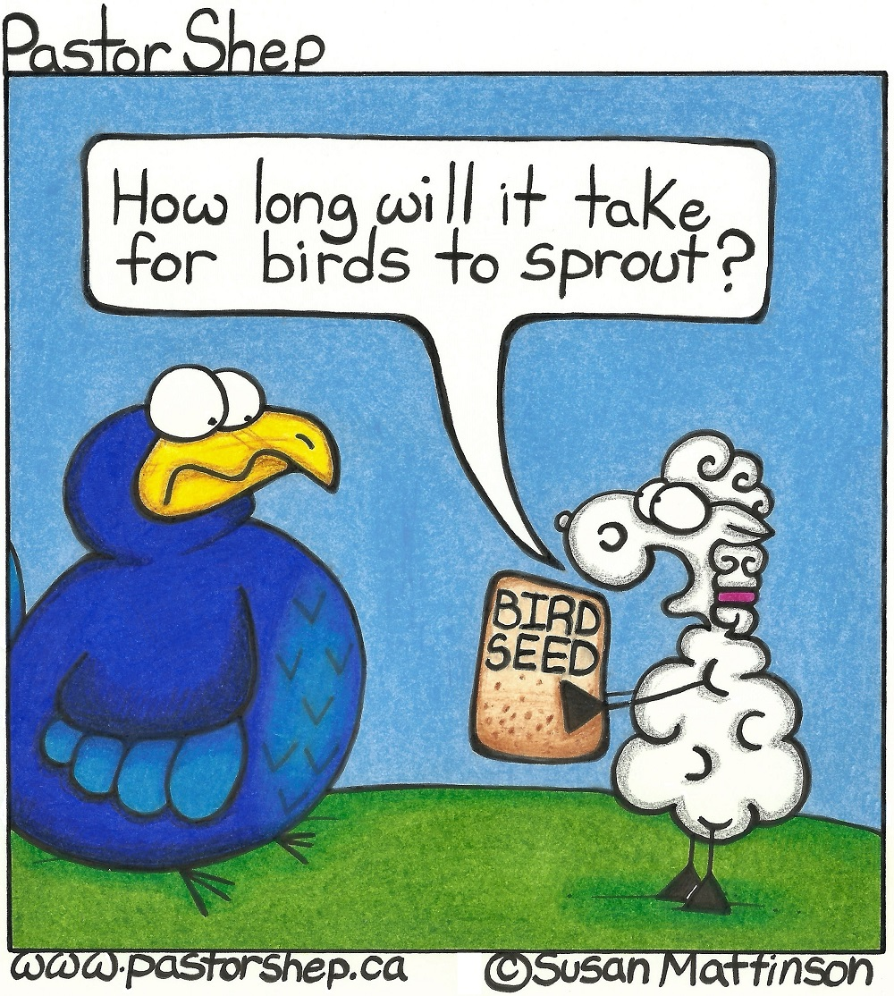
If you are visiting, or are new to the community we would like to getting to know you, and celebrating your gifts and growing together in our faith in Christ. God bless you.
Mission Moments Educating for Peace in Afghanistan “I became a teacher to serve the country. After three decades of war, Afghanistan needs reconstruction through education,” says Mirwas, the head teacher at a school in Laghman province. Presbyterian World Service & Development’s girls education project in Afghanistan is not only working to raise awareness about the importance of education for all children, it is also building the capacity of students and teachers to handle social, political, cultural and human rights issues. In a country struggling to rebuild after decades of conflict, female students and their teachers are learning about child rights and human rights—an incredibly important issue. The focus on education for girls is helping to raise a generation of young leaders who want to be teachers, lawyers, human rights workers and politicians. These girls will be forces of renewal and peace for their communities and their country.

