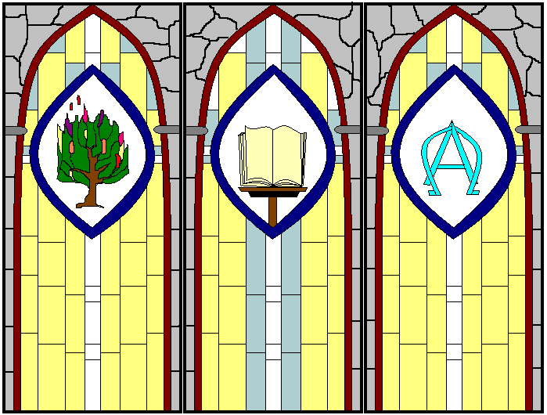
A Christian Church, A Family of Faith

The Presbyterian Church in Canada

Saint Mark’s Presbyterian Church; Bass River
Organists: Rodney Girvan Minister: Rev. Alexander [Sandy] D. Sutherland; B.A., B.Th. M.Div
www.pccweb.ca/brpc
August 17th 2014; 2:30

Call to Worship
Opening Praise Softly & Tenderly

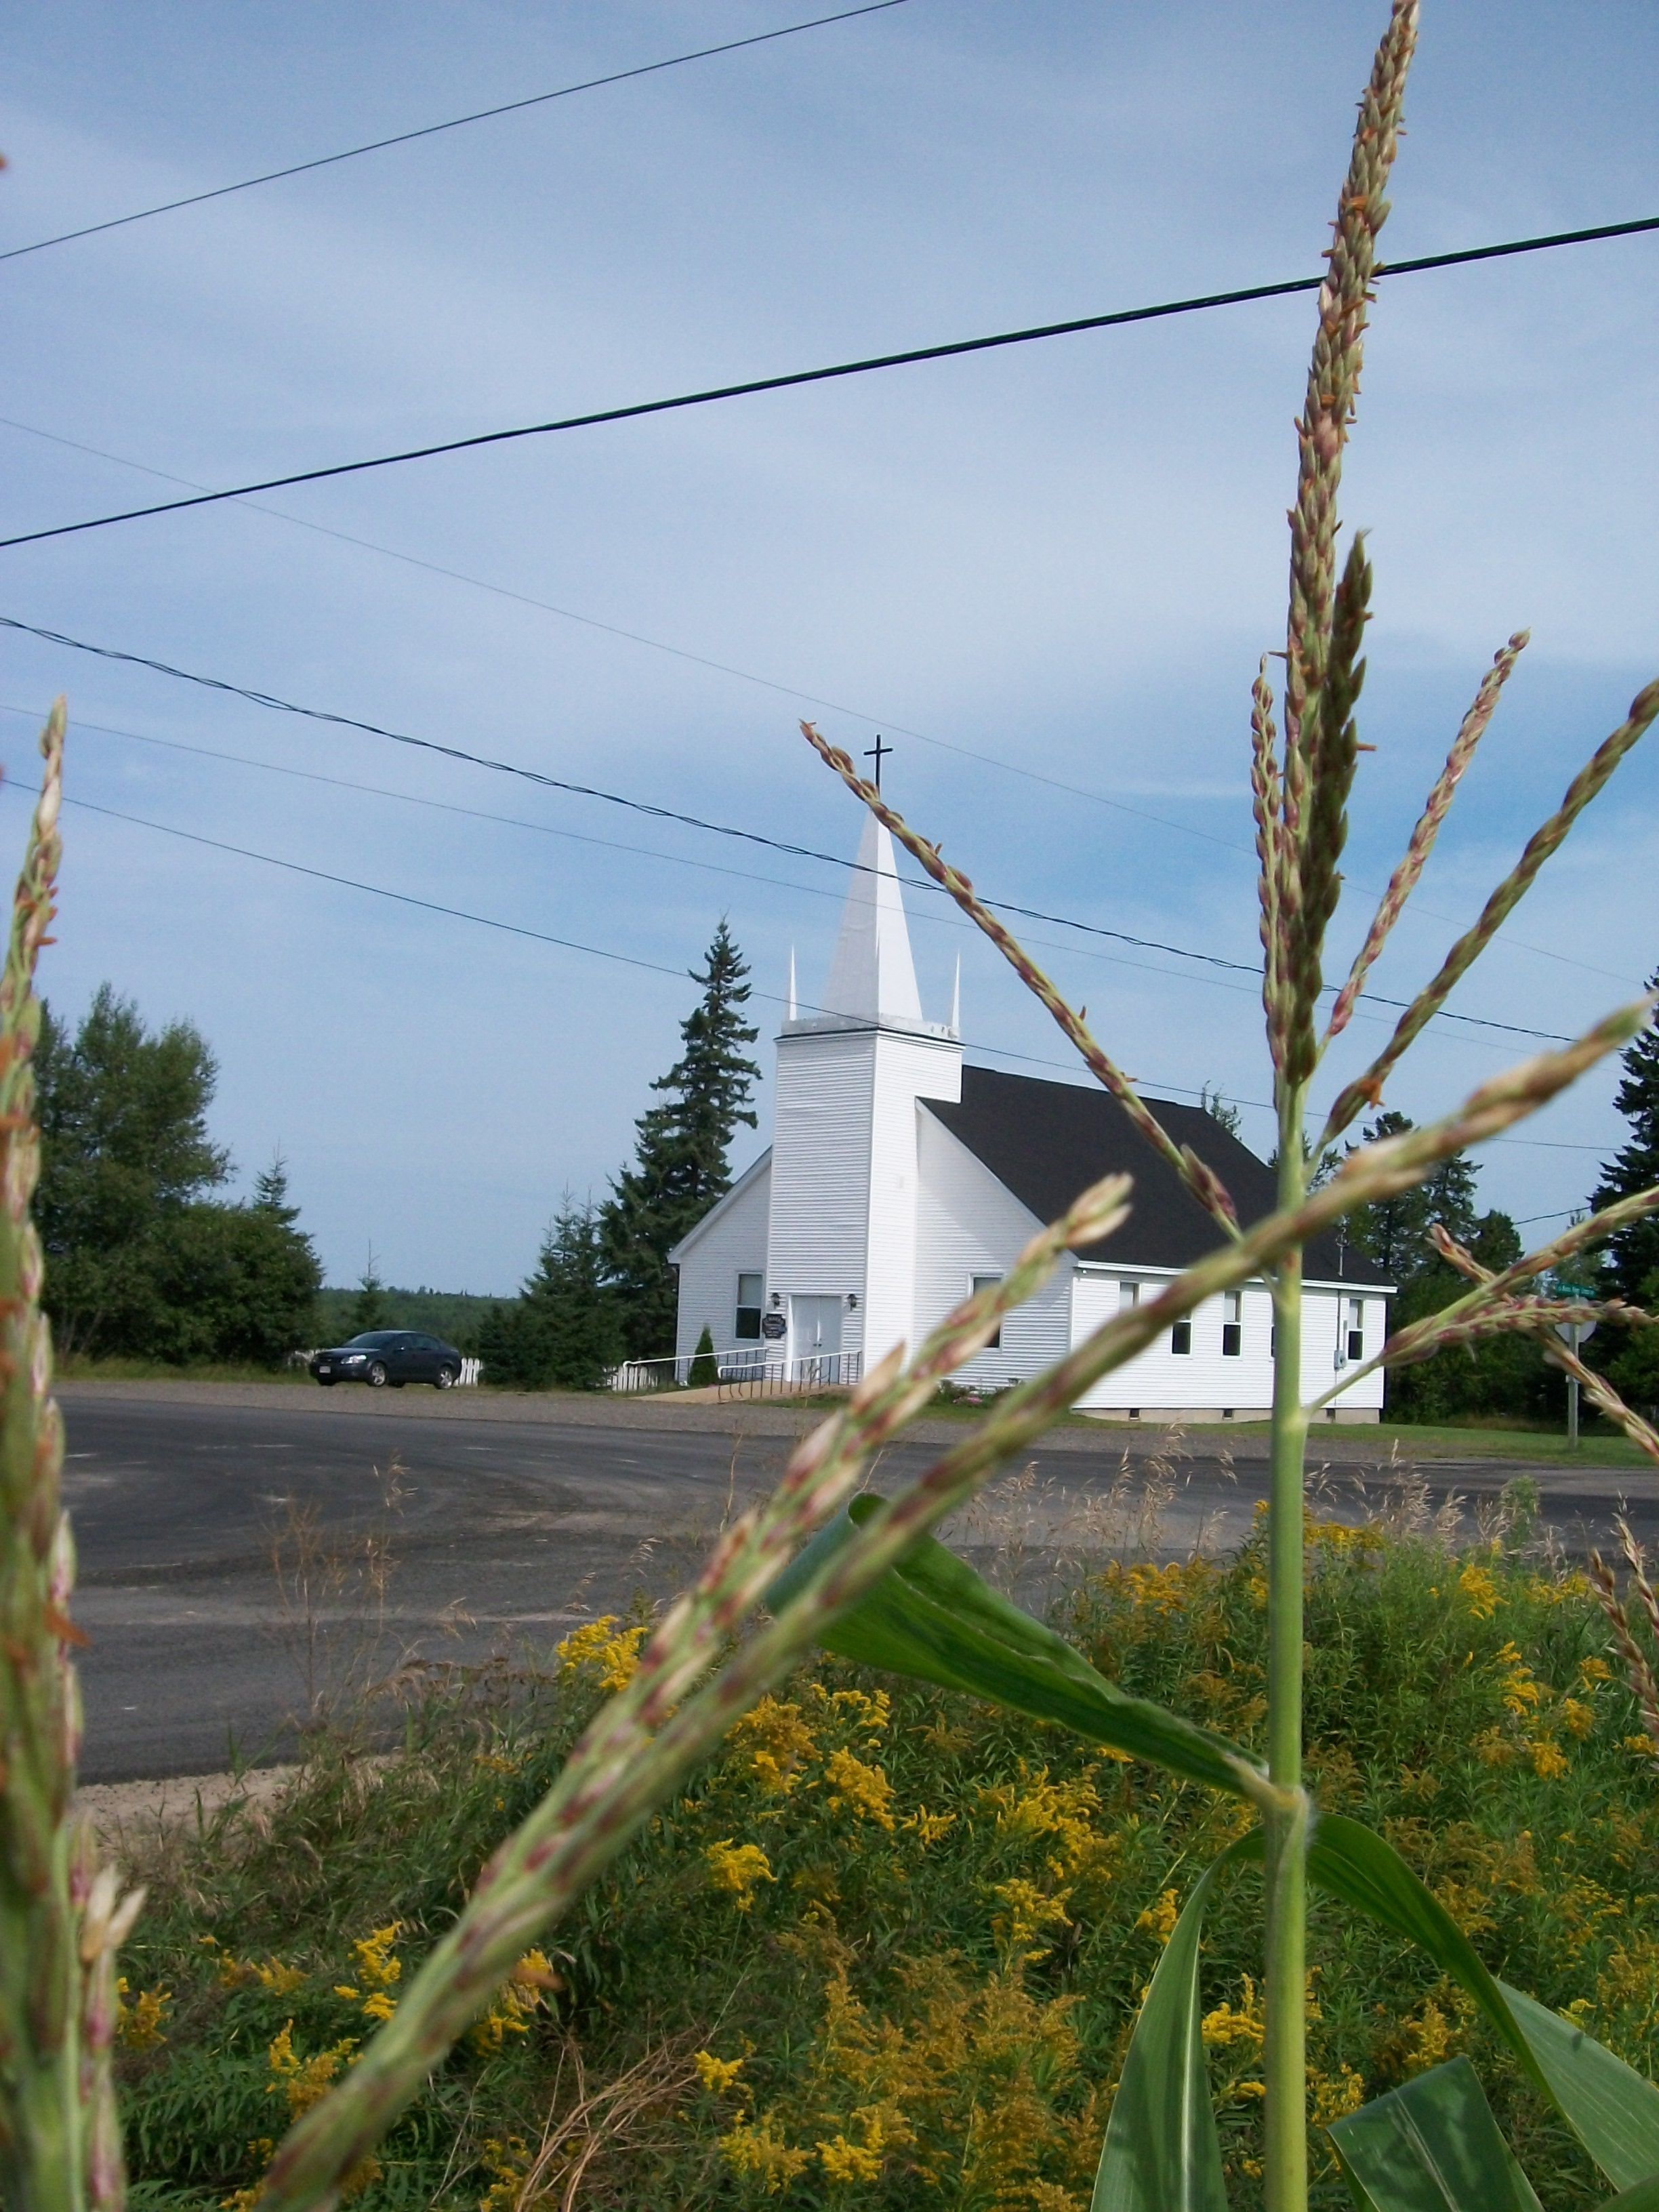
Softly & Tenderly
1. Softly and tenderly Jesus is calling,
Calling for you and for me;
See, on the portals he's waiting and watching,
Watching for you and for me.
Refrain:
Come home, (come home) come home (come home);
Ye who are weary come home;
Earnestly, tenderly, Jesus is calling,
Calling, O sinner, come home!
2. Why should we tarry when Jesus is pleading,
Pleading for you and for me?
Why should we linger and heed not his mercies,
Mercies for you and for me? [Refrain]
3. Time is now fleeting, the moments are passing,
Passing from you and from me;
Shadows will stretch in the sunset that’s coming
Coming for you and for me. [Refrain]
4.O for the wonderful love he has promised,
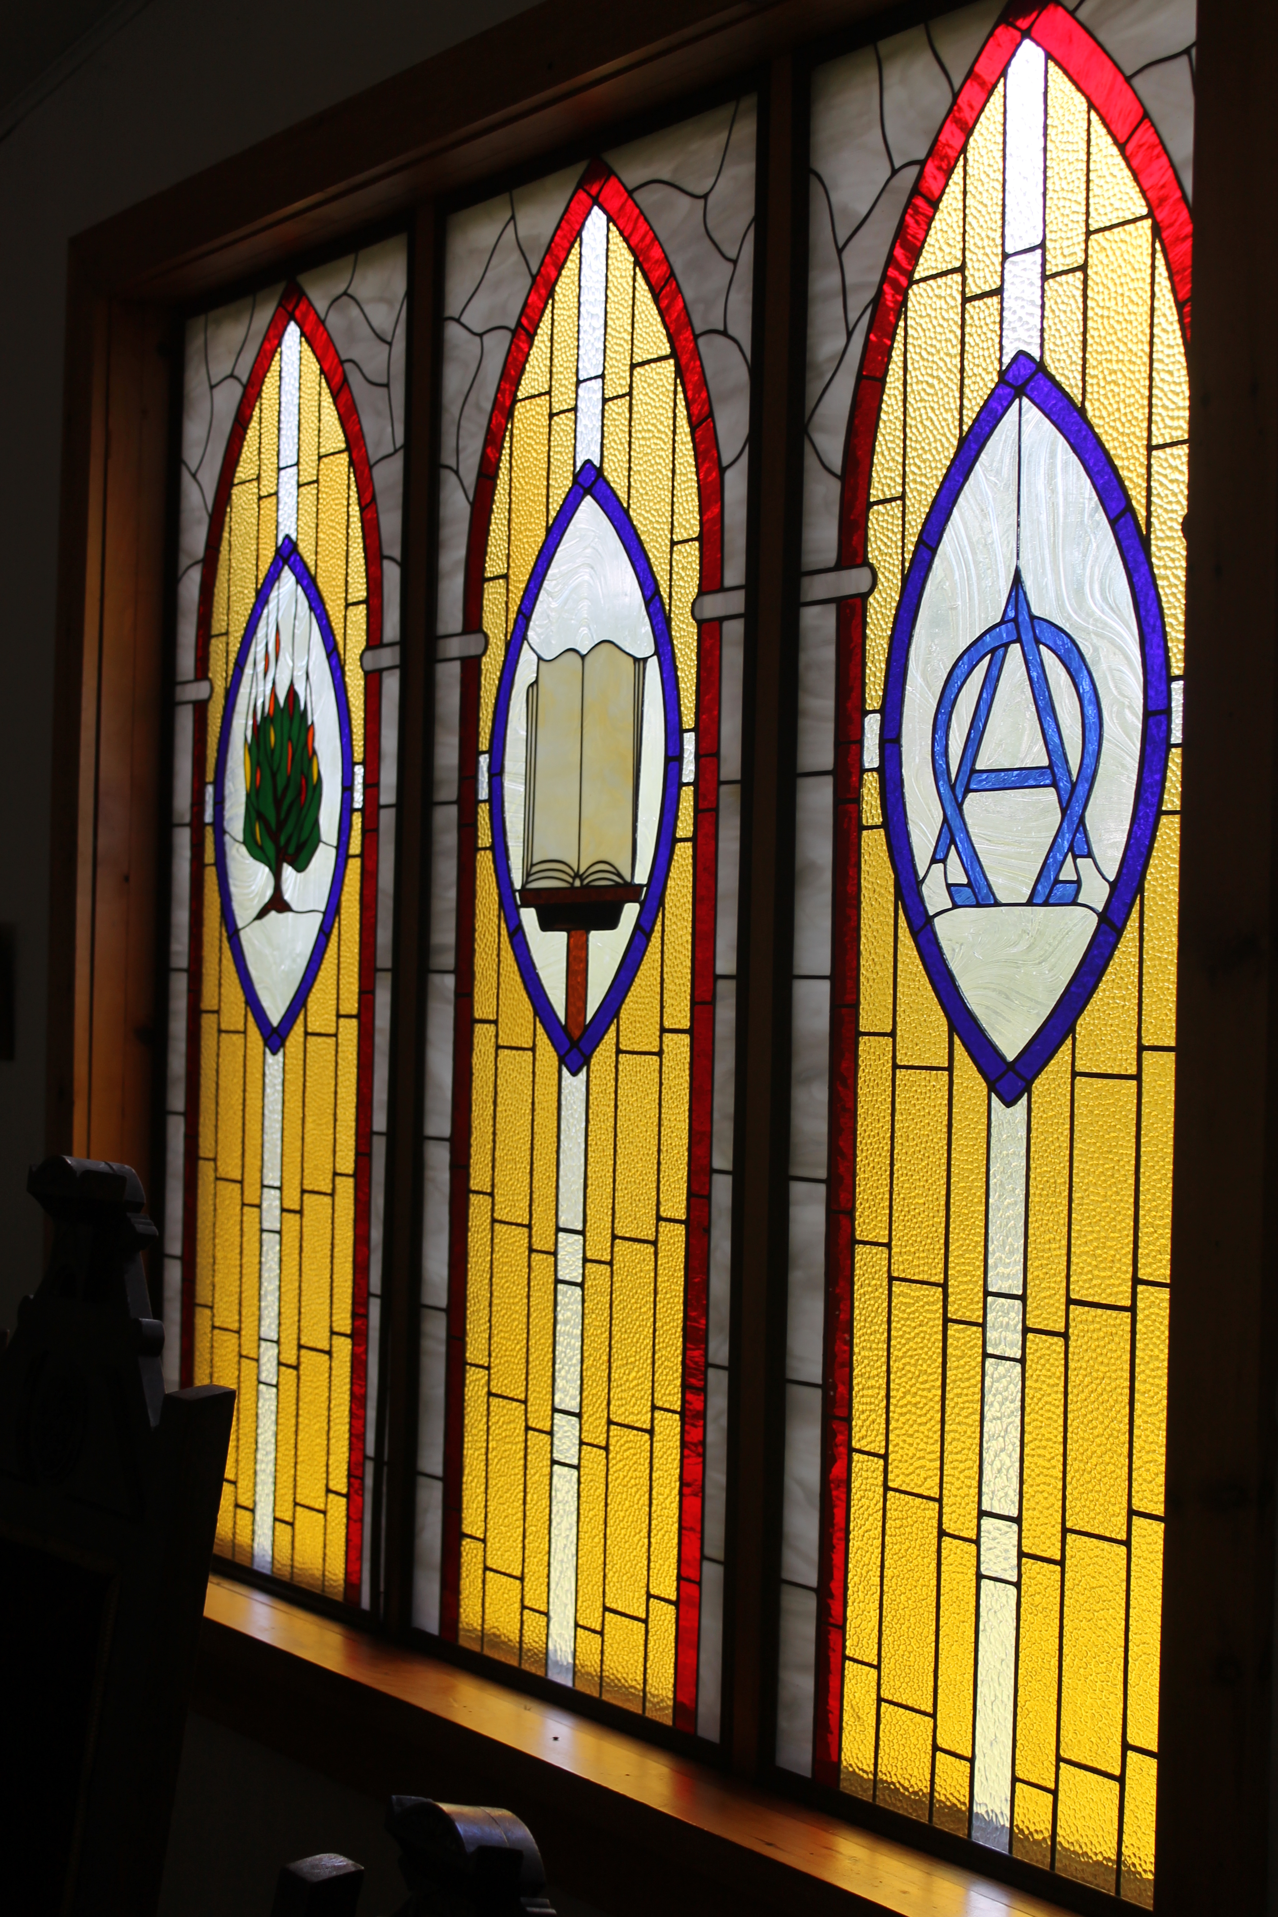
Promised for you and for me!
Though we have sinned, he has mercy and pardon,
Pardon for you and for me. [Refrain]

Prayers of Approach & The Lord’s Prayer

Special Music

Recalling our Heritage and Memorial
Today we remember those who have gone on in the Lord’s victory, to grace and to life everlasting.
We remember and honour Freeman.
Now I am to understand that the washroom here was put together in memorial to Freeman, but that is not an invite for the whole family to come up and try it out. Let’s break it in more gently than that.

Today’s memorials are made in honour of
Scripture Reading: Psalm 63 Read by Olive Ward
¹ O God, you are my God,
earnestly I seek you;
my soul thirsts for you,
my body longs for you,
in a dry and weary land
where there is no water.
² I have seen you in the sanctuary
and beheld your power and your glory.
³ Because your love is better than life,
my lips will glorify you.
⁴ I will praise you as long as I live,
and in your name I will lift up my hands.
⁵ My soul will be satisfied as with the richest of foods;
with singing lips my mouth will praise you.
⁶ On my bed I remember you;
I think of you through the watches of the night.
⁷ Because you are my help,
I sing in the shadow of your wings.
⁸ My soul clings to you;
your right hand upholds me.
⁹ They who seek my life will be destroyed;
they will go down to the depths of the earth.
¹⁰ They will be given over to the sword
and become food for jackals.
¹¹ But the king will rejoice in God;
all who swear by God’s name will praise him,
while the mouths of liars will be silenced.

1 Peter 5:1-11 Read by Willah Ryan
¹To the elders among you, I appeal as a fellow elder, a witness of Christ’s sufferings and one who also will share in the glory to be revealed: ²Be shepherds of God’s flock that is under your care, serving as overseers—not because you must, but because you are willing, as God wants you to be; not greedy for money, but eager to serve; ³not lording it over those entrusted to you, but being examples to the flock. ⁴And when the Chief Shepherd appears, you will receive the crown of glory that will never fade away.
⁵Young men, in the same way be submissive to those who are older. All of you, clothe yourselves with humility toward one another, because,
“God opposes the proud
but gives grace to the humble.”
⁶Humble yourselves, therefore, under God’s mighty hand, that he may lift you up in due time. ⁷Cast all your anxiety on him because he cares for you.
⁸Be self-controlled and alert. Your enemy the devil prowls around like a roaring lion looking for someone to devour. ⁹Resist him, standing firm in the faith, because you know that your brothers throughout the world are undergoing the same kind of sufferings.
¹⁰And the God of all grace, who called you to his eternal glory in Christ, after you have suffered a little while, will himself restore you and make you strong, firm and steadfast. ¹¹To him be the power for ever and ever. Amen.

Hymn of Illumination My hope is built on nothing less

Edward Mote

1. My hope is built on nothing less
than Jesus' blood and righteousness.
I dare not trust the sweetest frame,
but wholly lean on Jesus' name.
Refrain:
On Christ the solid rock I stand,
all other ground is sinking sand;
all other ground is sinking sand.
2. When Darkness veils his lovely face,
I rest on his unchanging grace.
In every high and stormy gale,
my anchor holds within the veil. (Refrain)
3. His oath, his covenant, his blood
supports me in the whelming flood.
When all around my soul gives way,
he then is all my hope and stay. (Refrain)
4. When he shall come with trumpet sound,
O may I then in him be found!
Dressed in his righteousness alone,
faultless to stand before the throne! (Refrain)

Gospel Reading: Mark 16:1-8 Read by Jean Chilcott
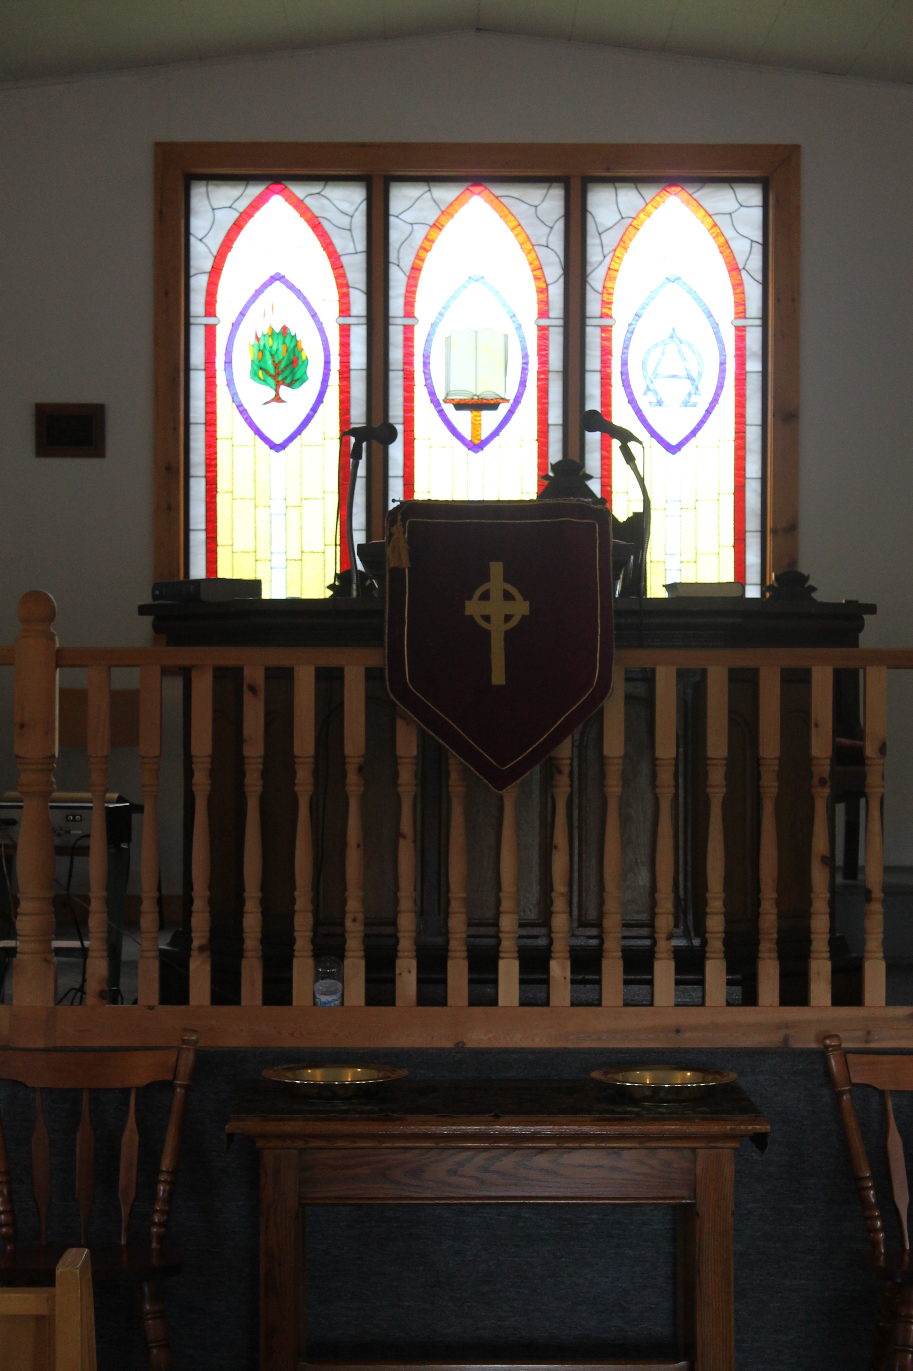
¹When the Sabbath was over, Mary Magdalene, Mary the mother of James, and Salome bought spices so that they might go to anoint Jesus’ body. ²Very early on the first day of the week, just after sunrise, they were on their way to the tomb ³and they asked each other, “Who will roll the stone away from the entrance of the tomb?”
⁴But when they looked up, they saw that the stone, which was very large, had been rolled away. ⁵As they entered the tomb, they saw a young man dressed in a white robe sitting on the right side, and they were alarmed.
⁶“Don’t be alarmed,” he said. “You are looking for Jesus the Nazarene, who was crucified. He has risen! He is not here. See the place where they laid him. ⁷But go, tell his disciples and Peter, ‘He is going ahead of you into Galilee. There you will see him, just as he told you.’”
⁸Trembling and bewildered, the women went out and fled from the tomb. They said nothing to anyone, because they were afraid.

Sermon Good news keeps on going
The question asked by popular theologians today is, “Where is the Church on Monday morning?” Some of the more cynical ask, ‘well where is the church on Sunday morning.”
But a Christian needs to ask, each and every day, doesn’t matter the reason, we all need to ask, “Where is the church each and every day?”, “Where is the Church today?”
When faith goes into crisis mode, and we feel the world pressing against us, and we are worn down by the doubts and fear and lack of faith that seems to be all around us, we can become defensive. We can close ourselves off.
Jesus disciples did that very thing. Jesus was tried and executed and the disciples go into hiding; those that were left. Some even walked away from it all and tried to take up living life from where they were before. And when they hide themselves away from the world the goodness of everything Jesus taught them becomes hidden too; as Jesus said, “No one lights a lamp and hides it under a bushel.”
Well, they would not stay hidden for long.
Because the good news that Jesus had planted in them like a seed; all the parables about the kingdom of heaven, all the miracles, all the wisdom, and most of all the example of the cross. That was not going to remains hidden in a room, or in a city and certainly it could not remain hidden in anyone’s heart. ‘
Hymn writer Frederick William Faber wrote that “Earth grows into heaven, as we come to live and breathe in the atmosphere of the Incarnation. Jesus makes heaven wherever he is.”
In the resurrection of Jesus the disciples discover that the words of Jesus were far more than they had every imagined. Jesus was not spouting philosophy or an idealism, but reality; a reality that was more real than even death.
There is some contention among bible scholars about the gospel of Mark. It has become such a point that some bibles now have a very interesting notation after Mark chapter 16 verse 8; it reads in our NIV “[The most reliable early manuscripts and other ancient witnesses do not have Mark 16:9-20.]” That means that several old bible scrolls do not have the last twelve verses that we have noted in our bibles. Did someone ADD to the bible? Did someone ADD to the gospel of Mark?
And I can give you a very definite ‘Maybe!’
There are variations, just like there are differences between the gospels. Some gospels talk more about Jesus humanity, while others really describe Jesus as very divine. Is one gospel more wrong than the others? Not really. Should we read only parts of the bible? Which parts?
I don’t think it matters much, and that someone felt compelled to add some more to the gospel of Mark doesn’t surprise me or upset me. Because when it comes down to who we are and what we are about we are still supposed to be, we are the next lines of the gospel, we are what comes after the book of Acts the letters of the apostles to the church, we are the church that is living in the midst of the revelation of John.
Our Bible might be a closed canon, meaning thee will not be any adding of books to it, the Bible is a baseline measurement of our journey of faith, that is written as an extension of its pages, of its words.
Living along this river as we do, we know how news travels up and down it s banks to ever tributary and stream; gossip, trouble, sadness, even good news from time to time, even The Good News. Even with modern communication methods I don’t always beat a bit of juicy news from down in Rexton up here to Bass River sometimes.
We are mean to be the living gospel; the verses that come after what is written, as the message of the living Christ goes out to all the world. The good news in Jesus Christ comes from the testimony of scripture, yet it comes through those who have humbled their hearts to encounter each other with the same sense we encounter God’s word; hoping to a hear a word of God from each other. That is the power of Church that no other fellowship – not even family – can have. God has promised to speak through the fellowship of faith, those called together in Christ to be givers of good news to a world; and who stand in the face of doubts and fears, angers and all forms of strife, even in the face and declare that “God of all grace will himself restore you and make you strong, firm and steadfast”.
Where does it end. God’s love knows its beginning and its end in eternity, and you are caught up in that eternity; for you are caught up in the good news in Jesus Christ. Jesus saves
Let us now sing of Christ’s salvation . . .
Hymn of Response Jesus saves William J. Kirkpatrick
1. We have heard the joyful sound, Jesus saves, Jesus saves; spread the tidings all around, Jesus saves, Jesus saves; bear the news to ev’ry land, climb the steeps and cross the waves, onward! -’tis our Lord’s command, Jesus saves, Jesus saves.
2. Waft if on the rolling tide, Jesus saves, Jesus saves; tell to sinners far and wide, Jesus saves, Jesus saves; sing, ye islands of the sea, echo back, ye ocean caves, earth shall keep her jubilee, Jesus saves, Jesus saves.
3. Sing above the battle’s strife, Jesus saves, Jesus saves; by his death and endless life, Jesus saves, Jesus saves; sing it softly thru the gloom, when the heart for mercy craves, sing in triumph o’er the tomb, - Jesus saves, Jesus saves.
4. Give the winds a mighty voice, Jesus saves, Jesus saves; let the nations now rejoice, - Jesus saves, Jesus saves; shout salvation full and free, highest hills and deepest caves. This our song of victory, - Jesus saves, Jesus saves.

Offering
Prayers of Thanksgiving

Thought and Final Reading Read by Jean Chilcott

Commissioning Praise Blessed Assurance Frances Crosby
Blessed assurance, Jesus is mine! O, what a foretaste of glory divine!
Heir of salvation, purchase of God, born of his Spirit, washed in his blood.
Refrain: This is my story, this is my song, praising my Saviour all the day long;
This is my story, this is my song, praising my Saviour all the day long.
Perfect submission, perfect delight, visions of rapture now burst on my sight;
Angels descending, bring from above echoes of mercy, whispers of love. Refrain
Perfect submission, all is at rest, I in my Saviour am happy and blest;
Watching and waiting; looking above, filled with his goodness, lost in his love. Refrain

Blessing and Benediction

Please join us for a luncheon at the hall for fellowship

No church or other association truly thrives unless struggles and differences are alive within it. George Macaulay Trevelyan (1876–1962)
Within the congregation and the community people who go out of their way sharing their gifts and talents, supporting this church in its missions, its ministry, building upkeep and maintenance. Your gifts today work with what is given week by week in support of the church in the general, cemetery, and special funds, contributing time and effort, and we treasure everyone who upholds us in prayer. In this way the life and work of St. Mark’s is sustained and upheld.
Special Memorials this year are roof repairs to the steeple & Our washroom facilities
Thank you & God bless you.
The Count
Some count their days by setting suns and things that pass away;
By homes and friends, and where they’ve been
But I’ve found a better way
I will count by unseen tomorrows, and stars yet unborn to the sky
By friends to be, and the hope in me
And the Love that will never die.
I will count by Jesus and the one perfect life that He gave
Who is my life, my will, my way
For my soul He came and saved.
And there will be a counting, of the sheep of the goats,
Of sheaves and tares, yes of us all
And none of us should dare to boast
All we count is God’s good grace, given to each soul in love
Till comes the time, the count is full,
And we are called above.
ADS
During the service let God speak to you.
After the service speak with your neighbour.

