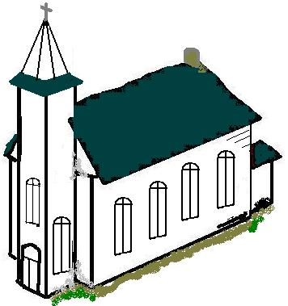
A Christian Church, A Family of Faith

The Presbyterian Church in Canada

St. James’ Presbyterian Church, Beersville
Minister: Rev. Alexander [Sandy] D. Sutherland Organists: Mrs. Marly Sutherland
www.pccweb.ca/brpc
August 21st 2016
Memorial & Homecoming
Welcome & Call to Worship James 2:5-13
⁵Listen, my beloved brethren. Has not God chosen those who are poor in the world to be rich in faith and heirs of the kingdom which he has promised to those who love him? ⁶But you have dishonored the poor man. Is it not the rich who oppress you, is it not they who drag you into court? ⁷Is it not they who blaspheme the honorable name which was invoked over you?
⁸If you really fulfil the royal law, according to the scripture, “You shall love your neighbor as yourself,” you do well. ⁹But if you show partiality, you commit sin, and are convicted by the law as transgressors. ¹⁰For whoever keeps the whole law but fails in one point has become guilty of all of it. ¹¹For he who said, “Do not commit adultery,” said also, “Do not kill.” If you do not commit adultery but do kill, you have become a transgressor of the law. ¹²So speak and so act as those who are to be judged under the law of liberty. ¹³For judgment is without mercy to one who has shown no mercy; yet mercy triumphs over judgment.

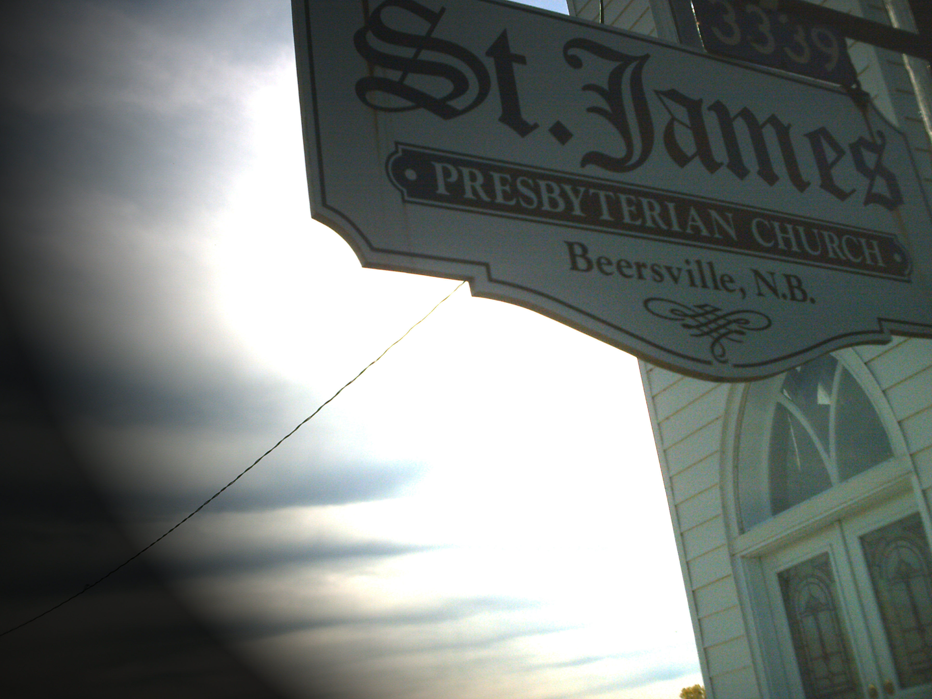
Opening Praise Softly & Tenderly
Softly & Tenderly Will L. Thompson
Softly and tenderly Jesus is calling, Calling for you and for me;
See, on the portals he's waiting and watching, Watching for you and for me.
Refrain: Come home, (come home) come home (come home); Ye who are weary come home;
Earnestly, tenderly, Jesus is calling, Calling, O sinner, come home!
Why should we tarry when Jesus is pleading, Pleading for you and for me?
Why should we linger and heed not his mercies, Mercies for you and for me? [Refrain]
Time is now fleeting, the moments are passing, Passing from you and from me;
Shadows will stretch in the sunset that’s coming Coming for you and for me. [Refrain]
O for the wonderful love he has promised, Promised for you and for me!
Though we have sinned, he has mercy and pardon, Pardon for you and for me. [Refrain]

Prayers of Approach & The Lord’s Prayer

Recalling our Heritage

Special Music – “Daddy doesn’t pray” Brent Cotterell

Memorials & Dedications – Warren Beers
Carmen Fillmore
Emerson
Wade Wry
William &Elizabeth Fillmore

Scripture Reading: Psalm 71(sel)
¹ In you, O LORD, I have taken refuge;
let me never be put to shame.
² Rescue me and deliver me in your righteousness;
turn your ear to me and save me.
³ Be my rock of refuge,
to which I can always go;
give the command to save me,
for you are my rock and my fortress.
⁴ Deliver me, O my God, from the hand of the wicked,
from the grasp of evil and cruel men.
⁵ For you have been my hope, O Sovereign LORD,
my confidence since my youth.
⁶ From birth I have relied on you;
you brought me forth from my mother’s womb.
I will ever praise you.
⁷ I have become like a portent to many,
but you are my strong refuge.
⁸ My mouth is filled with your praise,
declaring your splendor all day long.
⁹ Do not cast me away when I am old;
do not forsake me when my strength is gone.
¹⁰ For my enemies speak against me;
those who wait to kill me conspire together.
¹¹ They say, “God has forsaken him;
pursue him and seize him,
for no one will rescue him.”
¹² Be not far from me, O God;
come quickly, O my God, to help me.
¹³ May my accusers perish in shame;
may those who want to harm me
be covered with scorn and disgrace.
¹⁴ But as for me, I will always have hope;
I will praise you more and more.
¹⁵ My mouth will tell of your righteousness,
of your salvation all day long,
though I know not its measure.
¹⁶ I will come and proclaim your mighty acts, O Sovereign LORD;
I will proclaim your righteousness, yours alone.
¹⁷ Since my youth, O God, you have taught me,
and to this day I declare your marvelous deeds.
¹⁸ Even when I am old and gray,
do not forsake me, O God,
till I declare your power to the next generation,
your might to all who are to come.
¹⁹ Your righteousness reaches to the skies, O God,
you who have done great things.
Who, O God, is like you?
²⁰ Though you have made me see troubles, many and bitter,
you will restore my life again;
from the depths of the earth
you will again bring me up.
²¹ You will increase my honor
and comfort me once again.
²² I will praise you with the harp
for your faithfulness, O my God;
I will sing praise to you with the lyre,
O Holy One of Israel.
²³ My lips will shout for joy
when I sing praise to you—
I, whom you have redeemed.
²⁴ My tongue will tell of your righteous acts
all day long,
for those who wanted to harm me
have been put to shame and confusion.

Jeremiah 1:4-10
⁴The word of the LORD came to me, saying,
⁵ “Before I formed you in the womb I knew£ you,
before you were born I set you apart;
I appointed you as a prophet to the nations.”
⁶“Ah, Sovereign LORD,” I said, “I do not know how to speak; I am only a child.”
⁷But the LORD said to me, “Do not say, ‘I am only a child.’ You must go to everyone I send you to and say whatever I command you. ⁸Do not be afraid of them, for I am with you and will rescue you,” declares the LORD.
⁹Then the LORD reached out his hand and touched my mouth and said to me, “Now, I have put my words in your mouth. ¹⁰See, today I appoint you over nations and kingdoms to uproot and tear down, to destroy and overthrow, to build and to plant.”

Hymn of Illumination Tell me the old, old story
Tell me the old, old story Katherine (Kate) Hankey
Tell me the old, old story of unseen things above,
Of Jesus and His glory, of Jesus and His love.
Tell me the story simply, as to a little child,
For I am weak and weary, and helpless and defiled.
Refrain
Tell me the old, old story, tell me the old, old story,
Tell me the old, old story, of Jesus and His love.

Tell me the story slowly, that I may take it in,
That wonderful redemption, God’s remedy for sin.
Tell me the story often, for I forget so soon;
The early dew of morning has passed away at noon. Refrain
Tell me the story softly, with earnest tones and grave;
Remember I’m the sinner whom Jesus came to save.
Tell me the story always, if you would really be,
In any time of trouble, a comforter to me. Refrain
Tell me the same old story when you have cause to fear
That this world’s empty glory is costing me too dear.
Yes, and when that world’s glory is dawning on my soul,
Tell me the old, old story: “Christ Jesus makes thee whole.” Refrain

Gospel Reading: Mark 10:35-45
³⁵Then James and John, the sons of Zebedee, came to him. “Teacher,” they said, “we want you to do for us whatever we ask.”
³⁶“What do you want me to do for you?” he asked.
³⁷They replied, “Let one of us sit at your right and the other at your left in your glory.”
³⁸“You don’t know what you are asking,” Jesus said. “Can you drink the cup I drink or be baptized with the baptism I am baptized with?”
³⁹“We can,” they answered.
Jesus said to them, “You will drink the cup I drink and be baptized with the baptism I am baptized with, ⁴⁰but to sit at my right or left is not for me to grant. These places belong to those for whom they have been prepared.”
⁴¹When the ten heard about this, they became indignant with James and John. ⁴²Jesus called them together and said, “You know that those who are regarded as rulers of the Gentiles lord it over them, and their high officials exercise authority over them. ⁴³Not so with you. Instead, whoever wants to become great among you must be your servant, ⁴⁴and whoever wants to be first must be slave of all. ⁴⁵For even the Son of Man did not come to be served, but to serve, and to give his life as a ransom for many.”

Sermon Reserved Seating
Here are top ten list of thing Pastors dream of hearing in his church.
1. Hey! It's my turn to sit in the front pew.
2. I was so enthralled, I never noticed your sermon went 25 minutes over time.
3. Personally I find witnessing much more enjoyable than golf.
4. I've decided to give our church the $500 a month I used to send to TV evangelists.
5. I volunteer to be the permanent teacher for the Junior High Sunday School class.
7. I love it when we sing hymns I've never heard before!
8. Since we're all here, let's start the service early.
9. Pastor, we'd like to send you to this Bible seminar in the Bahamas.
10. Nothing inspires me and strengthens my commitment like our annual stewardship campaign!
11. I couldn't find space to park outside. Praise God!

I will keep dreaming and praying
Where is your seat in this church? If you are not in your ‘proper’ seat right now are you sore at the person who is sitting there? Not in the least?!
It used to be that we would rent out seats in many of our churches, money from the pew rental would go to the building fund - most of the time – the building fund. But such a thing is out of practice and outside our theology as well, but their was a day when you would come to church sit in what was ‘your’ pew. That is back when seating in church was a premium (and every Sunday the church was filled up like it is today).
So our gospel reading takes us to a situation where the disciples James and John have something similar in mind. It Seems that James and John though highly enough of themselves and the relationship as disciples of Jesus, that they figured they had not only places reserved in heaven – something I hope you all have in your mind and on your hearts – but they were vying for premium front row – slightly to the right-hand seats in the throne section of God’s kingdom & court.
They thought of themselves as not only chosen, but Christ’s own personal advisors and close associates. So, they wanted to check with Jesus to make sure that their assumption was about right, and that Jesus plan was to put them in those special reserved heavenly seats.
They were perhaps being a bit presumptuous, but at least they served Christ with confidence, and to their credit – after Jesus essentially shot their whole plan for eternal placement down, they stuck by Jesus and John even stood with Jesus and Christ family as they watched him die on the cross, John was there at Jesus side as he died.
But Jesus answer is so open, that it just makes me wonder, to who else might Jesus be speaking? Another disciple, some faithful person or people down through the ages, may someone from today, perhaps you or me. Could it be?
Jesus leaves those positions open and says, God has got plan for everything and everyone will have their own place in heaven and everyone will be satisfied with where they are. Now that catches me off guard, just a little, everyone has their perfect place.
Even on my best days I don’t know if I am completely ever satisfied. Wanting one more thing, one more moment, one more chance, one last opportunity.
You see those are God’s, and we get handed them moment by moment as life passes fleetingly by. We have been given the promise there is a place for us.
No I don’t know your prayers, but we hope today we‘ve touched your hearts in all we’ve read and shared and done. I want you to think about your place that Christ for you has won. And when you sing this next hymn, consider God made a place, when His son Jesus took the cross to give you Amazing Grace.
Let us praise God together

Hymn of Response Amazing Grace
Amazing Grace (John Newton, 1725-1807)
Amazing grace, how sweet the sound, that saved a wretch like me! I once was lost, but now am found, was blind, but now I see.
Twas grace that taught my heart to fear, and grace my fears relieved; how precious did that grace appear the hour I first believed.
Thro’ many dangers, toils and snares, I have already come; ‘tis grace hath brought me safe thus far, and grace will lead me home.
The Lord has promised good to me, this word my hope secures; God will my shield and portion be as long as life endures.
What thanks I owe you, and what love—a boundless, endless store—shall echo through the realms above, when time shall be no more.
When we’ve been there ten thousand years, bright shining as the sun, we’ve no less days to sing God’s praise than when we’d first begun.

Offering “Heaven Sent”

Prayers of Thanksgiving

Commissioning Praise Blessed Assurance
Blessed Assurance
Blessed assurance, Jesus is mine! O, what a foretaste of glory divine!
Heir of salvation, purchase of God, born of his Spirit, washed in his blood.
Refrain: This is my story, this is my song, praising my Saviour all the day long;
This is my story, this is my song, praising my Saviour all the day long.
Perfect submission, perfect delight, visions of rapture now burst on my sight;
Angels descending, bring from above echoes of mercy, whispers of love. Refrain
Perfect submission, all is at rest, I in my Saviour am happy and blest;
Watching and waiting; looking above, filled with his goodness, lost in his love. Refrain

Blessing and Benediction

We are thankful for you, and the many ways the life and mission of this congregation is supported through everyone who contributes to our memorial, general and cemetery funds, and especially thankful for those who have taken time, effort, and expense in the upkeep of these facilities for its regular worship & use.
God Bless You All
Ross Lawson has been very busy with grounds keeping and all that is involved in managing the cemetery and keeping things in general in good and decent order. We hope you have a chance to enjoy his hard work.

This past year’s projects/events:
-Continued work on the PA System, [new amp needed].
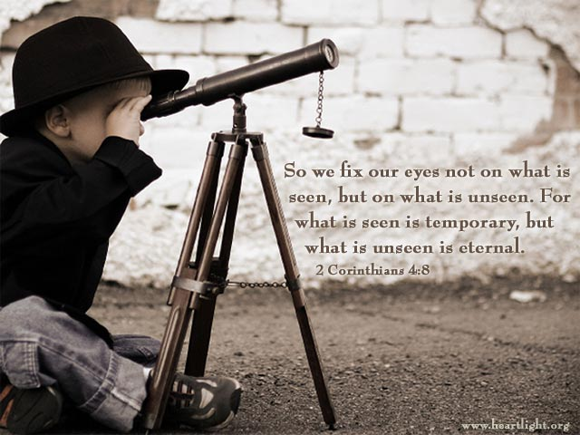
-Developing children’s ministries and a successful VBS with/in Clairville
- New fellowship events!
- Special music Sundays with Celtic Flavour

