A Christian Church, A Family of Faith

The Presbyterian Church in Canada

St. James’ Presbyterian Church, Beersville

Minister: Rev. Alexander [Sandy] D. Sutherland; B.A., B.Th. M.Div
Organists: Mrs. Marly Sutherland B.Sc B.Ed
www.pccweb.ca/brpc
August 24th 2014
Memorial & Homecoming
Welcome & Call to Worship

Opening Praise Just as I am
Just as I am - Charlotte Elliott
Just as I am, without one plea, but that thy blood was shed for me, and that thou bidds’t me come to thee, O Lamb of God, I come! I come!
Just as I am, though tossed about with many a conflict, many a doubt, fightings and fears within, without, O Lamb of God, I come! I come!
Just as I am, poor, wretched, blind; sight, riches, healing of the mind, yea, all I need in thee I find, O Lamb of God, I come! I come!
Just as I am, thou wilt receive, wilt welcome, pardon, cleanse, relieve; because thy promise I believe, O Lamb of God, I come! I come!
Just as I am; thy love unknown has broken every barrier down. Now to be thine, yea, thine alone, O Lamb of God, I come! I come!
Just as I am; of that free love the breadth, length, depth and height to prove, here for a season, then above, O Lamb of God, I come! I come!

Prayers of Approach & The Lord’s Prayer

Recalling our Heritage

Special Music – O Lord my God/ How great Thou art
O Lord my God/ How great Thou art CG Bobrug
O Lord my God, when I in awesome wonder consider all the works Thy hand hath made, I see the stars, I hear the rolling thunder, Thy power thro’ out the universe displayed.
Chorus: Then sings my soul, my Saviour God, to thee, How great Thou art! How great Thou art! Then sings my soul, my Saviour God, to thee, How great Thou art! How great Thou art!
When thro’ the woods and forest glades I wander, I hear the birds sing sweetly in the trees; when I look down from lofty mountain grandeur and hear the brook and feel the gentle breeze. Chorus
But when I think that God, his Son not sparing, sent him to die, I scarce can take it in, that on the cross, my burden gladly bearing, he bled and died to take away my sin. Chorus
When Christ shall come, with shout of acclamation, and take me home, what joy shall fill my heart! Then I shall bow in humble adoration and there proclaim, ‘My God, how great Thou art!’ Chorus

Memorials & Dedications
We remember and honour with our remembering all who have gone before in love and service and who, in Christ, now celebrate at the great reunion and the perfect reward of our heavenly home.
Today we remember Jacques Verrier whose dedication to the love of his family is a very real and touching way of the love we are all mean to share as a family in Christ.
We remember and honour Arnold Roberts, who always sought for the right way to serve his community, and by so doing shared in our struggle in faith as we seek to serve and love our neighbour.
We remember James Lawson, and the unassuming way he was a leader in the church for Christ. Steadfast and sure, he walked like Christ in his own shoes and through his own fields to remind us of Christ in prayer for family and friends.
We miss them all, yet we have not lost sight. For as we raise our eyes in the hope we share in Jesus Christ we can see through faith they are not far off, but wait for us ahead in the perfection of God’s love.

Scripture Reading: Psalm 124 Donna Wellwood
¹ If the LORD had not been on our side—
let Israel say—
² if the LORD had not been on our side
when men attacked us,
³ when their anger flared against us,
they would have swallowed us alive;
⁴ the flood would have engulfed us,
the torrent would have swept over us,
⁵ the raging waters
would have swept us away.
⁶ Praise be to the LORD,
who has not let us be torn by their teeth.
⁷ We have escaped like a bird
out of the fowler’s snare;
the snare has been broken,
and we have escaped.
⁸ Our help is in the name of the LORD,
the Maker of heaven and earth.

James 5:7-16 Susie Campbell
⁷Be patient, then, brothers, until the Lord’s coming. See how the farmer waits for the land to yield its valuable crop and how patient he is for the autumn and spring rains. ⁸You too, be patient and stand firm, because the Lord’s coming is near. ⁹Don’t grumble against each other, brothers, or you will be judged. The Judge is standing at the door!
¹⁰Brothers, as an example of patience in the face of suffering, take the prophets who spoke in the name of the Lord. ¹¹As you know, we consider blessed those who have persevered. You have heard of Job’s perseverance and have seen what the Lord finally brought about. The Lord is full of compassion and mercy.
¹²Above all, my brothers, do not swear—not by heaven or by earth or by anything else. Let your “Yes” be yes, and your “No,” no, or you will be condemned.
¹³Is any one of you in trouble? He should pray. Is anyone happy? Let him sing songs of praise. ¹⁴Is any one of you sick? He should call the elders of the church to pray over him and anoint him with oil in the name of the Lord. ¹⁵And the prayer offered in faith will make the sick person well; the Lord will raise him up. If he has sinned, he will be forgiven. ¹⁶Therefore confess your sins to each other and pray for each other so that you may be healed. The prayer of a righteous man is powerful and effective.

Hymn of Illumination Faith of our Fathers
Faith of our Fathers Frederick W. Faber
Faith of our Fathers! living still; in spite of dungeon, fire and sword,
O how our hearts beat high with joy, whene’er we hear that glorious word!
Refrain: Faith of our Fathers! holy faith! We will be true to thee till death!
Our fathers, chained in prisons dark, were still in heart and conscience free;
how sweet would be their children’s fate, if they, like them, could die for thee!
Refrain
Faith of our Fathers! we will love; both friend and foe in all our strife;
and preach thee, too, as love knows how; by kindly word and virtuous life!
Refrain

Gospel Reading: Luke 8:49-56
⁴⁹While Jesus was still speaking, someone came from the house of Jairus, the synagogue ruler. “Your daughter is dead,” he said. “Don’t bother the teacher any more.”
⁵⁰Hearing this, Jesus said to Jairus, “Don’t be afraid; just believe, and she will be healed.”
⁵¹When he arrived at the house of Jairus, he did not let anyone go in with him except Peter, John and James, and the child’s father and mother. ⁵²Meanwhile, all the people were wailing and mourning for her. “Stop wailing,” Jesus said. “She is not dead but asleep.”
⁵³They laughed at him, knowing that she was dead. ⁵⁴But he took her by the hand and said, “My child, get up!” ⁵⁵Her spirit returned, and at once she stood up. Then Jesus told them to give her something to eat. ⁵⁶Her parents were astonished, but he ordered them not to tell anyone what had happened.

Sermon Weight of Witnesses
On several occasions Jesus singles out James and John and Peter and takes them to witness something absolutely amazing. There are a couple of things that seem really interesting about this, and the first is that for the most part the other disciples seem to have no problem with this. Oh there is a little bit of a disagreement at one point where James and John get it into their head that they should be seated right beside Jesus in his coming kingdom, and Peter will get himself in some trouble about overstating his ability to be trustworthy, but the disciples seem quite alright with Jesus taking this small group aside, not just the once that we shared in our reading today, but several times.
Was it because These three would have special jobs when Jesus arose and ascended to heaven. Was there something that Jesus was preparing them especially to do.
We know that Peter becomes very important to the leading of the church. He became one of the first bishops of the church, and along with the apostle Paul was one of the most traveled.
John becomes the church’s visionary; a missionary and a martyr of sorts – John gives the church a root of faith that does not just rely on the examples of the past, or only on the witness of who Jesus was when he was with the disciples, but help ing the church to see who Jesus was after ascension, and to give us a vision of who Jesus is in the life of the church even now today.
But James, James does not go on to either of these ends. James writes a litter to the church and he may have been involved in the writing of at least one of the Gospels, but it seems as though James was given the experiences of being present for the most amazing miracles, and the transfiguration and these very significant events in the life and ministry of Christ so that he can offer the church a message of witness to the reality of Jesus; to make the church a real witness to the world of the love of God.
There is a purpose in everyone’s experience.
Peter was going to take the experience and become a leader and guide the other people who were leading the church to be good leaders. John would help the church see past its current difficulties and give the church of his day and even our day a vision that tell us there is meant to be a fellowship of faith – led by Christ. But these are both very theoretical. These are good ideas, a wonderful use of the witness Jesus offered, but someone needed to remind the church not to become to philosophical and ‘religious’ that people would not be able to grasp a real concreteness.
And James takes his witness and gives guidance to the church that it should be grounded, and concrete. There should be something reachable and touchable about believing in Jesus. James has to make Jesus real, because we need Jesus to be as real as he was for the disciples even at this stage in the life of the church some two thousand years later.
Imagine three letters written to someone who was in a terrible prison on an indefinite sentence. The first letter from Peter would be a guide on how to achieve freedom and how to free others; something very useful and exciting and very important. The second letter, from John, would help you imagine your freedom and tell you about what that freedom should be like for you and for others. But the third, a letter from James, tells you simply: “You are free right now.”
All three are significant, but for the prisoner in any kind of prison, only James is giving the news they most want to hear. That freedom is ahead, and that it is achievable is all very good and interesting, but the first witness to a people in pain and suffering is that the message of real and concrete freedom.
Those three witnesses stood by the bed as Jesus raised the little daughter of Jarius from seeming death. Jesus whose touch could remove the stain of sin that held both body and spirit back from a life of happiness took three witnesses into the room, to offer the truth of himself.
And as the child rose from her bed of death to be embraced in her parent’s arms, the three witnesses of Jesus stood by, ready to take this witness into the future of the church, each in their own way.
You have been made witness to some amazing miracles to. There are no accidents, and the moments of awe that you have witnessed are to help you see the power of God in your life, but you are made witness to help other see the power of God in their lives. What will you do with the witness, the special witness you have been given. What we will we do as a church to the special witness we have been given. Will we come before God? Will we come before the world?
How will you offer Christ to the world?

Hymn of Response Rock of Ages
Rock of ages - Augustus M. Toplady
Rock of ages, cleft for me, let me hide myself in thee; let the water and the blood, from thy riven side which flowed, be of sin the double cure; cleanse me from its guilt and power.
2. Not the labours of my hands can fulfil thy law’s demands; could my zeal no respite know, could my tears for ever flow, all for sin could not atone; thou must save, and thou alone.
3. Nothing in my hand I bring; simply to thy cross I cling; naked, come to thee for dress; helpless, look to thee for grace; foul, I to the fountain fly; wash me, Saviour, or I die.
4. While I draw this fleeting breath, when my eyelids close in death, when I soar through tracts unknown, see thee on thy judgement throne; rock of ages, cleft for me, let me hide myself in thee.

Offering
Prayers of Thanksgiving

Commissioning Praise Simply Trusting Every Day
Simply trusting every day Edgar Stites
Simply trusting every day, Trusting through a stormy way;
Even when my faith is small, Trusting Jesus, that is all.
Refrain Trusting as the moments fly, Trusting as the days go by; Trusting Him whate’er befall, Trusting Jesus, that is all.

Brightly doth His Spirit shine Into this poor heart of mine;
While He leads I cannot fall; Trusting Jesus, that is all. Refrain

Singing if my way is clear, Praying if the path be drear;
If in danger for Him call; Trusting Jesus, that is all. Refrain

Trusting Him while life shall last, Trusting Him till earth be past;
Till within the jasper wall, Trusting Jesus, that is all. Refrain


Blessing and Benediction

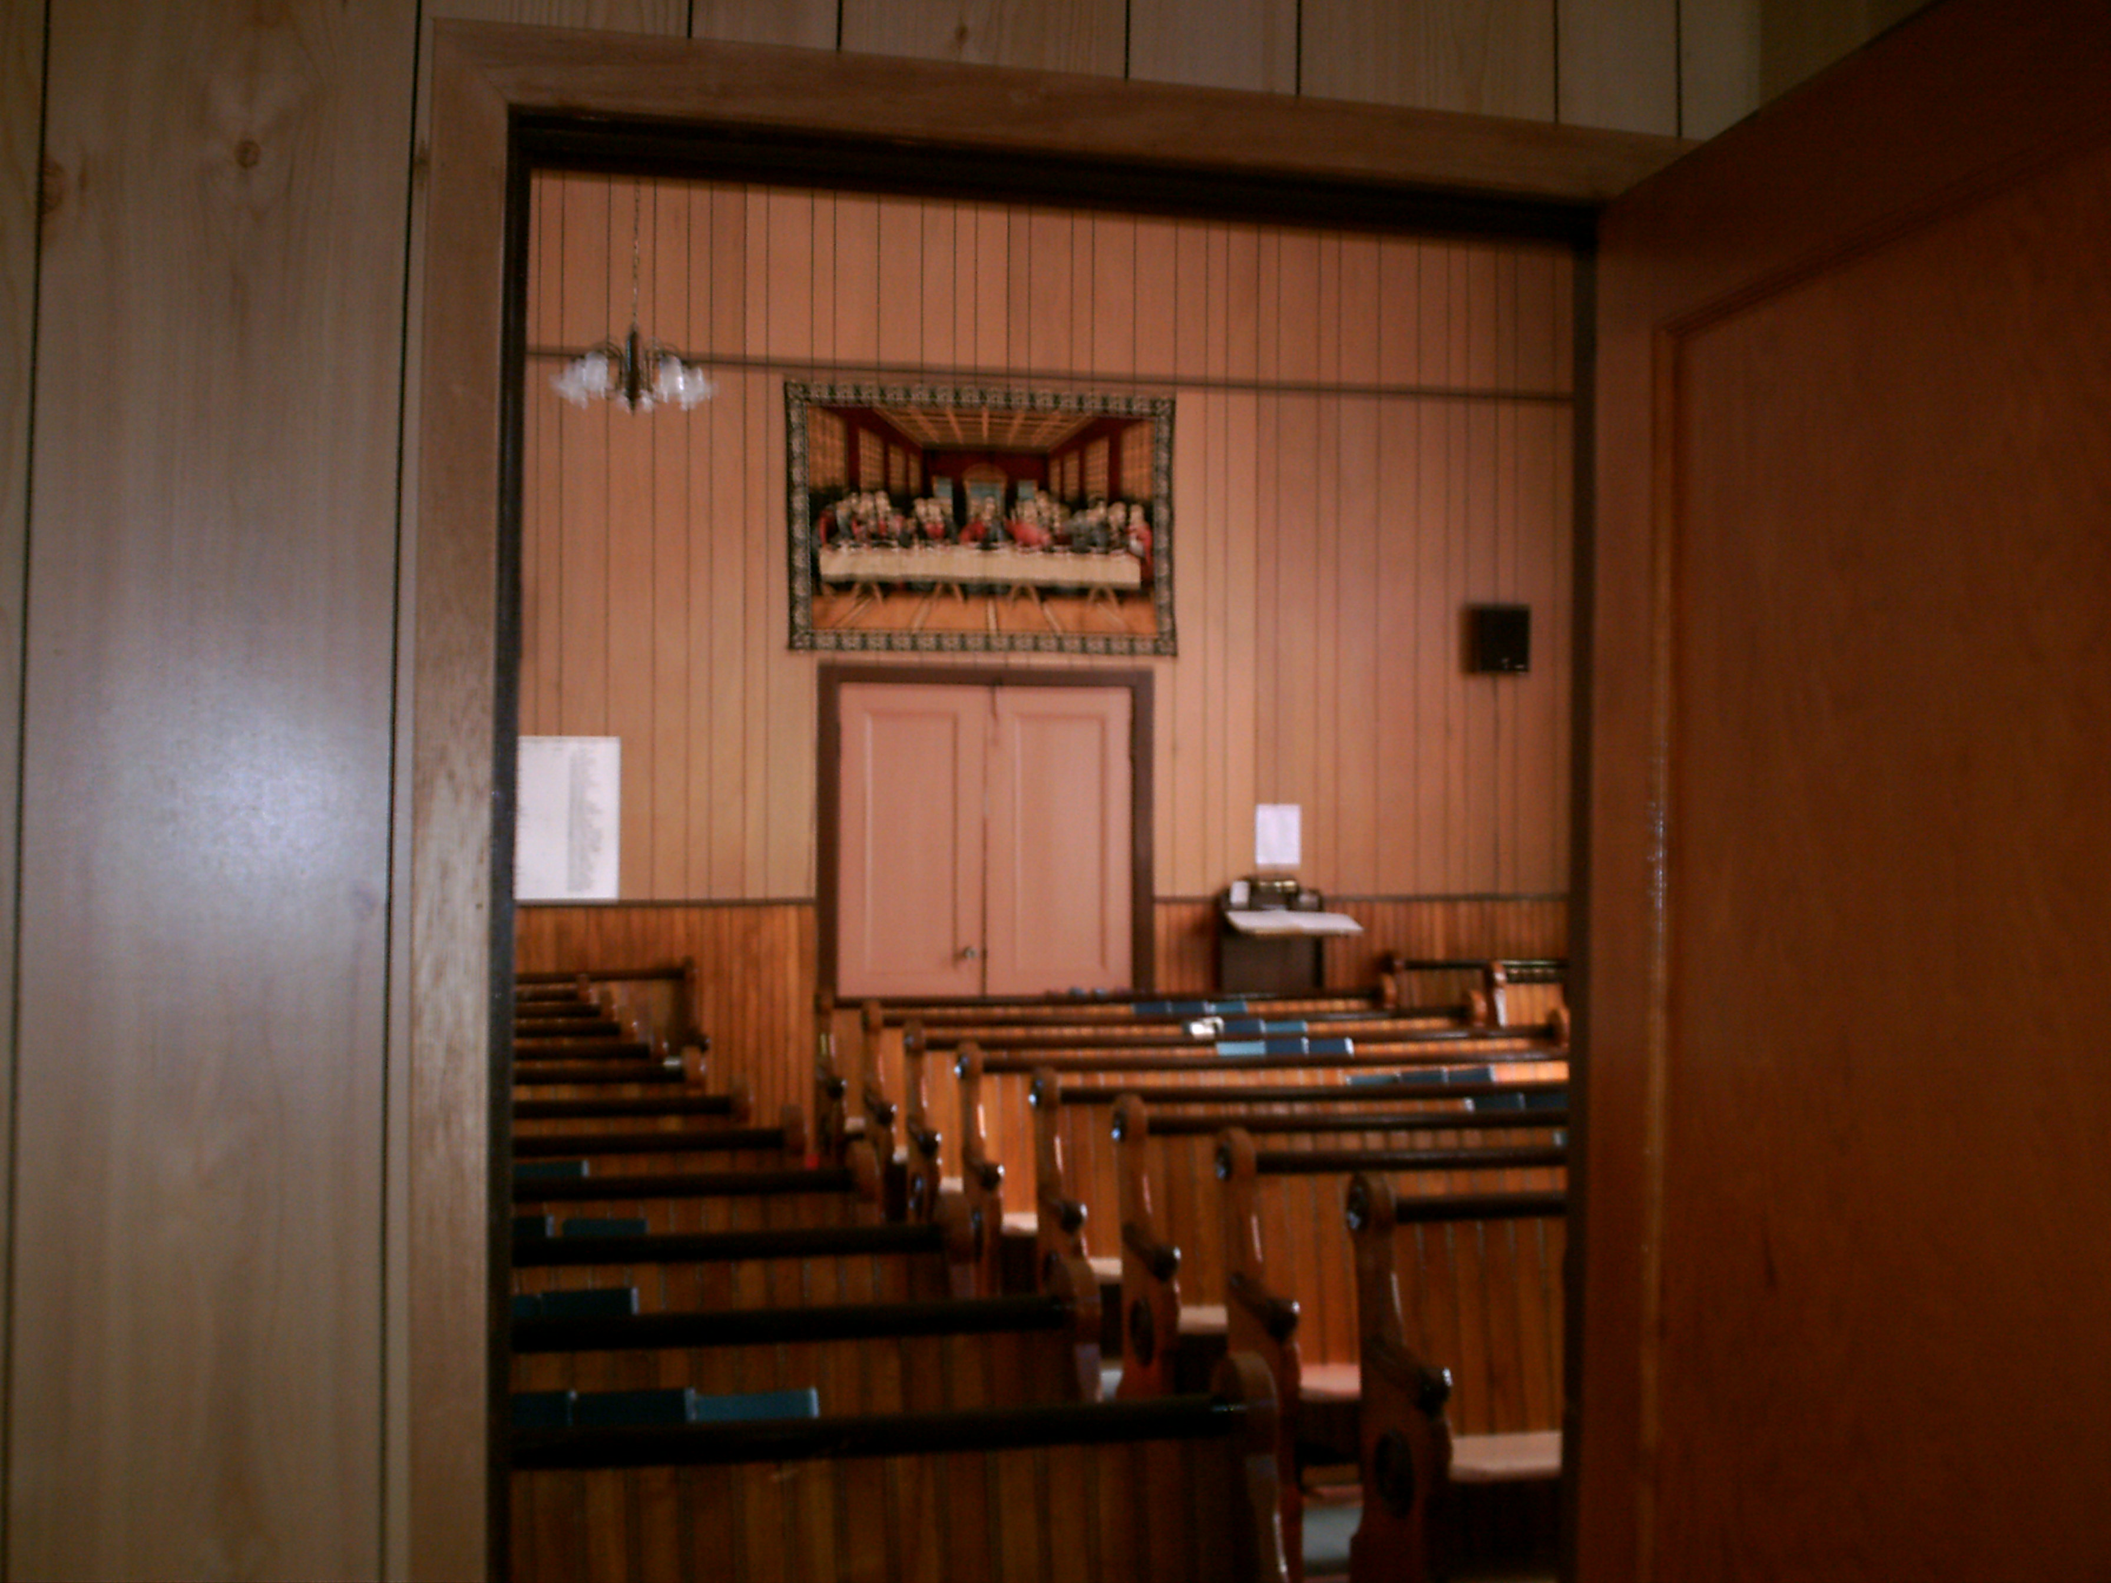
We are thankful for you, and the many ways the life and mission of this congregation is supported through everyone who contributes to our memorial, general and cemetery funds, and especially thankful for those who have taken time, effort, and expense in the upkeep of these facilities for its regular worship & use. God Bless You All


This past year’s Building and Ministry projects:

The sound system is almost complete with one outdoor speaker left to install.

Stones were straightened [some backs were made crooked doing this] and many areas were reseeded.
The rough wooden cross was mounted in the sanctuary.
We were able to support eh work of the Bible School and the Vacation Bible School for over twenty local children.
Thank you for your support that makes this and other work is possible


