
A Christian Family of Faith in Fellowship

The Bass River Pastoral Charge

The Presbyterian Church in Canada
St. Mark’s, Bass River; St. James, Beersville; St. Andrew’s, Clairville & Zion, West Branch
Organists: Heather Morton, Marly Sutherland, Rodney Girvan, Dolly MacDonald, Shanece Wilson
Minister: Rev. Alexander [Sandy] D. Sutherland; B.A., B.Th. M.Div
Manse #: 506-785-4383 Cell #: 506-521-0705 Email: thebrpc@gmail.com Twitter: thebrpc
www.pccweb.ca/brpc

ORDER OF SERVICE
November 2nd 2014 – Pentecost – All Saints
Welcome & Announcements
Call to Worship A&D 12 Be Glorified
In my life Lord; Be glorified, be glorified
In my life, Lord; Be glorified today.

In Your church, Lord; Be glorified, be glorified
In Your church, Lord; Be glorified today.

In my heart, Lord; Be glorified, be glorified
In my heart, Lord; Be glorified today.

In my praise, Lord; Be glorified, be glorified
In my praise, Lord; Be glorified today.

Prayer of Approach, Confession & the Lord’s Prayer (debts & debtors NBoP831; BoP605)

Opening Praise: BoP 233 Love divine all loves excelling

Responsive Reading - Psalm 43 [pew Bible]
¹ Vindicate me, O God,
and plead my cause against an ungodly nation;
rescue me from deceitful and wicked men.
² You are God my stronghold.
Why have you rejected me?
Why must I go about mourning,
oppressed by the enemy?
³ Send forth your light and your truth,
let them guide me;
let them bring me to your holy mountain,
to the place where you dwell.
⁴ Then will I go to the altar of God,
to God, my joy and my delight.
I will praise you with the harp,
O God, my God.
⁵ Why are you downcast, O my soul?
Why so disturbed within me?
Put your hope in God,
for I will yet praise him,
my Saviour and my God.

Children’s story –
Children’s Hymn BoP 251 Come, children join to sing

Scripture Readings: OT – Joshua 3:7-17
⁷And the LORD said to Joshua, “Today I will begin to exalt you in the eyes of all Israel, so they may know that I am with you as I was with Moses. ⁸Tell the priests who carry the ark of the covenant: ‘When you reach the edge of the Jordan’s waters, go and stand in the river.’”
⁹Joshua said to the Israelites, “Come here and listen to the words of the LORD your God. ¹⁰This is how you will know that the living God is among you and that he will certainly drive out before you the Canaanites, Hittites, Hivites, Perizzites, Girgashites, Amorites and Jebusites. ¹¹See, the ark of the covenant of the Lord of all the earth will go into the Jordan ahead of you. ¹²Now then, choose twelve men from the tribes of Israel, one from each tribe. ¹³And as soon as the priests who carry the ark of the LORD—the Lord of all the earth—set foot in the Jordan, its waters flowing downstream will be cut off and stand up in a heap.”
¹⁴So when the people broke camp to cross the Jordan, the priests carrying the ark of the covenant went ahead of them. ¹⁵Now the Jordan is at flood stage all during harvest. Yet as soon as the priests who carried the ark reached the Jordan and their feet touched the water’s edge, ¹⁶the water from upstream stopped flowing. It piled up in a heap a great distance away, at a town called Adam in the vicinity of Zarethan, while the water flowing down to the Sea of the Arabah (the Salt Sea£ ) was completely cut off. So the people crossed over opposite Jericho. ¹⁷The priests who carried the ark of the covenant of the LORD stood firm on dry ground in the middle of the Jordan, while all Israel passed by until the whole nation had completed the crossing on dry ground.

Epistle – 1 Thessalonians 2:9-13
⁹Surely you remember, brothers, our toil and hardship; we worked night and day in order not to be a burden to anyone while we preached the gospel of God to you.
¹⁰You are witnesses, and so is God, of how holy, righteous and blameless we were among you who believed. ¹¹For you know that we dealt with each of you as a father deals with his own children, ¹²encouraging, comforting and urging you to live lives worthy of God, who calls you into his kingdom and glory.
¹³And we also thank God continually because, when you received the word of God, which you heard from us, you accepted it not as the word of men, but as it actually is, the word of God, which is at work in you who believe.

Hymn of Illumination: BoP 232 Breathe on me breath of God

Scripture Readings: Gospel – Matthew 23:1-12
¹Then Jesus said to the crowds and to his disciples: ²“The teachers of the law and the Pharisees sit in Moses’ seat. ³So you must obey them and do everything they tell you. But do not do what they do, for they do not practice what they preach. ⁴They tie up heavy loads and put them on men’s shoulders, but they themselves are not willing to lift a finger to move them.
⁵“Everything they do is done for men to see: They make their phylacteries£ wide and the tassels on their garments long; ⁶they love the place of honor at banquets and the most important seats in the synagogues; ⁷they love to be greeted in the marketplaces and to have men call them ‘Rabbi.’
⁸“But you are not to be called ‘Rabbi,’ for you have only one Master and you are all brothers. ⁹And do not call anyone on earth ‘father,’ for you have one Father, and he is in heaven. ¹⁰Nor are you to be called ‘teacher,’ for you have one Teacher, the Christ.£ ¹¹The greatest among you will be your servant. ¹²For whoever exalts himself will be humbled, and whoever humbles himself will be exalted.

Sermon: The Hope and the Win
It was a Sunday morning very unlike today. It was a gorgeous Sunday, with a warm gentle breeze, a bright sun, the ground was dry and the air was fresh and sweet. The congregation gathered in the little country church, they began their worship, and when they got to time in the worship service when they took up the offering, just before the minister would give his sermon he held up three bundles of paper:
“This first sermon is an hour long, it has no jokes, and no illustrations.”
“However . . . this second sermon begins and ends with a joke, has a neat story in the middle, and is twenty minutes long, but I will only give THIS one instead for five hundred dollars”
“However . . . this third sermon” and he holds up just a couple of sheets of paper, “is just five minute long, its funny and has a cute story too, but only for a thousand dollars.”
Then he turned to the deacon and said, “We will now take up the collection.”
Some Sundays it can seem like the minister and the time of worship that we make week to week, holds us hostage for an hour, or so, from all the things we could be doing, or that we’d perhaps rather be doing. On a day like today in this nice warm building, with these nice friends, it is doesn’t seem so bad to sit together for a while and sing some songs and listen to the bible being read, even to hear a sermon. But other Sundays, those Sundays where summer is at its best, worship can almost feel like a prison, or a burden.
The apostle Paul puts this wonderful note in his letter to the Thessalonian church. It is the kind of note you or I might leave if we stayed with a friend or a member of the family saying: “I hope I was not to much of a bother. I hope you were not put out for hosting me.”
We put some hope in not getting in each others’ way, and we try our best not to interfere with each other, but on the other hand sometimes we do need to be inconvenienced, sometimes we do need to be burdened with each others lives, worries, time, sorrows. Paul says, “we worked night and day in order not to be a burden to anyone while we preached the gospel of God to you.”
And that is interesting because when you share the gospel in Christ you are inconveniencing every sinner who is content in their sin. When you share the message from worship on Sunday with those who chose not to attend; who are worshiping their sheets, their ‘me’ time, their Sunday programming, or their weekend hangover, then you are putting a burden on them when you share the gospel of Christ. Jesus said “my yoke is easy”, not ‘my yoke doesn’t exist at all.’ Having hope means taking up the cross of trust in God and faith in Christ.
What has been observed about hope is that it is a hard thing to see or understand in the middle of everything going right in our life. It is hard to understand what the rich or simply the content would want to hope for; ‘more of the same?!’ But when confronted for a time without hope, what is the answer to the hope? What is its fulfillment? What does hopelessness look like for you?
The past few weeks have been a lesson in hope for our region, and for our nation – especially for law enforcement. The Moncton Shooter was sentenced this week, a sentence that is a new precedent in Canadian law. Some people were hoping for a sentence that was not possible; yes there are people who still hope for the death penalty in cases like this; and as much as I understand I don’t agree [but that’s a whole other sermon]. But I think a lot of people hoped for a long sentence. I think a lot of people wanted the guilty party, even though he admitted his guilt, has had no other major offences, he was given the heaviest sentence in Canadian history since the death penalty was abolished, and our judiciary has decided to ‘lock him up and throw away the key.’
Our burden seems to have been lifted, yes we will be paying for his prison cell for a long time, but in doing that we prove that our society, that Canadian law is better than his sense of justice. But Canadian justice is not perfect either. He has taken hope from a family. He has taken hope from a community. So in return we took hope from him. He will not live to be free. He has no hope for that. Where will he find hope? Do you hope for his hope? Can you?
I think that though justice may be served in this sentence we must be careful on this path. Hear the words of the psalmist: “Vindicate me, O God, and plead my cause against an ungodly nation; rescue me from deceitful and wicked men.”
When we hope for what we hope for, we are cautioned about where we stand, and what our hopes mean to in the lives of others.
I don’t play the lotto. I have actually gone so far as to challenge people to show me where in the bible it specifically speak against playing the lotto. It doesn’t specifically. But we are cautioned about putting our hopes on things, putting our hope on money, or on stuff. We put our hope in the Lord. All these other things, if they are not a means of drawing close to God can become a barrier between us and each other, and even more between us an God. When we put hope in the lotto, we are hoping that we will gain, but we are also hoping that many other people will lose. Something to consider.
While visiting a Swiss town, an American businessman watched a man painstakingly carving the casing for one of the fine cuckoo clocks made in that region.
Noting the slow rate of progress, the businessman said, "My good man, you'll never make much money that way."
"Sir," the clock-maker replied, "I'm not making money, I'm making cuckoo clocks."
All last night I had hope that the weather would be clear enough that we could come together for worship today. I had hope and I said a prayer. It is good, when the weather starts getting really nasty, and it is hard to get out for anything, it is good to get out for worship and the fellowship that comes with our time together here. It was good for the prayer to be answered in this way instead of the perfectly beautiful kind of day mentioned in the
With the weather turning we can begin ti get the feeling that we are couped up. But can you really be couped up if you are with God. Being in the fortress of God means you are in the company of all eternity and of all power.
Hear the psalmist ask the question: “Why have you rejected me?” Does God ever leave us or forsake us. No, the promise we have in Christ is that he will never leave us or forsake us. When we feel some rejection regarding God, it is best to first see how we have rejected God, how we have forsaken hope.
For the light of God shines in the midst of God’s people, as we draw close to God in this holy place and in all the paces where God’s love dwells. We have come to the alter of God today, not this place or any of its fixtures, but to the sanctuary of a faith that you share with these others gathered. We do not believe all by ourselves, but we celebrate the faith we share as we get ready to go forth and proclaim it in service; offer hope in the love in the Lord, through Jesus Christ our Saviour and our God.

Announcements:
Remembrance Memorial Next Sunday, as we begin our regular worship services, we will begin with an Act of Remembrance.
Remembrance Day Rev. Sutherland will be offering the reflection at the Remembrance day service in Harcourt at the Legion this year.
Pamphlet – Please take a copy of our Autumn Activities for visitors and friends and help grow the church in its work, mission and programs.
Programs & Activities: Please pray for our ongoing work & learning
Card making Class –Bev Dunn will be hosting a card making classes Thursday mornings 9:30am 11:30am through the month of November. 6$ for materials all provided 785-4426; 3199 Route 465, Beersville
November Craft Sale – There will be a craft & Bake sale at St Mark’s Hall on Saturday November 22nd starting at 11am.
Bible Study A nativity bible study will be hosted in Harcourt at the home of Dave & Shelley Cail 10am. Starting November 4th [skipping the 11th] and then for the rest of the month.
PARTY! – The Rexton Lion Nursing home will be hosting their annual residents Christmas party on December 7th 1pm, all are invited
A Living Nativity – The Nativity will be presented on December 7th, at 6:30 pm at Bonnielm Farms [Ford Bank, Route 470 - ] Refreshments at the ‘Inn’, donation will be received at the census table, Come to Bethlehem and see . . .
Christmas Coral Concert – The Rexton Community Choir will be putting on a Christmas concert December 13th as an evening gala, tickets $10, proceeds to support the St. Andrew’s restoration project.
Poutine Rapėe – Available through Ste. Paul’s Catholic Church, St. Paul’s contact Rosa by the 27th of Nov. for orders
Community Food Bank – Think about what you will be planting in your garden. Can you plant extra carrots? Potatoes? Let’s all help with what we have

Prayer of Thanksgiving and Intercession

God’s Tithes and our gifts
Doxology (NBoP 830; BoP 603) & Offertory Prayer

Commissioning Hymn: BoP 480 Who is on the Lord’s side

Benediction

Dismissal: A&D 28 We celebrate the gifts we share [Martyrdom; BoP 13]
We celebrate the gifts we share,

In service we proclaim
Our Saviour Christ who for us died
To wash away sin’s stain.

By faith we go and labour on,
Through tasks God’s Word reveals;
Amidst the joy of worship done,
To wonder as He heals.
If you are visiting, or are new to the community we would like to getting to know you, and celebrating your gifts and growing together in our faith in Christ. God bless you.

Next week’s Services
9:30am – Zion Presbyterian Church (West Branch)
11:00am – St. James’ Presbyterian Church (Beersville)
Next week’s Readings: Deuteronomy 34, Psalm 1, 1 Thess. 2:1-8, Matthew 22:34-46
.
Givings – Your offerings & gifts support the work of this congregation, the teaching of our children, the expenses of ministry, local and foreign mission, the work of Presbyterian Sharing and upkeep of this building. Tax receipts available. Please remember that through the winter season especially the expenses of our pastoral charge and our buildings continue even if weekly worship is cancelled.
Prayers of the Pastoral Charge - Do you have a prayer, or know someone we should be praying for? Pray, as we support each other in faith, hope & love. Our Prayers are for: Savannah, Carmen, Joe, Percy, Althea, Edna, Ruby & Angus, Tara & Marc and little Jaxson, Jessie, Paul, Gary,
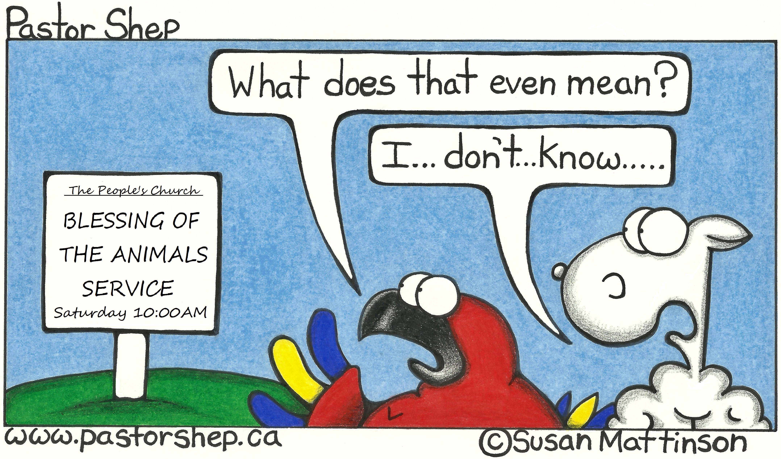
Mission Moments Meeting one another Face to Face! The Youth in Mission program with Presbyterians Sharing brought 14 young people from PCC’s partner churches in Malawi, Taiwan, Ukraine and Nicaragua to Canada for three weeks. The group visited churches and sites in Nova Scotia, PEI and Ontario and attended the Canada Youth conference. They talked to people in congregations about the joys and challenges they are facing in their own countries, and heard stories about church life in Canada. They celebrated, sang, danced and worshipped with 500+ young people at Canada Youth. Friendships were made, faith and partnerships were strengthened, and lives were changed, thanks to your! Thank You!

Sign behind an Amish carriage: Energy efficient vehicle. Runs on grass and oats. Extreme caution: Avoid exhaust.

