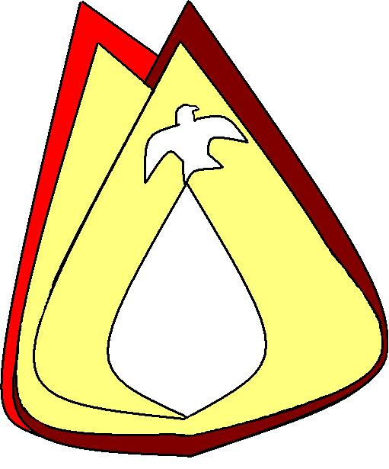
A Christian Family of Faith in Fellowship

The Bass River Pastoral Charge

The Presbyterian Church in Canada
St. Mark’s, Bass River; St. James, Beersville; St. Andrew’s, Clairville & Zion, West Branch
Organists: Heather Morton, Marly Sutherland, Rodney Girvan, Dolly MacDonald, Shanece Wilson
Minister: Rev. Alexander [Sandy] D. Sutherland; B.A., B.Th. M.Div
Manse #: 506-785-4383 Cell #: 506-521-0705 Email: thebrpc@gmail.com Twitter: thebrpc
www.pccweb.ca/brpc

ORDER OF SERVICE
October 5th 2014 – Pentecost – World Communion Sunday
Welcome & Announcements
Call to Worship A&D 8 Give thanks with a grateful heart
Prayer of Approach, Confession & the Lord’s Prayer (debts & debtors NBoP831; BoP605)
Opening Praise: BoP 567 Come, ye thankful people come
Responsive Reading - Psalm 19 [pew Bible]
¹ The heavens declare the glory of God; the skies proclaim the work of his hands.
² Day after day they pour forth speech; night after night they display knowledge.
³ There is no speech or language where their voice is not heard.
⁴ Their voice goes out into all the earth, their words to the ends of the world. In the heavens he has pitched a tent for the sun,
⁵ which is like a bridegroom coming forth from his pavilion, like a champion rejoicing to run his course.
⁶ It rises at one end of the heavens and makes its circuit to the other; nothing is hidden from its heat.
⁷ The law of the LORD is perfect, reviving the soul.
The statutes of the LORD are trustworthy, making wise the simple.
⁸ The precepts of the LORD are right, giving joy to the heart.
The commands of the LORD are radiant, giving light to the eyes.
⁹ The fear of the LORD is pure, enduring forever.
The ordinances of the LORD are sure and altogether righteous.
¹⁰ They are more precious than gold, than much pure gold; they are sweeter than honey, than honey from the comb.
¹¹ By them is your servant warned; in keeping them there is great reward.
¹² Who can discern his errors? Forgive my hidden faults.
¹³ Keep your servant also from wilful sins; may they not rule over me. Then will I be blameless,
innocent of great transgression.
¹⁴ May the words of my mouth and the meditation of my heart be pleasing in your sight, O LORD, my Rock and my Redeemer.

Children’s story –
Children’s Hymn BoP 378 Jesus loves me

Scripture Readings: OT – Exodus 20:1-20
¹And God spoke all these words:
²“I am the Lord your God, who brought you out of Egypt, out of the land of slavery.
³“You shall have no other gods before£ me.
⁴“You shall not make for yourself an idol in the form of anything in heaven above or on the earth beneath or in the waters below. ⁵You shall not bow down to them or worship them; for I, the Lord your God, am a jealous God, punishing the children for the sin of the fathers to the third and fourth generation of those who hate me, ⁶but showing love to a thousand generations of those who love me and keep my commandments.
⁷“You shall not misuse the name of the Lord your God, for the Lord will not hold anyone guiltless who misuses his name.
⁸“Remember the Sabbath day by keeping it holy. ⁹Six days you shall labor and do all your work, ¹⁰but the seventh day is a Sabbath to the Lord your God. On it you shall not do any work, neither you, nor your son or daughter, nor your manservant or maidservant, nor your animals, nor the alien within your gates. ¹¹For in six days the Lord made the heavens and the earth, the sea, and all that is in them, but he rested on the seventh day. Therefore the Lord blessed the Sabbath day and made it holy.
¹²“Honor your father and your mother, so that you may live long in the land the Lord your God is giving you.
¹³“You shall not murder.
¹⁴“You shall not commit adultery.
¹⁵“You shall not steal.
¹⁶“You shall not give false testimony against your neighbor.
¹⁷“You shall not covet your neighbor’s house. You shall not covet your neighbor’s wife, or his manservant or maidservant, his ox or donkey, or anything that belongs to your neighbor.”
¹⁸When the people saw the thunder and lightning and heard the trumpet and saw the mountain in smoke, they trembled with fear. They stayed at a distance ¹⁹and said to Moses, “Speak to us yourself and we will listen. But do not have God speak to us or we will die.”
²⁰Moses said to the people, “Do not be afraid. God has come to test you, so that the fear of God will be with you to keep you from sinning.”

Epistle – Philippians 3:4-14
If anyone else thinks he has reasons to put confidence in the flesh, I have more: ⁵circumcised on the eighth day, of the people of Israel, of the tribe of Benjamin, a Hebrew of Hebrews; in regard to the law, a Pharisee; ⁶as for zeal, persecuting the church; as for legalistic righteousness, faultless.
⁷But whatever was to my profit I now consider loss for the sake of Christ. ⁸What is more, I consider everything a loss compared to the surpassing greatness of knowing Christ Jesus my Lord, for whose sake I have lost all things. I consider them rubbish, that I may gain Christ ⁹and be found in him, not having a righteousness of my own that comes from the law, but that which is through faith in Christ—the righteousness that comes from God and is by faith. ¹⁰I want to know Christ and the power of his resurrection and the fellowship of sharing in his sufferings, becoming like him in his death, ¹¹and so, somehow, to attain to the resurrection from the dead.
¹²Not that I have already obtained all this, or have already been made perfect, but I press on to take hold of that for which Christ Jesus took hold of me. ¹³Brothers, I do not consider myself yet to have taken hold of it. But one thing I do: Forgetting what is behind and straining toward what is ahead, ¹⁴I press on toward the goal to win the prize for which God has called me heavenward in Christ Jesus.

Hymn of Illumination: BoP 357 For the bread which Thou hast broken

Scripture Readings: Gospel – Matthew 21:33-46
³³“Listen to another parable: There was a landowner who planted a vineyard. He put a wall around it, dug a winepress in it and built a watchtower. Then he rented the vineyard to some farmers and went away on a journey. ³⁴When the harvest time approached, he sent his servants to the tenants to collect his fruit.
³⁵“The tenants seized his servants; they beat one, killed another, and stoned a third. ³⁶Then he sent other servants to them, more than the first time, and the tenants treated them the same way. ³⁷Last of all, he sent his son to them. ‘They will respect my son,’ he said.
³⁸“But when the tenants saw the son, they said to each other, ‘This is the heir. Come, let’s kill him and take his inheritance.’ ³⁹So they took him and threw him out of the vineyard and killed him.
⁴⁰“Therefore, when the owner of the vineyard comes, what will he do to those tenants?”
⁴¹“He will bring those wretches to a wretched end,” they replied, “and he will rent the vineyard to other tenants, who will give him his share of the crop at harvest time.”
⁴²Jesus said to them, “Have you never read in the Scriptures:
“‘The stone the builders rejected has become the capstone the Lord has done this,
and it is marvelous in our eyes’ ?
⁴³“Therefore I tell you that the kingdom of God will be taken away from you and given to a people who will produce its fruit. ⁴⁴He who falls on this stone will be broken to pieces, but he on whom it falls will be crushed.”
⁴⁵When the chief priests and the Pharisees heard Jesus’ parables, they knew he was talking about them. ⁴⁶They looked for a way to arrest him, but they were afraid of the crowd because the people held that he was a prophet.

The Celebration of the Lord’s Supper -
The Sacrament of the Lord’s Supper

The Lord’s Supper
Today we recognize together with the whole of the Church:
The Lord Jesus Christ chose to humbly walk with us.
He has come to dwell with us, to be with us in our lives.
Through Christ we pray; In faith in Him our lives are healed; and through Him our sins are forgiven.
Jesus gave us the witness of his own words and actions, that we might speak and act, seeking understanding and purpose in God.
The only begotten Son of God has come, and facing the curse of our He sin conquered death, that we might know the Full measure of God’s love.
Holy, holy, holy Lord, God of power and might; heaven and earth are full of your glory.
Hosanna in the highest!

The Institution of the Lord’s Supper:
This is the joyful feast of the people of God! Even though it takes place of the shadow of the cross, we celebrate in the light of the resurrection.
We come to this table at Christ’s invitation, given in the grace of the Loving Shepherd who lays down his life for his sheep. The institution of this sacrament belongs to Jesus the Christ, for it is the memorial of Christ’s life, death, and the new life we share in Him.
In the words of the Apostle Paul, we declare this sacrament of our faith to draw from this truth:
“the Lord Jesus on the night when he was betrayed took bread, ²⁴and when he had given thanks, he broke it, and said, “This is my body which is for you. Do this in remembrance of me.” ²⁵In the same way also the cup, after supper, saying, “This cup is the new covenant in my blood. Do this, as often as you drink it, in remembrance of me.” ²⁶For as often as you eat this bread and drink the cup, you proclaim the Lord’s death until he comes.”
Yet the Apostle Paul also gives us this warning:
He says,
²⁷Therefore, whoever eats the bread or drinks the cup of the Lord in an unworthy manner will be guilty of sinning against the body and blood of the Lord. ²⁸A man ought to examine himself before he eats of the bread and drinks of the cup. ²⁹For anyone who eats and drinks without recognizing the body of the Lord eats and drinks judgment on himself.
[1 Corinthians 11:23-29]
This holy meal is a gift to all who confess with heart, and mind, and soul, the living and eternal Christ Jesus is Lord; who by God’s grace and the Holy Spirit’s power, gives us the understanding to know God in faith. Let us then, offer God our confession of faith as we together declare . . .

Confession of faith: [BoP 619; ref NBoP 539]
I believe in God the Father almighty, Maker of heaven and earth:
And in Jesus Christ, His only Son, our Lord, Who was conceived by the Holy Ghost, born of the Virgin Mary, and suffered under Pontius Pilate, was crucified, dead, and buried; He descended into hell. The third day He rose again from the dead; He ascended into heaven, and sits on the right hand of God the Father Almighty; from thence He shall come to judge the quick and the dead.
I believe in the Holy Ghost; the Holy Catholic Church; the communion of saints; the forgiveness of sins; the resurrection of the body; and the life everlasting. AMEN
Communion prayer:
Lord God of all mercy, we bring all of who we are, our very souls hear your call and we are humbled by your grace present here in all its signs. Our spirits are in need of the cleansing that can only come through Christ. May we truly enter into freedom in this time.
Hear our cry for mercy, for in looking for you we lift our eyes to the cross and see the cost of our salvation. Know our cry for peace as we lower our eyes in shame.
Lord, hear our prayer and draw us together in peace.
O Lord, this is your table, and we come seeking your presence; let nothing separate the Lord God and His people.
Lift the gifts of your Holy Spirit - humility, goodness, kindness, self control, knowledge, perseverance, and most of all love - as signs to the world of our faith; as we seek to be more like Christ.
Lord, this bread is made from the grain that you caused to grow and this cup is filled with the fruitfulness of the vine you have sustained. You brought them to this table and now, O Lord, we pray that by your blessing this bread and cup will be renewed as a blessing in their use in the special purpose you have for us in this sacrament.
Help us understand, that in Jesus we must finally see that we are made for more than ordinary purposes.
Let feel the support of the communion of faith in the Church, as we are gathered with all who confess faith in Christ and seek His presence in their life.
O Father in Heaven, by your Holy Spirit, let us be drawn together with you because of Jesus, our Saviour and Lord; who was begotten, who was born, who lived and died, and who is risen, and who is coming again.
In Jesus name we pray, Amen
The Holy Communion of the Lord’s Supper
This is the first table of thanksgiving, and yet this is also a memorial feast. We are gathered by God to this table with the whole Church. We are gathered with all who proclaim Christ, name Him Lord, and in communion with all who rejoice before God in glory.
In accordance with the teaching and direction of the good news in Jesus Christ, we do this:
The Lord Jesus - on the night he was betrayed - took bread, and after giving thanks to God, he broke it and said: “Take, eat, this is my body that is broken for you. This, you do, in remembrance of me.”
Bread distributed to all
When we break the bread it is the sharing in the body of Christ 1 Corinthians 10:16
We eat the bread together
In the same way also Jesus took the cup, After they had sup, and said: “This cup is the new covenant in my blood. Whenever you drink it, do so in remembrance of me”
The cup is shared
In remembrance, let us share the cup of the new covenant.
We drink the cup together
This bread and this cup are a proclamation; by them we declare the power and purpose of the Lord’s death until he comes.
Prayer of Thanksgiving
Loving God, thank you for the assurance of this sacrament of faith, and all the blessings we have received in Jesus Christ, our Lord. We rejoice that we are renewed in our spiritual bond to the whole of your Church through Christ’s sacrifice, here recalled.
Be present Lord as we hear your words given in grace and offered in hope as we move from this sacrament to shared devotion on your Holy Word. Speak to us Lord, and by your Spirit’s grace may we be given new words.
O God, give us the grace to carry Christ’s words into the world in the way we live our faith, as we are lifted up in all manner of being, because of Christ, through the Holy Spirit in your love:
Jesus, Lamb of God, have mercy on us
Jesus, bearer of our sins, have mercy on us
Jesus, redeemer of the world, grant us your peace.
Amen

Sermon: Heirs welcomed to the table
We came to this table, and I have to ask, did you stop to ask whether we should receive the sacrament? I do, every time, and every time I get the same answer. And it is a hard answer.
We have a bumpy history when it comes to the Sacrament of the Lord’s Supper and communion. There was a time when if you were not of a certain class, or status, and that was even if you were of the right religion, you could not receive this sacrament. If you were a woman, in some communities in some countries, over certain periods of time this sacrament was barred – at least in public worship. There was a time when you could arrange for this sacrament all by yourself, of for just your family which was a rather ironic sense of communion.
There was a time that if you were behind in your tithing you could not receive the sacrament, and for that matter, be married, buried or have family members baptized. If you had not attended church you were given an exam before you could receive the bread and wine. I promised you a few years ago that I would not give you a pop quiz on Sunday again and as always I am a man of my word.
Yet we all should know that there was a time that you knew where you stood in the church because the leadership of the church told you when you did or did not deserve and were entitled to receive the church’s sacraments, because for them and then they were just that ‘the church’s sacraments’; instead of what we know these ceremonies to be, that these are the sacraments that have been given to the church by Christ. Christ speaks to each soul, and while none of us deserve to be hear, or have earned the right to the sacrament, we can all receive it as the gift it is meant to be.
Many things have been given to God’s people throughout the ages. God started with our very breath of life which was followed by putting the whole world under our dominion. Now to clarify dominion – a very regal sounding word – what the Hebrew word ‘memshalah’ means is not simply dominion, as in dominant control, but governance through rules, as the dominion of a steward [not a tyrant]. And to that end, God gave us rules, the laws through Moses and God established the gift of the Laws with the governing under judges and prophets, whom God gave His people to help with the understanding and applying of the Laws of God.
God chose a people and gave them the a land to work these things out for themselves. We rejoice because God’s chosen people were chosen to be a gift to the world; so that through them the whole world would feel closer to God. Through the people of God, through the prophets of God, through the word of God, we have been given promises. The sacraments of the church are about those promises, and the fulfillment of the promises is the one who gave us the sacraments of our faith. There, the Old Testament in under five minutes.
Jesus, he is the promises fulfilled. He is the Law fulfilled. Is is every word the prophets spoke. He is ever miracle ever made. He was there with the Holy Spirit at the creation of everything and everything that is was made through Him. It is because Jesus was there for and before all the gifts of God that everything, you, me, our ancestors, our children and all creation can be saved through Him. No one and nothing else would ever do what Jesus did. No one and nothing could.
But what then, we are saved through his sacrifice, is that it? Is that what this table is about? If that was it then Jesus would have died for us and that would have been the end of it. But there, at what many people might call the beginning of Jesus ministry, and where Mark begins his gospel, Jesus is baptized by John [so we call him the Baptist]. That baptism changes what baptism is going to be and what it is going to mean because Jesus makes a new baptism, and that baptism is one that is not just water. Water we can see, we can pour out, we can capture, we can direct, we can control, but the new baptism that comes with Jesus is not just water, it is in the Holy Spirit.
There is more going on then just bread and juice, and prayers, and long liturgies when we celebrate the Lord’s supper. We are gathered at a spiritual feast that is for heirs only. Who is an heir? All who are baptized are heirs. Are the heirs because of water, because of other prayers and other words?
Sometimes in order to see the truth, you have to see with more than your eyes, even more than your imagination, because truth is only known through faith. You can be presented with the facts on anything, but unless you believe me I can tell you the truth until I am blue in the face, and it will not make a bit of difference.
The lies of the world tell us that we have got it figured out, and we can earn greatness, take a pill to ease our pain, buy something to feel better, none of it lasts. Next week, next month, next year we end up just as empty and searching as we were before, and if there’s good marketing around, well we might get suckered in again.
Broken bread, because his body was broken. Juice, because his blood was spilled. Water, because to come under the water is to face his death and the let it was over us is to be joined with Christ in everlasting life. You could say it is just a symbol, like Jesus parables and miracles, but we call them sacraments because they are something more then just symbols.
The minute you try and take a sacrament to mean what you want it to mean, it stops being a sacrament. Luke’s gospel even says that to take a sacrament in a wrong way it to eat and drink judgment to yourself. Like all the gifts that have come from God, these sacraments are meant to remind you, they are mean to draw you closer. When you can only think about the bread and the cup in relation to Jesus, and when you try to live out the promises made in your baptism and in the baptisms you have been a part of, then you are not trying to make the sacraments into what you want them to be, but are receiving them as they gift that they are.
Like the thieves who could not steal the vineyard, you cannot steal your status as an heir in God’s kingdom. God has sent, into this house of worship, and into this fellowship here the Holy Spirit who through Christ is meant to inspire and strengthen us. Our sin, like those wicked thieving stewards, is what put prophets under the stone and Christ to the cross, but that is not the end. If the cross was the end, if the grave was the last line in the gospel, then this would be bread and juice and that would be a basin of water, but that is not the end is it. Our sin could not defeat him, the grave is not the end.
Look in this cup, it is not blood and it is not Christ, but is the cup of the new covenant, the new and everlasting promise through him for our salvation. This looks like bread, it is bread, and is it Christ, no. But by it God has chosen to engraft us – to make us a part of one body in Christ the Church that is called the bride of Christ. Water, well it would be just getting wet if Christ had not said , “Go therefore and make disciples of all nations, baptizing them in the name of the Father and the Son and the Holy Spirit.
We live in a world where people want to have the greatest things that can be bought sought or acquired in their possession, yet where is the line up for this. If you knew someone in your life who had pulled away from Christ and all His promises, wouldn’t you want to help them out? If it were you, wouldn’t you want someone to come to your rescue?

Prayer of Thanksgiving and Intercession

Announcements:
Celebration of the Lord’s Supper – On Sundays October 5th & 12th our church communities will be celebrating the Lord’s Supper as a part of worship. There will be a special pair of sermons about the sacraments and how to make them a part of every day living.
Baptism – we also look forward to a baptism at Clairville on Oct. 19th
Pamphlet – Please take a copy of our Autumn Activities for visitors and friend and help grow the church in its work, mission and programs.
Programs & Activities: Please pray for our ongoing work & learning
Card making Class – Get a start on your Christmas cards and give them that personal touch. Bev Dunn will be hosting a card making classes Thursday mornings 9:30am 11:30am through the month of October. 6$ for materials all provided 785-4426; Route 465, Beersville
Fire Department – This is fire prevention week. Next Saturday the Beersville Fire Department will be having an open house with safety demonstrations, fun games and activities for the kids including a bouncy house and mini fire truck.
Bible Study The Bible study is looking for members and a host(ess).
Community Food Bank – Well, harvest has come, but do you know who has an empty plate? Make your table a little bigger. Let’s all help with what we have.
Givings Your offerings & gifts support the work of this congregation, the teaching of our children, the expenses of ministry, local and foreign mission, the work of Presbyterian Sharing and upkeep of this building. Tax receipts are available.

God’s Tithes and our gifts
Doxology (NBoP 830; BoP 603) & Offertory Prayer

Commissioning Hymn: NBoP 570 For the fruits of His creation

Benediction

Dismissal: A&D 25 Midst prayers of thanks

Next week’s Services
9:30am – Zion Presbyterian Church (West Branch)
11:00am – St. James’ Presbyterian Church (Beersville)

Next week’s Readings: Numbers 21, Psalm 98, 1 Cor 1:18-24, John 3:13-17

Together we rejoice in the fulfillment of faith, Christ Jesus. As God’s people we seek to welcome others knowing that there are many who seek to belong. God’s Holy Spirit draws us together, to search and encourage each other’s calling and purpose. If you are visiting, or are new to the community we would like to getting to know you, and celebrating your gifts and growing together in our faith in Christ. God bless you.
Prayers of the Pastoral Charge - Do you have a prayer, or know someone we should be praying for? Pray, as we support each other in faith, hope & love. Our Prayers are for: Savannah, Carmen, Joe, Janet, Percy, Marilyn, Ruby, Edna, Althea, Susie, Charlie & St. James’, Port Elgin
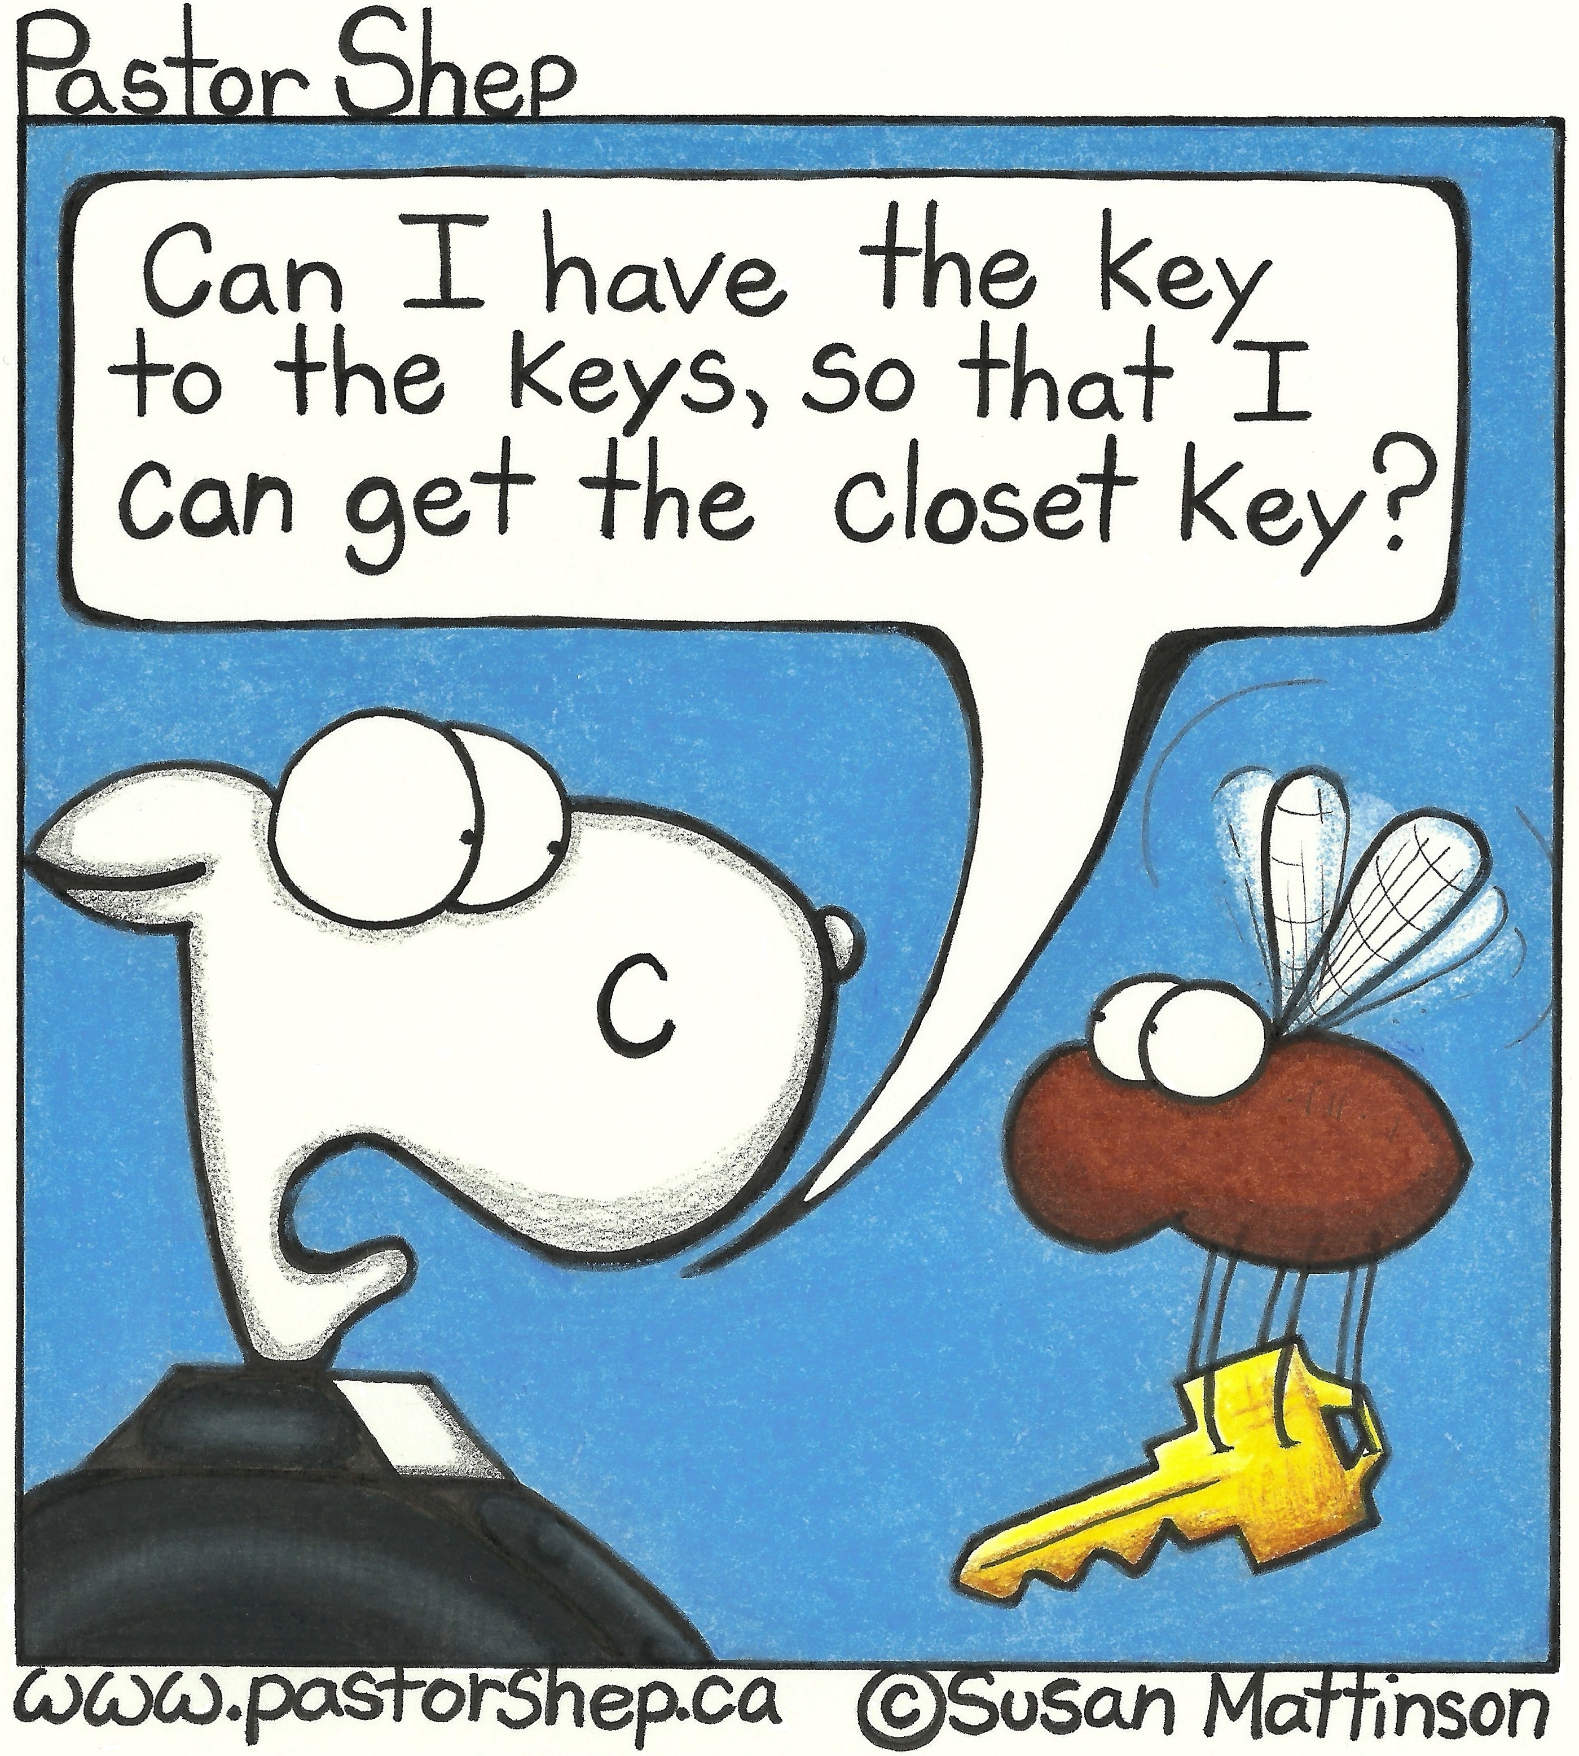
Mission Moments Transcribing church history in Taiwan Presbyterians Sharing supports Louise Gamble as she works with our partner church, The Presbyterian Church in Taiwan, to transcribe and translate reports and correspondence of the Canadian Presbyterian North Formosa (Taiwan) Mission. This includes over 7000 documents from 1868 to 1923. This is now complete, and Louise and her colleague, Mr. Chen Kuan-chou, are working on translation. Documents will be divided into three volumes, the first of covering the life of the first Canadian missionary to Taiwan, the Rev. Dr. George Leslie MacKay. These documents are records of the development of the Christian Church (at that time only Presbyterian) in North Formosa, from the point of view of its missionaries.

