A Christian Church, A Family of Faith

The Bass River Pastoral Charge

The Presbyterian Church in Canada
St. Mark’s, Bass River; St. James, Beersville; St. Andrew’s, Clairville & Zion, West Branch
Organists: Heather Morton, Marly Sutherland, Rodney Girvan, Dolly MacDonald, Shanece Wilson
Minister: Rev. Alexander [Sandy] D. Sutherland; B.A., B.Th. M.Div
Manse #: 506-785-4383 Cell #: 506-521-0705 Email: thebrpc@gmail.com Twitter: thebrpc
www.pccweb.ca/brpc

August 18th 2013 - Pentecost

ORDER OF SERVICE
Welcome
Call to Worship A&D 16 Lead me Jesus/Open my eyes

Prayer of Approach & Confession & The Lord’s Prayer (debts, debtors NBoP 831; BoP 605)
Opening Praise: NBoP 497 Word of God across the ages
BoP 291
Responsive Reading - Psalm 80 [Pew Bible]
¹ Give ear, O Shepherd of Israel, thou that leadest Joseph like a flock; thou that dwellest between the cherubims, shine forth.
² Before Ephraim and Benjamin and Manasseh stir up thy strength, and come and save us.
³ Turn us again, O God, and cause thy face to shine; and we shall be saved.
⁴ O LORD God of hosts, how long wilt thou be angry against the prayer of thy people?
⁵ Thou feedest them with the bread of tears; and givest them tears to drink in great measure.
⁶ Thou makest us a strife unto our neighbours: and our enemies laugh among themselves.
⁷ Turn us again, O God of hosts, and cause thy face to shine; and we shall be saved.
⁸ Thou hast brought a vine out of Egypt: thou hast cast out the heathen, and planted it.
⁹ Thou preparedst room before it, and didst cause it to take deep root, and it filled the land.
¹⁰ The hills were covered with the shadow of it, and the boughs thereof were like the goodly cedars.
¹¹ She sent out her boughs unto the sea, and her branches unto the river.
¹² Why hast thou then broken down her hedges, so that all they which pass by the way do pluck her?
¹³ The boar out of the wood doth waste it, and the wild beast of the field doth devour it.
¹⁴ Return, we beseech thee, O God of hosts: look down from heaven, and behold, and visit this vine;
¹⁵ And the vineyard which thy right hand hath planted, and the branch that thou madest strong for thyself.
¹⁶ It is burned with fire, it is cut down: they perish at the rebuke of thy countenance.
¹⁷ Let thy hand be upon the man of thy right hand, upon the son of man whom thou madest strong for thyself.
¹⁸ So will not we go back from thee: quicken us, and we will call upon thy name.
¹⁹ Turn us again, O LORD God of hosts, cause thy face to shine; and we shall be saved.
KJV
P_____________
¹ Hear us, O Shepherd of Israel, you who lead Joseph like a flock;
you who sit enthroned between the cherubim, shine forth
² before Ephraim, Benjamin and Manasseh.
Awaken your might;
come and save us.
³ Restore us, O God; make your face shine upon us, that we may be saved.
⁴ O LORD God Almighty,
how long will your anger smoulder against the prayers of your people?
⁵ You have fed them with the bread of tears; you have made them drink tears by the bowlful.
⁶ You have made us a source of contention to our neighbours, and our enemies mock us.
⁷ Restore us, O God Almighty;
make your face shine upon us, that we may be saved.
⁸ You brought a vine out of Egypt; you drove out the nations and planted it.
⁹ You cleared the ground for it, and it took root and filled the land.
¹⁰ The mountains were covered with its shade, the mighty cedars with its branches.
¹¹ It sent out its boughs to the Sea, its shoots as far as the River.
¹² Why have you broken down its walls so that all who pass by pick its grapes?
¹³ Boars from the forest ravage it and the creatures of the field feed on it.
¹⁴ Return to us, O God Almighty! Look down from heaven and see!
Watch over this vine,¹⁵ the root your right hand has planted,
the son you have raised up for yourself.
¹⁶ Your vine is cut down, it is burned with fire; at your rebuke your people perish.
¹⁷ Let your hand rest on the man at your right hand, the son of man you have raised up for yourself.
¹⁸ Then we will not turn away from you; revive us, and we will call on your name.
¹⁹ Restore us, O LORD God Almighty; make your face shine upon us, that we may be saved.
NIV

Children’s story –
Children’s Hymn: NBoP Those who wait on the Lord
Insert
Those who wait on the Lord John L. Bell (Iona Community) revised

Those who wait on the Lord shall renew their strength;
They shall rise upon wings as eagles;
They shall run and not be weary, they shall walk and not faint:
Help us Lord, Help us Lord in your way.

Those who serve the suffering world shall renew their strength;
They shall rise upon wings as eagles;
They shall run and be not weary, they shall walk and not faint:
Help us Lord, Help us Lord in your way.

Those who live the risen life shall renew their strength;
They shall rise upon wings as eagles;
They shall run and be not weary, they shall walk and not faint:
Help us Lord, Help us Lord in your way.

Those who love the Mystery shall renew their strength;
They shall rise upon wings as eagles;
They shall run and be not weary, they shall walk and not faint:
Help us Lord, Help us Lord in your way.

Those labour till the end shall renew their strength;
They shall rise upon wings as eagles;
They shall run and be not weary, they shall walk and not faint:
Help us Lord, Help us Lord in your way.
D Bm F#m Bm
Those who wait on the Lord shall renew their strength;
Em7 A7sus4-3 D D7
they shall rise upon wings as eagles;

G A7/G F#m7 Bm
they shall run and not be weary, they shall walk and not faint:
G6 A7 D
help us Lord, Help us Lord in your way.
Scripture Readings:
OT – Isaiah 5:1-7
¹Now will I sing to my wellbeloved a song of my beloved touching his vineyard. My wellbeloved hath a vineyard in a very fruitful hill: ²And he fenced it, and gathered out the stones thereof, and planted it with the choicest vine, and built a tower in the midst of it, and also made a winepress therein: and he looked that it should bring forth grapes, and it brought forth wild grapes. ³And now, O inhabitants of Jerusalem, and men of Judah, judge, I pray you, betwixt me and my vineyard. ⁴What could have been done more to my vineyard, that I have not done in it? wherefore, when I looked that it should bring forth grapes, brought it forth wild grapes? ⁵And now go to; I will tell you what I will do to my vineyard: I will take away the hedge thereof, and it shall be eaten up; and break down the wall thereof, and it shall be trodden down: ⁶And I will lay it waste: it shall not be pruned, nor digged; but there shall come up briers and thorns: I will also command the clouds that they rain no rain upon it. ⁷For the vineyard of the LORD of hosts is the house of Israel, and the men of Judah his pleasant plant: and he looked for judgment, but behold oppression; for righteousness, but behold a cry.
KJV
P_____________
¹ I will sing for the one I love a song about his vineyard:
My loved one had a vineyard on a fertile hillside.
² He dug it up and cleared it of stones
and planted it with the choicest vines.
He built a watchtower in it and cut out a winepress as well.
Then he looked for a crop of good grapes, but it yielded only bad fruit.
³ “Now you dwellers in Jerusalem and men of Judah,
judge between me and my vineyard.
⁴ What more could have been done for my vineyard
than I have done for it?
When I looked for good grapes, why did it yield only bad?
⁵ Now I will tell you what I am going to do to my vineyard:
I will take away its hedge, and it will be destroyed;
I will break down its wall, and it will be trampled.
⁶ I will make it a wasteland, neither pruned nor cultivated,
and briers and thorns will grow there.
I will command the clouds not to rain on it.”
⁷ The vineyard of the LORD Almighty
is the house of Israel, and the men of Judah
are the garden of his delight.
And he looked for justice, but saw bloodshed;
for righteousness, but heard cries of distress.
NIV

Hymn of Illumination songs 92 It is well

Scripture Readings:
Gospel – Luke 12:49-59
⁴⁹I am come to send fire on the earth; and what will I, if it be already kindled? ⁵⁰But I have a baptism to be baptized with; and how am I straitened till it be accomplished! ⁵¹Suppose ye that I am come to give peace on earth? I tell you, Nay; but rather division: ⁵²For from henceforth there shall be five in one house divided, three against two, and two against three. ⁵³The father shall be divided against the son, and the son against the father; the mother against the daughter, and the daughter against the mother; the mother in law against her daughter in law, and the daughter in law against her mother in law.
⁵⁴And he said also to the people, When ye see a cloud rise out of the west, straightway ye say, There cometh a shower; and so it is. ⁵⁵And when ye see the south wind blow, ye say, There will be heat; and it cometh to pass. ⁵⁶Ye hypocrites, ye can discern the face of the sky and of the earth; but how is it that ye do not discern this time? ⁵⁷Yea, and why even of yourselves judge ye not what is right? ⁵⁸When thou goest with thine adversary to the magistrate, as thou art in the way, give diligence that thou mayest be delivered from him; lest he hale thee to the judge, and the judge deliver thee to the officer, and the officer cast thee into prison. ⁵⁹I tell thee, thou shalt not depart thence, till thou hast paid the very last mite.
KJV
P_____________
⁴⁹“I have come to bring fire on the earth, and how I wish it were already kindled! ⁵⁰But I have a baptism to undergo, and how distressed I am until it is completed! ⁵¹Do you think I came to bring peace on earth? No, I tell you, but division. ⁵²From now on there will be five in one family divided against each other, three against two and two against three. ⁵³They will be divided, father against son and son against father, mother against daughter and daughter against mother, mother-in-law against daughter-in-law and daughter-in-law against mother-in-law.”
⁵⁴He said to the crowd: “When you see a cloud rising in the west, immediately you say, ‘It’s going to rain,’ and it does. ⁵⁵And when the south wind blows, you say, ‘It’s going to be hot,’ and it is. ⁵⁶Hypocrites! You know how to interpret the appearance of the earth and the sky. How is it that you don’t know how to interpret this present time?
⁵⁷“Why don’t you judge for yourselves what is right? ⁵⁸As you are going with your adversary to the magistrate, try hard to be reconciled to him on the way, or he may drag you off to the judge, and the judge turn you over to the officer, and the officer throw you into prison. ⁵⁹I tell you, you will not get out until you have paid the last penny.£”
NIV

Sermon: A Mighty Mockery
Sometimes, don’t you just wish, that God made it a little easier; to have faith, to believe. We read in the bible about miraculous healings, even people – besides Jesus – rising from the dead. God rescued Noah and the animals from the great flood, Moses walks through the Red Sea, Jesus walks on water.
It wouldn’t take too much: Maybe just a miraculous healing, a feeding of thousands, perhaps just a thumbs up from above.
The psalmist asks “How Long?”
How long till we are proven right? How long till God finally shows up and we get all the answers to all the questions we’ve been looking for? How long till God proves himself?
There is a blatant tone of exhaustion and exasperation with God offered by the psalmist of the 80th psalm. It sounds like things had not been going according to plan:
“You have fed them with the bread of tears; you have made them drink tears by the bowlful.”
When Jesus spoke of “living water” and the “bread of life” could he have been referring to such a meal as this? A meal of tears?
When things go wrong for the church, and things have gone really wrong for the church through the years, the whole world seems to gather around and mock who and what we are as a church. Sometimes it is violent. Some of your ancestors did not leave their home lands because they were poor, or looking for better farming conditions, but because they were running for their lives. Catholics fighting protestants fighting orthodox, protestants fighting protestants, catholics fighting catholics; the church has a checkered past of being embattled by itself before it ever comes to confronting the world. We make a mockery of ourselves before we ever get out the door to be mocked by the world. Really the world just has to sit back and watch the fireworks.
A radio evangelist once said - “Faith in God is like believing a man can walk over Niagara Falls on a tightrope while pushing a wheelbarrow. Trust in God is like getting into the wheelbarrow! To believe God can do something miraculous is one thing; to risk his willingness to do it in your life is another.”
We say we believe, but then we are confronted by our own disbelieving nature. Going to church does not make a person a Christian; it makes you a church-goer. Yet at the same time you cannot be truly Christian unless you are willing to be a part of the fellowship of faith. We are much happier and more comfortable believing our own thing, but we are called to this loving confrontation to make sure our faith does not wander off in selfish, or worse delusional directions.
God has built us up to be something wonderful and special. And perhaps we take that for granted.
Both the psalmist and Isaiah use the image of the vineyard. And despite the seeming quickness of the building and readying of the vineyard in Isaiah, true vineyard are years – even generations – in the making. Years and decades go into establishing them, so they are not readily abandoned. But vines and vineyards fail, they dry up, the land or the climate changes and they no longer bear good fruit. Sometimes vine twist so tightly into themselves that they will not accept the graph that might revitalize them, and so the fruit becomes bitter.

Prayer of Thanksgiving and Intercession
Announcements
God’s Tithes and our gifts
Doxology (NBoP 830; BoP 603)
Offertory Prayer

Commissioning Hymn: NBoP 665 Lord Jesus you shall be my song as I journey
Insert

Lord Jesus, you shall be my song as I journey;
I'll tell everybody about you wherever I go;
For our life and our peace and our love is yourself.
Lord Jesus, you shall be my song as I journey.
Lord Jesus, I'll praise you as long as I journey.
May all of my joy be a faithful reflection of you.
May the earth and the sea and the sky join my song.
Lord Jesus, I'll praise you as long as I journey.
As long as I live, Jesus, make me your servant,
to carry your cross and to share all your burdens and tears.
For you saved me by giving your body and blood.
As long as I live, Jesus, make me your servant.
I fear in the dark and the doubt of my journey;
but courage will come with the sound of your steps by my side.
And with all of the family you saved by your love,
we'll sing to your dawn at the end of your journey.
Benediction
Dismissal: A&D 23 Holy Spirit, on us fall

We stand in the garden of the Lord’s resurrection. We gather to worship as disciples living in the new life in Christ Jesus. We journey on the road with the risen Christ walking beside us; teaching us, reminding us of God’s promises., so that we can share our faith and offer the light of God’s love as a guiding light to the whole world.

Next Week’s Services:
9:00am – St. Andrew’s Presbyterian Church (Clairville)
11:15am – St. Mark’s Presbyterian Church (Bass River)

Announcements:
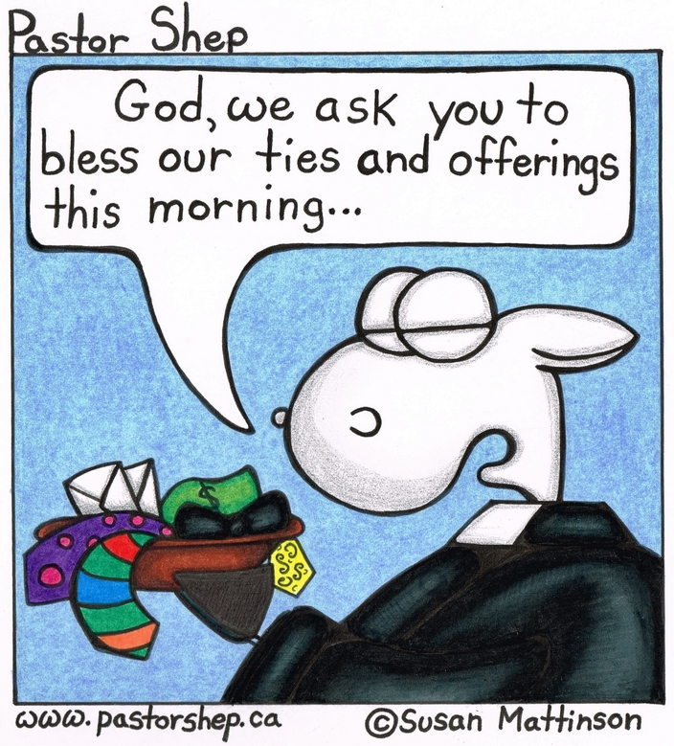
Memorial Services –Today St. Mark’s August 18th; St. James’ August 25th
Hymn Sing – St. Georges Anglican in Moncton tonight at 7pm.
Markets: UpRiver Country Market@ Bass River Hall Starts Next Saturday 9-12; produce, preserves, baking & More - its season running from now until October. Tables/booths available, vegetables now in season.
Kouchibouguac Market – Saturdays June 29-Aug. 31^{s}, 8-12 full breakfast and sale tables available; call Lucy MacDonald 524-7679
Bible School – Will start up again in the autumn.
Givings – Our offerings go to support the work of this congregation, the teaching of our children, the expenses of ministry, our dedicated world missions and upkeep of this building. Also, while there may be Sundays – during the stormy winter – where services are cancelled because of weather, costs remain. Gifts are receipted to givers for tax purposes.
Prayers of the Pastoral Charge - Do you have a prayer, or know someone we should be praying for? Pray, as we support each other in faith, hope & love.
Our Prayers are for: Raymond, V’roni & Arends, Savannah, Percy, Brent, Grace, Olga, Jody & Ryan & Waylon, Mike, Lisa & Alexander
Mission Moment Helping Maya Mam strengthen cultural identity August 9 is International Day for the World’s Indigenous People. In Guatemala, the indigenous Maya-Mam people have a rich culture but experience poverty and oppression. PWS&D is working with local partner Maya-Mam Association for Research and Development to improve the livelihoods of Maya Mam people, while also strengthening their cultural identity. With training in agro-ecological production, farmers are using traditional knowledge and locally available resources to grow more food, diversify their diets, and protect the environment. In addition, men and women are being taught how to exercise their collective rights in order to protect their land from mining operations. “I am very grateful,” says Teresa Diaz. “I hope that AMMID continues this work so we can improve our living conditions for our sons and daughters.”

