You may not have been around in 1853; however,
You are invited
To the
170th Anniversary
of

Ballyduff Church
2:30 pm October 22, 2023

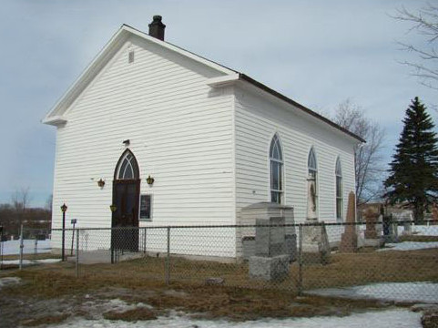
Guest preacher Reverend Barney Grace
Refreshments afterward in the schoolhouse

For info, 705-277-2907 or 705-277-2496
https://pccweb.ca/ballyduff

