FIRST PRESBYTERIAN CHURCH
Est. 1786
208 MacLean St., New Glasgow
Nova Scotia B2H 4M9
902-752-5691 first.church@ns.aliantzinc.ca

December 20, 2020

During COVID, the Order of Service will be on the screen at the front of the sanctuary. We are following all COVID 19 protocols, i.e. mandatory mask wearing, social distancing, sanitizing, etc. There is no singing, but we encourage you to hum along! If you are not ready to leave immediately following the service, we suggest you move toward the middle of your pew to allow people to pass safely then leave when you’re comfortable. The service is recorded and sent to those on the congregation email list. If you do not currently receive it but would like to, please contact the church office.

A N N O U N C E M E N T S

SPECIAL MUSIC:

The Anthem this morning will be "Mary's Little Boy Child" (Jester Harrison), a duet performed by Justin Savage and Keith MacDonald.

READING AND LIGHTING THE CANDLE OF LOVE THIS FOURTH SUNDAY IN ADVENT:

Chet Flemming

IN MEMORIAM:

A memorial donation has been received in loving memory of parents Melda and Roy MacGregor from Susan and Chuck Stallard.

SPECIAL OCCASIONS:

The congregation would like to extend greetings to Ray Webster who will be celebrating a special birthday this Wednesday, December 23rd. Happy Birthday from all of us Ray!!

We would also like to wish Sharon and Ron Mason a Happy 50th Anniversary and acknowledge that Sharon will be celebrating a special birthday soon!

2021 OFFERING ENVELOPES:

The 2021 envelopes are available for pick up in the sanctuary or at the office (Tues. – Fri.- 10 a.m. – 1 p.m.). In keeping with COVID protocols, an attendant will be passing them out. If you see envelopes for anyone you could deliver to, please do so. Thank you!

CHRISTMAS EVE SERVICES:
Christmas Eve services will be held at 2 p.m. and 6 p.m. with limited, reserved seating. If you have not already booked your seat, please contact the office to do so, 902-752-5691. Also, please bring a battery-operated tea light or small flashlight.

FAIR HEARTS – FRIENDS ASSISTING IRAQI REFUGEES:
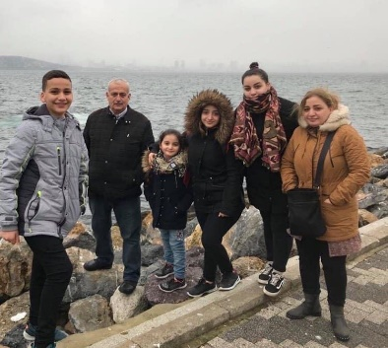
First Church is working with FAIR Hearts as sponsors of an Iraqi refugee family of 6 (2 adults, 4 children) who will be relocating to our community in Fall 2021. There is considerable work to be done to raise funds, secure clothing, furnishings and household goods for the family prior to their arrival.

Members of FAIR Hearts from First Church are: Rev. Andrew MacDonald, (902-331-0322), Sharon Mason (902-752-0724), Sara Fullerton (902-754-2142), Brent MacQuarrie (902-616-7787).
• Refundables can be donated to FAIR Hearts at Golden Penny and Stewarts.
• Monetary donations are welcomed and needed to meet our goals. Cheques should be made payable to “First Presbyterian Church” for taxable receipts. Please make a note in the “Memo” section that is for FAIR Hearts.
• We are gathering furniture and household items for the family. Winter clothing only is needed, a list will be provided soon. Please contact a FAIR Hearts committee member if you have items to donate.
The FAIR Hearts committee would like to thank everyone for your generosity, it is greatly appreciated.
UPCOMING EVENTS:
- There are no meetings scheduled for this week.
- Unless necessary, Session will not be meeting in December.
- Rev. Andrew is asking for volunteers to read and light the candles for the 2 p.m. Christmas Eve service. He is also seeking scripture readers for this service. If you are available, please let him know.
Minister: Rev. Andrew MacDonald
Organist: Lloyd MacLean
Rev. MacDonald’s office hours: Tues. to Fri. - 10:00 am – 2:00 pm or by appointment
Office hours: Tues to Fri: 10am-1pm

MISSION STATEMENT: But he’s already made it plain how to live, what to do, what God is looking for in men and women. It’s quite simple. Do what is fair and just to your neighbor, be compassionate and loyal in your love, and don’t take yourself too seriously – take God seriously. Micah 6: 8-The Message

