FIRST PRESBYTERIAN CHURCH
Est. 1786
208 MacLean St., New Glasgow
Nova Scotia B2H 4M9
902-752-5691 first.church@ns.aliantzinc.ca

December 27, 2020

During COVID, the Order of Service will be on the screen at the front of the sanctuary. We are following all COVID 19 protocols, i.e. mandatory mask wearing, social distancing, sanitizing, etc. There is no singing, but we encourage you to hum along! If you are not ready to leave immediately following the service, we suggest you move toward the middle of your pew to allow people to pass safely then leave when you’re comfortable. The service is recorded and sent to those on the congregation email list. If you do not currently receive it but would like to, please contact the church office.

A N N O U N C E M E N T S

SPECIAL MUSIC:

Lloyd will be taking requests for Christmas carols this morning.

COMMUNION:

We will celebrate communion today.

IN MEMORIAM:

A memorial donation has been received in loving memory of Peg, Edgar, Bill and Mike Fukes, from Joan Fukes.

SPECIAL OCCASIONS:

We would like to wish Ralph and Claire Foote a very Happy 58th Wedding Anniversary today!!

The congregation would also like to extend greetings to Chet Fleming who will celebrate his birthday tomorrow. Happy Birthday Chet!

THANK YOU:

We would like to thank Russell MacIntosh and family of Century Saw and Marine for the repairs to the church snow blower.

2021 OFFERING ENVELOPES:

The 2021 envelopes are available for pick up in the sanctuary or at the office (Tues. – Fri.- 10 a.m. – 1 p.m.). In keeping with COVID protocols, an attendant will be passing them out. If you see envelopes for anyone you could deliver to, please do so. Thank you!

FAIR HEARTS – FRIENDS ASSISTING IRAQI REFUGEES:
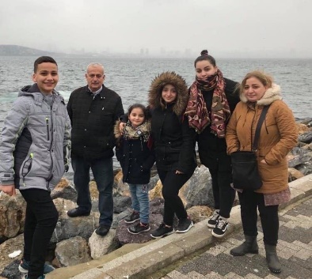
First Church is working with FAIR Hearts as sponsors of an Iraqi refugee family of 6 (2 adults, 4 children) who will be relocating to our community in Fall 2021. There is considerable work to be done to raise funds, secure clothing, furnishings and household goods for the family prior to their arrival.

Members of FAIR Hearts from First Church are: Rev. Andrew MacDonald, (902-331-0322), Sharon Mason (902-752-0724), Sara Fullerton (902-754-2142), Brent MacQuarrie (902-616-7787).
• Refundables can be donated to FAIR Hearts at Golden Penny and Stewarts.
• Monetary donations are welcomed and needed to meet our goals. Cheques should be made payable to “First Presbyterian Church” for taxable receipts. Please make a note in the “Memo” section that is for FAIR Hearts.
• We are gathering furniture and household items for the family. Winter clothing only is needed, a list will be provided soon. Please contact a FAIR Hearts committee member if you have items to donate.
The FAIR Hearts committee would like to thank everyone for your generosity, it is greatly appreciated.

UPCOMING EVENTS:
- There are no meetings scheduled for this week.
- Unless necessary, Session will not be meeting in December.

Minister: Rev. Andrew MacDonald
Organist: Lloyd MacLean
Rev. MacDonald’s office hours: Tues. to Fri. - 10:00 am – 2:00 pm or by appointment
Office hours: Tues to Fri: 10am-1pm

MISSION STATEMENT: But he’s already made it plain how to live, what to do, what God is looking for in men and women. It’s quite simple. Do what is fair and just to your neighbor, be compassionate and loyal in your love, and don’t take yourself too seriously – take God seriously. Micah 6: 8-The Message

