FIRST PRESBYTERIAN CHURCH
Est. 1786
208 MacLean St., New Glasgow
Nova Scotia B2H 4M9
902-752-5691 first.church@ns.aliantzinc.ca

January 10, 2021

During COVID, the Order of Service will be on the screen at the front of the sanctuary. We are following all COVID 19 protocols, i.e. mandatory mask wearing, social distancing, sanitizing, etc. There is no singing, but we encourage you to hum along! If you are not ready to leave immediately following the service, we suggest you move toward the middle of your pew to allow people to pass safely then leave when you’re comfortable. The service is recorded and sent to those on the congregation email list. If you do not currently receive it but would like to, please contact the church office.

WINTER CANCELLATION POLICY:

Reminder - When there is a weather watch or warning, cancellation notices will be posted on ECFM 94.1 and the church FaceBook page. The church voice message will be updated with cancellation information as well.

SPECIAL MUSIC:

Special music this morning will be provided by the trio, Kent Williams, Keith MacDonald and Justin Savage. They will sing "We Three Kings", and "When a Star is Shining". As well, Lloyd will play an arrangement of "Brightest and Best" (arr. Mark Hayes) on piano.

GUEST SPEAKER:

Sinan Al Shaltan will be with us today to tell of his experiences in his home country of Iraq and his journey to Canada.

YEAR END REPORTS:

All Teams are asked to start preparing their year-end reports for the annual meeting (date to be announced).

**************

The Congregation would like to extend belated birthday wishes to Keith Cruickshank. Keith celebrated a special birthday on Christmas Day!

We would also like to extend birthday wishes to Ralph Foote; Ralph will celebrate his birthday on January 12th.

FAIR HEARTS – FRIENDS ASSISTING IRAQI REFUGEES:
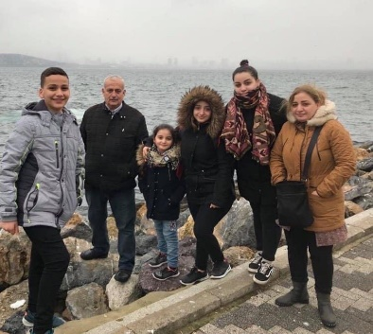
First Church is working with FAIR Hearts as sponsors of an Iraqi refugee family of 6 (2 adults, 4 children) who will be relocating to our community in Fall 2021. There is considerable work to be done to raise funds, secure clothing, furnishings and household goods for the family prior to their arrival.
Members of FAIR Hearts from First Church are: Rev. Andrew MacDonald, (902-331-0322), Sharon Mason (902-752-0724), Sara Fullerton (902-754-2142), Brent MacQuarrie (902-616-7787).
• Refundables can be donated to FAIR Hearts at Golden Penny and Stewarts.
• Monetary donations are welcomed and needed to meet our goals. Cheques should be made payable to “First Presbyterian Church” for taxable receipts. Please make a note in the “Memo” section that is for FAIR Hearts.
• We are gathering furniture and household items for the family. Winter clothing only is needed, a list will be provided soon. Please contact a FAIR Hearts committee member if you have items to donate.
The FAIR Hearts committee would like to thank everyone for your generosity, it is greatly appreciated.
“FOOD FOR THOUGHT”:
The Food Bank is always in need of donations. The following is a list of items, provided by a volunteer. If you can help, it is greatly appreciated.
- Kraft Mac & Cheese (needs milk and butter)
- Boxed milk (powdered), among many other uses, kids need it for cereal
- Canned foods with ‘pop tops’ are convenient OR donate can openers
- Oil for cooking and baking
- Sugar and flour, cake mixes and frosting (handy for children’s birthday cakes)
- Spices, salt and pepper
- Tea bags and coffee
- Fresh produce
- Fresh meat and eggs
- Canned fish
- Bread, crackers
- Butter and margarine
- Dishwashing detergent, personal care items, including feminine hygiene products
- “Stove Top” stuffing, can be used in many recipes.

UPCOMING EVENTS:
- A tentative meeting is scheduled for Thursday, Jan. 14th for the Choir.
- A meeting of the FAIRHearts Committee is scheduled for Thurs., Jan. 14th
- Session will hold a brief meeting after church today.
Minister: Rev. Andrew MacDonald
Organist: Lloyd MacLean
Rev. MacDonald’s office hours: Tues. to Fri. - 10:00 am – 2:00 pm or by appointment
Office hours: Tues to Fri: 10am-1pm

MISSION STATEMENT: But he’s already made it plain how to live, what to do, what God is looking for in men and women. It’s quite simple. Do what is fair and just to your neighbor, be compassionate and loyal in your love, and don’t take yourself too seriously – take God seriously. Micah 6: 8-The Message

