FIRST PRESBYTERIAN CHURCH
Est. 1786
208 MacLean St., New Glasgow
Nova Scotia B2H 4M9
902-752-5691 first.church@ns.aliantzinc.ca

February 28, 2021

During COVID, the Order of Service will be on the screen at the front of the sanctuary. We are following all COVID 19 protocols, i.e. mandatory mask wearing, social distancing, sanitizing, etc. There is no singing, but we encourage you to hum along! If you are not ready to leave immediately following the service, we suggest you move toward the middle of your pew to allow people to pass safely then leave when you’re comfortable. The service is recorded and sent to those on the congregation email list. If you do not currently receive it but would like to, please contact the church office.

WINTER CANCELLATION POLICY:

- Reminder – Cancellations will be posted on FaceBook, ECFM 94.1 and the church voicemail.

MUSIC:

  - 194 Come, let us to the Lord our God
  - 211 Take up your cross
  - 634 Will you come and follow me
  - 353 Hail, our once-rejected Jesus

SCRIPTURE READER THIS MORNING: Sara Fullerton

  - Genesis 17: 1-7; 15-16
  - Romans 4: 13-25

If you are interested in reading on Sundays, please contact Jane in the office, 752-5691.

WELCOME AND ANNOUNCEMENTS:

COMMUNITY EVENTS:
- Camp Geddie – Plans are afoot for the 2021 Camping Season…

Camp Geddie consistently provides a superior, safe Christian camping experience for the children and youth of Atlantic Canada, through the Atlantic Synod of the Presbyterian Church. The Geddie experience is enhanced by the natural beauty of the Camp's location on the Northumberland Shore.
Camp Geddie is hoping you are as anxious as the Camp is to get back to Camping in 2021. What will it look like? We are exploring and discovering exciting new possibilities. Watch for updates on Facebook and the Camp Geddie Website (campgeddie.ca)!
At this date, the Province of Nova Scotia has not relaxed restrictions for summer camping, so the team is being
creative in its planning. Like the entire Province of Nova Scotia, Camp Geddie is praying that restrictions will be lifted so that Camp can get back to “normal” (however that may be).
Building on last year’s successful on-line camp program, new options are open to provide a Christian Camping experience for young people - on-line? in person? a combination of on-line & in-person? community based camping? The Program Committee is excited to explore the many avenues that have opened up to provide Camp Geddie’s wonderful Christian camping experience.
Keep the Camp and the Program Committee in your prayers as everyone continues to deal with the COVID situation as it unfolds over the winter and spring! Camp Geddie always needs and appreciates your prayers and support. Keep safe and well! Stay tuned!!

- FAIR Hearts – Friends Assisting Iraqi Refugees:

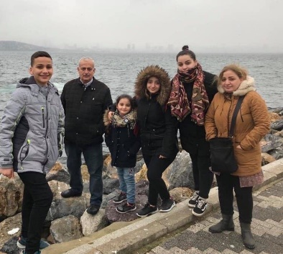
Fundraising continues by the members of FAIR Hearts; donations may be made at the church office.
Donations are sought for the following items: bedroom dressers, nightstands/bedside tables, one twin box spring and bed frame, twin bed sheets and twin quilts/comforters, new pillows.
These items can be picked up by contacting a FAIR Hearts member. Financial donations are also needed at this time and can also be made at the church office. The estimated arrival of the Iraqi family has been changed. Unfortunately, due to the backlog and delays with the Department of Immigration, it is expected to be at least 8 months before the family will arrive in Canada. Members of FAIR Hearts from First Church are: Rev. Andrew MacDonald (902-331-0322), Sharon Mason (902-752-0724), Sara Fullerton (902-754-2142), and Brent MacQuarrie (902) 616-7787). Sincere thanks to all who have donated funds and items thus far.
OPPORTUNITY – First United Church, Trenton is hiring a church secretary; 3 days/week, 5 hours/day. If you are interested, apply to:
First United Church
Position for Church Secretary
PO Box 625
Trenton, NS B0K 1X0
OR by email to: aajamieson@eastlink.ca
**************
UPCOMING CHURCH EVENTS:
- There are no meetings scheduled this week.

MINISTER: Rev. Andrew MacDonald
ORGANIST: Lloyd MacLean
Change re Rev. MacDonald’s office hours: Tues. to Thurs. - 10:00 am – 2:00 pm or by appointment.
Office hours: Tues to Fri: 10am-1pm

MISSION STATEMENT: But he’s already made it plain how to live, what to do, what God is looking for in men and women. It’s quite simple. Do what is fair and just to your neighbor, be compassionate and loyal in your love, and don’t take yourself too seriously – take God seriously. Micah 6: 8-The Message

