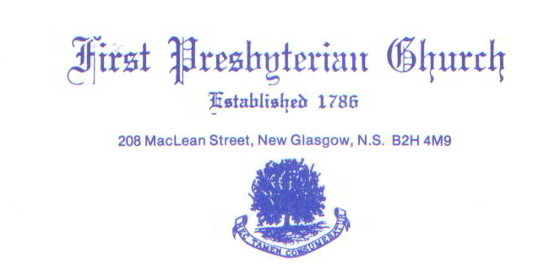
Virtual Memorial Hymn Sing
First Church wishes to extend an invitation to all persons in the congregation and beyond who may wish to support our first ever Virtual Memorial Hymn Sing. This is an opportunity for you to dedicate a favorite hymn to a loved one by way of a donation to the church. This is a way for all of us to remember those special people in our lives, contribute to the financial needs of our church and offer solace and peace to others in these turbulent times.
The funds generated from this hymn sing will be used by the Church for the maintenance and upkeep of the church and facilities (ie: sound system and costly organ repairs).
The attached list of musical selections includes vocal and instrumental performances either by soloists or groups currently from First Church and friends. Please complete the attached Donation Form listing your favorite hymns from the list provided and stating in whose memory the hymns are dedicated. Please fell free to sponsor as many hymns as you would like. Also, include how you wish to view the recording by selecting one of three options noted on the Donation Form.”
This is a major fundraiser for the Church and we suggest that you donate as you are able. Please feel free to share this information and form with other persons you think may also be interested. We believe the hymn selections represent many of the “traditional” as well as the current, more popular hymns of today.
The airing of this exciting musical event will take place on April 18, 2021 at 3 pm, so it is important your musical selection information and donation is received by the church on or before March 16,2021

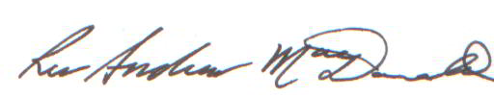
Rev. Andrew MacDonald

Attachments: Virtual Hymn Sing List and Donation Form
FIRST PRESBYTERIAN CHURCH, NEW GLASGOW, N.S.
Virtual Memorial Hymn Sing
Donation Form
1. Donor Name_______________________________________________________
2. Donor Mailing Address_______________________________________________
Email Address________________________________________________
3. In memory of:_____________________________________________________
Remarks:________________________________________________________
4. Selected Hym(s)______________________________________________________________________
____________________________________________________________________________________
5. Amount of Donation: $5.00/hymn _________________ $20.00/hymn _________________
$10.00/hymn _________________ $ 0ther/hymn _________________

6. Payment by: (cheque, cash or e-transfer) ______________________
Church mailing address:
208 MacLean Street, New Glasgow N.S., B2H 4M9
or Email- first.church@ns.aliantzinc.ca

7. Preferred Viewing Method (please check one of the following):
------ Viewing on YOUTUBE (Link will be sent to you at your email address)
------ Recording on DVD
------ Viewing of recorded hymn sing at 1st Church on April 18/21 at 3 pm (Limited to 100 seats)

Please note: This form with your donation must be received by First Church by March 16/21

First Presbyterian Church, New Glasgow, N.S.
Virtual Memorial Hymn Sing List
Amazing Grace
Be Thou My Vision
Blessed Assurance
Breathe On Me, Breath of God
Fairest Lord Jesus
Great Is Thy Faithfulness
Guide Me, O Thy Great Redeemer
His Eye Is On a Sparrow
Holy ,Holy, Holy
How Great Thou Art
I, The Lord of Sea and Sky
Jesus Loves Me
Just A Closer Walk With Thee
Just As I Am
Love Divine
Oh Happy Day
Praise To the Lord, Almighty
Precious Lord
Rock Of Ages
This Is My Father s World
What A Friend
Just a Closer Walk With Thee

