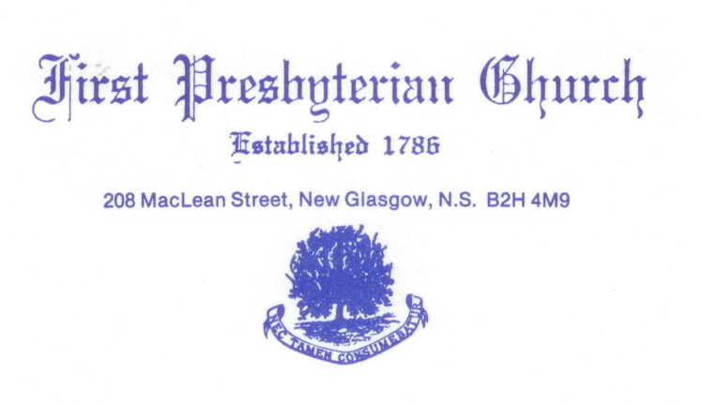
Virtual Memorial Hymn Sing
First Church wishes to extend an invitation to all persons in the congregation and beyond who may wish to support our first ever Virtual Memorial Hymn Sing. This is an opportunity for you to dedicate a favorite hymn to a loved one by way of a donation to the church. This is a way for all of us to remember those special people in our lives, contribute to the financial needs of our church and offer solace and peace to others in these turbulent times.
The funds generated from this hymn sing will be used by the Church for the maintenance and upkeep of the church and facilities (ie: sound system and costly organ repairs).
The attached list of musical selections includes vocal and instrumental performances either by soloists or groups currently from First Church and friends. Please complete the attached Donation Form listing your favorite hymns from the list provided and stating in whose memory the hymns are dedicated. Please fell free to sponsor as many hymns as you would like. Also, include how you wish to view the recording by selecting one of three options noted on the Donation Form.”
This is a major fundraiser for the Church and we suggest that you donate as you are able. Please feel free to share this information and form with other persons you think may also be interested. We believe the hymn selections represent many of the “traditional” as well as the current, more popular hymns of today.
The airing of this exciting musical event will take place on April 18, 2021 at 3 pm, so it is important your musical selection information and donation is received by the church on or before April 9, 2021 to ensure it’s inclusion in the Video Presentation.

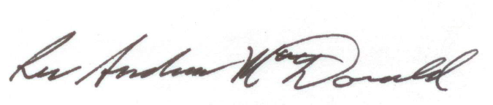
Rev. Andrew MacDonald
Attachments: Virtual Hymn Sing List and Donation Form
First Presbyterian Church, New Glasgow, N.S.
Virtual Memorial Hymn Song List

- Just A Closer Walk With Thee
- Holy, Holy, Holy
- Love Divine
- Jesus Loves Me
- Great Is Thy Faithfulness
- I Will Sing Of Thy Great Mercies, O Lord
- Praise To The Lord, The Almighty
- How Great Thou Art
- What A Friend We Have In Jesus
- Breathe On Me, Breath of God
- In The Garden
- Amazing Grace
- Precious Lord, Take My Hand
- When Peace Like A River
- I, The Lord Of Sea And Sky
- His Eye Is On The Sparrow
- This Is My Fathers World
- Order My Steps
- Be Thou My Vision
- Just As I Am/We Heard A Joyful Sound
- Guide Me, O, Thou Great Redeemer

FIRST PRESBYTERIAN CHURCH, NEW GLASGOW, N.S.
Virtual Memorial Hymn Sing
Donation Form
1. Donor Name______________________________________________________
2. Donor Mailing Address______________________________________________
Email Address_______________________________________________
3. In memory of:_____________________________________________________
___________________________________________________________________
Remarks:___________________________________________________________
___________________________________________________________________
___________________________________________________________________
4. Selected Hymn(s)__________________________________________________
______________________________________________________________________________________________________________________________________
5. Amount of Donation: $5.00/hymn _________________
$10.00/hymn _________________
$20.00/hymn _________________
$ 0ther/hymn _________________

6. Payment by: (cheque, cash or e-transfer) ______________________________
Church mailing address:
208 MacLean Street, New Glasgow N.S., B2H 4M9
or Email- first.church@ns.aliantzinc.ca
E-transfers to: first.church@ns.aliantzinc.ca

7. Preferred Viewing Method (please check one of the following):
------ Viewing on YOUTUBE (Link will be sent to you at your email address)
------ Recording on DVD
------ Viewing of recorded hymn sing at 1st Church on April 18/21 at 3 pm
(Limited to 100 seats please RSVP with the Church Office at 902-752-5691)

Please note: To ensure your Memorial is included in the Video this form with your donation must be received by First Church by April 9/21

