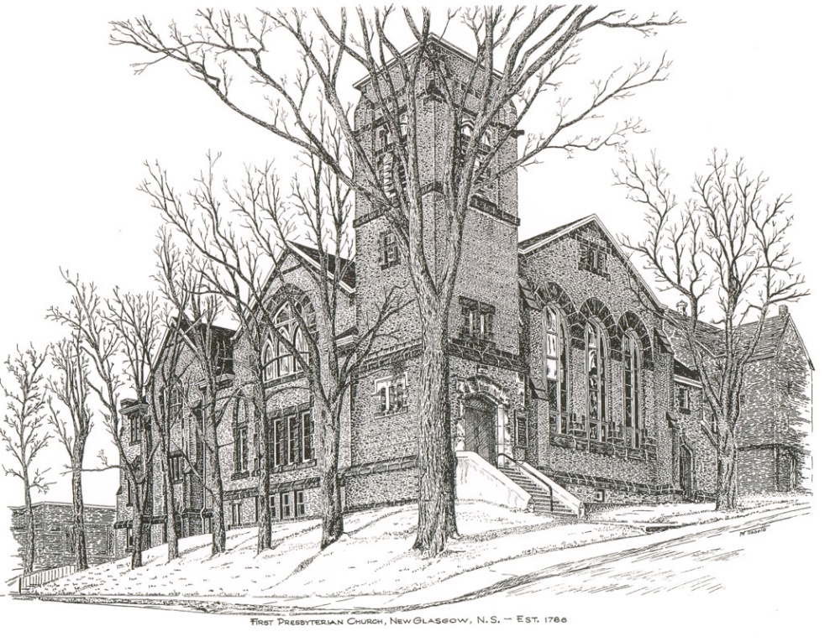

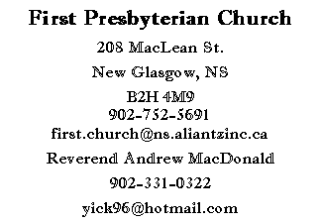
First Presbyterian Church
208 MacLean St.
New Glasgow, NS
B2H 4M9
902-752-5691 first.church@ns.aliantzinc.ca
Reverend Andrew MacDonald
902-331-0322
yick96@hotmail.com

First Presbyterian Church
208 MacLean St.
New Glasgow, NS
B2H 4M9
902-752-5691 first.church@ns.aliantzinc.ca
Reverend Andrew MacDonald
902-331-0322
yick96@hotmail.com

April 18, 2021
Third Sunday of Ester

THE APPROACH

Musical Prelude
Welcome and Announcements
Lighting the Christ candle
Musical Introit: At the dawning of salvation”
Responsive Reading:

Lighting the Christ Candle:
ONE: Let us light this Christ candle for tolerance, and pray for a unity that respects diversity and enhances the well-being of all the inhabitants of Canada and of the world. Let us pray for a society where it will be easier to live virtuously, where joy will be the lot of many, where all children will be surrounded with love, where prejudice will have no place and where God will be more evident to all.
All: Come, Lord, and grant us peace.
ONE: Let us now prepare our hearts to worship almighty God.
(LIGHT CANDLE)
Call to Worship
Hymn #248 At the dawning of salvation
Prayer of Adoration and Confession
Assurance of Pardon
Passing of the Peace
Hymn #260 – Alleluia, alleluia, give thanks to the risen Lord
Prayer of Illumination
Scripture: Acts 3:12-19
1 John 3:1-7

Gospel Reading: Luke 24:36-48

Anthem
Sermon: “We are the Children, the Children of God!”
Hymn #251 – Christ is alive
Offertory Prayer
Reaffirmation of Faith – The Apostle’s Creed
Prayer of the People and the Lord’s Prayer

Hymn #353 – Hail our once-rejected Jesus

Benediction

THIS MORNING:

Scripture Reader: Brent MacQuarrie

ANNOUNCEMENTS

Our Condolences:
The congregation is deeply saddened at the loss of our member and friend, Roger MacDonald. We extend our sincere condolences to Roger’s family and friends.
Memorial Donations:
Memorial Donations have been received in Roger’s memory from:
Phoebe Fraser
Nancy Montgomery
Melanie Lysyk
Lynn & Kevin Ballantyne
Kim & Debbie MacFarlane
1 anonymous donation
Virtual Memorial Hymn Sing:
The airing of the VMHS in the sanctuary will take place today starting at 3:00 pm. The doors will open at 2:15 pm with the show lasting approximately 1 hour 15 minutes. COVID restrictions continue to apply. Look forward to seeing you there. Enjoy the show.
F.A.I.R. Hearts:

Fundraising efforts continue by members of F.AI.R. Hearts. We are still in need of bedroom dressers, nightstands/bedside tables and twin size bedding. These items can be picked up by contacting a F.A.I.R. Hearts member. Financial donations are also needed. All donations can be made at the church office. Members of F.A.I.R. Hearts from First Church are: Rev. Andrew MacDonald (902-331-0322), Sharon Mason (902-752-0724), Sara Fullerton (902-754-2142), and Brent MacQuarrie (902) 616-7787). Sincere thanks to all who have donated funds and items thus far.

Request For Yarn:
Betty MacDonald is knitting afghans for cancer patients and is looking for donations of yarn. If you can help out, please drop your yarn off to the church office.
Assistance With Tax Returns:
For 25 years, Larry Ingham has been providing his services in preparing tax returns for low income people with the CVITP at no charge. You can contact Mr. Ingham at 902-752-1639. COVID rules apply.
Help Needed:
Our Church currently has three dedicated people who look after the Sound Board, the computer (Ipad) and the camera recording Church services. It would be beneficial to have one or preferably two persons available as backup for each position. The backup or alternate persons would be required on those occasions when the regular person cannot be available for a particular service. Training will be provided to interested persons. Please contact the church office if you would like to help out.
Reminder:
If you are a key holder, please make sure you double check that the outer doors are locked when you are leaving the church.
UPCOMING EVENTS

Geddie Clean Up Days are planned for April 22, 23 and 24 – Everyone is invited to come and help clean up the grounds whenever you are free. The priority is clearing brush from the Chapels and trails. Bring a lunch, dress accordingly and bring your own equipment. Thank you for your on-going support of Camp Geddie. Chris MacDonald, Property Committee, Camp Geddie.

The Aberdeen Palliative Care Society is hosting a “Death Café” May 7th, 7-9 pm. If you’re interested in attending, please contact Liz MacIntosh at 902-755-3148.
MEETINGS:

There are no meetings scheduled this week.

* * * * * * * * * * * * * * * * * *

Minister: Rev. Andrew MacDonald (c) 902-331-0322
Organist: Lloyd MacLean
Office hours: Tues. to Fri. – 10 -1pm
Rev. MacDonald office hours -Tues. to Fri. 10-2 or by appointment

Mission Statement: But he’s already made it plain how to live, what to do, what God is looking for in men and women. It’s quite simple. Do what is fair and just to your neighbor, be compassionate and loyal in your love, and don’t take yourself too seriously – take God seriously. Micah 6: 8-The Message

