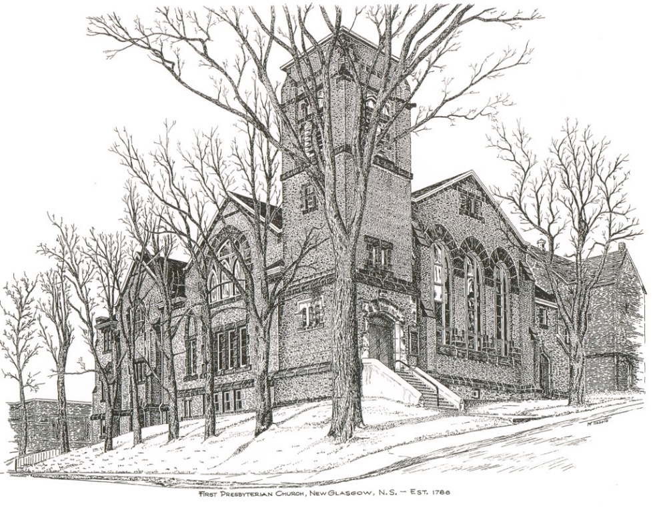

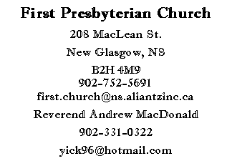
First Presbyterian Church
208 MacLean St.
New Glasgow, NS
B2H 4M9
902-752-5691 first.church@ns.aliantzinc.ca
Reverend Andrew MacDonald
902-331-0322
yick96@hotmail.com

First Presbyterian Church
208 MacLean St.
New Glasgow, NS
B2H 4M9
902-752-5691 first.church@ns.aliantzinc.ca
Reverend Andrew MacDonald
902-331-0322
yick96@hotmail.com

April 25, 2021
Fourth Sunday of Easter
Mission Awareness Sunday

THE APPROACH

Musical Prelude
Welcome and Announcements
Responsive Reading:

Lighting the Christ Candle: Please rise
ONE: Let us light a candle for justice, and pray for the eradication of poverty and want everywhere in Canada and the world, but especially among children and the First Nations. Let us pray for our young people, that they may find solid mentors, leading them to creative and satisfying lives.
ALL: Come, Lord, and grant us peace.
ONE: Let us now prepare our hearts to worship almighty God.
(Light Candle)
Musical Introit: Hymn # 252 He is Lord
Call to Worship
Hymn 482 – Christ is made the sure foundation
Prayer of Adoration and Confession
Assurance of Pardon
Passing of the Peace
Hymn #691 – My Shepherd is the King of love
Prayer of Illumination
Scripture: Acts 4:5-12
1 John 3:16-24

Gospel Reading: John 10:11-18

Anthem – With respect in creation (David Kai) –Justin, Shirley & Sharon
Sermon: “Tending God’s Sheep!”
Hymn #361 – A stranger, knocking on a door (tune: 162)
Offertory Prayer
Reaffirmation of Faith – The Apostle’s Creed – Please rise
Prayer of the People and the Lord’s Prayer

Hymn #699 – All the way my Saviour leads me

Benediction - Please rise

Musical Recessional

THIS MORNING:

Scripture Reader: Sharon Mason

ANNOUNCEMENTS

Memorial Donations:
Memorial Donations have been received in Roger’s memory from:
Franklyn Holman
Scott & Gaile MacDougall
Sheila Dempster
Chet Fleming
David & Marilyn Johnstone
Edna Fraser
Diane MacDonald on behalf of “Roddie’s” family

Virtual Memorial Hymn Sing:
The Virtual Memorial Hymn Sing was a resounding success. Thank you to all the organizers, Lloyd, and all who supported it!
F.A.I.R. Hearts:

Fundraising efforts continue by members of F.AI.R. Hearts. We are still in need of bedroom dressers, nightstands/bedside tables and twin size bedding. These items can be picked up by contacting a F.A.I.R. Hearts member. Financial donations are also needed. All donations can be made at the church office. Members of F.A.I.R. Hearts from First Church are: Rev. Andrew MacDonald (902-331-0322), Sharon Mason (902-752-0724), Sara Fullerton (902-754-2142), and Brent MacQuarrie (902) 616-7787). Sincere thanks to all who have donated funds and items thus far.

Request For Yarn:
Betty MacDonald is knitting afghans for cancer patients and is looking for donations of yarn. If you can help out, please drop your yarn off to the church office.

Assistance With Tax Returns:
For 25 years, Larry Ingham has been providing his services in preparing tax returns for low income people with the CVITP at no charge. You can contact Mr. Ingham at 902-752-1639. COVID rules apply.

Birthday: The congregation would like to send belated birthday wishes to Larry Ingham. Larry celebrated his birthday April 16th.
Help Needed:
Our Church currently has three dedicated people who look after the Sound Board, the computer (Ipad) and the camera recording Church services. It would be beneficial to have one or preferably two persons available as backup for each position. The backup or alternate persons would be required on those occasions when the regular person cannot be available for a particular service. Training will be provided to interested persons. Please contact the church office if you would like to help out.
Request for updated information:
We are in the process of updating all congregational contact information. If you haven’t already, please contact the office with your mailing address, preferred phone number, email address, birthdays and anniversaries, any information you feel is important, we would appreciate. Thank you.

UPCOMING EVENTS

Friday, May 28 – Circle of Friends are hosting a Soup & Dessert take out. Pick up will be between 3:00-5:00 pm (James St entrance behind J.R. Rahey’s). Please put your money in an envelope or clear bag. Choices will be tomato-cheddar, chicken vegetable or chili. $8.00 each (includes a roll, dessert will be cake). To place your order contact Marilyn 922-2859; Edna 752-4096 or Sheila 695-2295. Deadline for orders: May 21
The Aberdeen Palliative Care Society is hosting a “Death Café” May 7th, 7-9 pm. If you’re interested in attending, please contact Liz MacIntosh at 902-755-3148.
MEETINGS:

There are no meetings scheduled this week.

* * * * * * * * * * * * * * * * * *

Minister: Rev. Andrew MacDonald (c) 902-331-0322
Organist: Lloyd MacLean
Office hours: Tues. to Fri. – 10 -1pm
Rev. MacDonald office hours -Tues. to Fri. 10-2 or by appointment

Mission Statement: But he’s already made it plain how to live, what to do, what God is looking for in men and women. It’s quite simple. Do what is fair and just to your neighbor, be compassionate and loyal in your love, and don’t take yourself too seriously – take God seriously. Micah 6: 8-The Message

