FIRST PRESBYTERIAN CHURCH
Est. 1786
208 MacLean St., New Glasgow
Nova Scotia B2H 4M9
902-752-5691 first.church@ns.aliantzinc.ca

March 21, 2021

During COVID, the Order of Service will be on the screen at the front of the sanctuary. We are following all COVID 19 protocols, i.e. mandatory mask wearing, social distancing, sanitizing, etc. There is no singing, but we encourage you to hum along! If you are not ready to leave immediately following the service, we suggest you move toward the middle of your pew to allow people to pass safely then leave when you’re comfortable. The service is recorded and sent to those on the congregation email list. If you do not currently receive it but would like to, please contact the church office.

WINTER CANCELLATION POLICY: Cancellations will be posted on FaceBook, ECFM 94.1 and the church voicemail.

MUSIC:

  - 275 Jesus shall reign where’er the sun
  - 445 Open our eyes, Lord
  - 209 O love that wilt not let me go
  - 772 Christ for the word we sing (tune: 293)

SCRIPTURE READER THIS MORNING: - Ella Russell
- Jeremiah 31:31-34
- Hebrews 5:5-10

If you are interested in reading on Sundays, please contact Jane in the office at 902-752-5691.

WELCOME:

LIGHTING THE CHRIST CANDLE:

Fifth Sunday in Lent
Today is the fifth Sunday of Lent. As we travel with Jesus toward the cross, we hear him praying for his disciples and for all who will believe in him. We remember that just as he prayed for us during his ministry on earth, the risen Christ continues to pray for us as he reigns in heaven. Let us take comfort in this promise and seek the unity that will display God’s glory to the world.
Hear these words from Ephesians 4:
As a prisoner for the Lord, then, I urge you to live a life worthy of the calling you have received. Be completely humble and gentle; be patient, bearing with one another in love. Make every effort to keep the unity of the Spirit through the bond of peace. There is one body and one Spirit, just as you were called to one hope when you were called; one Lord, one faith, one baptism; one God and Father of all, who is over all and through all and in all.
Responsive Refrain
ONE: Lord Jesus, as we walk with you through these forty days, let your light shine into our hearts.
ALL: Brighten the darkness of our lives, and show us where we need to repent.
ONE: In our thoughts, words, and actions, teach us to rely on you.
ALL: Renew us as your people, that we may carry your light to the world.
UPCOMING CHURCH AND COMMUNITY EVENTS:
Virtual Memorial Hymn Sing:
- The VMHS is a new and exciting project for our church. The Hymn selections, all 21, have been rehearsed and recorded for viewing on April 18. Persons interested in viewing the hymn sing can do so in one of three ways but you need to first complete a donation form. These forms are available on the Church web site (bulletins) or at the church office. You don’t want to miss out as the donation form submission date (April 9) is drawing near. Be sure and share with family members and friends if they live a distance away.
- Fundraising continues by the members of F.A.I.R. Hearts; donations may be made at the church office. Donations are sought for the following items: bedroom dressers, nightstands/bedside tables, twin bed sheets and twin quilts/comforters, new pillows.
These items can be picked up by contacting a F.A.I.R. Hearts member. Financial donations are also needed at this time and can also be made at the church office.
Members of F.A.I.R. Hearts from First Church are: Rev. Andrew MacDonald (902-331-0322), Sharon Mason (902-752-0724), Sara Fullerton (902-754-2142), and Brent MacQuarrie (902) 616-7787). Sincere thanks to all who have donated funds and items thus far.

Benevolent Envelope Collection:
- Due to the COVID lockdown and regulations, we were unable to hold the Benefit Breakfast for Scott Grant as planned last year. Session has made the decision to offer our assistance through a Benevolent Envelope Collection. Special Envelopes have been provided for this collection and will be collected over the next couple of weeks. If you are making your donation by cheque, please make it out to First Presbyterian Church (include “Grant Family” in the memo line) and include your name and envelope number on the front of the special envelopes. Thank you for your support.

Assistance With Tax Returns:
- For 25 years, Larry Ingham has been providing his services in preparing tax returns for low income people with the CVITP at no charge. You can contact Mr. Ingham at 902-752-1639. COVID rules apply.

CONGREGATIONAL/COMMUNITY STORY:
Ellen Jardine has recently been recognized by the Aberdeen Hospital Foundation for her generous donation in memory of her mother, Kaye Jardine, who worked as a nurse at the hospital for many years.
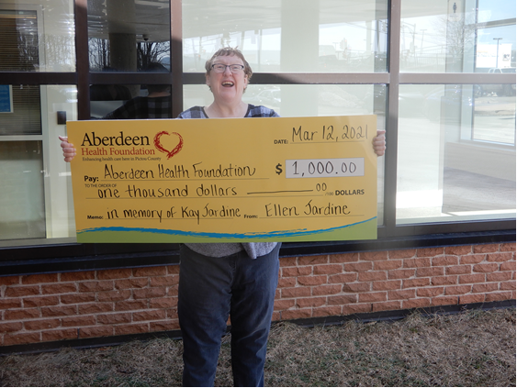

IN MEMORIAM:
A donation has been received from Catherine Matheson n Loving Memory of her husband, Hugh Matheson.

MEETINGS THIS WEEK:
- The Worship and Music Team will meet after church today at 12:15
- The Annual Meeting will take place after church next Sunday, March 28th. If you have not already received one, a copy of the Report is available in the Sanctuary. PLEASE BRING YOUR COPY OF THE REPORT TO THE MEETING AND BE SURE TO READ THE REPORT BEFORE HAND AS THE REPORTS WILL NOT BE READ AT THE MEETING.
- 0000000000000000000000000

**************
MINISTER: Rev. Andrew MacDonald
ORGANIST: Lloyd MacLean
Change re Rev. MacDonald’s office hours: Tues. to Thurs. - 10:00 am – 2:00 pm or by appointment.
Office hours: Tues to Fri: 10am-1pm

MISSION STATEMENT: But he’s already made it plain how to live, what to do, what God is looking for in men and women. It’s quite simple. Do what is fair and just to your neighbor, be compassionate and loyal in your love, and don’t take yourself too seriously – take God seriously. Micah 6: 8-The Message

