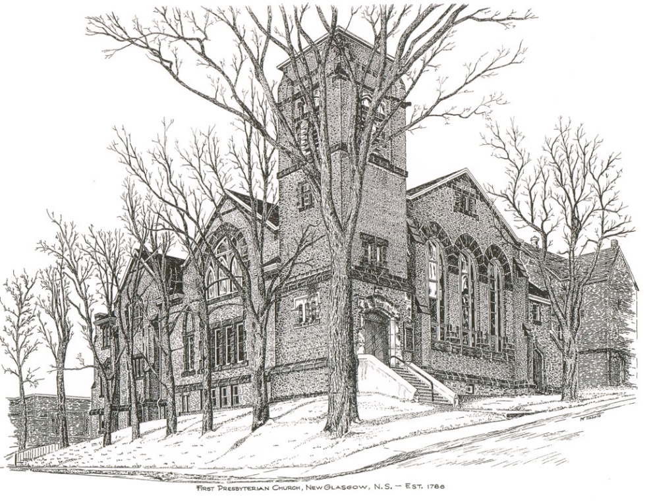

First Presbyterian Church
Virtual Memorial Hymn Sing

April 18, 2021
FIRST PRESBYTERIAN CHURCH
VIRTUAL MEMORIAL HYMN SING

Minister: Rev. Andrew MacDonald

Organist: Lloyd MacLean

Opening:

Just A Closer Walk With Thee – Brass United

In Memory Of: | Requested by:
Husband Bert; Son David; Daughter & Son-in-Law Barbara & Bill Hennigar | Margie Fraser
Father Bert; Brother David; Sister & Brother-in-Law Barbara & Bill Hennigar | Jack & Cathy Lewis
Husband Bill and Sons Donald & John Mailman | Helen Mailman
Mother & Father Chester & Tina Fleming | Chet Fleming
Parents Margaret & Leslie Robertson; Sister Frances MacIntosh | Marion Hayden
Aunts Frances & Muriel Henderson | Janice Henderson
Chester & Christine Fleming | Betty MacNeil
Parents Charles & Shirley Reid | Kevin & Terry Reid

Raymond & Audrey MacQuarrie | Brent MacQuarrie & Sara Fullerton
Donna MacIvor | Jim MacIvor
Doris Baudoux & Myrtle Atkins | Gary Baudoux & Colette Condon
John Franklin Campbell & Christena DeYoung | Emma Campbell
Wallace & Evelyn Henderson | Rosalie Cox
Parents Joseph F. & Catherine A. Watson, with thanks for giving us a life full of music, love and sharing of talents. | Daughters Deedee (Catherine) Klauss, Roberta MacKay and Linda Fraser

Welcome: Reverend MacDonald

Holy, Holy, Holy – Choir

In Memory Of: | Requested by:

Love Divine – Choir

In Memory Of: | Requested by:

Jesus Loves Me – Robyn & Family

In Memory Of: | Requested by:
Parents Kenneth & Laura Cruickshank; Parents Neil & Tressie MacDonald; Infant Grandson Joshua Cruickshank | Keith & Shirley Cruickshank

Great Is Thy Faithfulness – Brenda & Brian Bowden - Duet

In Memory Of: | Requested by:
Parents Melda & Roy MacGregor | Janet & Brian Hiscott
Parents Melda & Roy MacGregor | Susan & Chuck Stallard
Mary & Lawrence Robertson (long time supporters of the Kirk) | Laurene MacDonald
Husband Bert; Son David; Daughter & Son-in-Law Barbara & Bill Hennigar | Margie Fraser
Mervyn & Mabel MacKay; Glenn MacKay; Joan MacDonald; Leslie & Flo MacLeod | Austin & Marsha Sutton
Chester & Christine Fleming | Betty MacNeil
John Franklin Campbell & Christena DeYoung | Emma Campbell
Parents John & Alice MacMillan and Aunt Lenora Crockett | Eleanor MacDonald
My Dad Lennie Rhyno | Jane Taylor

I Will Sing Of Thy Great Mercies, O Lord – Choir (with strings)

In Memory Of: | Requested by:
William & Tina Robertson | Gwen & Lloyd MacLean

Praise To The Lord, The Almighty – Choir

In Memory Of: | Requested by:
Daughter-in-law Hettie | Hendrika & Hank vanVeld

How Great Thou Art – Jodie Miller - Solo

In Memory Of: | Requested by:
Parents, John Dan & Rita Fraser; Brothers James & Ronald Fraser; Neil and Thelma Campbell | Teela Billington
Clarence & Effie Bowen and Roy & Dot Biggar | Barb & Murray Biggar
Brother John Mailman | Patty Henderson
Mervyn & Mabel MacKay; Glenn MacKay; Joan MacDonald; Leslie & Flo MacLeod | Austin & Marsha Sutton
Grandmother Lottie Fraser; Grandparents Isaac & Doris Hussey | Mark & Jennifer Thibeau
Leonard & Ethel Jardine | Leanne, Laurel & Stephen Jardine
Hugh & Whilma Fraser | Renee & Barry Fraser
Parents Dan & Lottie Fraser; Sister Emma MacCulloch; Husband Cecil MacNeil | Marion J. MacNeil
Parents Bert & Mary Henderson | Janice Henderson
Chester & Christine Fleming | Betty MacNeil
James & Helen MacLeod | Kevin & Margaret MacLeod
Vernon Trefry | Ralph & Claire Foote
Sister Betty Irving | Don Haggart & Diane Bagnell
Friends who passed away | David & Marilyn Johnstone
Doris Baudoux & Myrtle Atkins | Gary Baudoux & Colette Condon
Lloyd Mason | Ron & Sharon Mason
Wallace & Evelyn Henderson | Rosalie Cox
Parents Joseph F. & Catherine A. Watson, with thanks for giving us a life full of music, love and sharing of talents. | Daughters Deedee (Catherine) Klauss, Roberta MacKay and Linda Fraser
In honour of my Mom, Charlotte Rhyno | Jane Taylor

What a Friend We Have In Jesus – Justin Savage &
Keith MacDonald – Duet with guitars

In Memory Of: | Requested by:
Mother, Kaye Jardine | Ellen Jardine
Dorothy & Ferguson MacDonald; Eileen(MacDonald) Williams; Evelynne & Norman Cuthbertson & Vernon Milligan | Jane & Keith MacDonald
John & Millie Savage; Jill Bass and Ann Lynch | Fran Savage
Parents Dan & Lottie Fraser; Sister Emma MacCulloch; Husband Cecil MacNeil | Marion J. MacNeil

Breathe On Me, Breath of God – Womens Chorus

In Memory Of: | Requested by:
Hugh & Whilma Fraser | Renee & Barry Fraser
Parents John & Alice MacMillan and Aunt Lenora Crockett | Eleanor MacDonald

In The Garden – Rev. Andrew MacDonald - Solo

In Memory Of: | Requested by:
Christie MacMillan | Agnes & Bob MacDonald; Jeannie & Johna MacDonald
Brother Donald Mailman | Patty Henderson
Parents Dan & Lottie Fraser; Sister Emma MacCulloch; Husband Cecil MacNeil | Marion J. MacNeil
My beloved Grandmother Christy MacMillan | Rev. Andrew, Natalie & Bridget MacDonald
Parents Kenneth & Laura Cruickshank; Parents Neil & Tressie MacDonald; Infant Grandson Joshua Cruickshank | Keith & Shirley Cruickshank
Clifford & Sarah Morrison; Daniel MacFarlane | Arnold & Georgina MacFarlane
Our parents and our military friends | Jack & Judy Marshall
Elizabeth & David Simpson | Lynn Simpson
Brothers David & Allan Henderson | Janice Henderson
Friends who passed away | David & Marilyn Johnstone
Russell & Mary Ross | Gary Ross
Doris Baudoux & Myrtle Atkins | Gary Baudoux & Colette Condon
Parents Joseph F. & Catherine A. Watson, with thanks for giving us a life full of music, love and sharing of talents. | Daughters Deedee (Catherine) Klauss, Roberta MacKay and Linda Fraser
Roger MacDonald | First Church Congregation

Amazing Grace –Shaun McLean – Solo

In Memory Of: | Requested by:
Jessie & Gerald Gillis; Anna, Danny, David & Ian MacEachern | Brian & Louise Gillis
Hugh & Whilma Fraser | Renee & Barry Fraser
Clifford & Sarah Morrison; Daniel MacFarlane | Arnold & Georgina MacFarlane
Our parents and our military friends | Jack & Judy Marshall
James & Helen MacLeod | Kevin & Margaret MacLeod
Alvin & Olive Foote | Ralph & Claire Foote
Friends who passed away | David & Marilyn Johnstone
Doris Baudoux & Myrtle Atkins | Gary Baudoux & Colette Condon
In Honour of Joyce Mason | Ron & Sharon Mason
Parents John & Alice MacMillan and Aunt Lenora Crockett | Eleanor MacDonald
Parents Joseph F. & Catherine A. Watson, with thanks for giving us a life full of music, love and sharing of talents. | Daughters Deedee (Catherine) Klauss, Roberta MacKay and Linda Fraser

Precious Lord, Take My Hand – Janice Alcorn – Solo

In Memory Of: | Requested by:
Our parents | John & Brenda Zinck
Angus Bruce MacDonald | Agnes & Bob MacDonald; Jeannie & Johna MacDonald
Father Bert; Brother David; Sister & Brother-in-Law Barbara & Bill Hennigar | Jack & Cathy Lewis
Husband Kenny; Parents Robert & Isabel Fraser | Shirley MacDonald
Husband Bill and Sons Donald & John Mailman | Helen Mailman
Marian MacIntosh | Russell MacIntosh & Family
Father Daniel (Bud) MacDonald | Elaine MacDonald
Parents Dan & Lottie Fraser; Sister Emma MacCulloch; Husband Cecil MacNeil | Marion J. MacNeil
Angus Bruce MacDonald | Rev. Andrew, Natalie (Little Mary) & Bridget MacDonald
Parents Kenneth & Laura Cruickshank; Parents Neil & Tressie MacDonald; Infant Grandson Joshua Cruickshank | Keith & Shirley Cruickshank
Parents Margaret & Leslie Robertson; Sister Frances MacIntosh | Marion Hayden
Elizabeth & David Simpson | Lynn Simpson
Chester & Christine Fleming | Betty MacNeil
Friends who passed away | David & Marilyn Johnstone
My wife Daphine and and my daughter Debbie Webster | Ray Webster
Betty Wilson | Ron & Sharon Mason
John Franklin Campbell & Christena DeYoung | Emma Campbell

When Peace Like A River – Choir with Justin Savage
on solo verses

In Memory Of: | Requested by:
Husband Kenny; Parents Robert & Isabel Fraser | Shirley MacDonald
Husband Bill and Sons Donald & John Mailman | Helen Mailman
Mervyn & Mabel MacKay; Glenn MacKay; Joan MacDonald; Leslie & Flo MacLeod | Austin & Marsha Sutton
John & Millie Savage; Jill Bass and Ann Lynch | Fran Savage
Graham Fraser | Phoebe Fraser & Family Members
Parents John & Alice MacMillan and Aunt Lenora Crockett | Eleanor MacDonald

I, The Lord of Sea And Sky – Ann Holton - Solo

In Memory Of: | Requested by:
Robert (Bob) Fraser | Edna Fraser
Marian MacIntosh | Evelyn MacLellan
Jessie & Gerald Gillis; Anna, Danny, David & Ian MacEachern | Brian & Louise Gillis
Bob Caughey | Lori & Daniel Caughey
Parents Margaret & Les Robertson and Walter & Charlotte Withers | Wayne & Marie Withers
Fred Fullerton, Elizabeth Fullerton Graham and Walter Graham | Sara Fullerton & Brent MacQuarrie
Jack & Phyllis Miller | Jackie Ross
Doris Baudoux & Myrtle Atkins | Gary Baudoux & Colette Condon

His Eye Is On The Sparrow - Jodie, Robyn & Natalie Alcorn - Trio

In Memory Of: | Requested by:
Husband Bert; Son David; Daughter & Son-in-Law Barbara & Bill Hennigar | Margie Fraser
Grandparents Jim & Bertha Mercer | Mark & Jennifer Thibeau
Mother & Father Chester & Tina Fleming | Chet Fleming
Pamela Smith Flanagan | Betty Smith & Family
Kay Jardine | Lilian B. Ross
Parents Charles & Shirley Reid | Kevin & Terry Reid
Bill Wilson | Ron & Sharon Mason
Parents Joseph F. & Catherine A. Watson, with thanks for giving us a life full of music, love and sharing of talents. | Daughters Deedee (Catherine) Klauss, Roberta MacKay and Linda Fraser
Parents George & Margaret Durning | Janice & Andrew Alcorn

This Is My Father’s World – Mens Choir

In Memory Of: | Requested by:
Husband Bert; Son David; Daughter & Son-in-Law Barbara & Bill Hennigar | Margie Fraser
Fred Fullerton, Elizabeth Fullerton Graham and Walter Graham | Sara Fullerton & Brent MacQuarrie
Grandparents Ellis & Kathleen Hatt | Sheila Dempster

Order My Steps - Choir

In Memory Of: | Requested by:

Be Thou My Vision – Choir

In Memory Of: | Requested by:
Clarence & Effie Bowen and Roy & Dot Biggar | Barb & Murray Biggar
Grandfather Harry Thibeau | Mark & Jennifer Thibeau
Mother Margaret MacDonald | Elaine MacDonald
Hugh & Whilma Fraser | Renee & Barry Fraser
Parents Margaret & Les Robertson and Walter & Charlotte Withers | Wayne & Marie Withers
Kay Jardine | Lilian B. Ross
Friends who passed away | David & Marilyn Johnstone

Just As I Am/We Heard A Joyful Sound – Choir

In Memory Of: | Requested by:
Father Bert; Brother David; Sister & Brother-in-Law Barbara & Bill Hennigar | Jack & Cathy Lewis
Father Donald Mailman | Patty Henderson
Mervyn & Mabel MacKay; Glenn MacKay; Joan MacDonald; Leslie & Flo MacLeod | Austin & Marsha Sutton

Guide Me, O, Thou Great Redeemer –
Brass United with organ

In Memory Of: | Requested by:
Sister, Marian MacIntosh | Shirley McCormick
Father Bert; Brother David; Sister & Brother-in-Law Barbara & Bill Hennigar | Jack & Cathy Lewis
Leonard & Ethel Jardine | Leanne, Laurel & Stephen Jardine
Husband Bill Campbell | Clarice Campbell
Raymond & Audrey MacQuarrie | Brent MacQuarrie & Sara Fullerton
Parents John & Alice MacMillan and Aunt Lenora Crockett | Eleanor MacDonald

Donations received in honour of or in memory of loved ones, with appreciation for all the hymn choices.

In Honour of or In Memory of: | Donation by:
In honour of my husband John, who recently suffered a stroke and kidney failure. Spreading the love to our Congregation. | Laura Macumber
Gary Mingo | Beverly Mingo
Loved Ones | Helen Crowell
Loved Ones | Sherry Green
Loved Ones | Rev. Morley & Joy Shaw
Rev. Russell Alcorn | Emmy Alcorn
Diane Alcorn | Emmy Alcorn

THANK YOU!!

First Presbyterian Church would like to thank all the performers who participated in this Virtual Memorial Hymn Sing. Thank you to all who have supported us. We hope you enjoyed the performances in whatever way you watched. God Bless and stay safe!

First Presbyterian Worship and Music Team

