FIRST PRESBYTERIAN CHURCH
Est. 1786
208 MacLean St., New Glasgow
Nova Scotia B2H 4M9
Phone: 902-752-5691
Email: first.church@ns.aliantzinc.ca

May 16, 2021

Due to the latest restrictions imposed by the Department of Public Health, the church will be closed until further notice. We will keep you informed of any church news through this “abbreviated” bulletin or email. Rev. Andrew will continue to send his You Tube videos of the Sunday sermon as well his mid-week message. If you require pastoral assistance during this time, please contact Rev. MacDonald at 902-331-0322. Please stay safe!

CHURCH NEWS & EVENTS

CONDOLENCES:

- The congregation extends our sincere condolences to Ray Webster on the recent passing of his sister-in-law, Barbara Webster.

PRAYERS FOR BERMA:
- Our friend Berma Marshall had surgery on Friday. We hold her in our prayers and wish her a full and speedy recovery. If you would like to send Berma a card, her address is:
3-541 South Frederick St., New Glasgow, NS, B2H 0H1.

F.A.I.R. Hearts:

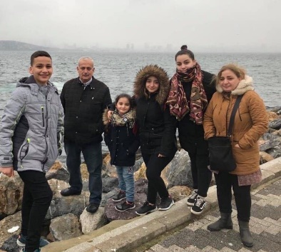
- While the church is closed, donations of household items cannot be accepted for F.A.I.R Hearts. Fundraising efforts continue and monetary donations may be made via mail, drop off in the mail slot at the church or via etransfer to the church email address (remember to email the answer to your question via separate message). We will let you know as soon as we are able to collect household items again. Thank you for your ongoing support of this important fundraiser.

HELP NEEDED:
- We currently have three dedicated people who look after the Sound Board, the computer (iPad), and the camera recording Church services. We are looking for one, preferably two persons, to be available as backup for each position. The backup persons would only be required on those occasions when the regular person cannot be available. Training will be provided. If you are interested and available to help, please contact the church office.

REQUEST FOR UPDATED INFORMATION:

- Thank you to everyone who has responded to our request for updated contact information. If you haven’t already done so, please contact the office with your mailing address, preferred phone number, email address, birthdays and anniversaries, any information you feel is important, we would appreciate.

MEETINGS THIS WEEK:
- There will be no meetings until Department of Health guidelines allow.

SUMMER STUDENT OPPORTUNITIES:

- The Pictou County Women's Resource and Sexual Assault Centre will be hiring 2 summer student this year. For details, contact Megan Moore:
Phone: 902-755-4647
Email: pcwc@womenscentre.ca
Website: http://womenscentre.ca/

HAPPY BIRTHDAY!!

This week, we send birthday greetings to Hendrika vanVeld. Hendrika will celebrate her birthday, Wednesday, May 19th.
**************

MINISTER: Rev. Andrew MacDonald
ORGANIST: Lloyd MacLean
Change re Rev. MacDonald’s office hours: Tues. to Thurs. - 10:00 am – 2:00 pm or by appointment.
Office hours: Tues to Fri: 10am-1pm

MISSION STATEMENT: But he’s already made it plain how to live, what to do, what God is looking for in men and women. It’s quite simple. Do what is fair and just to your neighbor, be compassionate and loyal in your love, and don’t take yourself too seriously – take God seriously. Micah 6: 8-The Message

**************

The following was shared by Rev. Morley Shaw:

