FIRST PRESBYTERIAN CHURCH
Est. 1786
208 MacLean St., New Glasgow
Nova Scotia B2H 4M9
Phone: 902-752-5691
Email: first.church@ns.aliantzinc.ca

May 9, 2021

Due to the latest restrictions imposed by the Department of Public Health, the church will be closed until at least May 12th when the situation will be reassessed. Until that time, we will keep you informed of any church news through this “abbreviated” bulletin or email. Rev. Andrew will continue to send his You Tube videos of the Sunday sermon as well his mid-week message. If you require pastoral assistance during this time, please contact Rev. MacDonald at 902-331-0322. Please stay safe!

IN MEMORIAM:
- A Memorial donation has been received in loving memory of Roger MacDonald from Doreen MacNeil.

CHURCH AND COMMUNITY EVENTS:
HAPPY MOTHER’S DAY!!

Though we cannot be together today, we wish all the Moms a very Happy Mother’s Day! Thank you for all you do!!

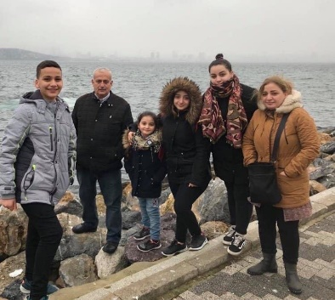
- While the church is closed, donations of household items cannot be accepted for F.A.I.R Hearts. Fundraising efforts continue and monetary donations may be made via mail, drop off in the mail slot at the church or via etransfer to the church email address (remember to email the answer to your question via separate message). We will let you know as soon as we are able to collect household items again. Thank you for your ongoing support of this important fundraiser.

HELP NEEDED:
- We currently have three dedicated people who look after the Sound Board, the computer (iPad), and the camera recording Church services. We are looking for one, preferably two persons, to be available as backup for each position. The backup persons would only be required on those occasions when the regular person cannot be available. Training will be provided. If you are interested and available to help, please contact the church office.

REQUEST FOR UPDATED INFORMATION:
- Thank you to everyone who has responded to our request for updated contact information. If you haven’t already done so, please contact the office with your mailing address, preferred phone number, email address, birthdays and anniversaries, any information you feel is important, we would appreciate.

THANK YOU NOTE:
A thank you note has been received from the 83rd New Glasgow Music Festival for “your commitment to the Festival… Thank you for providing this opportunity for the talented music students who participated this year”.

CANCELLATIONS:
- The Circle of Friends Soup & Dessert fundraiser has been cancelled for the time being and will be re-scheduled at a later date.

MEETINGS THIS WEEK:
- There will be no meetings until Department of Health guidelines allow.

SUMMER STUDENT OPPORTUNITIES:
- The Pictou County Women's Resource and Sexual Assault Centre will be hiring 2 summer student this year. For details, contact Megan Moore:
Phone: 902-755-4647
Email: pcwc@womenscentre.ca
Website: http://womenscentre.ca/

**************
MINISTER: Rev. Andrew MacDonald
ORGANIST: Lloyd MacLean
Change re Rev. MacDonald’s office hours: Tues. to Thurs. - 10:00 am – 2:00 pm or by appointment.
Office hours: Tues to Fri: 10am-1pm

MISSION STATEMENT: But he’s already made it plain how to live, what to do, what God is looking for in men and women. It’s quite simple. Do what is fair and just to your neighbor, be compassionate and loyal in your love, and don’t take yourself too seriously – take God seriously. Micah 6: 8-The Message

The following is a prayer for these COVID times, shared by Rev. Morley Shaw:

A PRAYER WHEN PUTTING ON OUR MASKS

(By Rev. Richard Bott)
“A PRAYER AS I PUT ON MY MASK:
Creator,
as I prepare to go into the world,
help me to see the sacrament
in the wearing of this cloth -
let it be "an outward sign
of an inward grace" -
a tangible and visible way of living
love for my neighbours,
as I love myself.
Christ,
since my lips will be covered,
uncover my heart,
that people would see my smile
in the crinkles around my eyes.
Since my voice may be muffled,
help me to speak clearly,
not only with my words,
but with my actions.
Holy Spirit,
As the elastic touches my ears,
remind me to listen carefully –
and full of care –
to all those I meet.
May this simple piece of cloth be
shield and banner,
and each breath that it holds,
be filled with your love.
In your Name and
in that love,
I pray.
May it be so.
May it be so.”

