FIRST PRESBYTERIAN CHURCH
Est. 1786
208 MacLean St., New Glasgow
Nova Scotia B2H 4M9
Phone: 902-752-5691
Email: first.church@ns.aliantzinc.ca

June 13, 2021

Due to the latest restrictions imposed by the Department of Public Health, the church will be closed until further notice. We will keep you informed of any church news through this “abbreviated” bulletin or email. Rev. Andrew will continue to send his You Tube videos of the Sunday sermon as well his mid-week message. If you require pastoral assistance during this time, please contact Rev. MacDonald at 902-331-0322. Please stay safe!

CHURCH NEWS
F.A.I.R. Hearts:
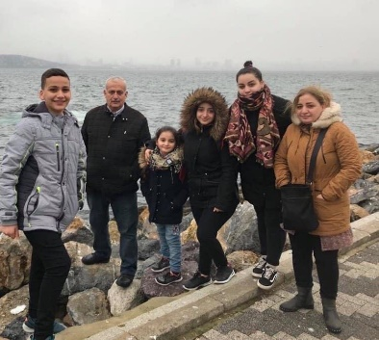
- While the church is closed, donations of household items cannot be accepted for F.A.I.R Hearts. Fundraising efforts continue and monetary donations may be made via mail, drop off in the mail slot at the church or via etransfer to the church email address (remember to email the answer to your question via separate message). We will let you know as soon as we are able to collect household items again. Thank you for your ongoing support of this important fundraiser.

- We will also be gathering quality used items for yard sales that will be held during the summer as well as new or gently used items that can be used for our online auctions. Please contact Fair Hearts members for more info or item pick up. Members of FAIR Hearts from First Church are: Rev. Andrew MacDonald (902-331-0322), Sharon Mason (902-752-0724), Sara Fullerton (902-754-2142), and Brent MacQuarrie (902) 616-7787).

VIRTUAL MEMORIAL HYMN SING:
- The Worship and Music Team will be producing a DVD and CD recording of the Virtual Memorial Hymn Sing held on April 18,2021. The price for a DVD is $10.00, the CD is $6.00. If you are interested in obtaining one or both for yourself or family member, please contact the church office by June 30, 2021.

CONGRATULATONS:
- Belated congratulations are extended to Hank and Hendrika vanVeld as they celebrated their 70th wedding anniversary June 7th!

THANK YOU:
- Scott Grant wishes to let everyone at First Church know he and his family greatly appreciate receiving their recent generous donation. It was unexpected but most welcomed given that Donna is currently undergoing treatment in Halifax. Scott himself is reasonably well. Thanks to all from Scott and family.

COMMUNITY NEWS

CAMP GEDDIE:
- Camp Geddie is looking for your help again. With the Camp closed last year, there is more work to be completed. Workdays are scheduled for June 24, 25, 26. All volunteers are welcome. Bring your own lunch, and any tools that might be useful. A list of tasks is available atg.cmacdonald@eastlink.ca. Thank you to the gentlemen from First Church, New Glasgow, who came in April and did a hard day’s work! If you have any questions, contact Chris MacDonald at 902)-485- 4011.

SUMMER JOB OPPORTUNITIES:
- The Loch Broom Log Church is looking to hire a summer student for the position of Interpretive Guide. We are looking for an outgoing student that is in post-secondary education (returning to school in the fall) or graduating from grade 12 and continuing with their studies. The job entails talking to the public about the history of the Log Church and surrounding area, keeping the place clean and mowed. Hours will be Wednesdays to Sundays 10am - 4pm. Starting week of June 27th. Any inquiries may be sent to lblogchurch@eastlink.ca.

MEETINGS THIS WEEK:
- There will be no meetings until Department of Health guidelines allow.

MINISTER: Rev. Andrew MacDonald
ORGANIST: Lloyd MacLean
Change re Rev. MacDonald’s office hours: Tues. to Thurs. - 10:00 am – 2:00 pm or by appointment.
Office hours: Tues to Fri: 10am-1pm

**********************

MISSION STATEMENT: But he’s already made it plain how to live, what to do, what God is looking for in men and women. It’s quite simple. Do what is fair and just to your neighbor, be compassionate and loyal in your love, and don’t take yourself too seriously – take God seriously. Micah 6: 8-The Message

