FIRST PRESBYTERIAN CHURCH
Est. 1786
208 MacLean St., New Glasgow
Nova Scotia B2H 4M9
Phone: 902-752-5691
Email: first.church@ns.aliantzinc.ca

June 20, 2021

WELCOME BACK!!!

We are happy to be able to hold our service in person this morning. We will continue to practice social distancing and wearing our masks until further notice. Welcome back!

We wish all dads a great day doing whatever makes you happy!

CHURCH NEWS
F.A.I.R. Hearts:
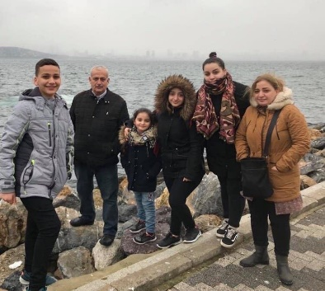
- While the church is closed, donations of household items cannot be accepted for F.A.I.R Hearts. Fundraising efforts continue and monetary donations may be made via mail, drop off in the mail slot at the church or via etransfer to the church email address (remember to email the answer to your question via separate message). We will let you know as soon as we are able to collect household items again. Thank you for your ongoing support of this important fundraiser.

- We will also be gathering quality used items for yard sales that will be held during the summer as well as new or gently used items that can be used for our online auctions. Please contact Fair Hearts members for more info or item pick up. Members of FAIR Hearts from First Church are: Rev. Andrew MacDonald (902-331-0322), Sharon Mason (902-752-0724), Sara Fullerton (902-754-2142), and Brent MacQuarrie (902) 616-7787).

VIRTUAL MEMORIAL HYMN SING:
- The Worship and Music Team will be producing a DVD and CD recording of the Virtual Memorial Hymn Sing held on April 18,2021. The price for a DVD is $10.00, the CD is $6.00. If you are interested in obtaining one or both for yourself or family member, please contact the church office by June 30, 2021.

CONGRATULATONS:
- Congratulations are extended to John and Laura Macumber as they celebrate their 60th wedding anniversary June 24th.

COMMUNITY NEWS
CAMP GEDDIE:
- Camp Geddie is looking for your help again. With the Camp closed last year, there is more work to be completed. Workdays are scheduled for June 24, 25, 26. All volunteers are welcome. Bring your own lunch, and any tools that might be useful. A list of tasks is available atg.cmacdonald@eastlink.ca. Thank you to the gentlemen from First Church, New Glasgow, who came in April and did a hard day’s work! If you have any questions, contact Chris MacDonald at 902)-485- 4011.

- Camp Geddie will be opening to in-person camps (pending the Province Phase 3 re-opening plan). Details can be found on their website campgeddie.ca. Registration for campers is open, the link is on their homepage, as well as their Facebook and Instagram pages.

SUMMER JOB OPPORTUNITIES:
- The Loch Broom Log Church is looking to hire a summer student for the position of Interpretive Guide. We are looking for an outgoing student that is in post-secondary education (returning to school in the fall) or graduating from grade 12 and continuing with their studies. The job entails talking to the public about the history of the Log Church and surrounding area, keeping the place clean and mowed. Hours will be Wednesdays to Sundays 10am - 4pm. Starting week of June 27th. Any inquiries may be sent to lblogchurch@eastlink.ca.

- Camp Geddie is also hiring for the following positions: Program Director, Medical Counselor, Mission Animator, Outdoor Education Counselor, Waterfront & Recreation Counselor, Canoe Counselor and Cabin Counselors. Applicants must be at least 16 years old by July 1, 2021. Ministry descriptions and a link to the application can be found on the website (www.campgeddie.ca). Please share with any young adults you think might be interested in a summer outdoors working with campers and living in Christian community.
Contact: Whitney Canning
Camping & Youth Consultant with the Synod of the Atlantic Provinces
Executive Director, Camp Geddie
902-926-2632
MEETINGS THIS WEEK:
- There will be no meetings until Department of Health guidelines allow.

MINISTER: Rev. Andrew MacDonald
ORGANIST: Lloyd MacLean
Change re Rev. MacDonald’s office hours: Tues. to Thurs. - 10:00 am – 2:00 pm or by appointment.
Office hours: Tues to Fri: 10am-1pm

