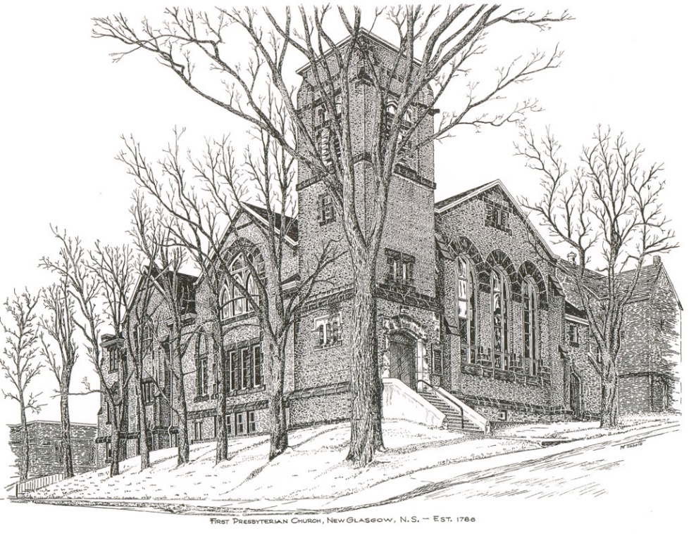

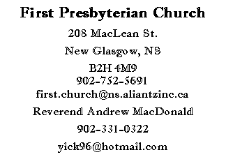
First Presbyterian Church
208 MacLean St.
New Glasgow, NS
B2H 4M9
902-752-5691 first.church@ns.aliantzinc.ca
Reverend Andrew MacDonald
902-331-0322
yick96@hotmail.com

First Presbyterian Church
208 MacLean St.
New Glasgow, NS
B2H 4M9
902-752-5691 first.church@ns.aliantzinc.ca
Reverend Andrew MacDonald
902-331-0322
yick96@hotmail.com

Communion Sunday
5th Sunday After Pentecost
June 27, 2021

THE APPROACH

Musical Prelude
Welcome and Announcements
Lighting the Christ candle
Responsive Reading:

Lighting the Christ Candle: Please Rise
ONE: Let us light a candle for love and forgiveness and pray for those whose lives give birth to evil and who pervert the truth and turn to violence. Let us pray for those who, as a result, now doubt the power of love and goodness, those lost in grief and all who have been robbed of hope or security. Let us pray for greater understanding between Christians, Muslims and Jews, that solidarity among all people of good will may promote harmony and tolerance and unite all people in the ways of justice and peace.
All: Come, Lord, and grant us peace.
ONE: Let us now prepare our hearts to worship almighty God.
Musical Introit – Hymn #421 Rejoice in the Lord
Call to Worship
Hymn #422 – Sing a new song
Prayer of Adoration and Confession
Assurance of Pardon
Passing of the Peace
Hymn # 728 The storm is strong
Prayer of Illumination
Scripture: 2 Corinthians 8:7-15
Gospel Reading: Mark 5:21-43

Anthem: Solo – Janice Alcorn “What Words Do I Put Here” (Rick Gunn)
Sermon “God wants us to live!”
Hymn #548 Let us break bread together
Offertory Prayer
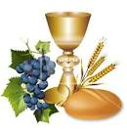

HOLY COMMUNION
Invitation to the Lord’s Table
Communion Hymn #540 One bread, one body vs. 1 & 2
Reaffirmation of Faith Apostle’s Creed

I believe in God the Father Almighty, Maker of heaven and earth; And in Jesus Christ His only Son our Lord, who was conceived by the Holy Ghost, born of the Virgin Mary, suffered under Pontuis Plate, was crucified, dead and buried; He descended into hell. The third day He rose again from the dead; He ascended into heaven, and sits on the right hand of God the Father Almighty; from thence He shall come to judge the quick and the dead.
I believe in the Holy Ghost; the Holy Catholic Church; the communion of saints; the forgiveness of sins; the resurrection of the body; and the life everlasting. AMEN
Great Prayer of Thanksgiving:
ONE: The Lord be with you.
ALL: And also with you.
ONE: Lift up your hearts.
ALL: We lift them to the Lord.
ONE: Let us give thanks to the Lord our God.
ALL: It is right to give God thanks and praise.
ONE: So now, with all the apostles and prophets, and that great cloud of witnesses who live forever with you in the heavenly kingdom, we join our voices in thanksgiving and in praise to you saying:
ALL: Holy, holy, holy Lord, God of power and might,
heaven and earth are full of your glory.
Hosanna in the highest.
Blessed is he who comes in the name of the Lord.
Hosanna in the highest.

ONE: Therefore, today we gather in remembrance of the sacrifice that was made for our sakes. We have set aside this bread and this wine, as a celebration feast, a meal of remembrance. In doing so we also give praise and thanksgiving to you Lord God, as we proclaim the great mystery of faith:

ALL: Christ has died,
Christ is risen,
Christ will come again.

ONE: Let us join together as we lift up our voices and say the prayer that our Lord Jesus Christ taught us to pray when he said:
ALL: Our Father, who art in heaven, hallowed be thy name, thy kingdom come, thy will be done on earth as it is in heaven. Give us this day, our daily bread, and forgive us our debts as we forgive our debtors. And lead us not into temptation, but deliver us from evil. For thine is the kingdom, the power and the glory forever. Amen.
The Sacrament of Holy Communion
Communion Hymn #540 One bread, one body vs. 3 & 4
Benediction
Musical Recessional Hymn # 722 Lord, whose Love

THIS MORNING:
Soloist: Janice Alcorn

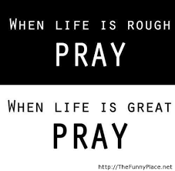

ANNOUNCEMENTS

IN MEMORIAL:
- Donations have been received in memory of Burma Marshall from John and Brenda Zinck and David and Marilyn Johnstone.
- A donation has been received in memory of Bill Campbell from Clarice Campbell.

PASTORAL CARE:
- In order to provide support to the people of First Church, when you or a loved one is sick or in hospital, we encourage you to contact the church (902-752-5691), Reverend Andrew (902-331-0322) or Phoebe Fraser, Chair of the Pastoral Care Team (902-752-4728), to inform us directly. It is also important that you inform the hospital that you would welcome a visit from your minister and/or your Elder.
F.A.I.R. Hearts:
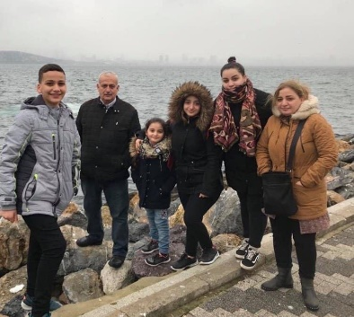
- While the church is closed, donations of household items cannot be accepted for F.A.I.R Hearts. Fundraising efforts continue and monetary donations may be made via mail, drop off in the mail slot at the church or via etransfer to the church email address (remember to email the answer to your question via separate message). We will let you know as soon as we are able to collect household items again. Thank you for your ongoing support of this important fundraiser.

- We will be gathering quality used items for yard sales that will be held during the summer as well as new or gently used items that can be used for our online auctions. Please contact Fair Hearts members for more info or item pick up. Members of FAIR Hearts from First Church are: Rev. Andrew MacDonald (902-331-0322), Sharon Mason (902-752-0724), Sara Fullerton (902-754-2142), and Brent MacQuarrie (902) 616-7787).

VIRTUAL MEMORIAL HYMN SING:
- The Worship and Music Team will be producing a DVD and CD recording of the Virtual Memorial Hymn Sing held on April 18,2021. The price for a DVD is $10.00, the CD is $6.00. If you are interested in obtaining one or both for yourself or family member, please contact the church office by June 30, 2021.

COMMUNITY NEWS
CAMP GEDDIE:

- Camp Geddie will be opening to in-person camps (pending the Province Phase 3 re-opening plan). Details can be found on their website campgeddie.ca. Registration for campers is open, the link is on their homepage, as well as their Facebook and Instagram pages.

MEETINGS THIS WEEK: No meetings this week.
VACATION:

- Rev Andrew MacDonald will be on vacation for the month of July. We will be joining with St Andrew's "The Kirk" for their worship services. To assist in following COVID procedures, we ask that you let us know if you plan to attend services at the Kirk. Please call the office and leave a voice message with your name, phone number and the number of people in your party so we can let the Kirk folks know how many of us will be joining them. If there is a Pastoral Emergency, please contact the Rev. Dr. Joon Ki Kim at 902-759-5961.
UPCOMING EVENTS

- Session will meet August 11th at 7:00 pm

Minister: Rev. Andrew MacDonald (c) 902-331-0322
Organist: Lloyd MacLean
Office hours: Tues. to Fri. – 10 -1pm
Rev. MacDonald office hours -Tues. to Fri. 10-2 or by appointment

Mission Statement: But he’s already made it plain how to live, what to do, what God is looking for in men and women. It’s quite simple. Do what is fair and just to your neighbor, be compassionate and loyal in your love, and don’t take yourself too seriously – take God seriously. Micah 6: 8-The Message

