FIRST PRESBYTERIAN CHURCH
Est. 1786
208 MacLean St., New Glasgow
Nova Scotia B2H 4M9
Phone: 902-752-5691
Email: first.church@ns.aliantzinc.ca

May 23, 2021

Due to the latest restrictions imposed by the Department of Public Health, the church will be closed until further notice. We will keep you informed of any church news through this “abbreviated” bulletin or email. Rev. Andrew will continue to send his You Tube videos of the Sunday sermon as well his mid-week message. If you require pastoral assistance during this time, please contact Rev. MacDonald at 902-331-0322. Please stay safe!

CHURCH NEWS

BERMA:
- Since Berma's surgery on Friday, May 14, she remains a patient at the Aberdeen Hospital in Room 186, bed 2. She has not been out of bed yet but is hoping to be able to do so soon. Cards or notes and prayers for healing are most welcomed. If you would like to send Berma a card, her address is:
3-541 South Frederick St., New Glasgow, NS, B2H 0H1.

F.A.I.R. Hearts:
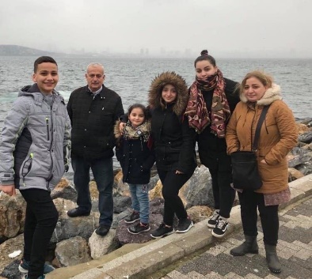
- While the church is closed, donations of household items cannot be accepted for F.A.I.R Hearts. Fundraising efforts continue and monetary donations may be made via mail, drop off in the mail slot at the church or via etransfer to the church email address (remember to email the answer to your question via separate message). We will let you know as soon as we are able to collect household items again. Thank you for your ongoing support of this important fundraiser.

MEETINGS THIS WEEK:
- There will be no meetings until Department of Health guidelines allow.

MINISTER: Rev. Andrew MacDonald
ORGANIST: Lloyd MacLean
Change re Rev. MacDonald’s office hours: Tues. to Thurs. - 10:00 am – 2:00 pm or by appointment.
Office hours: Tues to Fri: 10am-1pm

MISSION STATEMENT: But he’s already made it plain how to live, what to do, what God is looking for in men and women. It’s quite simple. Do what is fair and just to your neighbor, be compassionate and loyal in your love, and don’t take yourself too seriously – take God seriously. Micah 6: 8-The Message

