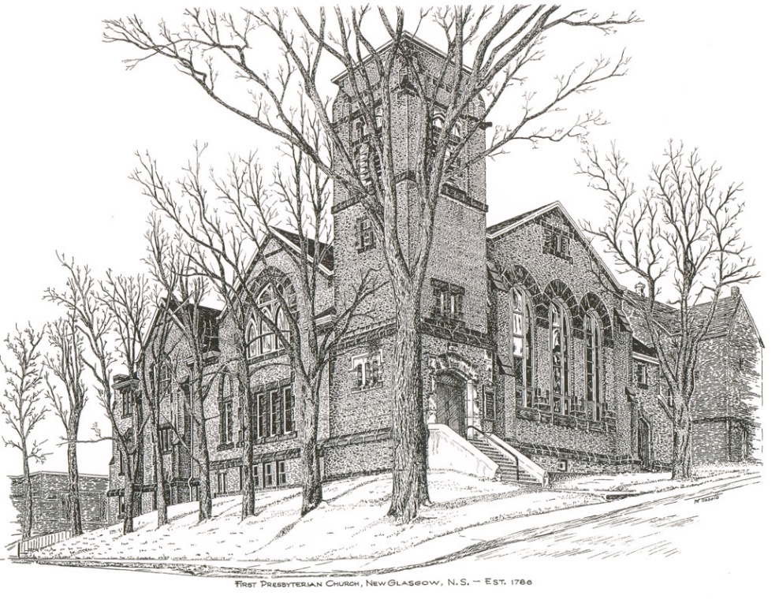

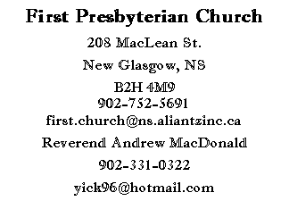
First Presbyterian Church
208 MacLean St.
New Glasgow, NS
B2H 4M9
902-752-5691 first.church@ns.aliantzinc.ca
Reverend Andrew MacDonald
902-331-0322
yick96@hotmail.com

First Presbyterian Church
208 MacLean St.
New Glasgow, NS
B2H 4M9
902-752-5691 first.church@ns.aliantzinc.ca
Reverend Andrew MacDonald
902-331-0322
yick96@hotmail.com

August 8, 2021
12th Sunday after Pentecost

THE APPROACH

Musical Prelude
Welcome and Announcements
Lighting the Christ Candle: Please Rise
Responsive Reading:

ONE:
All: Come, Lord, and grant us peace.
ONE: Let us light a candle for goodness and virtue, and pray for our government leaders that they may have the courage and wisdom always to decide what is best for the common good. Let us pray for ourselves and for all religious leaders that we may always speak what is true and good and live accordingly.
All: Come, Lord, and grant us peace.
ONE: Let us now prepare our hearts to worship almighty God.
Musical Introit – Hymn # 377 -“Come, children, join to sing” (v. 1)
Call to Worship
Hymn #459 – “O servants of God (v. 1, 4)”
Prayer of Adoration and Confession
Assurance of Pardon
Passing of the Peace
Hymn # 667 – “God, you touch the earth with beauty” (v. 1,3)
Prayer of Illumination
Scripture: Ephesians 5:15-20
Gospel Reading: John 6:51-58

Anthem: Solo – Justin Savage – “When peace, like a river”

Sermon - "All Thanks Be To God"
Hymn # 669 - “And Jesus said, our God is like a shepherd” (v. 1,3)
Offertory Prayer
Hymn #651 – Guide me, O thou great Redeemer” (v. 1,3)
Benediction
Musical Recessional

THIS MORNING:

Soloist: Justin Savage
Thanks to Justin Savage, Sharon Mason and Diane Bagnell for singing this morning.

ANNOUNCEMENTS

PASTORAL CARE:
- In order to provide support to the people of First Church, when you or a loved one is sick or in hospital, we encourage you to contact the church (902-752-5691), Reverend Andrew (902-331-0322) or Phoebe Fraser, Chair of the Pastoral Care Team (902-752-4728), to inform us directly. It is also important that you inform the hospital that you would welcome a visit from your minister and/or your Elder.

F.A.I.R. Hearts:
- Until further notice, donations of household items cannot be accepted for F.A.I.R Hearts at this time. Fundraising efforts continue and monetary donations may be made via mail, drop off in the mail slot at the church or via etransfer to the church email address (remember to email the answer to your question via separate message). We will let you know as soon as we are able to collect household items again. Thank you for your ongoing support of this important fundraiser.

- We will be gathering quality used items for yard sales that will be held during the summer as well as new or gently used items that can be used for our online auctions. Please contact Fair Hearts members for more info or item pick up. Members of FAIR Hearts from First Church are: Rev. Andrew MacDonald (902-331-0322), Sharon Mason (902-752-0724), Sara Fullerton (902-754-2142), and Brent MacQuarrie (902) 616-7787).

- Many positive comments were received when the church was decorated for Easter. As a result, we are asking for donations of artificial flowers. If you have any you would like to contribute, please drop them off at the church office or bring them with you when you come to church on Sundays.

UPCOMING EVENTS
- MEETINGS THIS WEEK: The FAIR Hearts committee will meet Monday, Aug. 16th at 7:00 p.m. in the Upper Hall. THIS IS A VERY IMPORTANT MEETING, PLEASE PLAN TO ATTEND

HAPPY ANNIVERSARY!

The Congregation would like to extend best wishes to Donald and Marion Johnstone as they celebrate their 63rd anniversary tomorrow, August 16th.

Minister: Rev. Andrew MacDonald (c) 902-331-0322
Organist: Lloyd MacLean
Office hours: Tues. to Fri. – 10 -1pm
Rev. MacDonald office hours -Tues. to Fri. 10-2 or by appointment

Mission Statement: But he’s already made it plain how to live, what to do, what God is looking for in men and women. It’s quite simple. Do what is fair and just to your neighbor, be compassionate and loyal in your love, and don’t take yourself too seriously – take God seriously. Micah 6: 8-The Message

