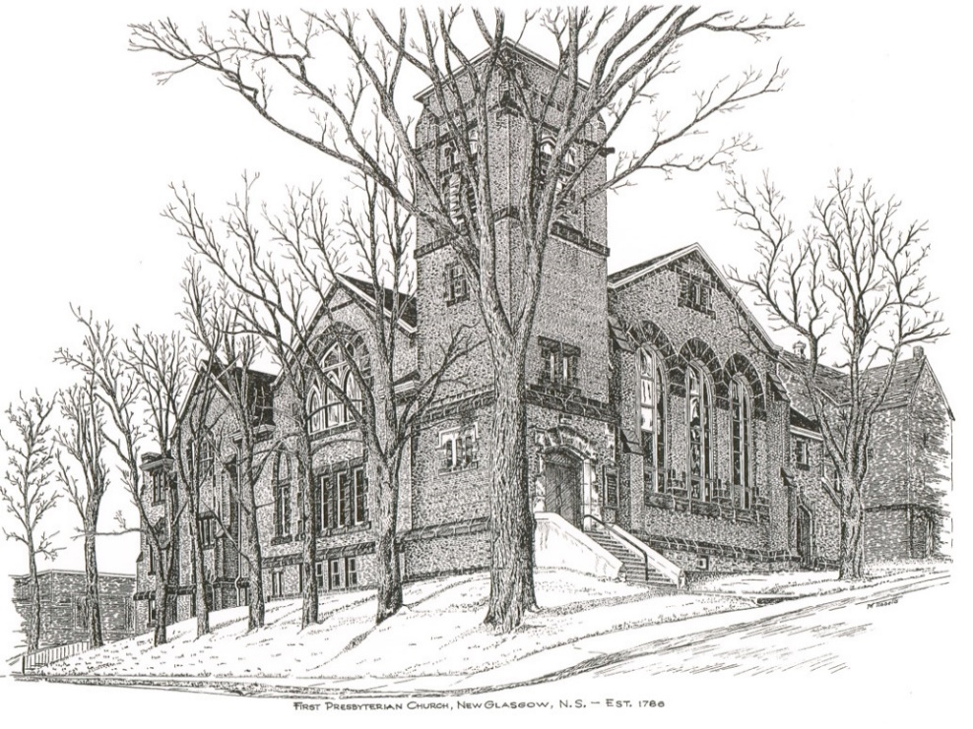

FIRST PRESBYTERIAN CHURCH
208 MacLean St., New Glasgow, NS
902-752-5691
First.church@ns.aliantzinc.ca
Reverend Andrew MacDonald
902-331-0322
Yick96@hotmail.com

First Presbyterian Church
208 MacLean St.
New Glasgow, NS
B2H 4M9
902-752-5691 first.church@ns.aliantzinc.ca
Reverend Andrew MacDonald
902-331-0322
yick96@hotmail.com

First Presbyterian Church
208 MacLean St.
New Glasgow, NS
B2H 4M9
902-752-5691 first.church@ns.aliantzinc.ca
Reverend Andrew MacDonald
902-331-0322
yick96@hotmail.com

August 22, 2021
13th Sunday after Pentecost

THE APPROACH

Musical Prelude
Welcome and Announcements
Lighting the Christ Candle: Please Rise
ONE: Let us light a candle in thanksgiving, and pray for all who are engaged in volunteer work, that it may lead them to deep spiritual peace. Let us pray for our parishes and families, for the sick and dying and for all Christians, that we may be true companions on the journey..
All: Come, Lord, and grant us peace.
ONE: Let us now prepare our hearts to worship almighty God.
Musical Introit
Call to Worship
Hymn: #776 - “Jesus, life of all the world”
Prayer of Confession and Pardon
Assurance of Pardon
Passing the Peace
Hymn: #533 – “Deck thyself, my soul, with gladness”
Prayer of Illumination
First Lesson: Ephesians 6:10-20
Gospel Lesson: John 6:56-69
Anthem – Guest Soloist - Ann Holton Melong
Sermon: "There is Power in Prayer"
Hymn: #699 – “All the way my Saviour leads me
Offertory Prayer
Reaffirmation of Faith – Please rise
I believe in God the Father Almighty, Maker of Heaven and Earth.
And in Jesus Christ His only Son our Lord, Who was conceived by the Holy Ghost, born of the Virgin Mary, suffered under Pontius Pilate, was crucified, dead, and was buried; He descended into Hell. The third day He rose again from the dead; He ascended into Heaven, and sits on the right hand of God the Father Almighty, from thence He shall come to judge the quick and the dead.
I believe in the Holy Ghost; the Holy Catholic Church; the communion of saints; the forgiveness of sins; the resurrection of the body; and the life everlasting. Amen.

Prayer of the People

Hymn: # 764 – “There’s a spirit in the air”

Benediction
Recessional

THIS MORNING:

Guest Soloist: Ann Holton Melong

ANNOUNCEMENTS

PASTORAL CARE:
- In order to provide support to the people of First Church, when you or a loved one is sick or in hospital, we encourage you to contact the church (902-752-5691), Reverend Andrew (902-331-0322) or Phoebe Fraser, Chair
- of the Pastoral Care Team (902-752-4728), to inform us directly. It is also important that you inform the hospital that you would welcome a visit from your minister and/or your Elder.
F.A.I.R. Hearts:
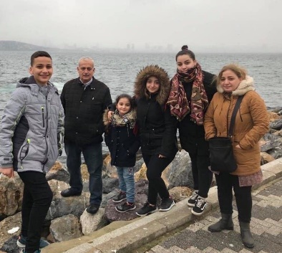
- Until further notice, donations of household items cannot be accepted for F.A.I.R Hearts at this time. Fundraising efforts continue and monetary donations may be made via mail, drop off in the mail slot at the church or via etransfer to the church email address (remember to email the answer to your question via separate message). We will let you know as soon as we are able to collect household items again. Thank you for your ongoing support of this important fundraiser.

- We will be gathering quality used items for yard sales that will be held during the summer as well as new or gently used items that can be used for our online auctions. Please contact Fair Hearts members for more info or item pick up. Members of FAIR Hearts from First Church are: Rev. Andrew MacDonald (902-331-0322), Sharon Mason (902-752-0724), Sara Fullerton (902-754-2142), and Brent MacQuarrie (902) 616-7787).

- Many positive comments were received when the church was decorated for Easter. As a result, we are asking for donations of artificial flowers. If you have any you would like to contribute, please drop them off at the church office or bring them with you when you come to church on Sundays.

UPCOMING EVENTS
- We will celebrate Communion next Sunday, Aug. 29th
- Session will meet after service next Sunday.
- First Church presents “Musique Royale”, featuring Balazs Barnkopf, one of Hungary’s most talented organists and guest soprano, Janelle Lucyk, in concert next Saturday, Aug. 28th at 7 p.m. Tickets are $20. To reserve a seat, please call 902-396-6147.

HAPPY ANNIVERSARY!

The Congregation would like to extend best wishes to the following couples celebrating special anniversaries this week:
- Larry and Robin MacLeod
- David and Marilyn Jnston
- John and Brenda Zinck
- Keith and Shirley Cruickshank
Minister: Rev. Andrew MacDonald (c) 902-331-0322
Organist: Lloyd MacLean
Office hours: Tues. to Fri. – 10 -1pm
Rev. MacDonald office hours -Tues. to Fri. 10-2 or by appointment

Mission Statement: But he’s already made it plain how to live, what to do, what God is looking for in men and women. It’s quite simple. Do what is fair and just to your neighbor, be compassionate and loyal in your love, and don’t take yourself too seriously – take God seriously. Micah 6: 8-The Message

