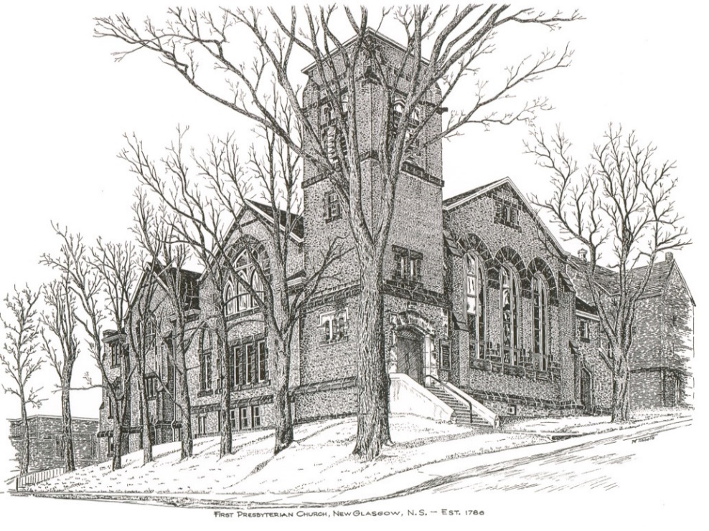

FIRST PRESBYTERIAN CHURCH
208 MacLean St., New Glasgow, NS
902-752-5691
First.church@ns.aliantzinc.ca
Reverend Andrew MacDonald
902-331-0322
Yick96@hotmail.com

First Presbyterian Church
208 MacLean St.
New Glasgow, NS
B2H 4M9
902-752-5691 first.church@ns.aliantzinc.ca
Reverend Andrew MacDonald
902-331-0322
yick96@hotmail.com

First Presbyterian Church
208 MacLean St.
New Glasgow, NS
B2H 4M9
902-752-5691 first.church@ns.aliantzinc.ca
Reverend Andrew MacDonald
902-331-0322
yick96@hotmail.com

August 29th, 2021
14th Sunday after Pentecost

THE APPROACH

Musical Prelude
Welcome and Announcements
Lighting the Christ Candle: Please Rise
ONE: Let us light a candle for hope and pray for God’s blessing upon each one and all, that we may have a life-filled, peaceful League year. Let us pray for those who have died this past year, especially the victims of terrorism and natural disasters and for those how gave their lives in acts of heroism and martyrdom; that they may behold God face-to-face.
All: Come, Lord, and grant us peace.
ONE: Let us now prepare our hearts to worship almighty God.
Musical Introit – Hymn # 538 – “You satisfy the hungry heart” (Refrain only)
Call to Worship
Hymn: #53 - “How lovely, Lord, how lovely” (v 1, 3)
Prayer of Confession and Pardon
Assurance of Pardon
Passing the Peace
Hymn: #690 – “Fight the good fight” (v 1,4)
Prayer of Illumination
First Lesson: James 1:17-27
Gospel Lesson: Mark 7:1-8,14-15,21-23
Anthem – Guest Soloist – Shaun McLean, singing a medley of “Lean on Me/Precious Lord, take my hand”.
Sermon: " Washing your hands with more than water"
Hymn: #551 – “Bread of the world” (v1, English)
Offertory Prayer

The Sacrament of Holy Communion (see insert)

Prayer of the People

Hymn: #571 – “Lord, I want to be a Christian” (v1,4)

Benediction

Recessional

THIS MORNING:

Guest Soloist: Shaun McLean

HOLY COMMUNION

Invitation to the Lord’s Supper
The Invitation
Communion Hymn #540 One bread, one body vs. 1 & 2
Affirmation of Faith Apostle’s Creed

I believe in God the Father Almighty, Maker of heaven and earth; And in Jesus Christ His only Son our Lord, who was conceived by the Holy Ghost, born of the Virgin Mary, suffered under Pontuis Plate, was crucified, dead and buried; He descended into hell. The third day He rose again from the dead; He ascended into heaven, and sits on the right hand of God the Father Almighty; from thence He shall come to judge the quick and the dead.
I believe in the Holy Ghost; the Holy Catholic Church; the communion of saints; the forgiveness of sins; the resurrection of the body; and the life everlasting. AMEN
Great Prayer of Thanksgiving:
ONE: The Lord be with you.
ALL: And also with you.
ONE: Lift up your hearts.
ALL: We lift them to the Lord.
ONE: Let us give thanks to the Lord our God.
ALL: It is right to give God thanks and praise.
ONE:…So now, with all the apostles and prophets, and that great cloud of witnesses who live forever with you in the heavenly kingdom, we join our voices in thanksgiving and in praise to you saying:
ALL: Holy, holy, holy Lord, God of power and might,
heaven and earth are full of your glory.
Hosanna in the highest.
Blessed is he who comes in the name of the Lord.
Hosanna in the highest.

ONE:…Therefore, today we gather in remembrance of the sacrifice that was made for our sakes. We have set aside this bread and this wine, as a celebration feast, a meal of remembrance. In doing so we also give praise and thanksgiving to you Lord God, as we proclaim the great mystery of faith:
ALL: Christ has died,
Christ is risen,
Christ will come again.

ONE: Let us join together as we lift up our voices and say the prayer that our Lord Jesus Christ taught us to prey when he said:
ALL: Our Father, who art in heaven, hallowed be thy name, thy kingdom come, thy will be done on earth as it is in heaven. Give us this day, our daily bread, and forgive us our debts as we forgive our debtors. And lead us not into temptation, but deliver us from evil. For thine is the kingdom, the power and the glory forever. Amen.

The Sacrament of Holy Communion
Communion Hymn #540 One bread, one body vs. 3 & 4
Hosanna in the highest.

ONE:…Therefore, today we gather in remembrance of the sacrifice that was made for our sakes. We have set aside this bread and this wine, as a celebration feast, a meal of remembrance. In doing so we also give praise and thanksgiving to you Lord God, as we proclaim the great mystery of faith:
ALL: Christ has died,
Christ is risen,
Christ will come again.

ONE: Let us join together as we lift up our voices and say the prayer that our Lord Jesus Christ taught us to prey when he said:
ALL: Our Father, who art in heaven, hallowed be thy name, thy kingdom come, thy will be done on earth as it is in heaven. Give us this day, our daily bread, and forgive us our debts as we forgive our debtors. And lead us not into temptation, but deliver us from evil. For thine is the kingdom, the power and the glory forever. Amen.

The Sacrament of Holy Communion
Communion Hymn #540 One bread, one body vs. 3 & 4

ANNOUNCEMENTS

PASTORAL CARE:
- In order to provide support to the people of First Church, when you or a loved one is sick or in hospital, we encourage you to contact the church (902-752-5691), Reverend Andrew (902-331-0322) or Phoebe Fraser, Chair of the Pastoral Care Team (902-752-4728), to inform us directly. It is also important that you inform the hospital that you would welcome a visit from your minister and/or your Elder.
F.A.I.R. Hearts:
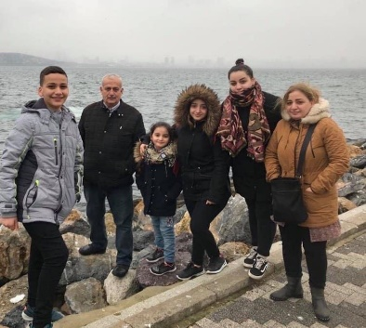
- Until further notice, donations of household items cannot be accepted for F.A.I.R Hearts at this time. Fundraising efforts continue and monetary donations may be made via mail, drop off in the mail slot at the church or via etransfer to the church email address (remember to email the answer to your question via separate message). We will let you know as soon as we are able to collect household items again. Thank you for your ongoing support of this important fundraiser.

- We will be gathering quality used items for yard sales that will be held during the summer as well as new or gently used items that can be used for our online auctions. Please contact Fair Hearts members for more info or item pick up. Members of FAIR Hearts from First Church are: Rev. Andrew MacDonald (902-331-0322), Sharon Mason (902-752-0724), Sara Fullerton (902-754-2142), and Brent MacQuarrie (902) 616-7787).

UPCOMING EVENTS
- Session will meet after church today
- Board of Managers will meet, Tuesday, Sept. 7th at 6:30 p.m.

HAPPY ANNIVERSARY!

The Congregation would like to extend best wishes to Larry and Robin MacLeod who are celebrating their anniversary today and to Rev. Dr. Morley Shaw and Mrs. Shaw on their 57th anniversary Tuesday, Aug. 31st.

Minister: Rev. Andrew MacDonald (c) 902-331-0322
Organist: Lloyd MacLean
Office hours: Tues. to Fri. – 10 -1pm
Rev. MacDonald office hours -Tues. to Fri. 10-2 or by appointment

Mission Statement: But he’s already made it plain how to live, what to do, what God is looking for in men and women. It’s quite simple. Do what is fair and just to your neighbor, be compassionate and loyal in your love, and don’t take yourself too seriously – take God seriously. Micah 6: 8-The Message

