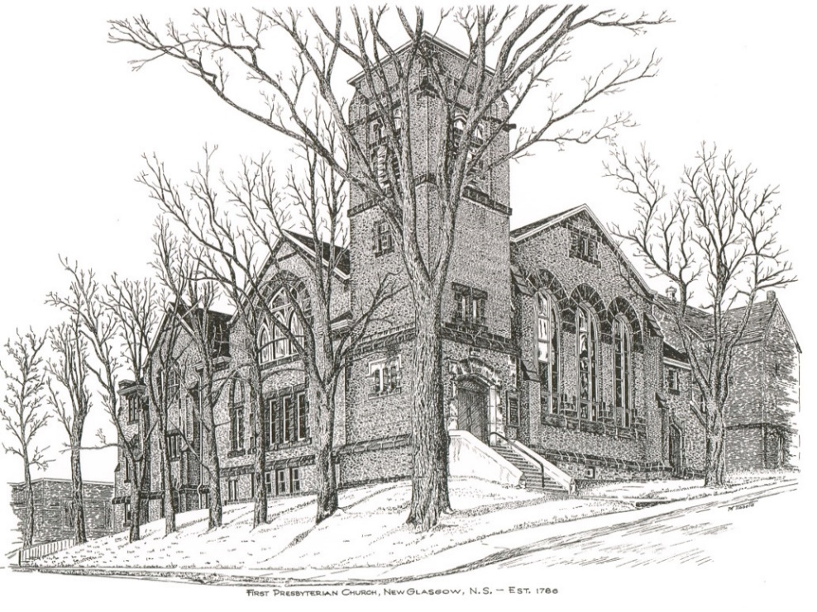

FIRST PRESBYTERIAN CHURCH
208 MacLean St., New Glasgow, NS
902-752-5691
First.church@ns.aliantzinc.ca
Reverend Andrew MacDonald
902-331-0322
Yick96@hotmail.com

First Presbyterian Church
208 MacLean St.
New Glasgow, NS
B2H 4M9
902-752-5691 first.church@ns.aliantzinc.ca
Reverend Andrew MacDonald
902-331-0322
yick96@hotmail.com

First Presbyterian Church
208 MacLean St.
New Glasgow, NS
B2H 4M9
902-752-5691 first.church@ns.aliantzinc.ca
Reverend Andrew MacDonald
902-331-0322
yick96@hotmail.com

September 12th, 2021
16th Sunday after Pentecost

THE APPROACH

Musical Prelude
Welcome and Announcements
Lighting the Christ Candle: Please Rise
ONE: As we have gathered together to worship almighty God, let us take a moment to bring our focus to this purpose. As I light this Christ Candle let us be reminded that Jesus said: “‘You are the light of the world. A city built on a hill cannot be hidden. No one after lighting a lamp puts it under the bushel basket, but on the lampstand, and it gives light to all in the house. In the same way, let your light shine before others, so that they may see your good works and give glory to your Father in heaven.” As this light shines, let the goodness of our Lord shine through us to the world. And when you leave this service of worship, share this light with those you love and the world, so no one need dwell in darkness.
All: Come, Lord, and grant us peace.
ONE: Let us now prepare our hearts to worship almighty God.
Musical Introit – Hymn # 251 (v5) – “Christ is alive”
Call to Worship
Hymn: #75 - “I love you, Lord, for you have heard my voice”
Prayer of Confession and Pardon
Assurance of Pardon
Passing the Peace
Hymn: #86 – “Those who rely on the Lord”
Prayer of Illumination

First Lesson: Proverbs 1:20-33
Epistle Lesson: James 3:1-12
Gospel Lesson: Mark 8:27-38
Anthem
Sermon: "Who do you say I am?"
Hymn: #787 – “The kingdom of God is justice and joy”
Offertory Prayer

Prayer of the People

Hymn: #736 – “For the healing of the nations”
Benediction

Recessional

Minister: Rev. Andrew MacDonald (c) 902-331-0322
Organist: Lloyd MacLean
Office hours: Tues. to Fri. – 10 -1pm
Rev. MacDonald office hours -Tues. to Fri. 10-2 or by appointment

Mission Statement: But he’s already made it plain how to live, what to do, what God is looking for in men and women. It’s quite simple. Do what is fair and just to your neighbor, be compassionate and loyal in your love, and don’t take yourself too seriously – take God seriously. Micah 6: 8-The Message

ANNOUNCEMENTS

PASTORAL CARE:
- In order to provide support to the people of First Church, when you or a loved one is sick or in hospital, we encourage you to contact the church (902-752-5691), Reverend Andrew (902-331-0322) or Phoebe Fraser, Chair of the Pastoral Care Team (902-752-4728), to inform us directly. It is also important that you inform the hospital that you would welcome a visit from your minister and/or your Elder.
F.A.I.R. Hearts:
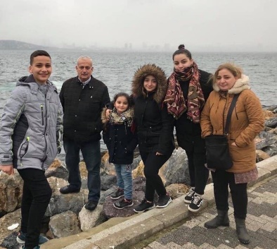
- Until further notice, donations of household items cannot be accepted for F.A.I.R Hearts at this time. Fundraising efforts continue and monetary donations may be made via mail, drop off in the mail slot at the church or via etransfer to the church email address (remember to email the answer to your question via separate message). We will let you know as soon as we are able to collect household items again. Thank you for your ongoing support of this important fundraiser.

- We will be gathering quality used items for yard sales that will be held during the summer as well as new or gently used items that can be used for our online auctions. Please contact Fair Hearts members for more info or item pick up. Members of FAIR Hearts from First Church are: Rev. Andrew MacDonald (902-331-0322), Sharon Mason (902-752-0724), Sara Fullerton (902-754-2142), and Brent MacQuarrie (902) 616-7787).

CONDOLENCES

Our condolences are extended to the family of Clarrie MacDonald. Clarrie’s family have a long history with First Presbyterian, including our late friend, Roger MacDonald.

UPCOMING EVENTS
- There are no meetings scheduled for this upcoming week.

- To all Members: The Elders will be delivering ballots this week, for nomination of new Elders. The ballots should be returned to your Elder, to the church office or to Rev. Andrew on or before September 26th, 2021.

- Sunday, September 19th we will be our Anniversary Service. Our guest Speaker will be the Reverend Dr. Morley Shaw. We will have Communion.

- Reminder – A Celebration of the Life of Burma Marshall will take place Sunday, September 19th at 3:00 p.m. here at First Presbyterian.

- September is Pediatric Cancer Awareness Month. The NS Chapter of“Ryan's Case for Smiles” has set a goal to sew 2,115 pillowcases for children with life -changing illnesses or injuries, the equivalent of I mile to sew during this month-long campaign. A Pillowcase Making Workshop is planned for Friday, Sept 24th at Pictou United Church from 9-3pm (pending Phase Covid Phase 5 opening). If you are interested in joining us, would like more information or to volunteer, contact Jane Williams at
902-755- 4764 or Janewilliams65@icloud.com.
GOOD NEWS!!

- We celebrate Teela this week as she received great news that her latest tests show, she no longer has lymphoma.

HAPPY BIRTHDAY!

- The Congregation would like to extend belated birthday wishes to Eunice Wood who celebrated her birthday September 7th and Laura Macumber who celebrated her birthday September 8th.

