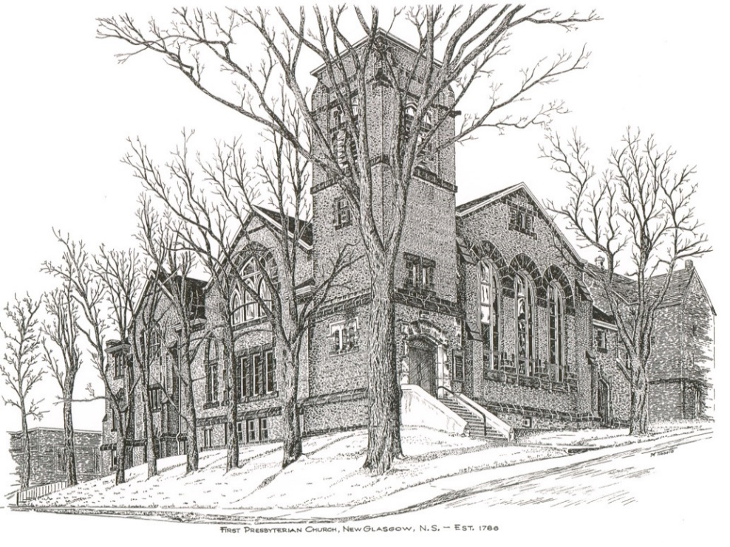

First Presbyterian Church
208 MacLean Street
New Glasgow, NS.
902-752-5691
First.church@ns.aliantzinc.ca
Reverend Andrew MacDonald
902-331-0322
Yick96@hotmail.com
Organist: Lloyd MacLean
FIRST PRESBYTERIAN CHURCH
September 19th, 2021
Anniversary Service
Guest Ministers - Reverend Dr. Morley Shaw and
Reverend Dr. Joon Ki Kim

THE APPROACH

Musical Prelude
Welcome and Announcements
Lighting the Christ Candle: Please Rise
ONE: As we have gathered together to worship almighty God, let us take a moment to bring our focus to this purpose. As I light this Christ Candle let us be reminded that Jesus said: “‘You are the light of the world. A city built on a hill cannot be hidden. No one after lighting a lamp puts it under the bushel basket, but on the lampstand, and it gives light to all in the house. In the same way, let your light shine before others, so that they may see your good works and give glory to your Father in heaven.” As this light shines, let the goodness of our Lord shine through us to the world. And when you leave this service of worship, share this light with those you love and the world, so no one need dwell in darkness.
All: Come, Lord, and grant us peace.
ONE: Let us now prepare our hearts to worship almighty God.
Musical Introit
Call to Worship
Hymn: #333 - “I sing the almighty power of God”
Prayer of Confession and Pardon - Rev. Dr. Joon Ki Kim
Passing the Peace

Hymn: #495 – “The Heavens declare your glory, O Lord”
Prayer of Illumination
Scripture Lessons: Rev. Dr. Morley Shaw
- First Lesson: Psalm 1
- Gospel Lesson: Matthew 1:1-17
Anthem – Janice Alcorn – “A Time for Everything” (Mark Hayes)
Sermon: "Looking both ways!" Rev. Dr. Morley Shaw
Hymn: #211 – “Take up your cross”
Offertory Prayer

The Sacrament of Holy Communion

Invitation to the Lord’s Supper

Communion Hymn: #543 – “Here, O my Lord, I see thee” (v.1-3)
Reaffirmation of Faith (see insert) - Please Rise
The Great Prayer of Thanksgiving (see insert)
The Sacrament of Holy Communion
Hymn: #543 – “Here, O my Lord, I see thee” (v.4-5)
Benediction

Recessional

ANNOUNCEMENTS

PASTORAL CARE:
- In order to provide support to the people of First Church, when you or a loved one is sick or in hospital, we encourage you to contact the church (902-752-5691), Reverend Andrew (902-331-0322) or Phoebe Fraser, Chair of the Pastoral Care Team (902-752-4728), to inform us directly. It is also important that you inform the hospital that you would welcome a visit from your minister and/or your Elder.
F.A.I.R. Hearts:
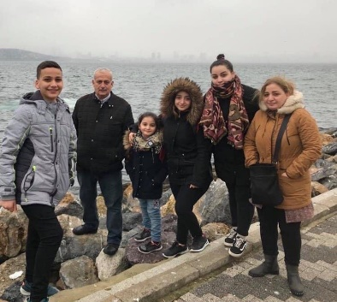
- Until further notice, donations of household items cannot be accepted for F.A.I.R Hearts at this time. Fundraising efforts continue and monetary donations may be made via mail, drop off in the mail slot at the church or via etransfer to the church email address (remember to email the answer to your question via separate message). We will let you know as soon as we are able to collect household items again. Thank you for your ongoing support of this important fundraiser.

- We will be gathering quality used items for yard sales that will be held during the summer as well as new or gently used items that can be used for our online auctions. Please contact Fair Hearts members for more info or item pick up. Members of FAIR Hearts from First Church are: Rev. Andrew MacDonald (902-331-0322), Sharon Mason (902-752-0724), Sara Fullerton (902-754-2142), and Brent MacQuarrie (902) 616-7787).

UPCOMING EVENTS
- Pictou Presbytery will meet at First Church, New Glasgow, on Tuesday, September 21st at 6 p.m.

- Members should have received their ballot for elder nominations by now. If you have not received a ballot, please contact the office. Ballots should be returned to your Elder, the church office or to Rev. Andrew on or before September 26th, 2021.

- September is Pediatric Cancer Awareness Month. The NS Chapter of“Ryan's Case for Smiles” has set a goal to sew 2,115 pillowcases for children with life -changing illnesses or injuries, the equivalent of I mile to sew during this month-long campaign. A Pillowcase Making Workshop is planned for Friday, Sept 24th at Pictou United Church from 9-3pm (pending Phase Covid Phase 5 opening). If you are interested in joining us, would like more information or to volunteer, contact Jane Williams at
902-755- 4764 or Janewilliams65@icloud.com.

- The Board of managers of First Presbyterian Church, Stellarton are looking to hire someone for lawn care/snow removal of the Church and Manse. If interested or know of someone who may be interested, please contact the Church office at 902-752-6548 or by email at sfpc@bellaliant.com, Attention: Board of Managers.

HAPPY BIRTHDAY!

- The Congregation would like to extend belated birthday wishes to Clarice Campbell who celebrated her birthday September 16th.

HOLY COMMUNION

Invitation to the Lord’s Supper
The Invitation
Communion Hymn #543 - “Here, O my Lord, I see thee” (v. 1-3)
Affirmation of Faith Apostle’s Creed

I believe in God the Father Almighty, Maker of heaven and earth; And in Jesus Christ His only Son our Lord, who was conceived by the Holy Ghost, born of the Virgin Mary, suffered under Pontuis Plate, was crucified, dead and buried; He descended into hell. The third day He rose again from the dead; He ascended into heaven, and sits on the right hand of God the Father Almighty; from thence He shall come to judge the quick and the dead.
I believe in the Holy Ghost; the Holy Catholic Church; the communion of saints; the forgiveness of sins; the resurrection of the body; and the life everlasting. AMEN
Great Prayer of Thanksgiving:
ONE: The Lord be with you.
ALL: And also with you.
ONE: Lift up your hearts.
ALL: We lift them to the Lord.
ONE: Let us give thanks to the Lord our God.
ALL: It is right to give God thanks and praise.
ONE:…So now, with all the apostles and prophets, and that great cloud of witnesses who live forever with you in the heavenly kingdom, we join our voices in thanksgiving and in praise to you saying:
ALL: Holy, holy, holy Lord, God of power and might,
heaven and earth are full of your glory.
Hosanna in the highest.
Blessed is he who comes in the name of the Lord.
Hosanna in the highest.

ONE:…Therefore, today we gather in remembrance of the sacrifice that was made for our sakes. We have set aside this bread and this wine, as a celebration feast, a meal of remembrance. In doing so we also give praise and thanksgiving to you Lord God, as we proclaim the great mystery of faith:
ALL: Christ has died,
Christ is risen,
Christ will come again.

ONE: Let us join together as we lift up our voices and say the prayer that our Lord Jesus Christ taught us to prey when he said:
ALL: Our Father, who art in heaven, hallowed be thy name, thy kingdom come, thy will be done on earth as it is in heaven. Give us this day, our daily bread, and forgive us our debts as we forgive our debtors. And lead us not into temptation, but deliver us from evil. For thine is the kingdom, the power and the glory forever. Amen.
The Sacrament of Holy Communion
Communion Hymn #543 - “Here, O my Lord, I see thee” (v. 4-5)

Reverend Andrew MacDonald - 902-331-0322
Yick96@hotmail.com
Organist: Lloyd MacLean
Office hours: Tues. to Fri. – 10a.m. - 1p.m.
Rev. MacDonald office hours -Tues. to Fri. 10a.m. – 2p.m. or by appointment

Mission Statement: But he’s already made it plain how to live, what to do, what God is looking for in men and women. It’s quite simple. Do what is fair and just to your neighbor, be compassionate and loyal in your love, and don’t take yourself too seriously – take God seriously. Micah 6: 8-The Message

