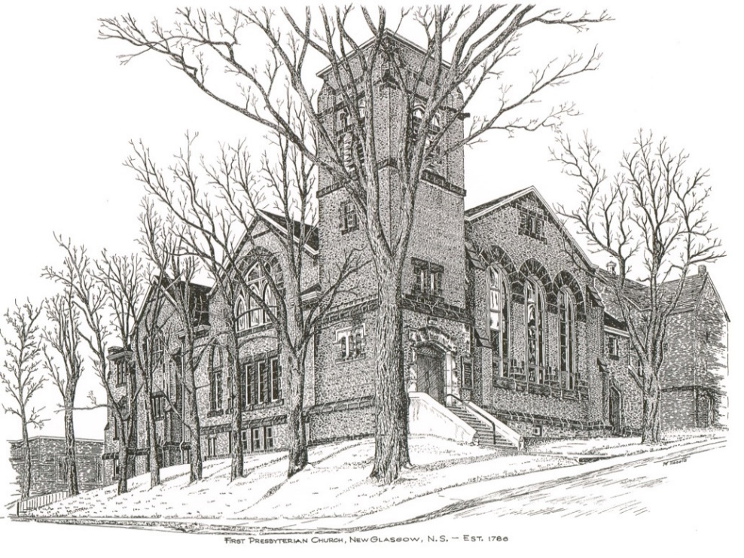

FIRST PRESBYTERIAN CHURCH
208 MacLean St., New Glasgow, NS
902-752-5691
First.church@ns.aliantzinc.ca
Reverend Andrew MacDonald
902-331-0322
Yick96@hotmail.com

First Presbyterian Church
208 MacLean St.
New Glasgow, NS
B2H 4M9
902-752-5691 first.church@ns.aliantzinc.ca
Reverend Andrew MacDonald
902-331-0322
yick96@hotmail.com

First Presbyterian Church
208 MacLean St.
New Glasgow, NS
B2H 4M9
902-752-5691 first.church@ns.aliantzinc.ca
Reverend Andrew MacDonald
902-331-0322
yick96@hotmail.com

September 26th, 2021
18th Sunday after Pentecost
Presbyterian Sharing Sunday

THE APPROACH

Musical Prelude
Welcome and Announcements
Lighting the Christ Candle: Please Rise
ONE: As we have gathered together to worship almighty God, let us take a moment to bring our focus to this purpose. As I light this Christ Candle let us be reminded that Jesus said: “‘You are the light of the world. A city built on a hill cannot be hidden. No one after lighting a lamp puts it under the bushel basket, but on the lampstand, and it gives light to all in the house. In the same way, let your light shine before others, so that they may see your good works and give glory to your Father in heaven.” As this light shines, let the goodness of our Lord shine through us to the world. And when you leave this service of worship, share this light with those you love and the world, so no one need dwell in darkness.
All: Come, Lord, and grant us peace.
ONE: Let us now prepare our hearts to worship almighty God.
Musical Introit – Hymn #251 (v. 5) – “Christ is Alive”
Call to Worship
Hymn # 296 – “The clay-stained hands of love”
Prayer of Confession and Pardon
Assurance of Pardon
Passing the Peace
Hymn: #272 - “Christ is King!”
Prayer of Illumination
First Lesson: Esther 7:1-6, 9-10
Second Lesson: James 5:13-2000
Anthem – “O Lord, my Rock, I cry aloud to You” – Sharon, Shirley & Justin
Sermon: "Feeling tempted? Cut it out!"
Hymn: #724 – “Come now, you blessed, eat at my table”
Offertory Prayer

Prayer of the People

Hymn: #585 – “Christ, you call us all to service”
Benediction

Recessional

Scripture Reader: Mark Thibeau

Minister: Rev. Andrew MacDonald (c) 902-331-0322
Organist: Lloyd MacLean
Office hours: Tues. to Fri. – 10 -1pm
Rev. MacDonald office hours -Tues. to Fri. 10-2 or by appointment

Mission Statement: But he’s already made it plain how to live, what to do, what God is looking for in men and women. It’s quite simple. Do what is fair and just to your neighbor, be compassionate and loyal in your love, and don’t take yourself too seriously – take God seriously. Micah 6: 8-The Message

ANNOUNCEMENTS

PASTORAL CARE:
- In order to provide support to the people of First Church, when you or a loved one is sick or in hospital, we encourage you to contact the church (902-752-5691), Reverend Andrew (902-331-0322) or Phoebe Fraser, Chair of the Pastoral Care Team (902-752-4728), to inform us directly. It is also important that you inform the hospital that you would welcome a visit from your minister and/or your Elder.
F.A.I.R. Hearts:
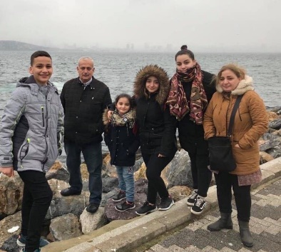
- Until further notice, donations of household items cannot be accepted for F.A.I.R Hearts at this time. Fundraising efforts continue and monetary donations may be made via mail, drop off in the mail slot at the church or via etransfer to the church email address (remember to email the answer to your question via separate message). We will let you know as soon as we are able to collect household items again. Thank you for your ongoing support of this important fundraiser.

- We will be gathering quality used items for yard sales that will be held during the summer as well as new or gently used items that can be used for our online auctions. Please contact Fair Hearts members for more info or item pick up. Members of FAIR Hearts from First Church are: Rev. Andrew MacDonald (902-331-0322), Sharon Mason (902-752-0724), Sara Fullerton (902-754-2142), and Brent MacQuarrie (902) 616-7787).

UPCOMING EVENTS
- There are no meetings scheduled for this upcoming week.

- There will be a Worship and Music Team meeting on Sunday, October 17/21 after church.

- Thursday, September 30th has been designated the “National Day for Truth and Reconciliation”. This day provides an opportunity for all Canadians to recognize and commemorate the legacy of residential schools. Sunday, October 3rd, we will welcome Chief Andrea Paul and members of the Pictou Landing First Nations.

- To all Members: Reminder that your ballots for the nomination of Elders are due today.

- Little Harbour Presbyterian Church Choir is hosting an outdoor concert this afternoon, at Acadia Park in Westville. Featuring Brenda and Brian Bowden and Sam Graham, the concert will take place at 1:30 p.m.

HAPPY BIRTHDAY!

- The Congregation would like to extend birthday wishes to Lorraine MacLean who will celebrate her birthday Wednesday, September 29th!

