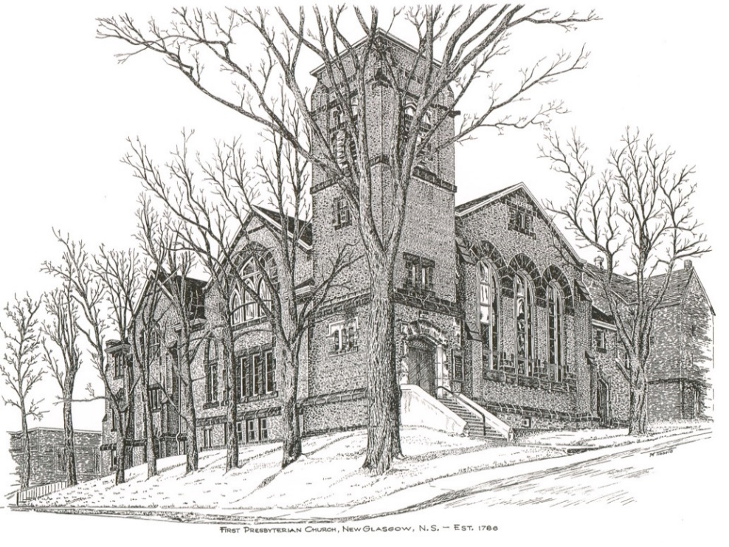

FIRST PRESBYTERIAN CHURCH
208 MacLean St., New Glasgow, NS
902-752-5691
First.church@ns.aliantzinc.ca
Reverend Andrew MacDonald
902-331-0322
Yick96@hotmail.com

First Presbyterian Church
208 MacLean St.
New Glasgow, NS
B2H 4M9
902-752-5691 first.church@ns.aliantzinc.ca
Reverend Andrew MacDonald
902-331-0322
yick96@hotmail.com

First Presbyterian Church
208 MacLean St.
New Glasgow, NS
B2H 4M9
902-752-5691 first.church@ns.aliantzinc.ca
Reverend Andrew MacDonald
902-331-0322
yick96@hotmail.com

September 5th, 2021
15th Sunday after Pentecost

THE APPROACH

Musical Prelude
Welcome and Announcements
Lighting the Christ Candle: Please Rise
ONE: As we have gathered together to worship almighty God, let us take a moment to bring our focus to this purpose. As I light this Christ Candle let us be reminded that Jesus said: “‘You are the light of the world. A city built on a hill cannot be hidden. No one after lighting a lamp puts it under the bushel basket, but on the lampstand, and it gives light to all in the house. In the same way, let your light shine before others, so that they may see your good works and give glory to your Father in heaven.” As this light shines, let the goodness of our Lord shine through us to the world. And when you leave this service of worship, share this light with those you love and the world, so no one need dwell in darkness.
All: Come, Lord, and grant us peace.
ONE: Let us now prepare our hearts to worship almighty God.
Musical Introit – Hymn # 432 – “O Lord of heaven and earth and sea”
Call to Worship
Hymn: #710 - “What does the Lord require of you”
Prayer of Confession and Pardon
Assurance of Pardon
Passing the Peace
Hymn: #756 – “O Christ, our Lord, we meet here as your people”
Prayer of Illumination
Epistle Lesson: James 2:1-13
Gospel Lesson: Mark 7:24-37
Anthem
Sermon: "Even the Dogs Receive Crumbs!"
Hymn: #663 – “God whose giving knows no ending”
Offertory Prayer

Prayer of the People

Benediction

Recessional

Minister: Rev. Andrew MacDonald (c) 902-331-0322
Organist: Lloyd MacLean
Office hours: Tues. to Fri. – 10 -1pm
Rev. MacDonald office hours -Tues. to Fri. 10-2 or by appointment

Mission Statement: But he’s already made it plain how to live, what to do, what God is looking for in men and women. It’s quite simple. Do what is fair and just to your neighbor, be compassionate and loyal in your love, and don’t take yourself too seriously – take God seriously. Micah 6: 8-The Message

ANNOUNCEMENTS

PASTORAL CARE:
- In order to provide support to the people of First Church, when you or a loved one is sick or in hospital, we encourage you to contact the church (902-752-5691), Reverend Andrew (902-331-0322) or Phoebe Fraser, Chair of the Pastoral Care Team (902-752-4728), to inform us directly. It is also important that you inform the hospital that you would welcome a visit from your minister and/or your Elder.
F.A.I.R. Hearts:
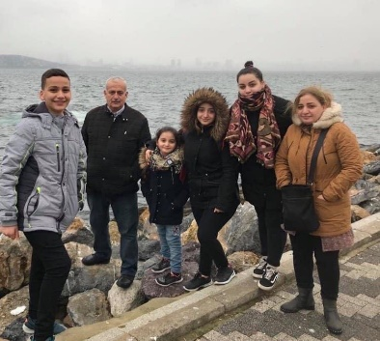
- Until further notice, donations of household items cannot be accepted for F.A.I.R Hearts at this time. Fundraising efforts continue and monetary donations may be made via mail, drop off in the mail slot at the church or via etransfer to the church email address (remember to email the answer to your question via separate message). We will let you know as soon as we are able to collect household items again. Thank you for your ongoing support of this important fundraiser.

- We will be gathering quality used items for yard sales that will be held during the summer as well as new or gently used items that can be used for our online auctions. Please contact Fair Hearts members for more info or item pick up. Members of FAIR Hearts from First Church are: Rev. Andrew MacDonald (902-331-0322), Sharon Mason (902-752-0724), Sara Fullerton (902-754-2142), and Brent MacQuarrie (902) 616-7787).

UPCOMING EVENTS
- The Board of Managers will meet, Tuesday, Sept. 7th at 6:30 p.m.

- September is Pediatric Cancer Awareness Month. The NS Chapter of“Ryan's Case for Smiles” has set a goal to sew 2,115 pillowcases for children with life -changing illnesses or injuries, the equivalent of I mile to sew during this month-long campaign. A Pillowcase Making Workshop is planned for Friday, Sept 24th at Pictou United Church from 9-3pm (pending Phase Covid Phase 5 opening). If you are interested in joining us, would like more information or to volunteer, contact Jane Williams at
902-755- 4764 or Janewilliams65@icloud.com.

THANK YOU!!

Thanks are extended to Murray Biggar and Chet Canning for installing the folding doors at the back of the sanctuary. It was a difficult job and we are grateful for their hard work.

HAPPY BIRTHDAY!

- The Congregation would like to extend belated birthday wishes to Barry Fraser of Timberlea. Barry celebrated his birthday September 3rd. Hope you had a great day!

