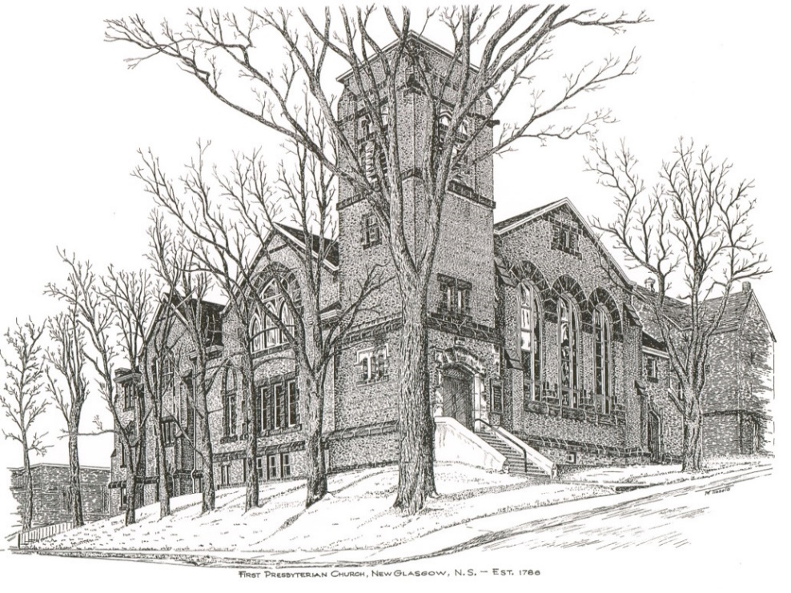

FIRST PRESBYTERIAN CHURCH
208 MacLean St., New Glasgow, NS
902-752-5691
First.church@ns.aliantzinc.ca
Reverend Andrew MacDonald
902-331-0322
Yick96@hotmail.com

First Presbyterian Church
208 MacLean St.
New Glasgow, NS
B2H 4M9
902-752-5691 first.church@ns.aliantzinc.ca
Reverend Andrew MacDonald
902-331-0322
yick96@hotmail.com

First Presbyterian Church
208 MacLean St.
New Glasgow, NS
B2H 4M9
902-752-5691 first.church@ns.aliantzinc.ca
Reverend Andrew MacDonald
902-331-0322
yick96@hotmail.com

October 3rd, 2021
19th Sunday after Pentecost

THE APPROACH

Musical Prelude
Welcome and Announcements
Lighting the Christ Candle: Please Rise
ONE: In the beginning when God created the heavens and the earth, the earth was a formless void and darkness covered the face of the deep, while a wind from God swept over the face of the waters. Then God said, ‘Let there be light’; and there was light. And God saw that the light was good; and God separated the light from the darkness. God called the light Day, and the darkness he called Night. As this light shines, let the goodness of our Lord shine through us to the world. And when you leave this service of worship, share this light with those you love and the world, so no one need dwell in darkness.
All: Come, Lord, and grant us peace.
ONE: Let us now prepare our hearts to worship almighty God.
Musical Introit – Hymn #251 (v. 5) – “Christ is Alive”
Call to Worship
Hymn #799 (v. 1,2,4) – “God is here! As we your people meet”
Prayer of Confession and Pardon
Assurance of Pardon
Passing the Peace
Hymn: #301 (v. 1,2) - “Many and great, O God, are your works”
Prayer of Illumination
First Lesson: Psalm 133
Second Lesson: 2 Corinthians 5:17-20
Gospel Lesson – Matthew 18:15-2
Anthem – Hymn #471 (v.1-4) - “We Are One in the Spirit” - Shirley, Diane, Sharon & Justin
Guest Speaker - Chief Andrea Paul, Pictou Landing First Nations
Sermon: "We are all God’s children!"
Hymn: #759 (v. 1-4) – “In loving partnership”
Offertory Prayer

Prayer of the People

Hymn: #762 (v. 1-4) – “When the poor ones”
Benediction

Recessional

Scripture Reader: Brent MacQuarrie

Minister: Rev. Andrew MacDonald (c) 902-331-0322
Organist: Lloyd MacLean
Office hours: Tues. to Fri. – 10 -1pm
Rev. MacDonald office hours -Tues. to Fri. 10-2 or by appointment

Mission Statement: But he’s already made it plain how to live, what to do, what God is looking for in men and women. It’s quite simple. Do what is fair and just to your neighbor, be compassionate and loyal in your love, and don’t take yourself too seriously – take God seriously. Micah 6: 8-The Message

ANNOUNCEMENTS

PASTORAL CARE:
- In order to provide support to the people of First Church, when you or a loved one is sick or in hospital, we encourage you to contact the church (902-752-5691), Reverend Andrew (902-331-0322) or Phoebe Fraser, Chair of the Pastoral Care Team (902-752-4728), to inform us directly. It is also important that you inform the hospital that you would welcome a visit from your minister and/or your Elder.
F.A.I.R. Hearts:
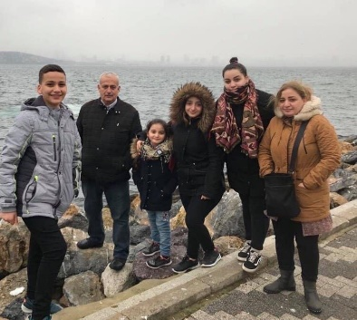
- Until further notice, donations of household items cannot be accepted for F.A.I.R Hearts at this time. Fundraising efforts continue and monetary donations may be made via mail, drop off in the mail slot at the church or via etransfer to the church email address (remember to email the answer to your question via separate message). We will let you know as soon as we are able to collect household items again. Thank you for your ongoing support of this important fundraiser.

- We will be gathering quality used items for yard sales that will be held during the summer as well as new or gently used items that can be used for our online auctions. Please contact Fair Hearts members for more info or item pick up. Members of FAIR Hearts from First Church are: Rev. Andrew MacDonald (902-331-0322), Sharon Mason (902-752-0724), Sara Fullerton (902-754-2142), and Brent MacQuarrie (902) 616-7787).

UPCOMING EVENTS
- The Trustees will meet Monday, Oct. 4th at 5pm.

- The Board of Managers will meet Tuesday, Oct. 5th at 6:30 p.m.

- There will be a meeting of the Worship and Music Team, Sunday, October 17th after church.

IN MEMORIAM
- A donation has been received from Karen Garner, Stony Plain, Alberta, in memory of her parents Vera and Arnold Campbell, her brother Glen Campbell and her aunt, Katherine Stewart. Karen and her family were members of First for many years.

COMMUNITY EVENT

- Middle River Church, 59 E. Fraser Crossroad, will host a Quilt/Craft Tea and Sale, Sat., Oct. 16th from 10 a.m. to 4 p.m. Admission $5.00. Masks & social distancing required.

CONGRATULATIONS!

- The Congregation would like to extend birthday wishes to Ellen Jardine who celebrates her birthday today!!

The Congregation would also like to extend belated wishes to Ralph and Dorothy Holmes who celebrated their 68th wedding anniversary, Friday, October 1st.
Go forth in the world in peace
Have courage
Hold fast to that which is good
Render to no evil for evil
Strengthen the fainthearted
Support the weak
Help the afflicted
Honour all people
LOVE and serve the Lord with gladness
Rejoicing in the power of the Holy Spirit.

First Presbyterian Church
Mission, Texas

(Submitted by Sharon Mason)

