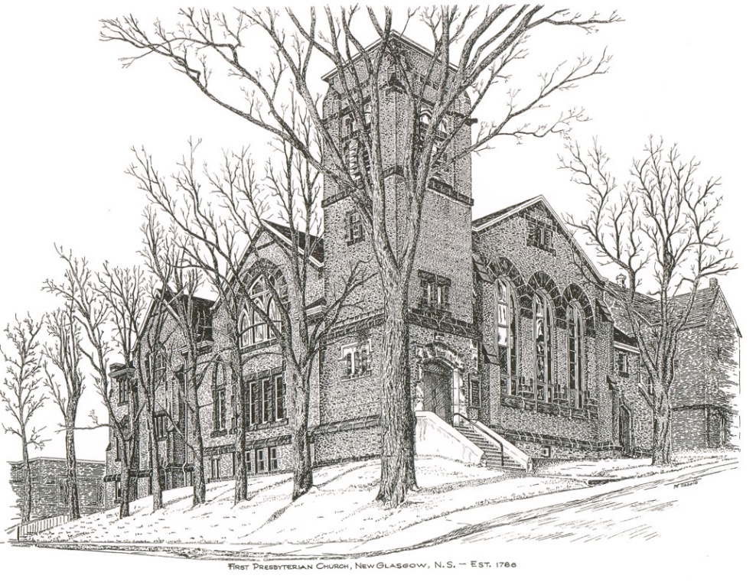

FIRST PRESBYTERIAN CHURCH
208 MacLean St., New Glasgow, NS
902-752-5691
First.church@ns.aliantzinc.ca
Reverend Andrew MacDonald
902-331-0322
Yick96@hotmail.com
November 14th, 2021
25th Sunday after Pentecost

THE APPROACH

Musical Prelude
Welcome and Announcements
Lighting the Christ Candle: Please Rise
One: In this Season of the Spirit we light a candle, reminding us of the fire of hope and freedom
All: As this flame flickers in our midst, we commit ourselves to spread its light and heat in the world
One: Over the centuries, God has spoken through many prophets.
All: May the light of this candle remind us that God is still speaking to us and to the world.
One: Gathered as Spirit-filled disciples of Christ, we quiet our hearts for worship
Musical Introit
Call to Worship
Hymn #425 – “We praise you, O God”
Prayer of Confession and Pardon
Assurance of Pardon
Passing the Peace
Hymn: #682 – “Just as I am, without one plea”
Prayer of Illumination
First Lesson: Amos 5:18-24
Epistle Lesson: 1 Thessalonians 4:13-18
Gospel Lesson: Matthew 25:1-13
Anthem – Choir
Sermon: "Here comes the groom!"
Hymn: #231 – “When I survey the wondrous cross”
Offertory Prayer

Reaffirmation of Faith

Prayer of the People and the Lord’s Prayer

Hymn: #351 – “There is a fountain opened wide”
Benediction

Recessional

Scripture Reader: Sharon Mason
************************************

Minister: Rev. Andrew MacDonald (c) 902-331-0322
Organist: Lloyd MacLean
Office hrs: Tues. to Fri. – 10 -1pm
Rev. MacDonald office hours -Tues. to Fri. 10-2 or by appointment

Mission Statement: But he’s already made it plain how to live, what to do, what God is looking for in men and women. It’s quite simple. Do what is fair and just to your neighbor, be compassionate and loyal in your love, and don’t take yourself too seriously – take God seriously. Micah 6: 8-The Message

ANNOUNCEMENTS

PASTORAL CARE:
In order to provide support to the people of First Church, when you or a loved one is sick or in hospital, we encourage you to contact the church (902-752-5691), Reverend Andrew (902-331-0322) or Phoebe Fraser, Chair of the Pastoral Care Team (902-752-4728), to inform us directly. It is also important that you inform the hospital that you would welcome a visit from your minister and/or your Elder.
F.A.I.R. HEARTS - UPDATE:

The meeting with Representatives of F.A.I.R. Hearts and Sean Fraser has been re-scheduled. A further update will be provided at that time.
FAIR Hearts members from First Church are: Rev. Andrew MacDonald (902-331-0322), Sharon Mason (902-752-0724), Sara Fullerton (902-754-2142), and Brent MacQuarrie (902) 616-7787).

BEST WISHES

The congregation sends our best wishes to David Johnstone as he recovers from his successful open-heart surgery earlier this week.

CONDOLENCES

The Congregation extends our deepest sympathies to the family of Jean MacDonald.

IN MEMORIAM
An in-memoriam donation has been received in memory of Marilyn MacLeod from her sisters Beverly Chennell, Sheila MacMillan and Christine Bonaparte.
THANK YOU!
Thank you to Larry MacLeod for donating and installing a new First Aid Kit, located below the AED (defibrillator) in the vestibule

Thank You to everyone who participated in the Poppy Campaign. Though it was short notice, to date, we collected $515.00 for the Legion. They are very grateful for the assistance in fundraising during this second year of the pandemic.
**The “List of the Fallen” from First Presbyterian and Westminster Churches was inadvertently omitted from the Remembrance Sunday bulletin. It is with respect and gratitude, the list is included today.
.
UPCOMING EVENTS
- Trinity United is hosting “Mount Allison Bursary Concert”, this afternoon at 3p.m. The concert is in support of an education bursary and features many local Mount Allison musical alumni. Admission $10.00.
- A Presbytery Service of Dissolution/Closing of St. Luke’s Presbyterian Church, Saltsprings, will take place on November 21st, 2021, at 2 p.m. If you cannot attend this service, please keep the members of this congregation and pastoral charge in your thoughts and prayers as they move forward.
- Ruth Ann MacIntosh and Sara Fullerton are coordinating the decorating of the sanctuary for Christmas on Thursday, Nov. 25th beginning at 5:30 p.m. Any volunteers would be appreciated!
- Sheila Dempster is coordinating the annual Christmas Memory Tree fundraiser again this year. The forms are available for pickup inside the sanctuary. The deadline for requests will be December 15th. If you would like to donate a ball(s), simply fill out the form and leave it, along with the donation, in the collection baskets. The Christmas Eve bulletin will list the names of those remembered and the donors.
- Return of Coffee Hour – Session has decided we can return to coffee hour after church on Sundays, beginning today. Though there is no need to show Proof of Vaccination to attend services, any other gatherings such as coffee hour, meetings etc., do require Proof of Vaccination per Dept. of Health regulations. Cathy Lewis and Larry MacLeod are coordinating this and are asking for volunteers to supply cookies, muffins etc. for future Sundays.

