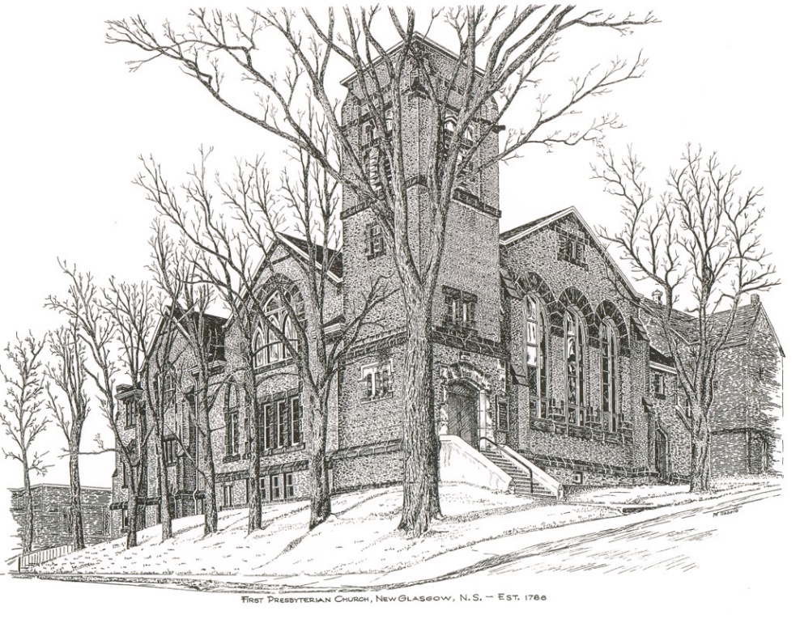

FIRST PRESBYTERIAN CHURCH
208 MacLean St., New Glasgow, NS
902-752-5691
First.church@ns.aliantzinc.ca
Reverend Andrew MacDonald
902-331-0322
yick96@hotmail.com

November 21st, 2021
26th Sunday after Pentecost
Reign of Christ Sunday

THE APPROACH

Musical Prelude
Welcome and Announcements
Lighting the Christ Candle: Please Rise
One: In this Season of the Spirit we light a candle, reminding us of the fire of hope and freedom
All: As this flame flickers in our midst, we commit ourselves to spread its light and heat in the world
One: Over the centuries, God has spoken through many prophets.
All: May the light of this candle remind us that God is still speaking to us and to the world.
One: Gathered as Spirit-filled disciples of Christ, we quiet our hearts for worship
Musical Introit
Call to Worship
Hymn #267 – “Rejoice, the Lord is King” (vs. 1,2, 5)
Prayer of Confession and Pardon
Assurance of Pardon
Passing the Peace
Hymn: #607 –“Ye watchers and ye holy ones” (vs. 1,2, 4)
Prayer of Illumination
First Lesson: 2 Samuel 23: 1-7
Epistle Lesson: Revelation 1:4-8
Gospel Lesson: Luke 23: 26-43
Anthem – Choir – “I’ll Love the Lord” (Iona Community)
Sermon: "Christ is King!"
Reaffirmation of Faith

Hymn: #363 – “All hail the power of Jesus’ name” (vs. 1,2, 5)

Offertory Prayer

Prayer of the People and the Lord’s Prayer

Hymn: #274 – “Crown him with many crowns”
Benediction

Recessional

Scripture Reader: Clarice Campbell

♫♫♫♫♫♫♫♫♫♫♫♫♫♫♫♫♫♫♫♫♫

Minister: Rev. Andrew MacDonald (c) 902-331-0322
Organist: Lloyd MacLean
Office hrs: Tues. to Fri. – 10 -1pm
Rev. MacDonald office hours -Tues. to Fri. 10-2 or by appointment

Mission Statement: But he’s already made it plain how to live, what to do, what God is looking for in men and women. It’s quite simple. Do what is fair and just to your neighbor, be compassionate and loyal in your love, and don’t take yourself too seriously – take God seriously. Micah 6: 8-The Message

This Brand New Day
This brand new day I go in faith,
But I know not what lies in wait,
So dear God, this morning I pray,
Take control and lead the way.
I do not see with these two eyes,
I cannot tell where danger lies.
Please, dear Lord, be my guide.
Let me not stray from Your side.
Show me today the journeys to make.
Steer me on the right paths to take.
Grant me grace to discern your will,
For when to strive and when to be still.
Help me to love and trust You more
And radiate Your love to my neighbor.
Then bring me back safe and sound,
And let my praise for You abound.
Amen
By Abimbola T. Alabi
Published: March 2018

ANNOUNCEMENTS
PASTORAL CARE:
In order to provide support to the people of First Church, when you or a loved one is sick or in hospital, we encourage you to contact the church (902-752-5691), Reverend Andrew (902-331-0322) or Phoebe Fraser, Chair of the Pastoral Care Team (902-752-4728), to inform us directly. It is also important that you inform the hospital that you would welcome a visit from your minister and/or your Elder.
F.A.I.R. HEARTS - UPDATE:

The meeting with Representatives of F.A.I.R. Hearts and Sean Fraser has been re-scheduled. A further update will be provided at that time.
FAIR Hearts members from First Church are: Rev. Andrew MacDonald (902-331-0322), Sharon Mason (902-752-0724), Sara Fullerton (902-754-2142), and Brent MacQuarrie (902) 616-7787).

BEST WISHES

The congregation sends our best wishes to Ella Russell as she celebrates her birthday November 24th.

IN MEMORIAM
An in-memoriam donation to the Benevolent Fund has been received in memory of Jean MacDonald from Pheobe Fraser.
UPCOMING EVENTS
- A Presbytery Service of Dissolution/Closing of St. Luke’s Presbyterian Church, Saltsprings, will take place this afternoon, November 21st, 2021, at 2 p.m. If you cannot attend this service, please keep the members of this congregation and pastoral charge in your thoughts and prayers as they move forward.

CHRISTMAS NOTES:

- Ruth Anne MacIntosh and Sara Fullerton are coordinating the decorating of the sanctuary for Christmas on Thursday, Nov. 25th beginning at 5:30 p.m. Any volunteers would be appreciated!
They are also looking for an artificial Christmas tree, lights and tree decorations for the Upper Hall. If anyone has anything that they would like to donate, it would be appreciated.
- Sheila Dempster is coordinating the annual Christmas Memory Tree fundraiser again this year. The forms are available for pickup inside the sanctuary. The deadline for requests will be December 15th. If you would like to donate a ball(s), simply fill out the form and leave it, along with the donation, in the collection baskets. The Christmas Eve bulletin will list the names of those remembered and the donors.
- Reverend Andrew is looking for 5 volunteer readers for the Christmas Eve service and also a family to light the Christ Candle at that service. If you are available to help, please contact Rev. Andrew ASAP.
- Return of Coffee Hour – Session has decided we can return to coffee hour after church on Sundays. Though there is no need to show Proof of Vaccination to attend services, any other gatherings such as coffee hour, meetings etc., do require Proof of Vaccination per Dept. of Health regulations. Cathy Lewis and Larry MacLeod are coordinating this and are asking for volunteers to supply cookies, muffins etc. for future Sundays.

