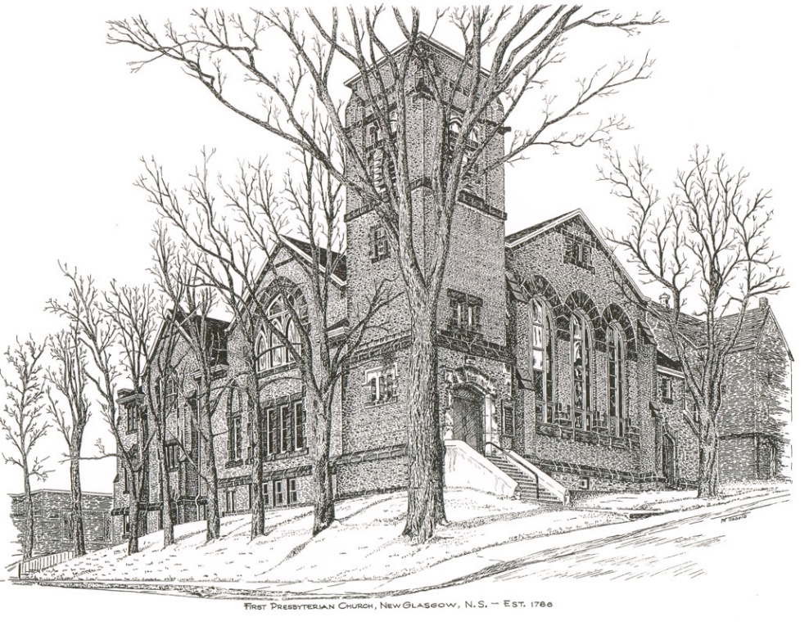

FIRST PRESBYTERIAN CHURCH
208 MacLean St., New Glasgow, NS
902-752-5691
First.church@ns.aliantzinc.ca
Reverend Andrew MacDonald
902-331-0322
yick96@hotmail.com

December 12th, 2021
ADVENT 4 - LOVE

THE APPROACH

Musical Prelude - Brass United Quintet –
- “He is Born” (arr. Lawrence Eden)
- “Gesu Bambino” (arr. Howard Rowe)
- “O Thou That Tellest Tidings to Zion” (G.F. Handel)

Welcome and Announcements
Musical Introit 114 – Emmanuel, Emmanuel
Call to Worship
Hymn #126 – “On Jordan’s bank” (vs 1,2,5)
Prayer of Confession and Pardon
Assurance of Pardon
Passing the Peace
Hymn: #125 – “People, look east” (vs 1,4,5)
Lighting the Advent Candle (Insert)
Advent Hymn – #119 “Hope is a star” (vs. 4)
Prayer of Illumination
First Lesson: Micah 5:2-5
Epistle Lesson: Hebrews 10:5-10
Gospel Lesson: Luke 1:39-55
Anthem – Brass United Quintet – Shepherd’s Farewell (H. Berlioz)
Sermon: "Love!"
Reaffirmation of Faith – Apostles’ Creed

Hymn: #129 - “Prepare the way, O Zion” (vs 1,2,3)
Offertory Prayer

Prayer of the People and the Lord’s Prayer

Hymn: #128 –“There’s a voice in the wilderness crying” (vs. 1, 2, 3)

Benediction

Recessional - Brass United Quintet – “Ding Dong Merrily on High” (arr. Don Robb)

Scripture Reader: Kevin Reid

Brass United Quintet:
Brent MacQuarrie – Trumpet
Bob MacMillan – Cornet
Pat Craig – Mellophone
Fred Davison – Trombone
David Prince - Tuba

♫♫♫♫♫♫♫♫♫♫♫♫♫♫♫♫♫♫♫♫♫

Minister: Rev. Andrew MacDonald (c) 902-331-0322
Organist: Lloyd MacLean
Office hours: Tues. to Fri. – 10 -1pm
Rev. MacDonald office hours -Tues. to Fri. 10-2 or by appointment

Mission Statement: But he’s already made it plain how to live, what to do, what God is looking for in men and women. It’s quite simple. Do what is fair and just to your neighbor, be compassionate and loyal in your love, and don’t take yourself too seriously – take God seriously. Micah 6: 8-The Message

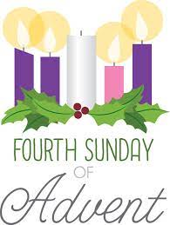

ANNOUNCEMENTS
PASTORAL CARE:
In order to provide support to the people of First Church, when you or a loved one is sick or in hospital, we encourage you to contact the church (902-752-5691), Reverend Andrew (902-331-0322) or Phoebe Fraser, Chair of the Pastoral Care Team (902-752-4728), to inform us directly. It is also important that you inform the hospital that you would welcome a visit from your minister and/or your Elder.
F.A.I.R. HEARTS - UPDATE:

On Dec. 7th, FAIR Hearts members met with Karen MacLean, the immigration caseworker at the office of Sean Fraser MP, Minister of Immigration, Refugees and Citizenship. Key questions were asked and Karen seemed very eager to obtain answers to our questions and assist us in bringing the AlQassMatte Family to Pictou County. Please keep this family in your thoughts and prayers.
FAIR Hearts members from First Church are: Rev. Andrew MacDonald (902-331-0322), Sharon Mason (902-752-0724), Sara Fullerton (902-754-2142), and Brent MacQuarrie (902) 616-7787).

UPCOMING EVENTS & NEWS

December 21, 2021 - 7:00pm - “Blue Christmas”
A Service of Healing and Anointing. For many people Christmas is not a joyous season. Sickness, death, and loneliness are a heavy burden to carry most of the time and Christmas can add to those feelings of sorrow and isolation. Please join Rev. Andrew on the Longest Night of the Year in a service of Healing and Anointing as we pray for those who are suffering or feel alone.
December 24, 2021 - 7:00pm - Christmas Eve Service
Please join us for our Annual Celebration of the Birth of our Lord and Saviour, Jesus Christ. A Service of Carols and Readings.
December 26, 2021 - 11:00Am - Regular church service
January 2 2022 11:00AM
A Service of Carols and Readings led by the Session, Choir, and Members of the Congregation.
- The congregation extends special Christmas Birthday greetings to Keith Cruickshank and Evie MacLellan who celebrate their birthdays on Christmas Day!!

- A donation has been received in loving memory of Hugh Matheson from Catherine Matheson.

- Donations have been received in loving memory of parents Melda and Roy MacGregor from Susan and Chuck Stallard and from Janet and Brian Hiscott.

- Thank You to those ushers who have volunteered for the months of December and January. We need volunteers for the upcoming year. Anyone wishing to usher (following COVID protocols), please contact Sharon Mason (902-752-0724) or leave your name at the office.

- Coffee Hour – Due to the current COVID situation and return to restrictions, coffee hour is being suspended for the time being. Session will reassess in the new year.

- Clyde MacDonald has just published his 19th book entitled “Pictonians At Home and Afar”. Due to COVID 19 restrictions, there will be no formal book launch. If you’re interested in purchasing a copy of Clyde’s latest book, you can contact him at 902-755-4738 or clydefinlay@me.com. All proceeds from the sales of this book will be donated to the MS Society.

