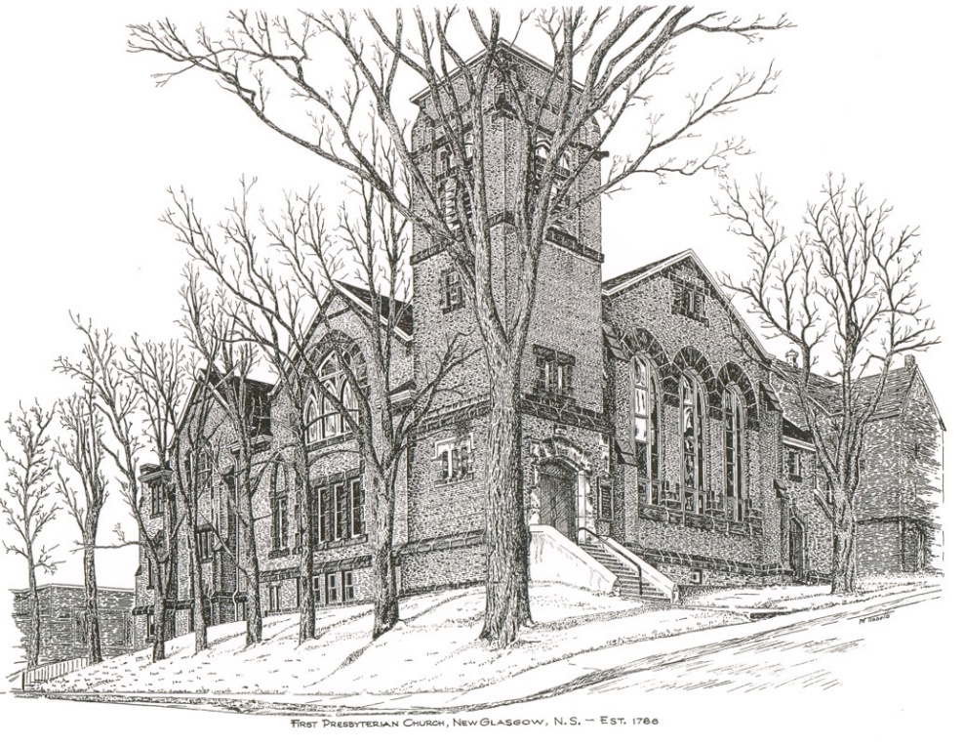

FIRST PRESBYTERIAN CHURCH
208 MacLean St., New Glasgow, NS
902-752-5691
First.church@ns.aliantzinc.ca
Reverend Andrew MacDonald
902-331-0322
yick96@hotmail.com

December 5th, 2021
ADVENT 2 - PEACE

THE APPROACH

Musical Prelude
Welcome and Announcements
Musical Introit 114 – Emmanuel, Emmanuel
Call to Worship
Hymn #115 – “Hail to the Lord’s anointed”
Prayer of Confession and Pardon
Assurance of Pardon
Passing the Peace
Hymn: #117 – “Herald! Sound the note of judgement”
Lighting the Advent Candle (Insert)
Advent Hymn – #119 “Hope is a star” (vs. 2)
Prayer of Illumination
First Lesson: Malachi 3: 1-4
Epistle Lesson: Philippians 1: 3-11
Gospel Lesson: Luke 1: 68-79, 3:1-6
Anthem – "Come Into Our World" (George Durning)
Sermon: "Peace!"
Reaffirmation of Faith – Apostles’ Creed

Hymn: #118 “Hark the glad sound”

Offertory Prayer

Prayer of the People and the Lord’s Prayer

Hymn: #120 – “Lo! Christ comes with clouds”

Benediction

Recessional

Scripture Reader: Chet Fleming

♫♫♫♫♫♫♫♫♫♫♫♫♫♫♫♫♫♫♫♫♫

Minister: Rev. Andrew MacDonald (c) 902-331-0322
Organist: Lloyd MacLean
Office hours: Tues. to Fri. – 10 -1pm
Rev. MacDonald office hours -Tues. to Fri. 10-2 or by appointment

Mission Statement: But he’s already made it plain how to live, what to do, what God is looking for in men and women. It’s quite simple. Do what is fair and just to your neighbor, be compassionate and loyal in your love, and don’t take yourself too seriously – take God seriously. Micah 6: 8-The Message

♫♫♫♫♫♫♫♫♫♫♫♫♫♫♫♫♫♫♫♫♫

ANNOUNCEMENTS

PASTORAL CARE:
In order to provide support to the people of First Church, when you or a loved one is sick or in hospital, we encourage you to contact the church (902-752-5691), Reverend Andrew (902-331-0322) or Phoebe Fraser, Chair of the Pastoral Care Team (902-752-4728), to inform us directly. It is also important that you inform the hospital that you would welcome a visit from your minister and/or your Elder.
F.A.I.R. HEARTS - UPDATE:

The meeting with Representatives of F.A.I.R. Hearts and Sean Fraser has been re-scheduled. A further update will be provided at that time.
FAIR Hearts members from First Church are: Rev. Andrew MacDonald (902-331-0322), Sharon Mason (902-752-0724), Sara Fullerton (902-754-2142), and Brent MacQuarrie (902) 616-7787).

IN MEMORIAMS

In-memoriam donations have been received in memory of Jean MacDonald from Shirley MacDonald and Fran and Justin Savage.

Natalie and Bridget MacDonald have placed the red poinsettia in memory of their Grandpa, Bob Caughey, and the white poinsettia in memory of their great-grandmother, Nanny Chrissie.

UPCOMING EVENTS

- F.A.I.R. HEARTS will meet Mon., Dec. 6th at 7:00 p.m.
- The Board of Managers will meet Tues., Dec. 7th, at 6:30 p.m.

CHRISTMAS NOTES
The annual Christmas Memory Tree fundraiser is under way again this year. The forms are available for pickup inside the sanctuary. The deadline for requests will be December 15th. If you would like to donate a ball(s), simply fill out the form and leave it, along with the donation, in the collection baskets. The Christmas Eve bulletin will list the names of those remembered and the donors.

- Coordinating with the New Glasgow Dept. of Community Services, we are doing an outreach project for Christmas. “The Tree of Kindness” at the front of the sanctuary, is decorated with paper ornaments. On each is a note naming a small, practical gift. If you can, please take an ornament, purchase the gift, and place it in one of the 2 baskets under the tree (1 female and 1 male basket). The baskets will be given to 2 clients (more if we have extra items) who are disabled and unable to work and have limited income. Useful items would be: toiletries, laundry or dish detergent, toilet tissue/Kleenex, dish cloths/towels, socks, hats, gloves, any other useful household or personal items. We will collect these gifts during Advent up to Sunday, Dec 19th. For more information, please contact Sara Fullerton (902-754-2142) or the church office.

- Reverend Andrew is looking for 5 volunteer readers for the Christmas Eve service and also a family to light the Christ Candle at that service. If you are available to help, please contact Rev. Andrew ASAP.

- Thank You to those ushers who have volunteered for the months of December and January. We need volunteers for the upcoming year. Anyone wishing to usher (following COVID protocols), please contact Sharon Mason (902-752-0724) or leave your name at the office.

- Return of Coffee Hour – Session has decided to return to coffee hour after church on Sundays. Though there is no need to show Proof of Vaccination to attend services, any other gatherings such as coffee hour, meetings etc., do require Proof of Vaccination per Dept. of Health regulations. Cathy Lewis is coordinating this and asking for volunteers to supply cookies, muffins etc. for future Sundays.

- Clyde MacDonald has just published his 19th book entitled “Pictonians At Home and Afar”. Due to COVID 19 restrictions, there will be no formal book launch. If you’re interested in purchasing a copy of Clyde’s latest book, you can contact him at 902-755-4738 or clydefinlay@me.com. All proceeds from the sales of this book will be donated to the MS Society.

