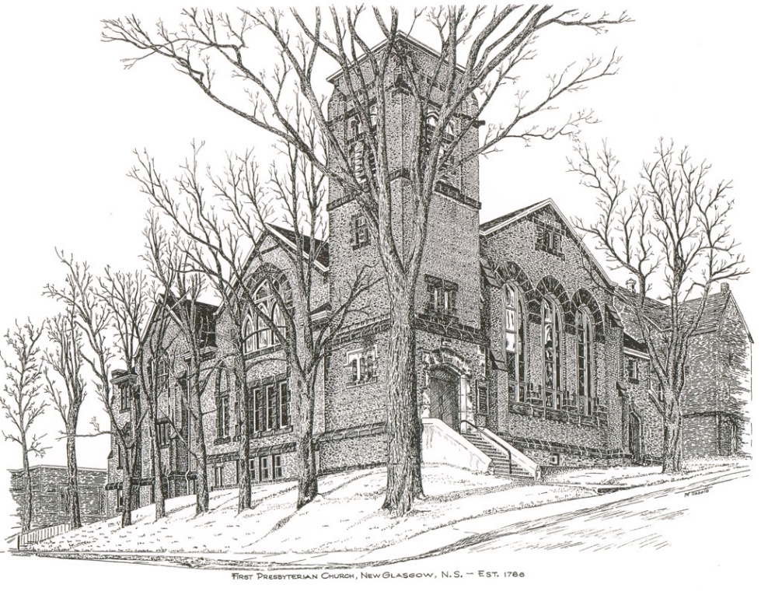

FIRST PRESBYTERIAN CHURCH
208 MacLean St., New Glasgow, NS
902-752-5691
First.church@ns.aliantzinc.ca
Reverend Andrew MacDonald
902-331-0322
yick96@hotmail.com

November 28th, 2021
ADVENT 1 HOPE

THE APPROACH

Musical Prelude
Welcome and Announcements
Musical Introit
Call to Worship
Hymn #110 – “Come, thou long-expected Jesus”
Prayer of Confession and Pardon
Assurance of Pardon
Passing the Peace
Hymn: #112 –“Prepare the way of the Lord”
Lighting the Advent Candle (Insert)
Advent Hymn – “Hope is a star” (v.1)
Prayer of Illumination
First Lesson: Jeremiah 33:14-16
Epistle Lesson: 1 Thessalonians 3:9-13
Gospel Lesson: Luke 21: 25-36
Anthem – "In the Stillness of This Hour" (Dan Damon)
Sermon: "Hope!"
Reaffirmation of Faith – Apostles’ Creed

Hymn: #109 – “All earth is waiting”

Offertory Prayer

Prayer of the People and the Lord’s Prayer

Hymn: #113 – “Comfort, comfort you my people”
Benediction

Recessional

Scripture Reader: Mark Thibeau

♫♫♫♫♫♫♫♫♫♫♫♫♫♫♫♫♫♫♫♫♫

Minister: Rev. Andrew MacDonald (c) 902-331-0322
Organist: Lloyd MacLean
Office hours: Tues. to Fri. – 10 -1pm
Rev. MacDonald office hours -Tues. to Fri. 10-2 or by appointment

Mission Statement: But he’s already made it plain how to live, what to do, what God is looking for in men and women. It’s quite simple. Do what is fair and just to your neighbor, be compassionate and loyal in your love, and don’t take yourself too seriously – take God seriously. Micah 6: 8-The Message

ANNOUNCEMENTS

PASTORAL CARE:
In order to provide support to the people of First Church, when you or a loved one is sick or in hospital, we encourage you to contact the church (902-752-5691), Reverend Andrew (902-331-0322) or Phoebe Fraser, Chair of the Pastoral Care Team (902-752-4728), to inform us directly. It is also important that you inform the hospital that you would welcome a visit from your minister and/or your Elder.
F.A.I.R. HEARTS - UPDATE:

The meeting with Representatives of F.A.I.R. Hearts and Sean Fraser has been re-scheduled. A further update will be provided at that time.
FAIR Hearts members from First Church are: Rev. Andrew MacDonald (902-331-0322), Sharon Mason (902-752-0724), Sara Fullerton (902-754-2142), and Brent MacQuarrie (902) 616-7787).

HAPPY BIRTHDAY

The congregation sends our belated wishes to Fannie Porter who celebrated her birthday November 26th.

CHRISTMAS NOTES
The annual Christmas Memory Tree fundraiser is under way again this year. The forms are available for pickup inside the sanctuary. The deadline for requests will be December 15th. If you would like to donate a ball(s), simply fill out the form and leave it, along with the donation, in the collection baskets. The Christmas Eve bulletin will list the names of those remembered and the donors.

- Reverend Andrew is looking for 5 volunteer readers for the Christmas Eve service and also a family to light the Christ Candle at that service. If you are available to help, please contact Rev. Andrew ASAP.

- Return of Coffee Hour – Session has decided to return to coffee hour after church on Sundays. Though there is no need to show Proof of Vaccination to attend services, any other gatherings such as coffee hour, meetings etc., do require Proof of Vaccination per Dept. of Health regulations. Cathy Lewis is coordinating this and asking for volunteers to supply cookies, muffins etc. for future Sundays.

- Clyde MacDonald has just published his 19th book entitled “Pictonians At Home and Afar”. Due to COVID 19 restrictions, there will be no formal book launch. If you’re interested in purchasing a copy of Clyde’s latest book, you can contact him at 902-755-4738 or clydefinlay@me.com. All proceeds from the sales of this book will be donated to the MS Society.

