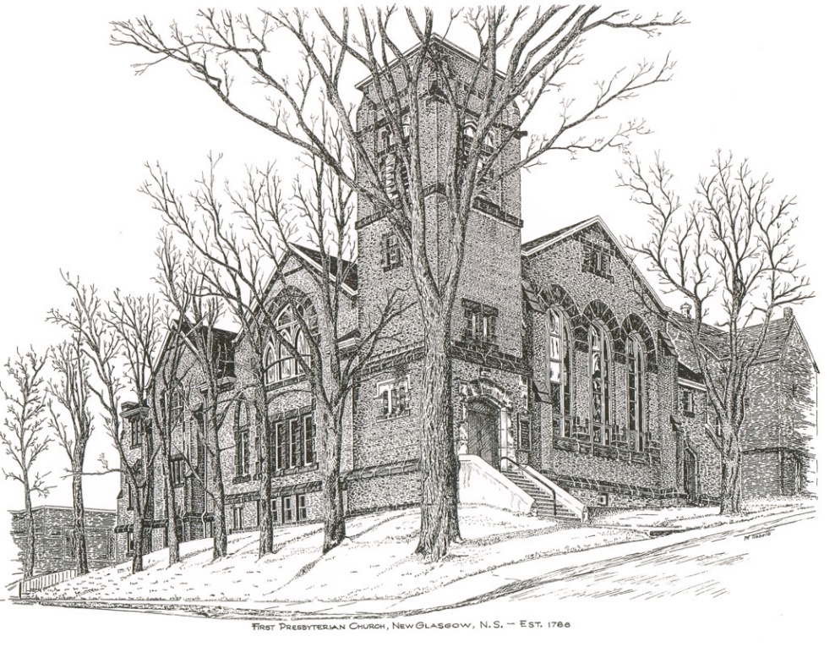

FIRST PRESBYTERIAN CHURCH
208 MacLean St., New Glasgow, NS
902-752-5691
First.church@ns.aliantzinc.ca
Reverend Andrew MacDonald
902-331-0322
yick96@hotmail.com

March 13th, 2022
Second Sunday in Lent
THE APPROACH

Musical Prelude
Welcome and Announcements
Lighting the Christ Candle: Please Rise
ONE: O Blessed Lord, accept this burning candle as a sign of our faith and love for you.
Like this candle, We are ready to be used in your service, without asking why and to what purpose.
Even as this candle, We wish to stand in your presence to be consumed in the light and warmth of your love.
Please hear our prayers and, if it be your will, grant our petitions.
Above all, make us loyal and faithful to you in all circumstances of our lives.
All: Come, Lord, and grant us peace.
ONE: Let us now prepare our hearts to worship almighty God.
Musical Introit - #575 – Lead me, Lord
Call to Worship
Hymn #194 – “Come, let us to the Lord our God”
Prayer of Adoration, Confession and Lord’s Prayer
Assurance of Pardon
Passing the Peace
Hymn: #14 – “Safe in your hands, O God who made me”
Prayer of Illumination
First Lesson: Isaiah 40:1-11
Epistle Lesson: 2 Corinthians 1:3-11
Gospel Lesson: John 21:2-8
Anthem – “Dust and Ashes” (Brian Wren/Ron Klusmeier)
Sermon: "Finding Comfort in the Uncomfortable!"
Hymn: #332 - “O Lord my God!”
Offertory Prayer

Reaffirmation of Faith – Apostles’ Creed – Please rise

Prayer of the People

Hymn: #334 - “God who gives to life its goodness”

Benediction

Recessional

Scripture Reader: Brent MacQuarrie

♫♫♫♫♫♫♫♫♫♫♫♫♫♫♫♫♫♫♫♫♫

ANNOUNCEMENTS

PASTORAL CARE:
In order to provide support to the people of First Church, when you or a loved one is sick or in hospital, we encourage you to contact the church (902-752-5691), Reverend Andrew (902-331-0322) or Phoebe Fraser, Chair of the Pastoral Care Team (902-752-4728), to inform us directly. It is also important that you inform the hospital that you would welcome a visit from your minister and/or your Elder.

F.A.I.R. HEARTS - UPDATE:

The AlQasseMatte Family completed their interviews with Canadian Immigration officials in Turkey on Jan. 19 and have been approved to come to Canada. This is absolutely wonderful news after their 8 year wait as refugees. There are still several more steps that must be completed such as medicals that must be completed for each family member, passports issued by the Canadian Government and arrangements made for transportation to Canada. Hopefully these steps will be completed in the next few months, however a time frame is unknown at this time.
Fundraising continues in order to meet our commitment of financially supporting the family for their 1st year in Nova Scotia. If you would like to make a monetary donation to FAIR Hearts it would be greatly appreciated. Please contact the church office or a member of FAIR Hearts (Sara Fullerton, Brent MacQuarrie, Sharon Mason or Rev Andrew). Through generous donations of furnishings and other household items from the congregation and the Pictou County community, we now have all that is required for furnishings and household items. Financial donations to support them in their 1st year, however, are still required.
FAIR Hearts members from First Church are: Rev. Andrew MacDonald (902-331-0322), Sharon Mason (902-752-0724), Sara Fullerton (902-754-2142), and Brent MacQuarrie (902) 616-7787).

CONDOLENCES

We extend our sincere condolences to Sherry Greene on the loss of her mother, Vesta Clark. Celebration of Vesta’s life will take place at a later date.

UPCOMING EVENTS & NEWS

Today – Session will meet Sun., Mar. 13th at 2p.m.
Mon., Mar. 14th. – F.A.I.R. Hearts Committee will meet at 7 p.m
Sun. Mar. 20th – Annual Meeting – after service
Workshop for Elders – Date to be determined
For the 26th year, Larry Ingham is preparing tax returns for low-income seniors. You can reach Larry at 902-752-1639.

HAPPY ANNIVERSARY!!
The Congregation extends our best wishes to Sandy and Marion MacIntosh who will celebrate their 58th wedding anniversary tomorrow, March 15th.
♫♫♫♫♫♫♫♫♫♫♫♫♫♫♫♫♫♫♫♫♫

Minister: Rev. Andrew MacDonald (c) 902-331-0322
Organist: Lloyd MacLean
Office hours: Tues. to Fri. – 10 -1pm
Rev. MacDonald office hours -Tues. to Fri. 10-2 or by appointment.

Mission Statement: But he’s already made it plain how to live, what to do, what God is looking for in men and women. It’s quite simple. Do what is fair and just to your neighbor, be compassionate and loyal in your love, and don’t take yourself too seriously – take God seriously. Micah 6: 8-The Message

