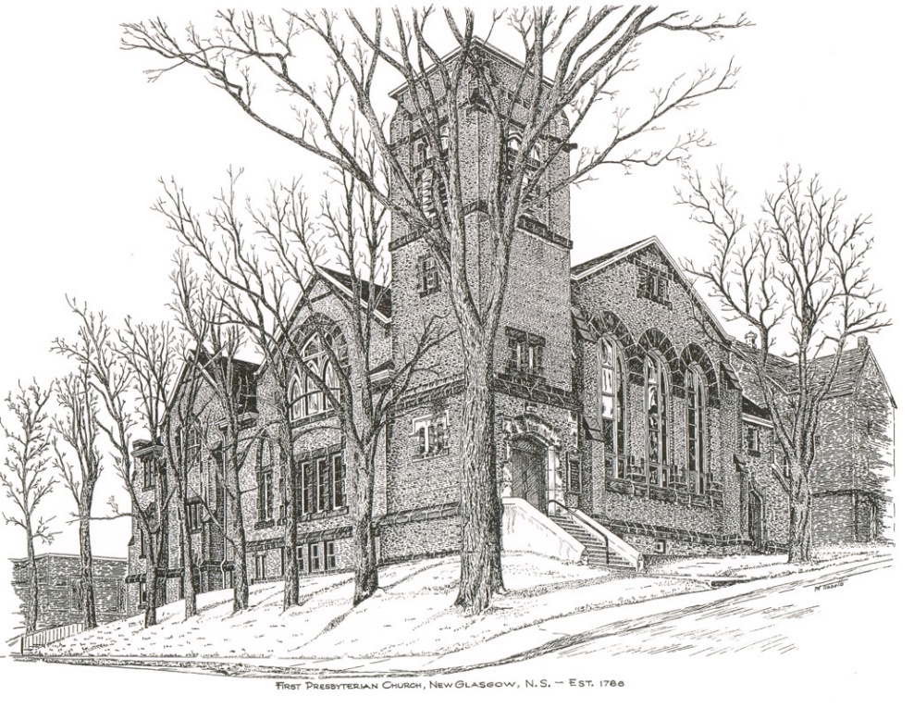

FIRST PRESBYTERIAN CHURCH
208 MacLean St., New Glasgow, NS
902-752-5691
First.church@ns.aliantzinc.ca
Reverend Andrew MacDonald
902-331-0322
yick96@hotmail.com

March 20th, 2022
Third Sunday in Lent
THE APPROACH

Musical Prelude
Welcome and Announcements
Lighting the Christ Candle: Please Rise
ONE: As we light this candle, set our hearts on fire with love for you, O Christ our God so that in its flame we may love you with all our heart, with all our mind, with all our soul, and with all our strength, and our neighbors as ourselves, So that by keeping your commandments we may glorify you, The giver of all good gifts.
All: Come, Lord, and grant us peace.
ONE: Let us now prepare our hearts to worship almighty God.
Musical Introit - #575 – Lead me, Lord
Call to Worship
Hymn #366 – “Jesus, thou joy of loving hearts”
Prayer of Adoration, Confession and Lord’s Prayer
Assurance of Pardon
Passing the Peace
Hymn: #645 – “Follow me, the Master said”
Prayer of Illumination
First Lesson: Isaiah 55:1-9
Epistle Lesson: 1 Corinthians 10:1-13
Gospel Lesson: Luke 13:1-9

Anthem –“I rest in God alone” (John Daniels–Book of Praise #36)
Sermon – “Under the Cloud!”
Hymn: #209 - “O Love that wilt not let me go”
Offertory Prayer

Reaffirmation of Faith – Apostles’ Creed – Please rise

Prayer of the People

Hymn: #670 - “Amazing grace”

Benediction

Recessional

Scripture Reader: Sara Fullerton
Ushers – Clarice Campbell and Cathy Lewis

♫♫♫♫♫♫♫♫♫♫♫♫♫♫♫♫♫♫♫♫♫

Minister: Rev. Andrew MacDonald (c) 902-331-0322
Organist: Lloyd MacLean
Office hours: Tues. to Fri. – 10 -1pm
Rev. MacDonald office hours -Tues. to Fri. 10-2 or by appointment

Mission Statement: But he’s already made it plain how to live, what to do, what God is looking for in men and women. It’s quite simple. Do what is fair and just to your neighbor, be compassionate and loyal in your love, and don’t take yourself too seriously – take God seriously. Micah 6: 8-The Message

ANNOUNCEMENTS

PASTORAL CARE:
In order to provide support to the people of First Church, when you or a loved one is sick or in hospital, we encourage you to contact the church (902-752-5691), Reverend Andrew (902-331-0322) or Phoebe Fraser, Chair of the Pastoral Care Team (902-752-4728), to inform us directly. It is also important that you inform the hospital that you would welcome a visit from your minister and/or your Elder.
F.A.I.R. HEARTS - UPDATE:

The AlQasseMatte Family completed their interviews with Canadian Immigration officials in Turkey on Jan. 19 and have been approved to come to Canada. This is absolutely wonderful news after their 8 year wait as refugees. There are still several more steps that must be completed such as medicals that must be completed for each family member, passports issued by the Canadian Government and arrangements made for transportation to Canada. Hopefully these steps will be completed in the next few months, however a time frame is unknown at this time.
Fundraising continues in order to meet our commitment of financially supporting the family for their 1st year in Nova Scotia. If you would like to make a monetary donation to FAIR Hearts it would be greatly appreciated. Please contact the church office or a member of FAIR Hearts (Sara Fullerton, Brent MacQuarrie, Sharon Mason or Rev Andrew). Through generous donations of furnishings and other household items from the congregation and the Pictou County community, we now have all that is required for furnishings and household items. Financial donations to support them in their 1st year, however, are still required.
FAIR Hearts members from First Church are: Rev. Andrew MacDonald (902-331-0322), Sharon Mason (902-752-0724), Sara Fullerton (902-754-2142), and Brent MacQuarrie (902) 616-7787).

UPCOMING EVENTS & NEWS

Today – The Annual Meeting will take place after service.
For the 26th year, Larry Ingham is preparing tax returns for low-income seniors. You can reach Larry at 902-752-1639.

IN MEMORIAM
A generous donation has been received in memory of Jean (Cruickshank) Morrow from her family, Rob & Karen Morrow of Bellville, Ontario. Jean and her family had a long history with First Presbyterian spanning several generations. Among her many accomplishments, Jean was an accredited horticultural judge, and an expert on roses. For many years she donated a centerpiece for the Christmas Tea and Sale. Appropriately, the donation is to be used for flowers for the sanctuary for special occasion(s). We thank the Morrows for their kindness.

USHERS
Ushers for the month of March are Clarice Campbell and Cathy Lewis and for the month of April, Brent MacQuarrie and Sandra Arthur. Except for August when the church is closed for vacation, we need volunteers for the rest of the year. If you would be interested in helping out, please contact Sharon Mason (902-752-0724) or leave your name at the office.

FOOD BANK
We have received thanks from the Pictou East Food Bank for your regular donations of food items.
PAR
For many years, PAR (Pre-Authorized Remittance Plan) has been a convenient option for making regular donations to the church. It ensures your donations continue when you are away, or, as we learned this past 2 years, when the church is closed due to COVID. For the church, it provides a regular, dependable flow of contributions. The forms for PAR are available on Sundays or through the office. The funds are debited from your bank account on or about the 20th of the month. For those who like to put something in the offering tray, cards are available, or drop your envelope marked PAR in the tray. If you have any questions, contact the office for more information.

