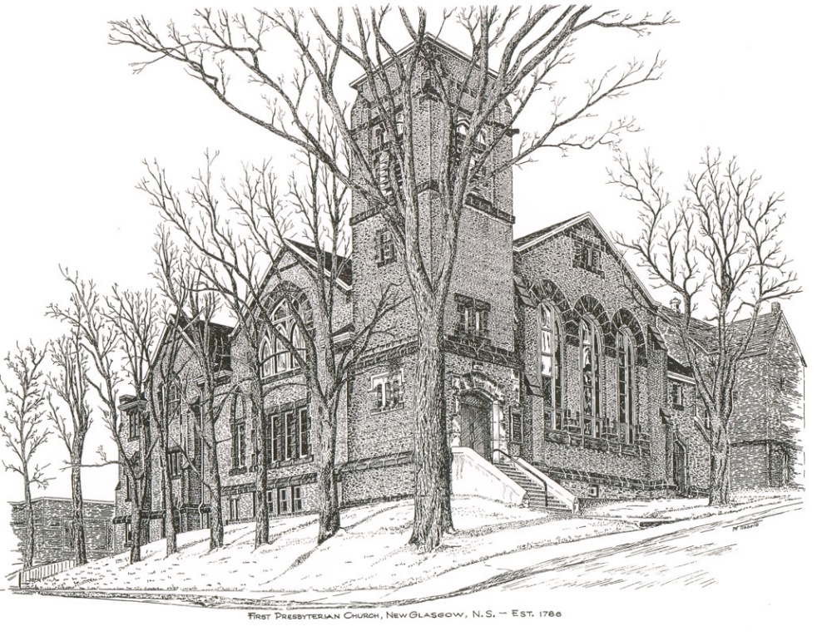

FIRST PRESBYTERIAN CHURCH
208 MacLean St., New Glasgow, NS
902-752-5691
First.church@ns.aliantzinc.ca
Reverend Andrew MacDonald
902-331-0322
yick96@hotmail.com

May 15th, 2022
Fifth Sunday of Easter
THE APPROACH

Musical Prelude
Welcome and Announcements
Lighting the Christ Candle: (Please rise if you are able)
ONE: Let us light a candle for justice and pray for the eradication of poverty and want everywhere in Canada and the world, but especially among children and the First Nations. Let us pray for our young people, that they may find solid mentors, leading them to creative and satisfying lives.
All: Come, Lord, and grant us peace.
(LIGHT CANDLE)
Let us now prepare our hearts to worship almighty God.
Musical Introit - # 640 "Softly and tenderly" (vs 1)
Call to Worship
Hymn #500 – “Open my eyes, that I may see” (vs. 1-3)
Prayer of Adoration, Confession and Lord’s Prayer
Assurance of Pardon
Passing the Peace
Hymn: #639 – “We are marching/Siyahamba”
Prayer of Illumination

First Reading: Acts 11:1-18
Second Reading: Revelation 21:1-6
Gospel Reading: John 13:31-35
Anthem
Sermon: "A New Commandment, a New Hope"
Hymn: #225 - “A new commandment”

Offertory Prayer

Reaffirmation of Faith – Apostles’ Creed – Please rise

Prayer of the People

Hymn: #730 - “Oh for a world where everyone”

Benediction

Recessional

Scripture Reader: Kevin Reid

* * * * * * * * * * * * *

Minister: Rev. Andrew MacDonald (c) 902-331-0322
Organist: Lloyd MacLean
Office hours: Tues. to Fri. – 10 -1pm
Rev. MacDonald office hours -Tues. to Thurs. 10-2 or by appointment

Mission Statement: But he’s already made it plain how to live, what to do, what God is looking for in men and women. It’s quite simple. Do what is fair and just to your neighbor, be compassionate and loyal in your love, and don’t take yourself too seriously – take God seriously. Micah 6: 8-The Message

Apostles Creed

I believe in God, the Father Almighty, maker of Heaven and earth; and in Jesus Christ, His only Son, Our Lord, who was conceived by the Holy Ghost, born of the Virgin Mary,
suffered under Pontius Pilate, was crucified, died, and was buried. He descended into Hell. On the third day He arose again from the dead; He ascended into Heaven, and sits
at the right hand of God, the Father Almighty; from thence He shall come to judge the quick and the dead.
I believe in the Holy Ghost, the holy Catholic Church,
the communion of saints, the forgiveness of sins, the resurrection of the body, and the life everlasting. Amen.

The Lord’s Prayer

Our Father which art in heaven,

Hallowed be thy name.

Thy kingdom come,

Thy will be done in earth,

as it is in heaven.

Give us this day our daily bread.

And forgive us our debts,

as we forgive our debtors.

And lead us not into temptation,

but deliver us from evil:

For thine is the kingdom,

and the power, and the glory,

forever. Amen.

ANNOUNCEMENTS

FAIR HEARTS:
FAIR Hearts needs help to move the furnishings stored at the church to the home we have in Westville for our refugee family. Any able-bodied persons willing to help, please meet us at 1pm - James St. entrance.
HAPPY BIRTHDAY!

Best wishes to Hendrika Vanveld as she celebrates her birthday Thursday, May 19th.

UPCOMING EVENTS & NEWS
- Service scheduled for Ivey’s Terrace today has been cancelled.
- May 24th-27th – Rev. Andrew will be away on study leave.
- May 20, 2022 - Musique Royale will be presenting Capella Regalis Men and Boys Choir from Halifax at First Presbyterian Church on May 20, 2022, at 7pm. Tickets will be available at the door or in advance by calling the church office at 902-752-5691 or by email at first.church@ns.aliantzinc.ca Ticket prices are: $25 at the door ($20 in advance). Students - $10.00.
USHERS
Ushers today are Gary Baudoux and Colette Condon; If you would be interested in ushering, please contact Sharon Mason (902-752-0724) or leave your name at the office.
REQUEST FOR ASSISTANCE
The Trustees of Riverside Cemetery Company, Administrator of the Riverside, Lorne St. and the Pioneer Cemeteries, New Glasgow, are seeking assistance with the spring clean up of the cemeteries. We also welcome financial donations to help operating expenses. For further information regarding clean up or donations, please contact Murray Biggar at 902-752-4378.

WORKDAY AT CAMP GEDDIE
If you’re available, please join us at Camp Geddie for a workday, Sat., June 4th at 10 a.m. Bring your equipment/tools along with a lunch and be prepared for a great day of work and laughter! There are a variety of jobs needing to be completed including putting the docks in the water; painting; minor repairs to cabins; clearing brush etc. Your support is always appreciated! Chris MacDonald, Property Committee.

Financial Report to April 30, 2022

 | Actual to Apr 2022 | Budget to Apr 2022 | Variance
Envelope Offering | $ 25,371 | $ 50,400 | $ (25,029)
Loose Offering | 132 | 500 | (368)
Special Donations | 1,464 | 2,280 | (816)
Rent & Fundraising | 3,264 | 3,400 | (136)
Total Revenue | 30,231 | 56,580 | (26,349)
Fuel | 13,887 | 12,300 | 1,587
Dues (Synod/Presbytery) | - | 3,275 | (3,275)
Manse Expenses | 4,243 | 3,400 | 843
Office expenses | 488 | 1,015 | (527)
Miscellaneous | (199) | 1,240 | (1,439)
Repairs & Maintenance | 3,912 | 4,167 | (255)
Salaries & Benefits | 39,552 | 40,384 | (832)
Utilities | 1,863 | 1,767 | 96
Total Expenses | 63,747 | 67,548 | (3,801)
Net Income (Loss) | $ (33,516) | $ (10,968) | $ (22,548)

